**AWS Workshop Exercises**

**Table of Contents**

Exercise 1. To Launch Amazon Linux EC2 Instance ……………………………………………………3-8

1.1. To connect to Amazon Linux instance from linux client operating system ……….8-9

1.2. To connect to Amazon Linux instance from Windows client operating system …9-12

Exercise 2. To Launch Windows EC2 instance in AWS…………………………………………………

2.1. To connect to Amazon Windows instance from linux client operating system…12-17

2.2. To connect Windows instance from Windows client operating system…………18-20

Exercise 3. To configure Web Server on Amazon Linux instance with Elastic IP……………………21-22

Exercise 4. To Assign Elastic IP address ……………………………………………………………22-26

Exercise 5. To Manage Elastic Block Storage(EBS)..............................................................................27-36

Exercise 6. To Configure Amazon Simple Storage Service (Amazon s3).............................................36-50

Exercise 7. To Manage IAM User, Group and Policies…………………………………………………51

7.1 Creating an IAM role to login other users………………………………………51-69

7.2 Creating an IAM role to Access EC2 read only, Full access to only EC2……….69-73

7.3 Creating an IAM role to provide access to particular bucket with full access……..

Exercise 8. To configure Amazon S3 Glacier………………………………………………………….74-82

Exercise 9. To Configure Amazon Glacier……………………………………………………………83-88

Exercise 10. To Configure Amazon EFS………………………………………………………………89-98

Exercise 11. To Configure Amazon Virtual Private Cloud (VPC)...........................................................

11.1. To Create your own VPC………………………………………………………...

11.2. To Create public subnet………………………………………………………….

11.3. To Create private subnet………………………………………………………...

11.4. Create a Internet gateway and attach to your VPC ……………………………..

11.5. Create Pubic Routing Table, associate subnet and add routing rules…………...

11.6. Create Private Routing Table, associate subnet and add routing rules………………………………………………………………………

11.7. To launch Windows instance in Public subnet………………

11.8. To launch Windows instance in private Subnet under your VPC……………………………………………………………………...

11.9. To Connect to Public subnet instance

11.10. To Connect to Private subnet instance

11.11. To Connect linux instance in private subnet

11.12. To Connect linux instance in public subnet

Exercise 12. To configure Amazon cloud watch …………………...179-192

Exercise 13. To configure Amazon simple notification service (SNS)..............193-199

Exercise 14. To configure Amazon Elastic Load Balancer……………....200-209

Exercise 15. To configure Amazon Auto Scaling with load balancer and snapshot …………………………………...

Exercise 16. To configure an Elastic Beanstalk with Tomcat Application ……………………………………..

Exercise 17. To configure an lightsail with apache2 ………………..

Exercise 18. To configure Relational Database Service(RDS) ……….

Exercise 19. To configure DynamoDB……………………………….

Exercise 20. To Configure Cloud Formation ………………………….

Exercise 21. To Configure Simple EMail Service(SES)..........................

Exercise 22. To Configure Simple Queue Service (SQS)...........................

Exercise 23. To Configure Route 53……………………………………….

23.1 get free domain from freenom

23.2 Shift of DNS

24.3 aliasing the load balancer DNS to A record.

Exercise 24. To Configure cloudfront service…………………...

24.1 Setting up cloudfront for S3 - static website and setting DNS in Route 53

24.2 Setting up cloudfront for Load Balancer and setting the DNS in Route 53

Exercise 25. Deploy the wordpress website in highly scalable and highly available architecture …………………..

**Exercise 1: Launching Amazon Linux EC2 Instance**

**Amazon EC2 :** Amazon Elastic Compute Cloud (Amazon EC2) is a web service that provides secure, resizable compute capacity in the cloud. It is designed to make web-scale computing easier for developer’s .It is a simple web service interface allows you to obtain and configure capacity with minimal friction. It provides you with complete control of your computing resources and lets you run on Amazon’s proven computing environment. AmazonEC2 reduces the time required to obtain and boot new server instances (called Amazon EC2 instances) to minutes, allowing you to quickly scale capacity, both up and down, as your

computing requirements change.

**Objective:**

To Launch Amazon Linux instance and to connect from Linux and windows client PC.

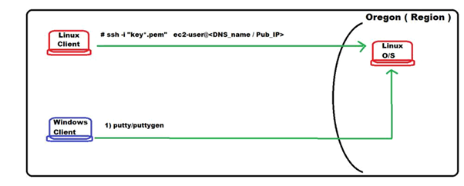

**Setting Up with Amazon EC2:** Sign Up for AWS : When you sign up for Amazon Web Services (AWS), your AWS account is automatically signed up for all services in AWS, including Amazon EC2.

In the navigation pane first of all you need to choose your region and then click on EC2 in the Compute services.

* **Launching Amazon Linux EC2 Instance**

**Step 1: Choose an Amazon Machine Image (AMI)**

An AMI is a template that contains the software configuration (operating system, application server, and applications) required to launch your instance. You can select an AMI provided by AWS, our user community, or the AWS Marketplace; or you can select one of your own AMIs.

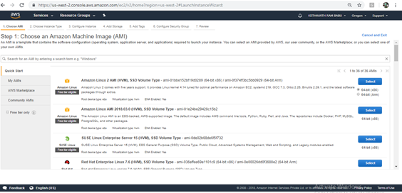

**Select-> Ubuntu Server 18.04 LTS (HVM), SSD Volume Type** - ami-0bbe6b35405ecebdb (64-bit x86) / ami-0db180c518750ee4f (64-bit Arm).

**Step 2: Choose an Instance Type Amazon**

EC2 provides a wide selection of instance types optimized to fit different use cases. Instances are virtual servers that can run applications. They have varying combinations of CPU, memory, storage, and networking capacity, and give you the flexibility to choose the appropriate mix of resources for your applications.

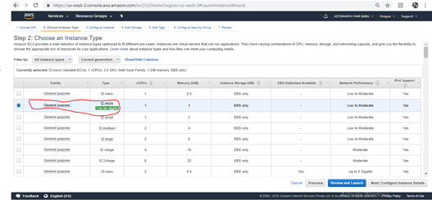

Select à Next: Configure Instance Details

**Step 3: Configure Instance Details**

Configure the instance to suit your requirements. You can launch multiple instances from the same AMI, request Spot instances to take advantage of the lower pricing, assign an access management role to the instance, and more.

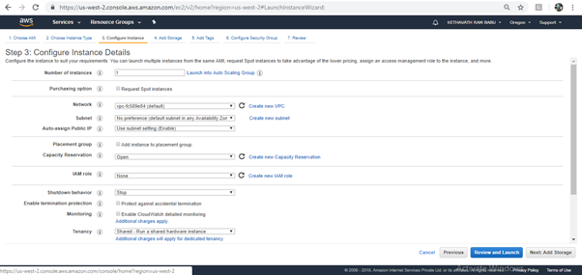

Select à Based on your requirement select instance type and subnet .

**Step 4: Add Storage**

Your instance will be launched with the following storage device settings. You can attach additional EBS volumes and instance store volumes to your instance, or edit the settings of the root volume. You can also attach additional EBS volumes after launching an instance, but not instance store volumes

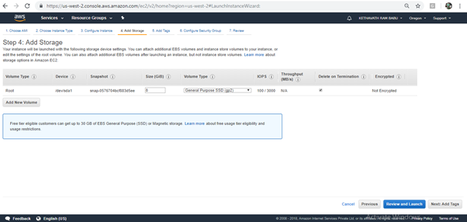

**Step 5: Add Tags**

A tag consists of a case-sensitive key-value pair. For example, you could define a tag with key = Name and value = Webserver.

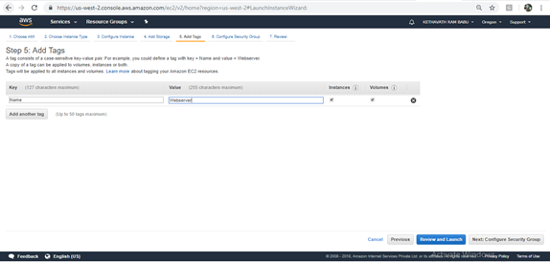

**Step 6: Configure Security Group**

A security group is a set of firewall rules that control the traffic for your instance. On this page, you can add rules to allow specific traffic to reach your instance. For example, if you want to set up a web server and allow Internet traffic to reach your instance, add rules that allow unrestricted access to the HTTP and HTTPS ports. You can create a new security group or select from an existing one .

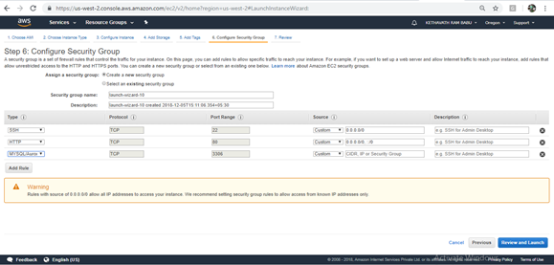

**Click on -> Review and launch**

**Step 7: Review Instance Launch**

Please review your instance launch details. You can go back to edit changes for each section. Click **Launch** to assign a key pair to your instance and complete the launch process.

**Create a Key Pair**:

Before launching your instance AWS uses public-key cryptography to secure the login information for your instance. A Linux instance has no password; you use a key pair to log in to your instance securely. You specify the name of the key pair when you launch your instance, then provide the private key when you login using SSH. If you haven't created a key pair already, you can create one using the Amazon EC2 console. From the navigation bar, select a region for the key pair. You can select any region that's available to you, regardless of your location. However, key pairs are specific to a region; for example, if you plan to launch an instance in the US East (Ohio) Region, you must create a key pair for the instance in the US East (Ohio) Region.

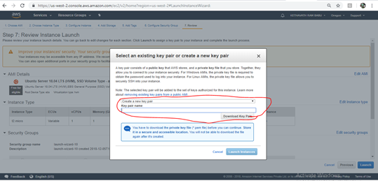

To connect to your instance using your key pair To connect to your Ubuntu instance from a computer running Mac or Linux, you'll specify the .pem file to your SSH client with the -i option and the path to your private key.

**1.1. To connect to Amazon Linux instance from linux client operating system**

**Command:**

**$ ssh -i key.pem ubuntu@ec2-35-164-184-80.us-west-2.compute.amazonaws.com**

Select your instance and make sure your key (pem file) matches your key pair name

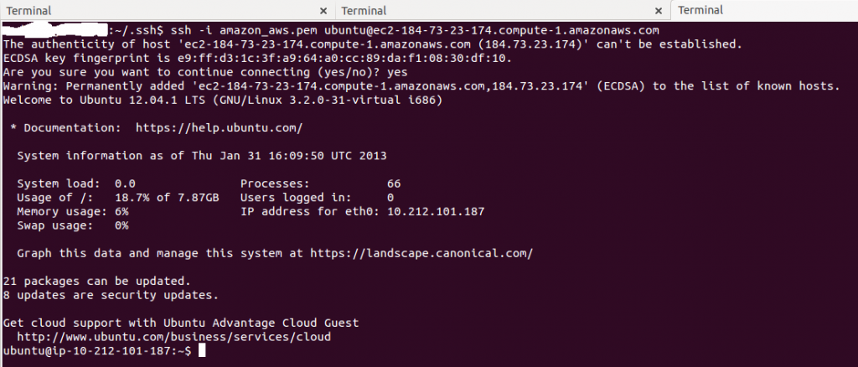

**1.2. To connect to Amazon Linux instance from Windows client operating system**

To connect to your Ubuntu instance from a computer running Windows, you can use either MindTerm or PuTTY. If you plan to use PuTTY, you'll need to install it and use the following procedure to convert the .pem file to a .ppk file(for generation of PPK file Install Puttygen)

Download PuTTY: <https://www.chiark.greenend.org.uk/~sgtatham/putty/latest.html>.

To prepare to connect to a Ubuntu instance from Windows using PuTTY ,**CONVERT YOUR PEM FILE TO PPK FORMAT**

1. Open puttygen and load the pem file into the puttygen

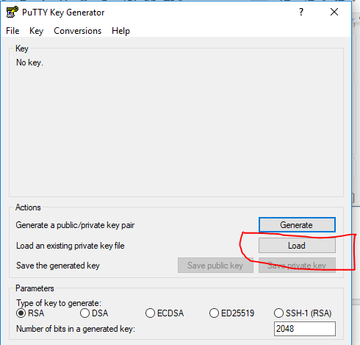

2. Save the private key by assigning a name to that file

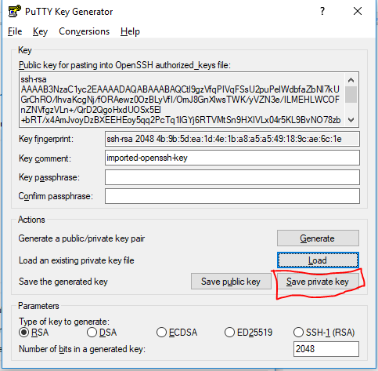

-> Open Putty

i. Enter Host Name

ii.Select your PPK file.

iii.Open your terminal Session

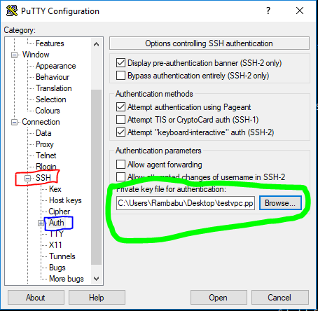

**Installing a LAMP Web Server on Amazon**

To install and start the LAMP web server on Amazon Ubuntu .

1. Connect to your instance in putty

**User name: ubuntu or ec2-user**

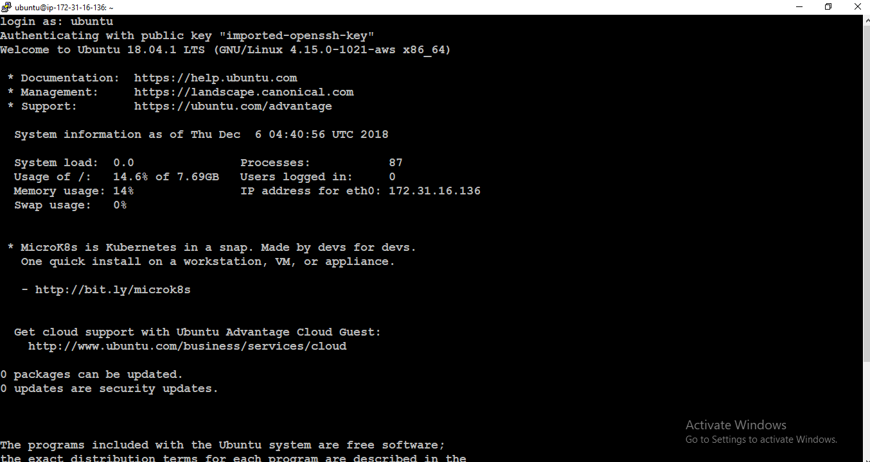

2. To ensure that all of your software packages are up to date, perform a quick software update on your instance. **$ sudo apt-get update**

3 Now that your instance is current, you can install the Apache web server, MySQL, and PHP software packages. **$ sudo apt-get install php7 mysql-server php7-mysqlnd**

4. Restart the Apache web server. **$ sudo /etc/init.d/apache2 restart**

5. Also start all the web servers by executing its commands

6. If your server is installed and running, and your file permissions are set correctly, your ec2-user account should be able to create a PHP file in the /var/www/html directory that is available from the internet

7. In the web browser, type the URL of the file that you just created. This URL is the public DNS or ip address of your instance followed by a forward slash and the file name.

e.g: 54.187.117.10

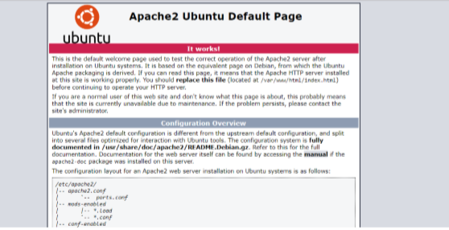

**Exercise 2: To Launch Windows EC2 instance in AWS**

Amazon EC2 instances created from most Windows Amazon Machine Images (AMIs) enable you to connect using Remote Desktop. Remote Desktop uses the Remote Desktop Protocol (RDP) and enables you to connect to and use your instance in the same way you use a computer sitting in front of you. It is available on most editions of Windows and available for Mac OS.

**-> To Launch Windows EC2 instance**

**Step 1:** An AMI is a template that contains the software configuration (operating system, application server, and applications) required to launch your instance. You can select an AMI provided by AWS, our user community, or the AWS Marketplace; or you can select one of your own AMIs.

**Select -> Microsoft Windows Server 2016 Base - ami-0be9369ce05f0a8ff**

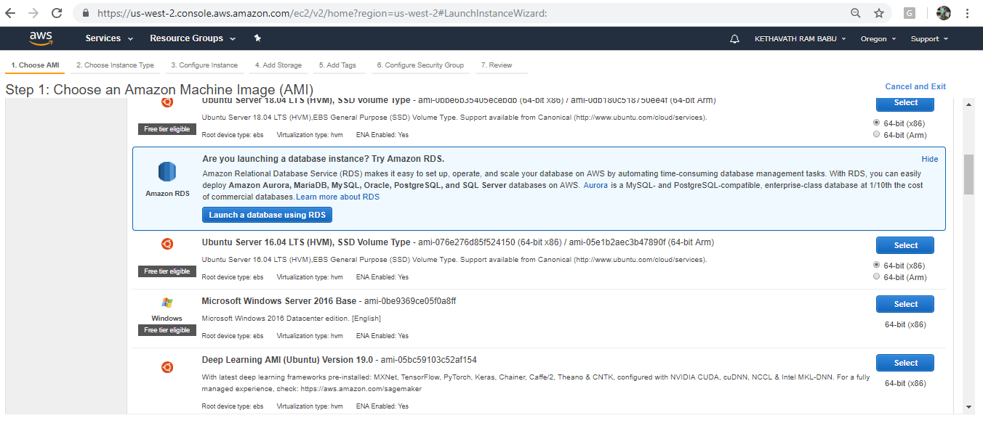

**Step 2:** **Choose an Instance Type**

Amazon EC2 provides a wide selection of instance types optimized to fit different use cases. Instances are virtual servers that can run applications. They have varying combinations of CPU, memory, storage, and networking capacity, and give you the flexibility to choose the appropriate mix of resources for your applications.

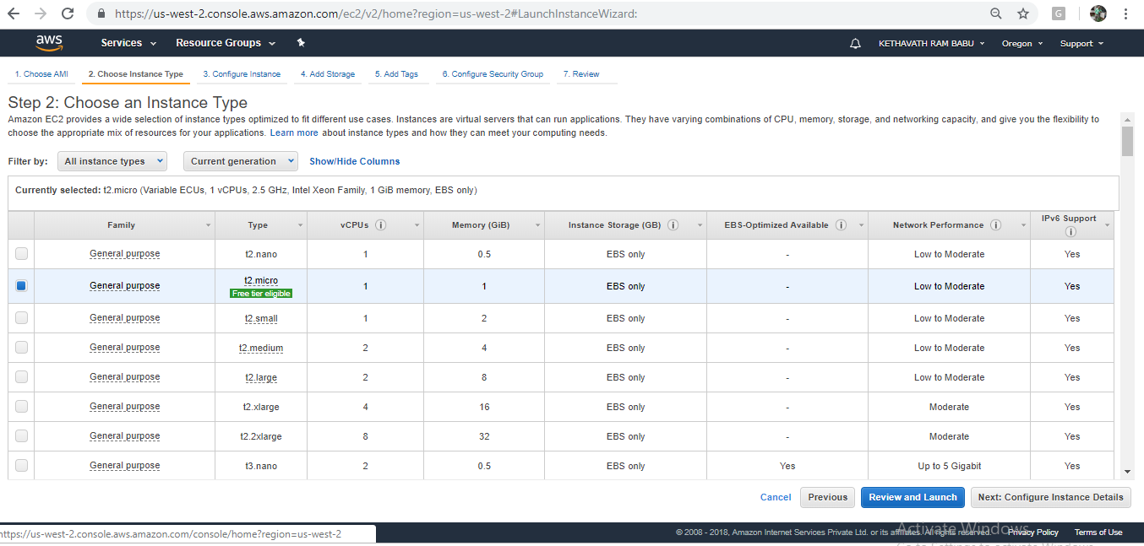

**Step 3: Configure Instance Details**

Configure the instance to suit your requirements. You can launch multiple instances from the same AMI, request Spot instances to take advantage of the lower pricing, assign an access management role to the instance.

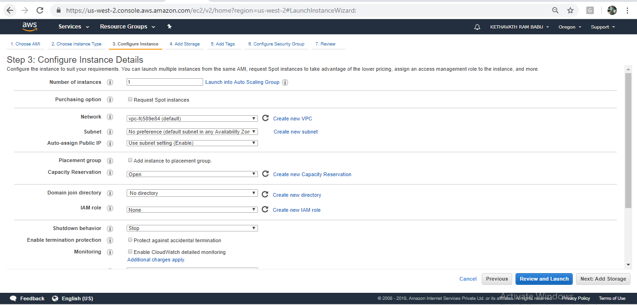

**Step 4: Add Storage**

Your instance will be launched with the following storage device settings. You can attach additional EBS volumes and instance store volumes to your instance, or edit the settings of the root volume. You can also attach additional EBS volumes after launching an instance, but not instance store volumes.(Free tier eligible customers can get up to 30 GB of EBS General Purpose (SSD) or Magnetic storage.)

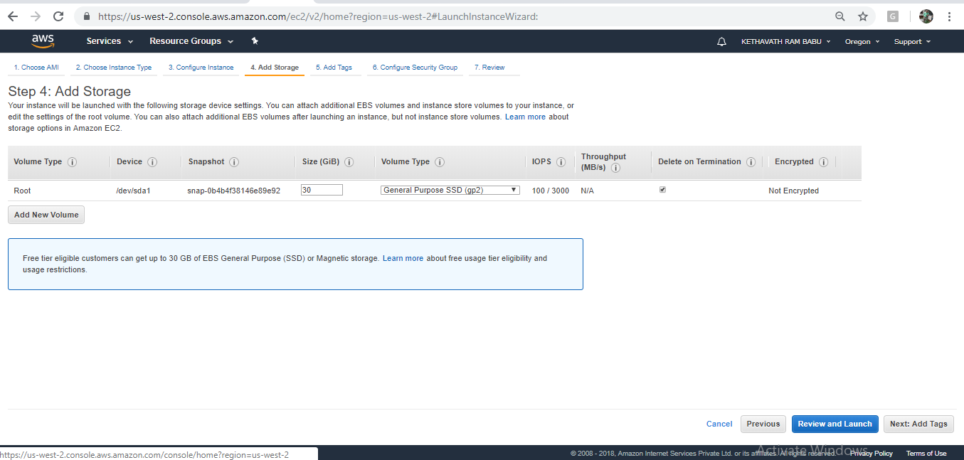**Step**

**5: Add Tags**

A tag consists of a case-sensitive key-value pair. For example, you could define a tag with key = Name and value = Webserver.A copy of a tag can be applied to volumes, instances or both.Tags will be applied to all instances and volumes.

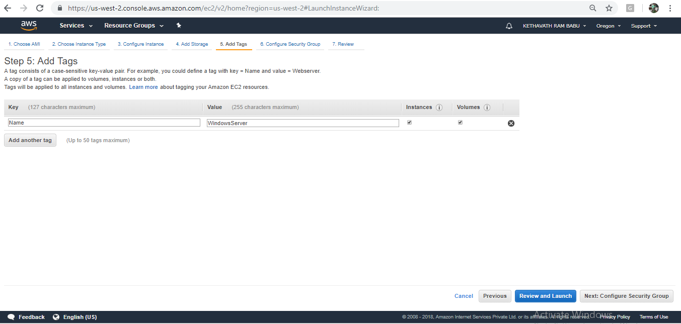

**Step 6: Configure Security Group**

A security group is a set of firewall rules that control the traffic for your instance. On this page, you can add rules to allow specific traffic to reach your instance. For example, if you want to set up a web server and allow Internet traffic to reach your instance, add rules that allow unrestricted access to the HTTP and HTTPS ports. You can create a new security group or select from an existing one below. If want to launch a windows remote desktop, allow the port RDP with port range-3389.

**Step7:Review Instance Launch**

Please review your instance launch details. You can go back to edit changes for each section. Click **Launch** to assign a key pair to your instance and complete the launch process.

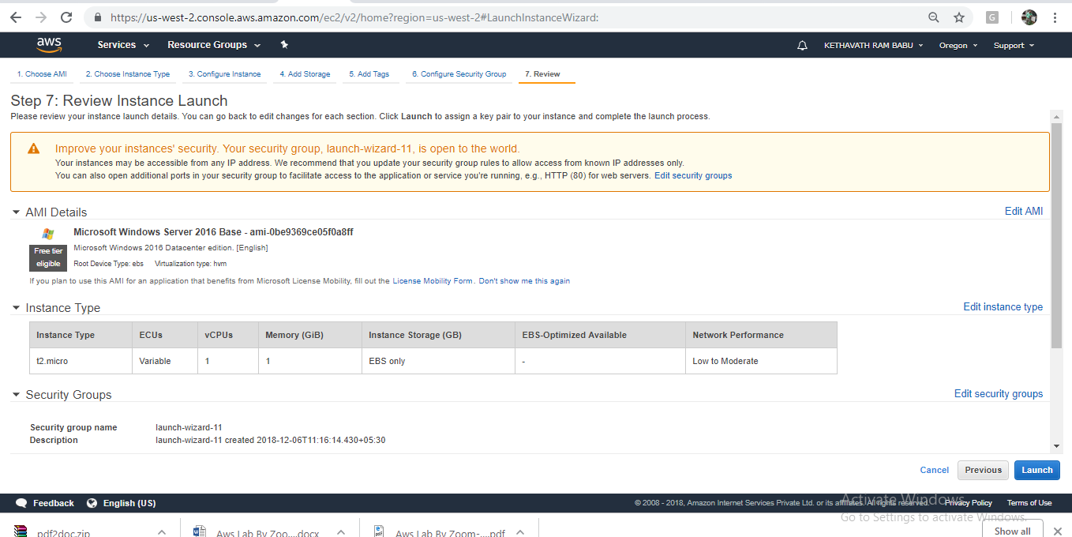

**2.1. To connect to Amazon Windows instance from linux client operating system**

Login to client operating system

-> Open linux terminal

**Note: rdesktop or xfreerdp { RHEL-6,7 } package should be installed**

**$ rdesktop -u Administrator <Pub_DNS_name/Public_IP>**

Or

$ **xfreerdp -u Administrator <Pub_DNS_name/Public_IP>**

In  **{ RHEL-6,7 } ->**

**-u -> user name**

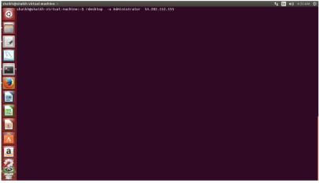

**Click on Administrator and Provide the password and click on verify**

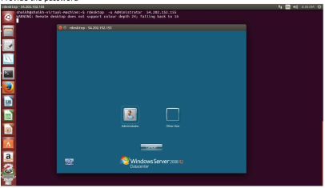

**Once logged in Windows, Desktop is available.{ If you are going to use the instance,terminate the instance }**

**2.2. To connect Windows instance from Windows client operating system**

**->In the navigation pane, under Instances, choose Instances.**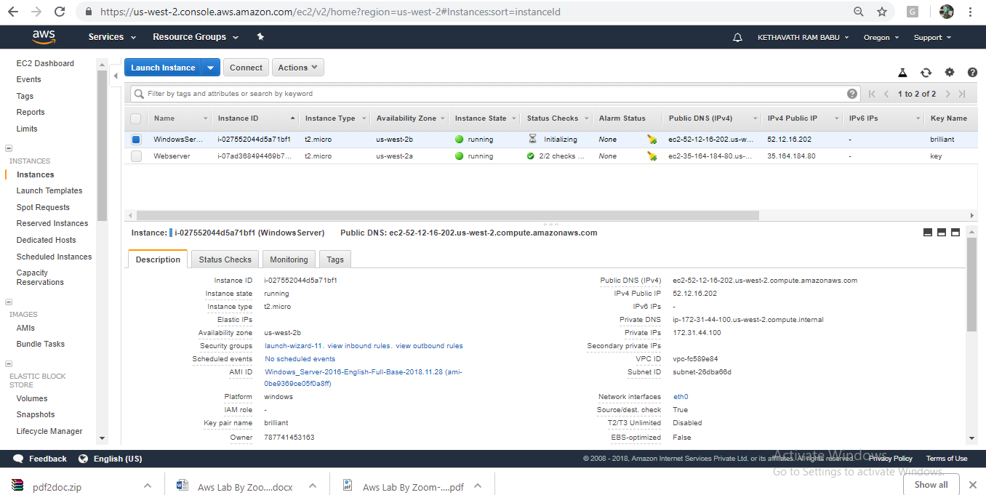Browse to and choose your Windows Server instance in the list.  
  
-> Choose **Connect** and click on **Get Password**

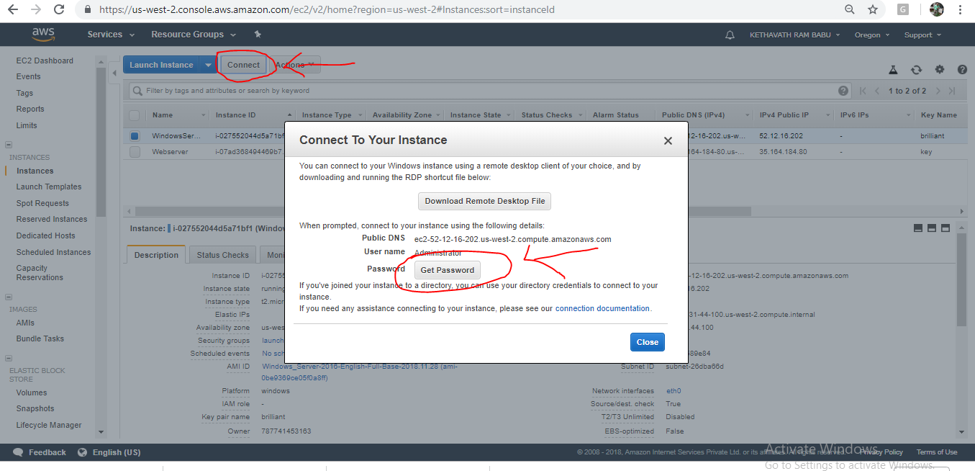

**->** Choose **Browse**. Browse to and choose the Amazon EC2 instance **key pair** file associated with the Windows Server Amazon EC2 instance, and then choose Open

.  
->Choose **Decrypt Password**. Make a note of the password that is displayed. Later You need it.

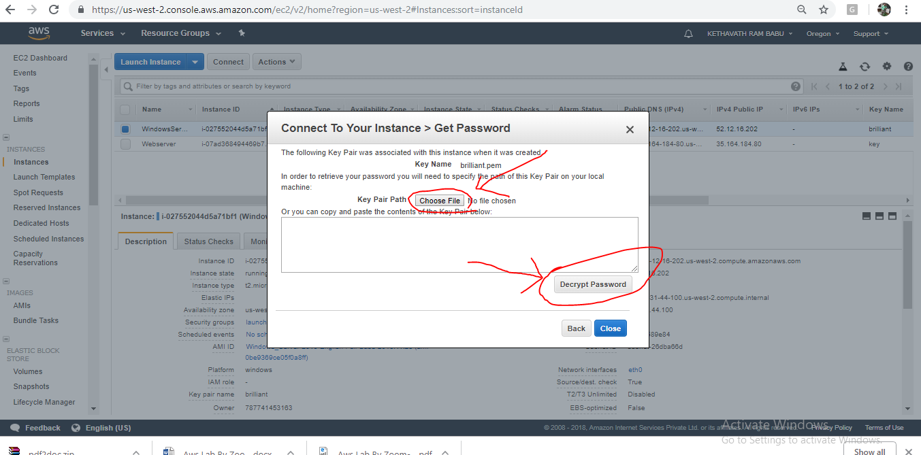

-> Choose **Download Remote Desktop File**, and then open the file.

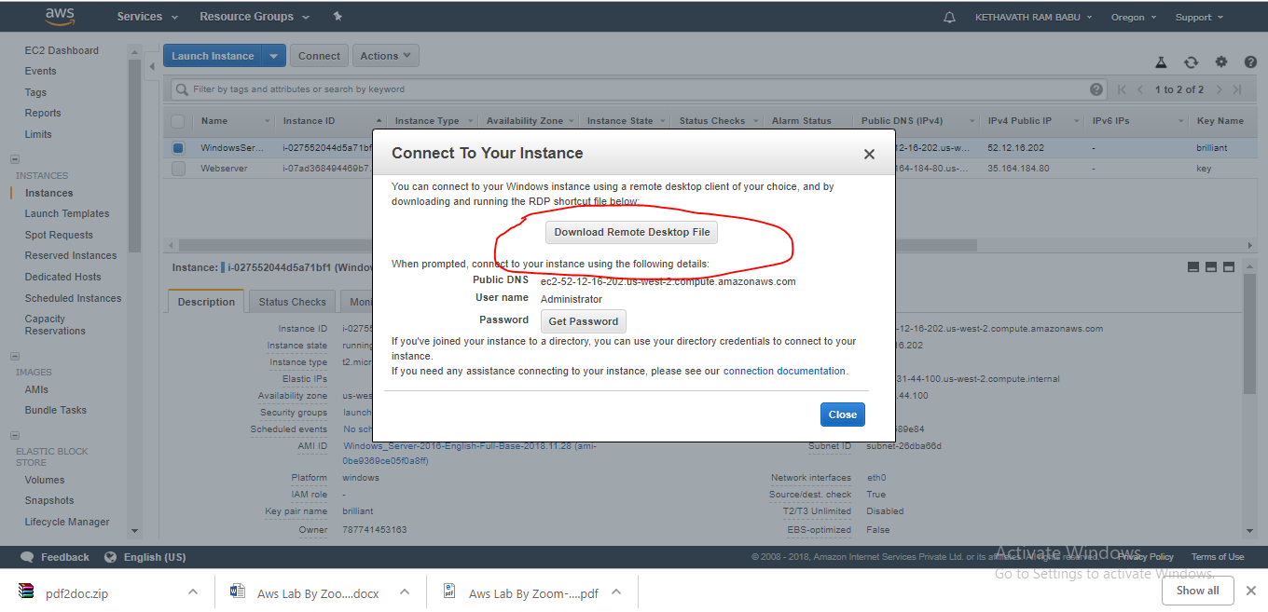

-> f you are prompted to connect even though the publisher of the remote connection can't be identified, proceed.

->Type the password you noted in step 7, and then proceed. (If your RDP connection client application prompts you for a user name, type **Administrator**.)

->If you are prompted to connect even though the identity of the remote computer cannot be verified, proceed.  
->After you are connected, the desktop of the Amazon EC2 instance running Windows Server is displayed.

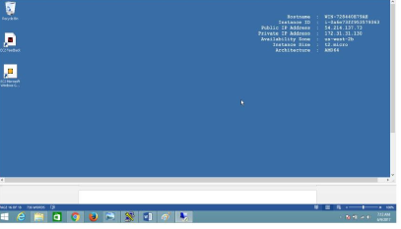

**Exercise 3: To configure Web Server on Amazon Linux instance with Elastic IP.**

**Amazon EC2 Instance IP Addressing**

Amazon EC2 and Amazon VPC support both the IPv4 and IPv6 addressing protocols. By default, Amazon EC2 and Amazon VPC use the IPv4 addressing protocol; you can't disable this behavior. When you create a VPC, you must specify an IPv4 CIDR block (a range of private IPv4 addresses). You can optionally assign an IPv6 CIDR block to your VPC and subnets, and assign IPv6 addresses from that block to instances in your subnet. IPv6 addresses are reachable over the Internet.  
**Private IPv4 Addresses and Internal DNS Hostnames**

A private IPv4 address is an IP address that's not reachable over the Internet. You can use private IPv4 addresses for communication between instances in the same VPC.

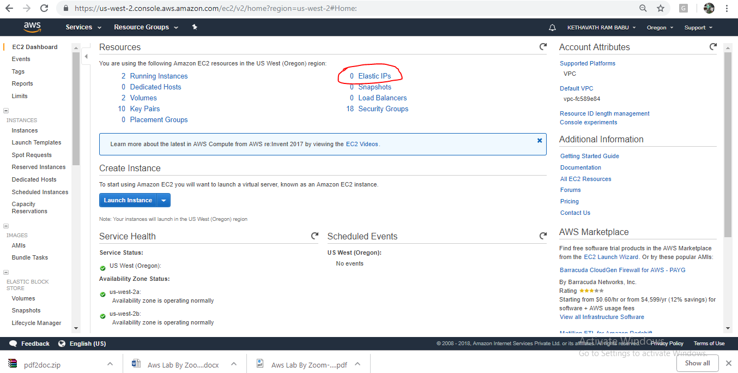

**Public IPv4 Addresses and External DNS Hostnames**

A public IP address is an IPv4 address that's reachable from the Internet. You can use public addresses for communication between your instances and the Internet.

**Exercise 4. To Assign Elastic IP address**

**Elastic IP Addresses (IPv4)**

An Elastic IP address is a public IPv4 address that you can allocate to your account. You can associate it to and from instances as you require, and it's allocated to your account until you choose to release it.

To allocate an Elastic IP and associate it with an Amazon Web Services (AWS) instance, do the following:

i. Open the AWS Management Console, click the **EC2** link, and display the page associated with your region.

ii. Click the **Elastic IPs** link in the **EC2 Dashboard**.



iii. Click **Allocate New Address** and choose **VPC** or **EC2** from the drop-down list, depending whether you're going to associate this IP with an instance in Amazon EC2-Virtual Private Cloud (VPC) or Amazon EC2-Classic, respectively. Click **Yes, Allocate** to confirm your choice.

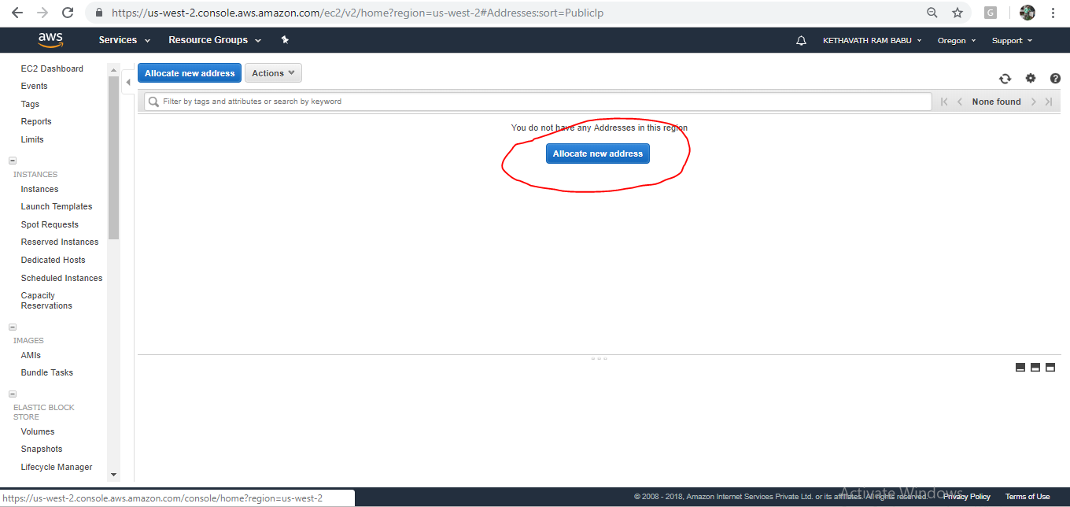

iv. Right-click the newly created Elastic IP and choose **Associate Address**.

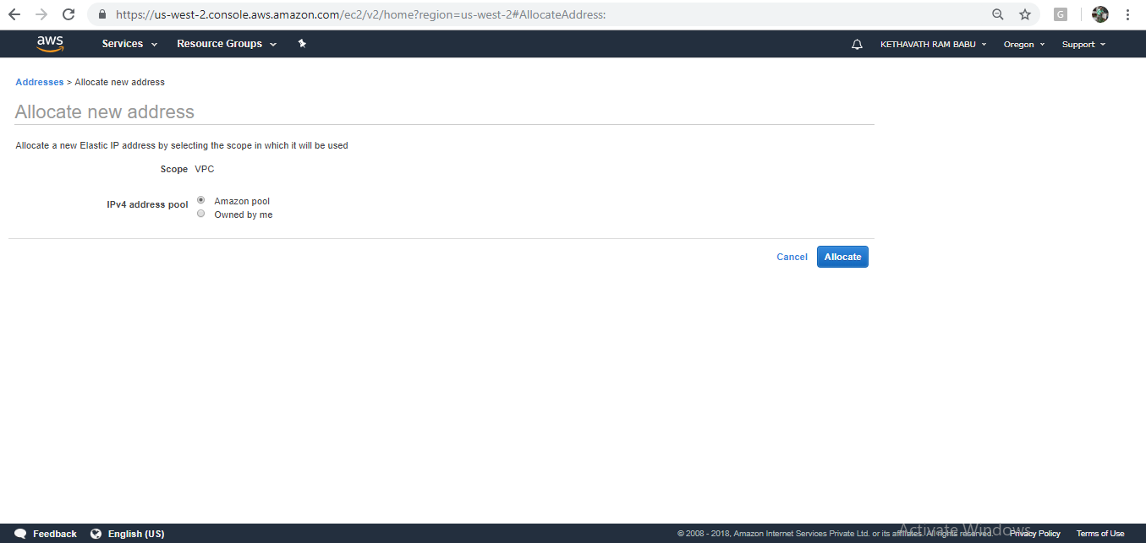

v. Choose your desired EC2 instance from the drop-down list of running instances and click **Associate**.

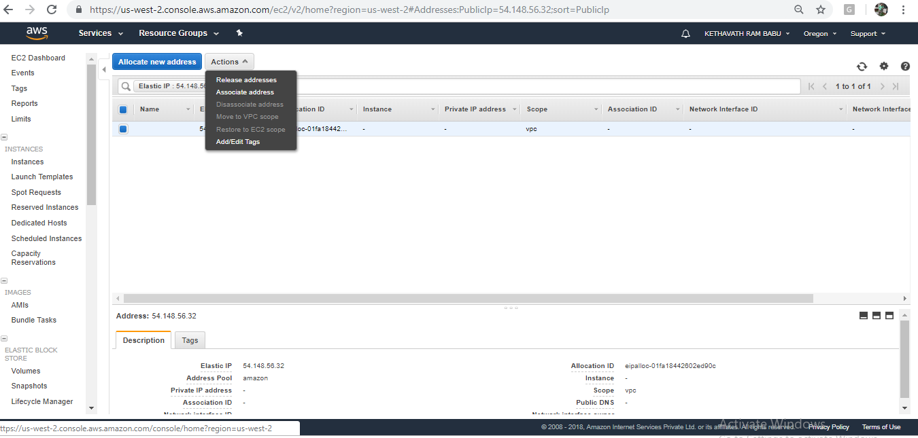

vi. Choose your desired instance to associate Elastic IP.

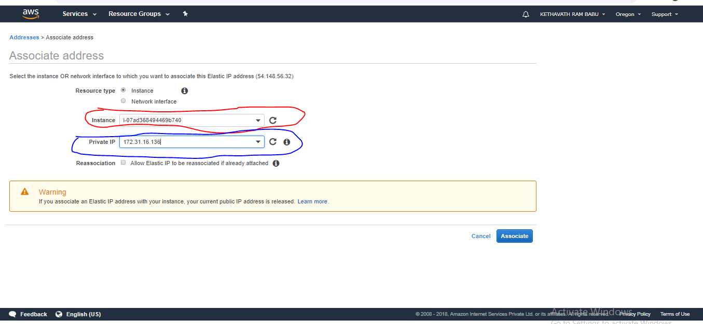

vii. Click on associate, now your instance has been associated with instance.

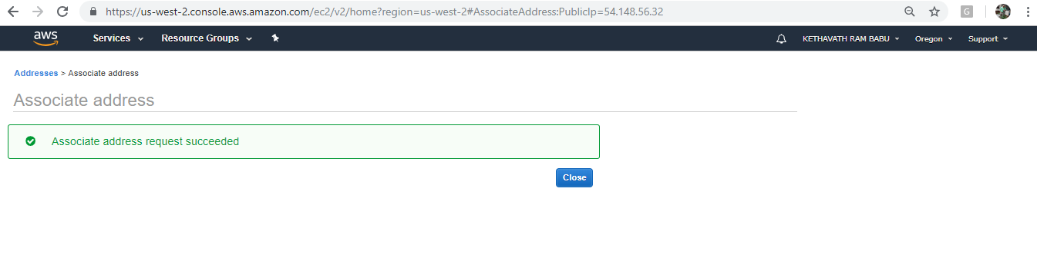

To release Elastic IP

Open the console EC2 Dashboard

Select **Elastic IP** and click on **Action** button

Select Disassociate Address

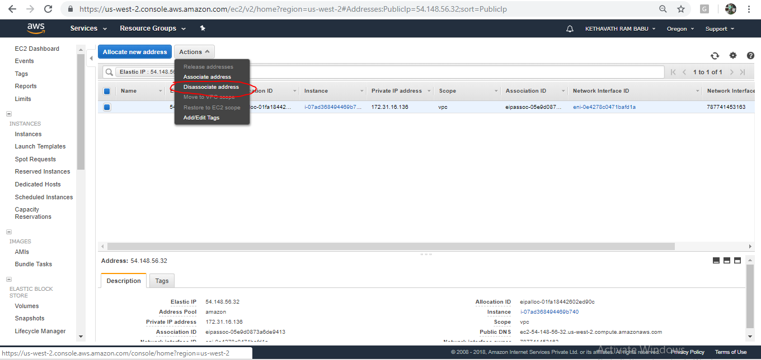

**Click on Disassociate address**

**Click On Action Button and then click on Release Address**

**Exercise 5. To Manage Elastic Block Storage(EBS)**

Amazon Elastic Block Store (Amazon EBS) provides block level storage volumes for use with EC2 instances. EBS volumes are highly available and reliable storage volumes that can be attached to any running instance that is in the same Availability Zone. EBS volumes that are attached to an EC2 instance are exposed as storage volumes that persist independently from the life of the instance.

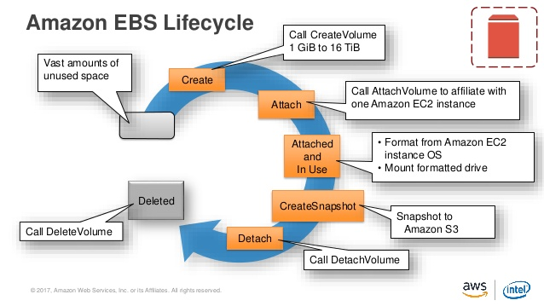

**To Configure EBS with Following task**

Create EBS Volume

Attaching and Detaching EBS Volume

Taking the snapshot of EBS Volume.

**-> To create an EBS Volume**

1. **Open the Amazon EC2 console**

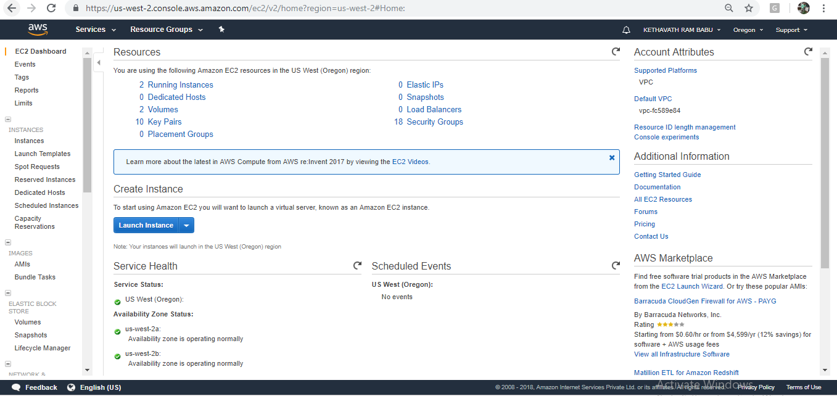

1. **From the navigation bar, select the region in which you would like to create your volume. This choice is important because some Amazon EC2 resources can be shared between regions, while others can't.**
2. **In the navigation pane, choose ELASTIC BLOCK STORE, Volumes.**
3. **Choose Create Volume.**

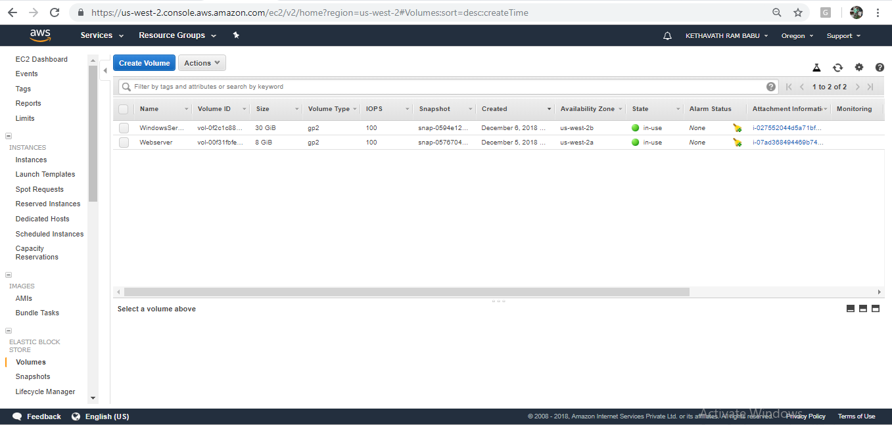

1. **For Volume Type, choose a volume type.**

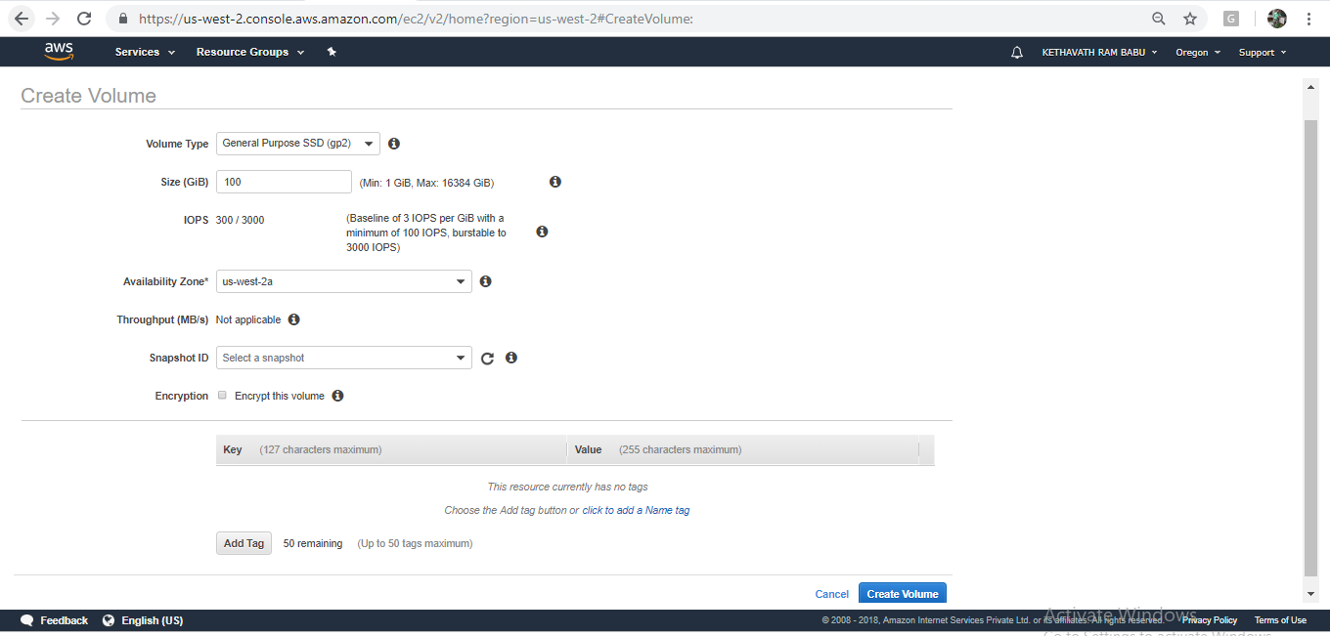

1. **For Size (GiB), type the size of the volume(General Purpose SSD (gp2)).**
2. **With a Provisioned IOPS SSD volume, for IOPS, type the maximum number of input/output operations per second (IOPS) that the volume should support(100/3000).**
3. **For Availability Zone, choose the Availability Zone in which to create the volume. EBS volumes can only be attached to EC2 instances within the same Availability Zone(us-west-2a)**
4. **(Optional) Choose Create additional tags to add tags to the volume. For each tag, provide a tag key and a tag value.**
5. **Choose Create Volume.**

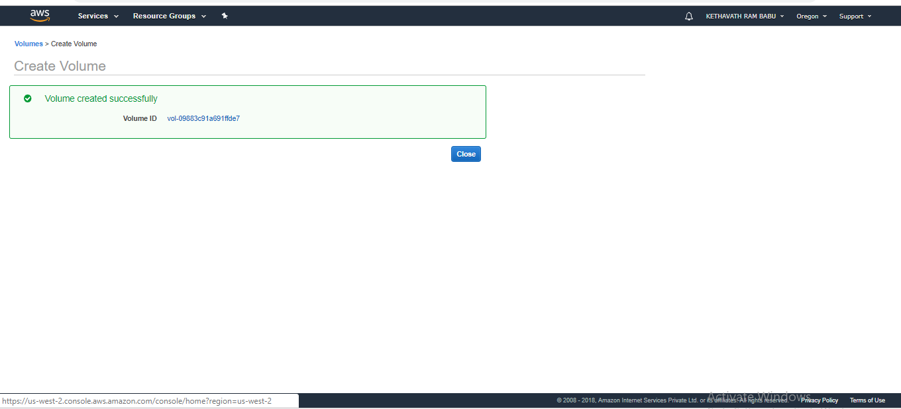

To Monitoring the state of your volumes

Select the volume check state→ Available

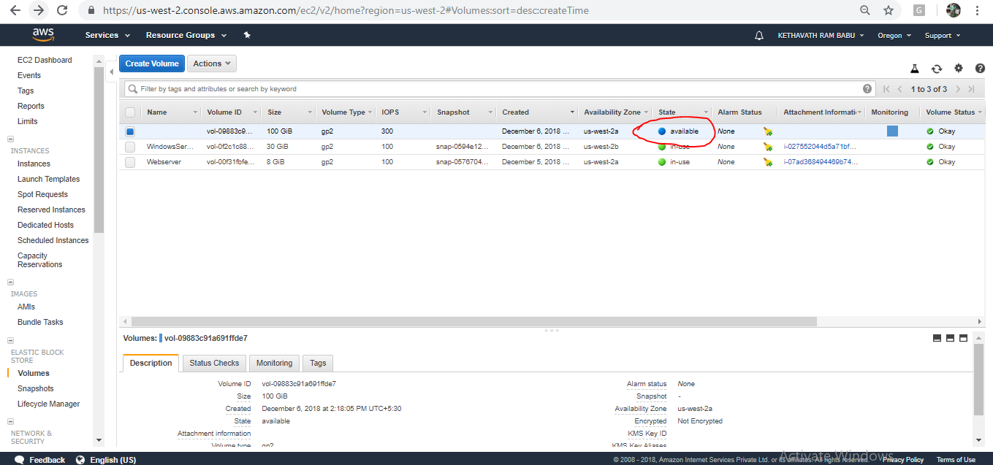

To attaching and detaching EBS volume in windows instance

On the EC2 Dashboard panel

Choose “ Elastic Block Store” click on volume

Note: The volume which you want to attach to an instance should be in the same availability zone.

Now click on **Action button,**

In the navigation pane, choose Elastic Block Store, Volumes.Select an available volume and choose **Actions**, **Attach Volume**. Select **Attach Volume**

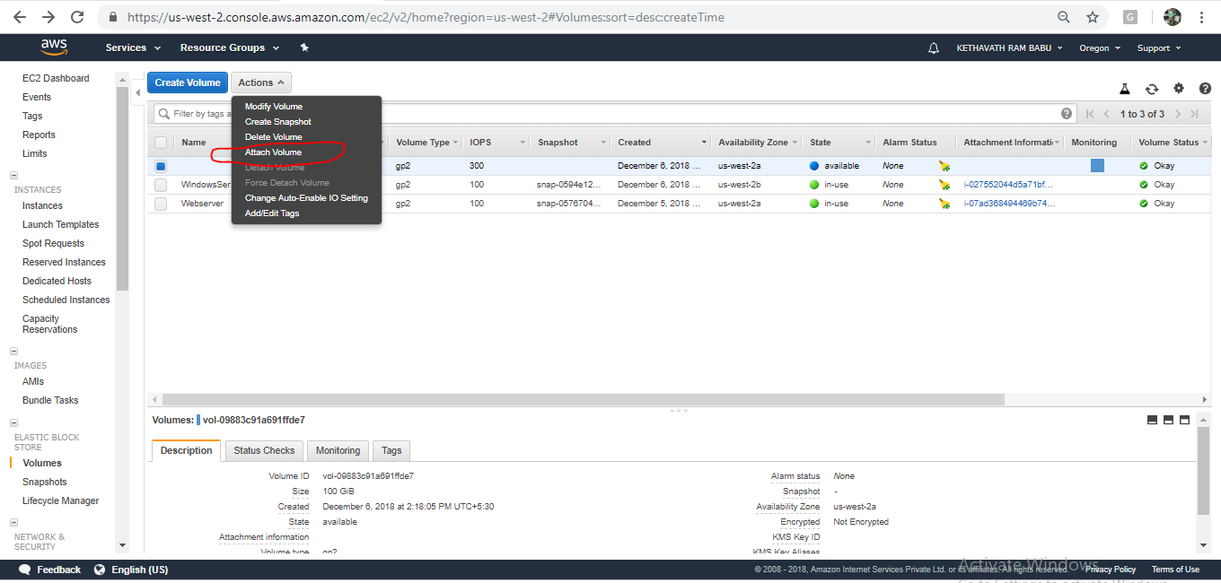

For Instance, start typing the name or ID of the instance. Select the instance from the list of options (only instances that are in the same Availability Zone as the

volumearedisplayed). 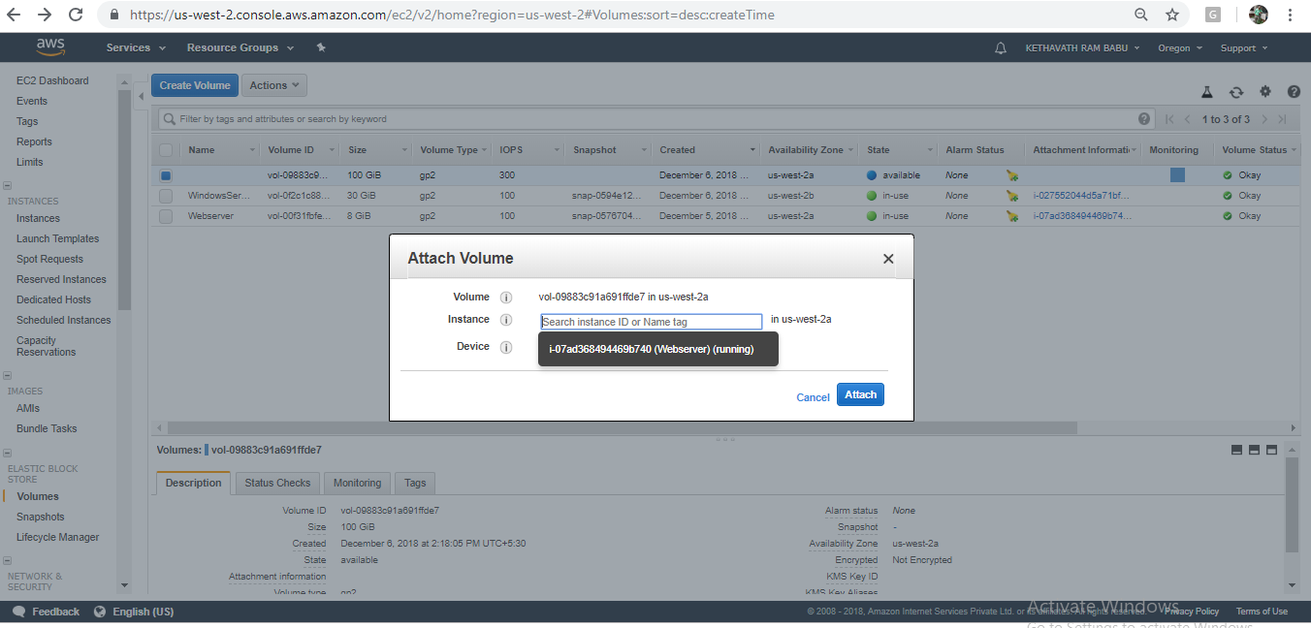

For **Device**, you can keep the suggested device name, or type a different supported device name. **Select Instance and then Click on Attach**.

**To Detach the volume**

**Click On Detach Volume**

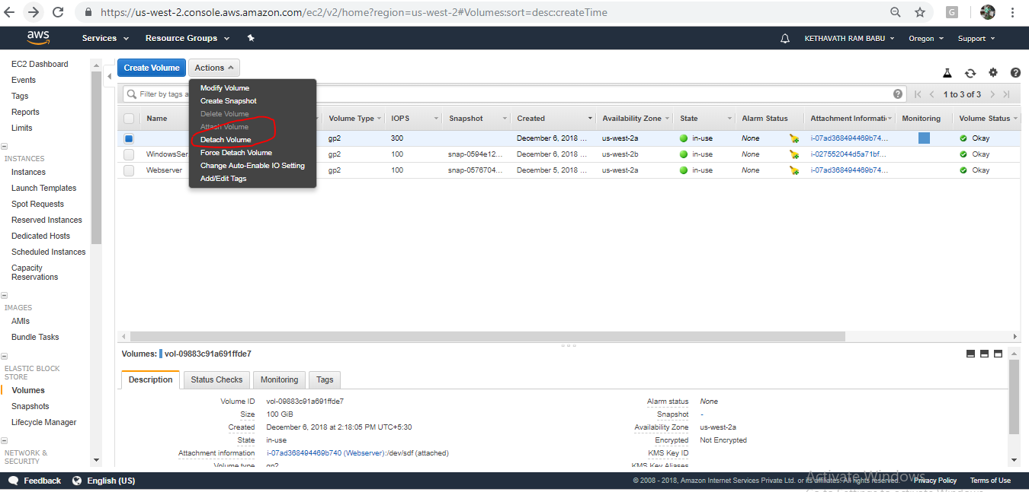

**Click On Yes, Detach**

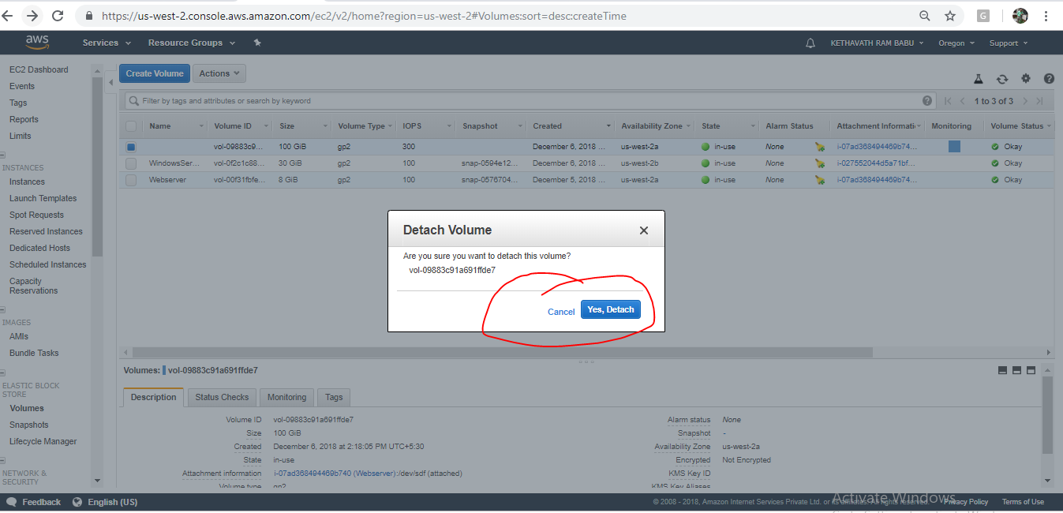

**Amazon Machine Images (AMI)** An Amazon Machine Image (AMI) provides the information required to launch an instance, which is a virtual server in the cloud. You specify an AMI when you launch an instance, and you can launch as many instances from the AMI as you need. You can also launch instances from as many different AMIs as you need. An AMI includes the following:

• A template for the root volume for the instance (for example, an operating system, an application server, and applications)

• Launch permissions that control which AWS accounts can use the AMI to launch instances

• A block device mapping that specifies the volumes to attach to the instance when it's launched.

Creating Your Own AMI You can customize the instance that you launch from a public AMI and then save that configuration as a custom AMI for your own use. Instances that you launch from your AMI use all the customizations that you've made.

To create an AMI from an instance using the console Select an appropriate EC2 instance at instances.

Go to Actions and click on image. -> Then click on Create Image and then give a name to the image, you can also give description about your AMI and the Click on Create Image which has in the shown below figure

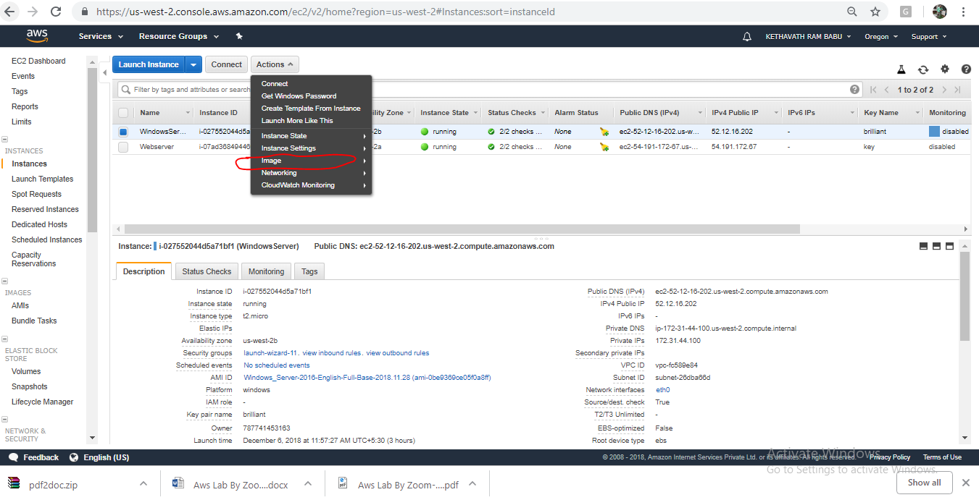

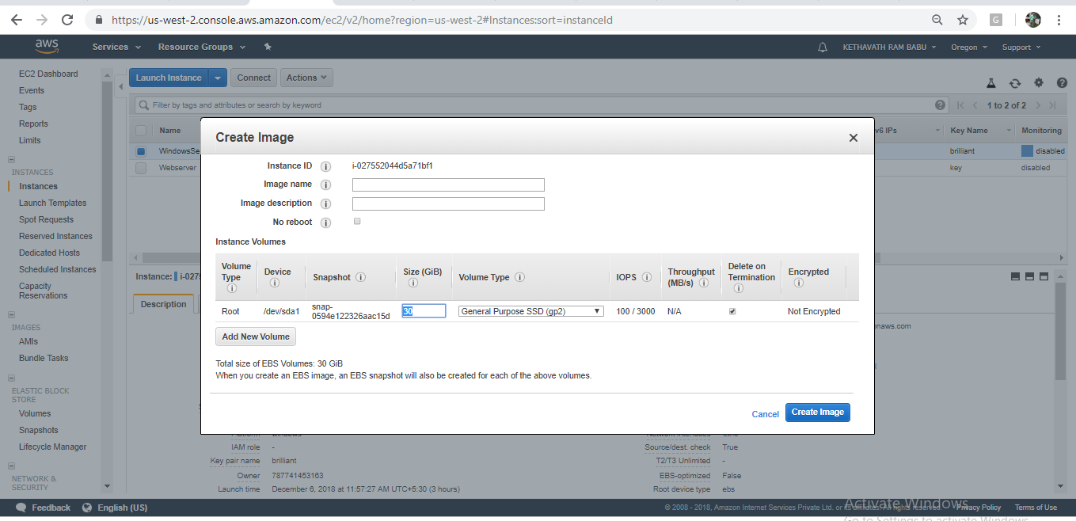

-> After following above steps you have successfully created an AMI of your instance.you can see it by clicking on AMI id which you got after the creating Image or else at AMI tab by pulling down the left Scroll bar.

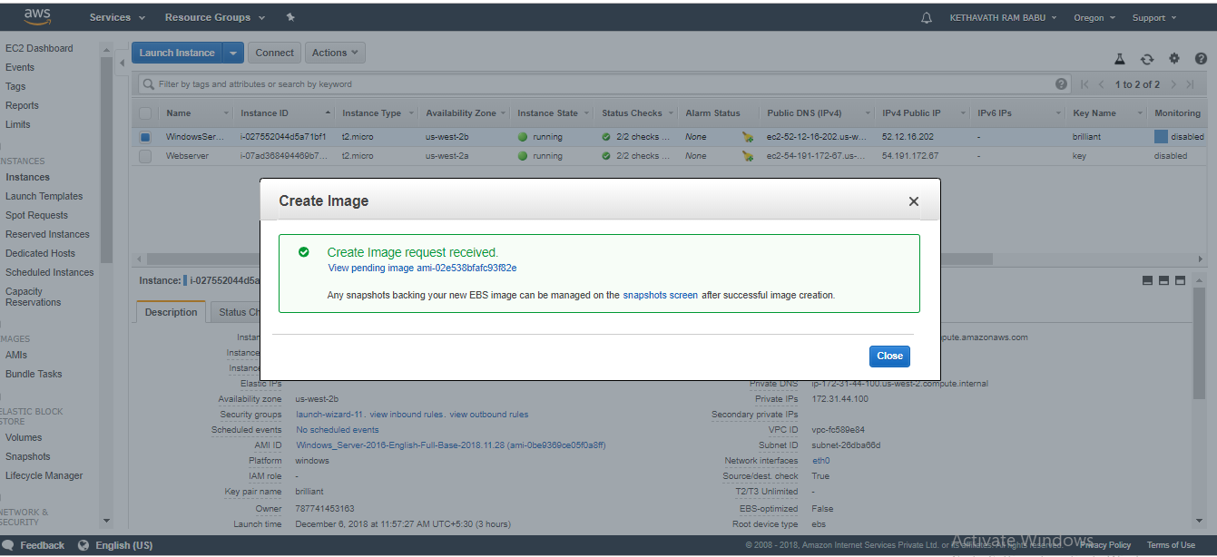

You can also give Public or private permission to your AMI. If you want to give public permissions select public and save else select private.

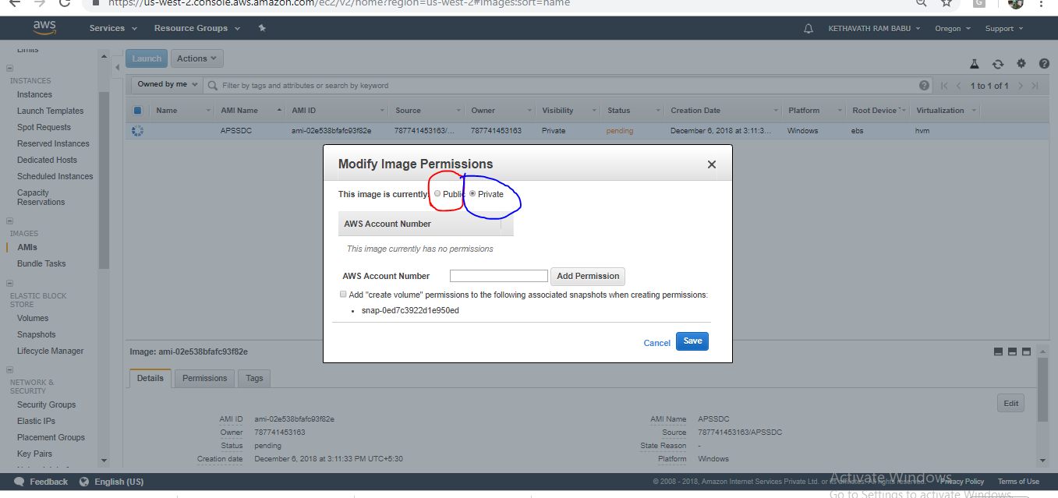

You can also Delete the AMI by Deregister the AMI -> In the navigation pane, choose **AMIs**. Select the AMI, and take note of its ID — this can help you find the correct snapshot in the next step. Choose **Actions**, and then **Deregister**. When prompted for confirmation, choose **Continue**.

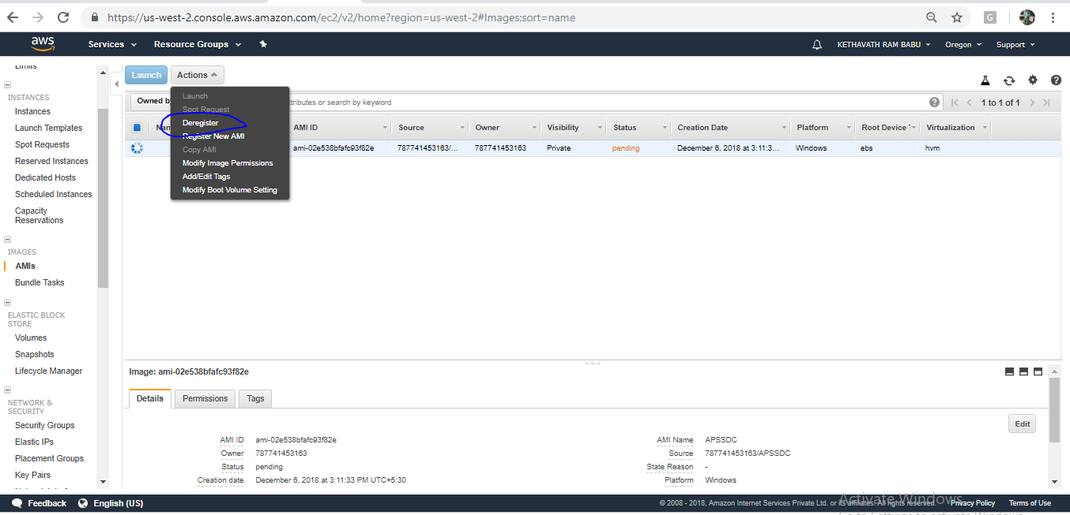

**Note:** It may take a few minutes before the console removes the AMI from the list. Choose **Refresh** to refresh the status.

**Exercise 6. To Configure Amazon Simple Storage Service (Amazon s3)**

**Amazon Simple Storage Service** is storage for the Internet. It is designed to make web-scale computing easier for developers. Amazon S3 has a simple web services interface that you can use to store and retrieve any amount of data, at any time, from anywhere on the web. It gives any developer access to the same highly scalable, reliable, fast, inexpensive data storage infrastructure that Amazon uses to run its own global network of websites. The service aims to maximize benefits of scale and to pass those benefits on to developers.

**Amazon s3 Bucket**. A bucket is a logical unit of storage in Amazon Web Services (AWS) object storage service, Simple Storage Solution S3. Buckets are used to store objects, which consist of data and metadata that describes the data.

When you subscribe to the data feed, you must specify an Amazon S3 bucket to store the data feed files. Before you choose an Amazon S3 bucket for the data feed, consider the following: You must use a bucket from the US East. You must have FULL_CONTROL permission to the bucket.

If you're the bucket owner, you have this permission by default. Otherwise, the bucket owner must grant your AWS account this permission.

When you create your data feed subscription, Amazon S3 updates the ACL of specified bucket to allow the AWS data feed account read and write permissions

Removing the permissions for the data feed account does not disable the data feed. If you remove those permissions but don't disable the data feed, we restore those permissions the next time that the data feed account needs to write to the bucket.

Each data feed file has its own ACL. The bucket owner has FULL_CONTROL permission to the data files. The data feed account has read and write permissions. If you delete your data feed subscription, Amazon EC2 doesn't remove the read and write permissions for the data feed account on either the bucket or the data files. You must remove these permissions yourself.

To create an S3 bucket

1. Sign in to the AWS Management Console and open the Amazon S3 console

2. Choose Create bucket.

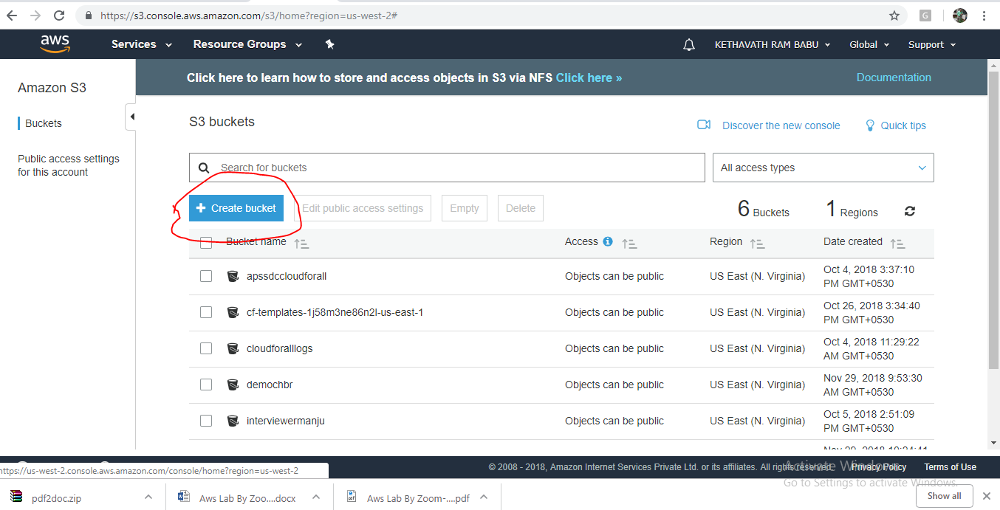

The bucket name you choose must be globally unique across all existing bucket names in Amazon S3 (that is, across all AWS customers).

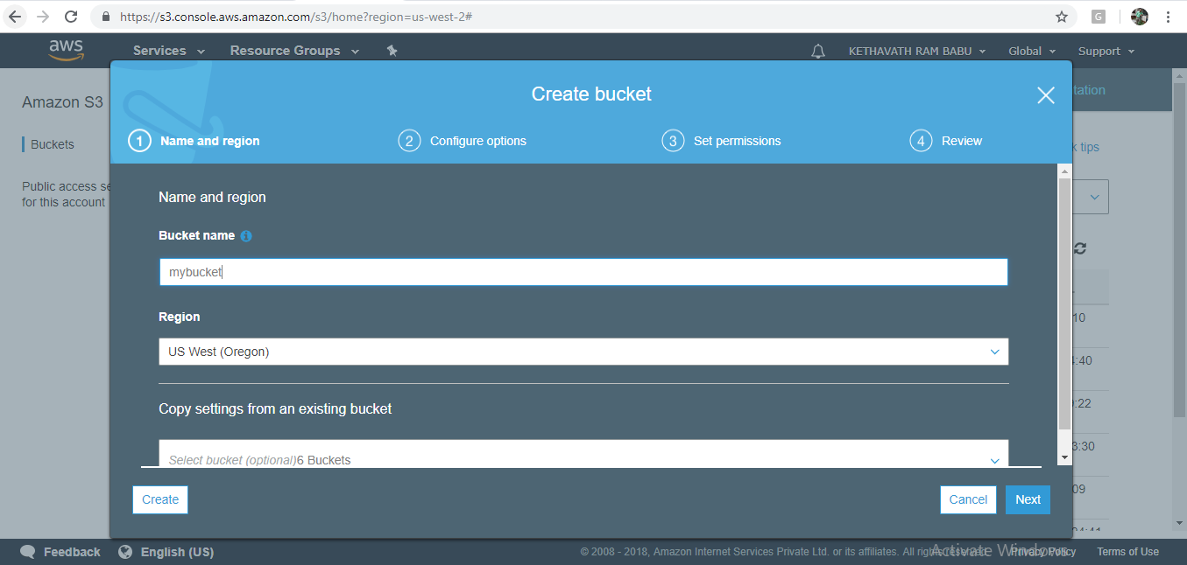

In **Region**, choose **Region** and Click on **Create**.

When Amazon S3 successfully creates your bucket, the console displays your empty bucket in the **Buckets** pane

**Step 2: Upload a File to Your Amazon S3 Bucket**

Now that you've created a bucket, you're ready to add an object to it. An object can be any kind of file: a document, a photo, a video, a music file, or other file type.

1. In the Amazon S3 console, choose the bucket where you want to upload an object, choose **Upload**, and then choose **Add Files**.

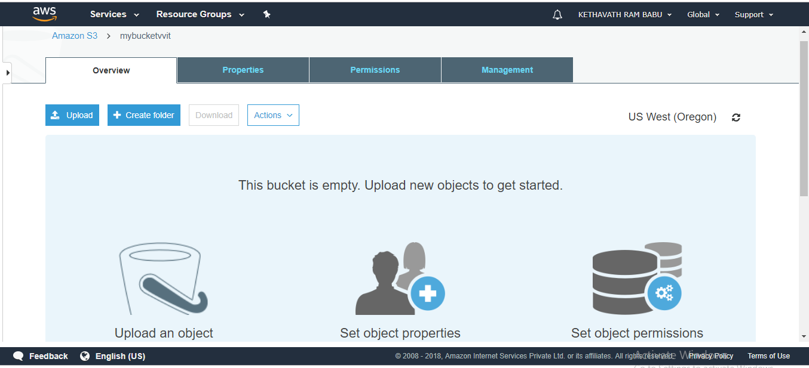

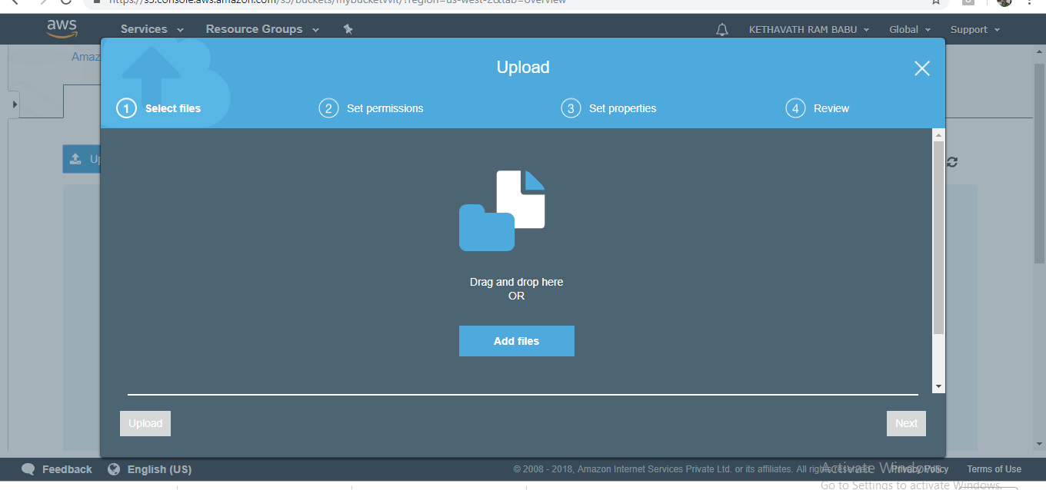

In the **Upload** dialog box, do one of the following:

1. Drag and drop more files and folders to the console window that displays the **Upload** dialog box. To add more files, you can also choose **Add more files**. This option works *only* for files, not folders.
2. To immediately upload the listed files and folders without granting or removing permissions for specific users or setting public permissions for all of the files that you're uploading, choose **Upload**.
3. To set permissions or properties for the files that you are uploading, choose **Next**.

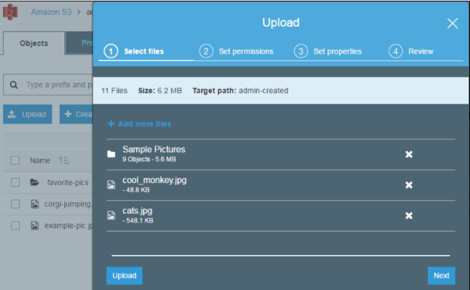

-> On the **Set Permissions** page, under **Manage users** you can change the permissions for the AWS account owner. The *owner* refers to the AWS account root user, and not an AWS Identity and Access Management (IAM) user.

->Under **Manage public permissions** you can grant read access to your objects to the general public (everyone in the world), for all of the files that you're uploading. Granting public read access is applicable to a small subset of use cases such as when buckets are used for websites. We recommend that you do not change the default setting of **Do not grant public read access to this object(s)**. You can always make changes to object permissions after you upload the object.

-> When you're done configuring permissions, choose **Next**.

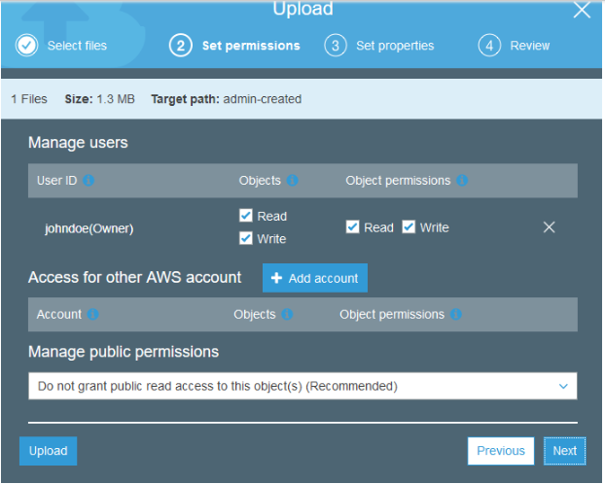

On the **Set Properties** page, choose the storage class and encryption method to use for the files that you are uploading. You can also add or modify metadata.

Choose a storage class for the files you're uploading.

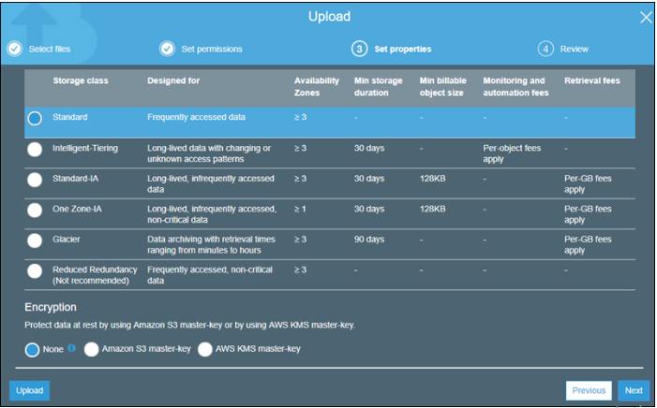

Choose the type of encryption for the files that you're uploading. If you don't want to encrypt them, choose **None**.

1. To encrypt the uploaded files using keys that are managed by Amazon S3

, choose **Amazon S3 master-key**.

ii. To encrypt the uploaded files using the AWS Key Management Service (AWS KMS), choose **AWS KMS master-key**. Then choose a master key from the list of AWS KMS master keys.

**Note**

To encrypt objects in a bucket, you can use only keys that are available in the same AWS Region as the bucket.

You can give an external account the ability to use an object that is protected by an AWS KMS key. To do this, select **Custom KMS ARN** from the list and enter the Amazon Resource Name (ARN) for the external account. Administrators of an external account that have usage permissions to an object protected by your AWS KMS key can further restrict access by creating a resource-level IAM policy.

Metadata for Amazon S3 objects is represented by a name-value (key-value) pair. There are two kinds of metadata: system-defined metadata and user-defined metadata.

If you want to add Amazon S3 system-defined metadata to all of the objects you are uploading, for **Header**, select a header. You can select common HTTP headers, such as **Content-Type** and **Content-Disposition**. Type a value for the header, and then choose **Save**.

Any metadata starting with prefix x-amz-meta- is treated as user-defined metadata. User-defined metadata is stored with the object, and is returned when you download the object.

To add user-defined metadata to all of the objects that you are uploading, type x-amz-meta- plus a custom metadata name in the **Header** field. Type a value for the header, and then choose **Save**. Both the keys and their values must conform to US-ASCII standards. User-defined metadata can be as large as 2 KB. 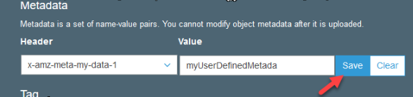

Object tagging gives you a way to categorize storage. Each tag is a key-value pair. Key and tag values are case sensitive. You can have up to 10 tags per object.

To add tags to all of the objects that you are uploading, type a tag name in the **Key** field. Type a value for the tag, and then choose **Save**. A tag key can be up to 128 Unicode characters in length and tag values can be up to 255 Unicode characters in length.

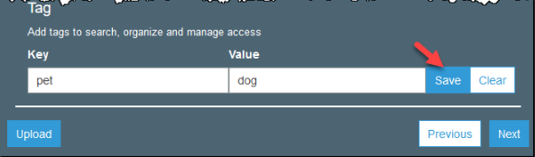

* Choose **Next**.
* On the **Upload** review page, verify that your settings are correct, and then choose **Upload**. To make changes, choose **Previous**.

To see the progress of the upload, choose **In progress** at the bottom of the browser window.

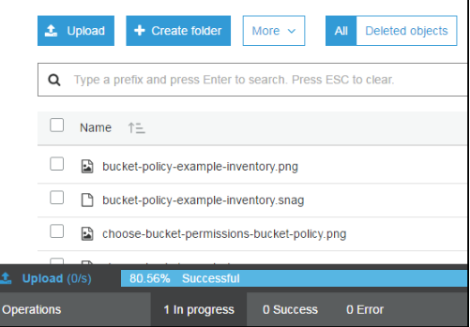

To see a history of your uploads and other operations, choose **Success**.

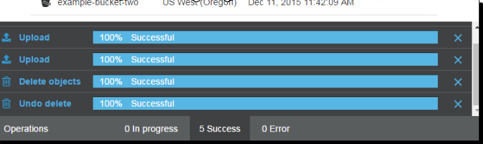

**Hosting a Static Website on Amazon S3**

You can host a static website on Amazon Simple Storage Service (Amazon S3). On a static website, individual web pages include static content. They might also contain client-side scripts. By contrast, a dynamic website relies on server-side processing, including server-side scripts such as PHP, JSP, or ASP.NET. Amazon S3 does not support server-side scripting.

* To host a static website, you configure an Amazon S3 bucket for website hosting, and then upload your website content to the bucket. This bucket must have public read access. It is intentional that everyone in the world will have read access to this bucket. The website is then available at the AWS Region-specific website endpoint of the bucket,

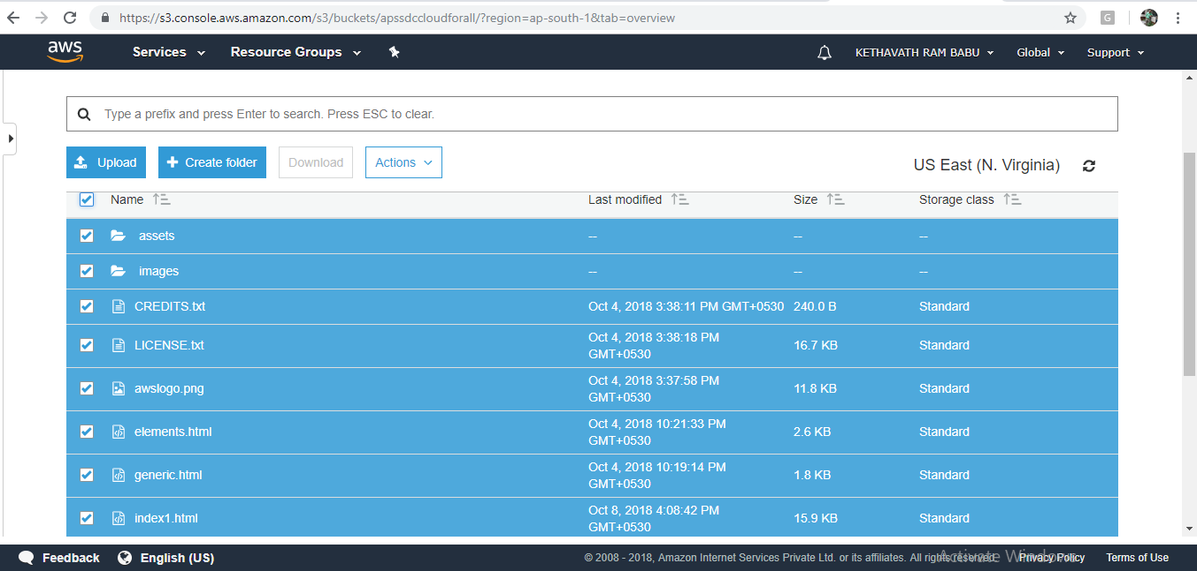

* After successful completion of code uploaded to S3, then select all object in bucket make it as public as shown below slide,
* 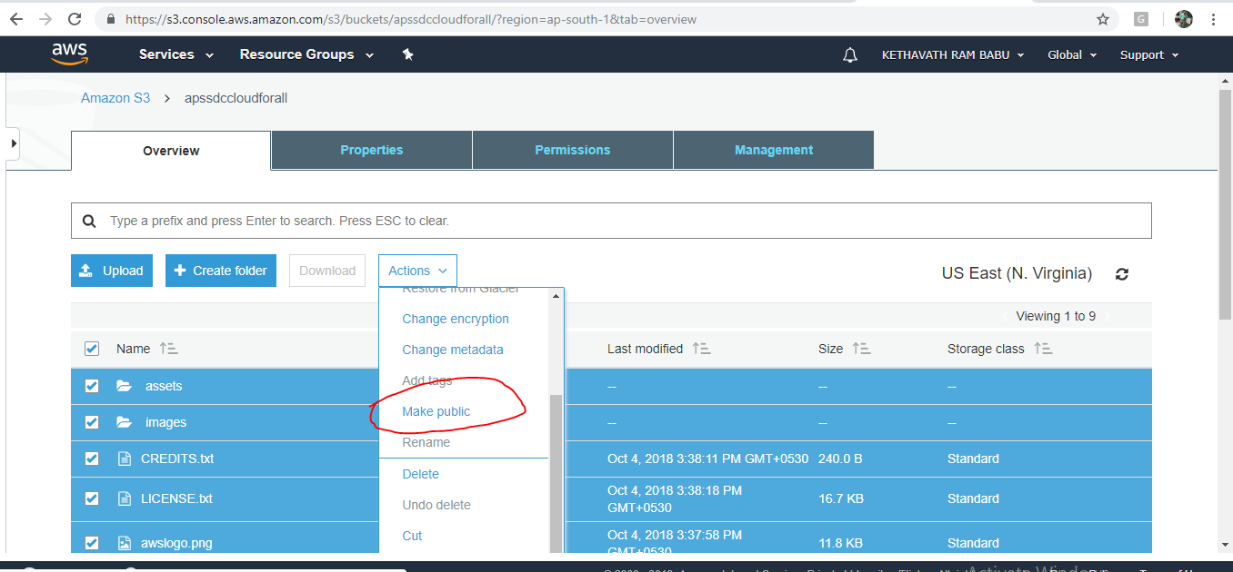

-->Open the bucket **Properties** pane, choose **Static Website Hosting**, and do the following:

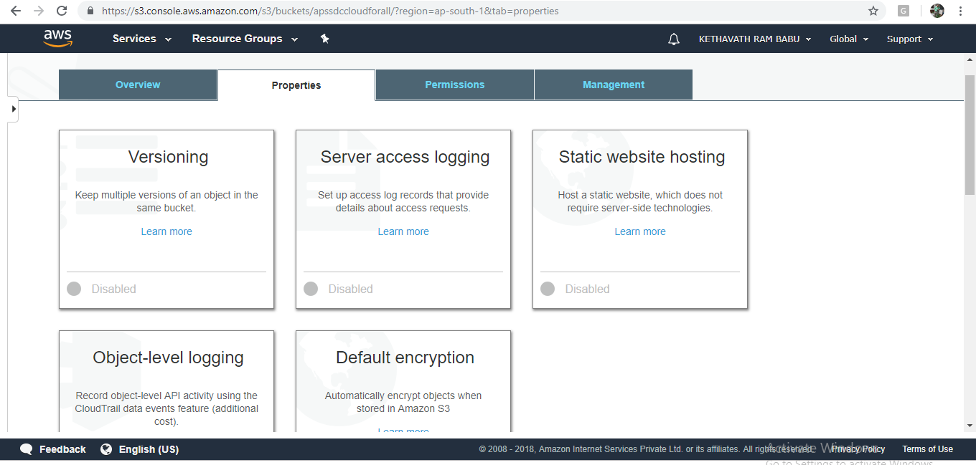

* Choose **Use this bucket to host a website**.
* In the **Index Document** box, type the name of your index document. The name is typically index.html.

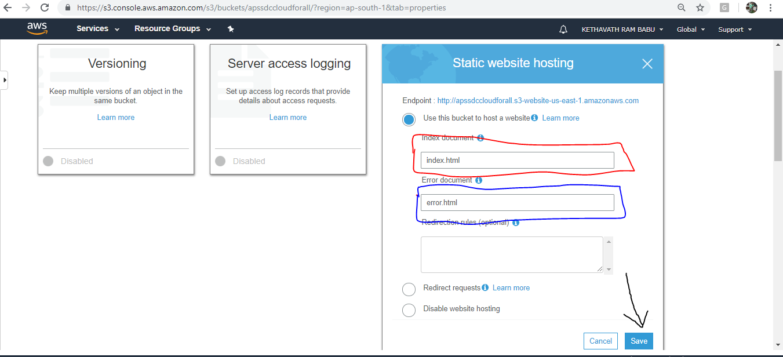

* Choose **Save** to save the website configuration.
* Write down the **Endpoint**.

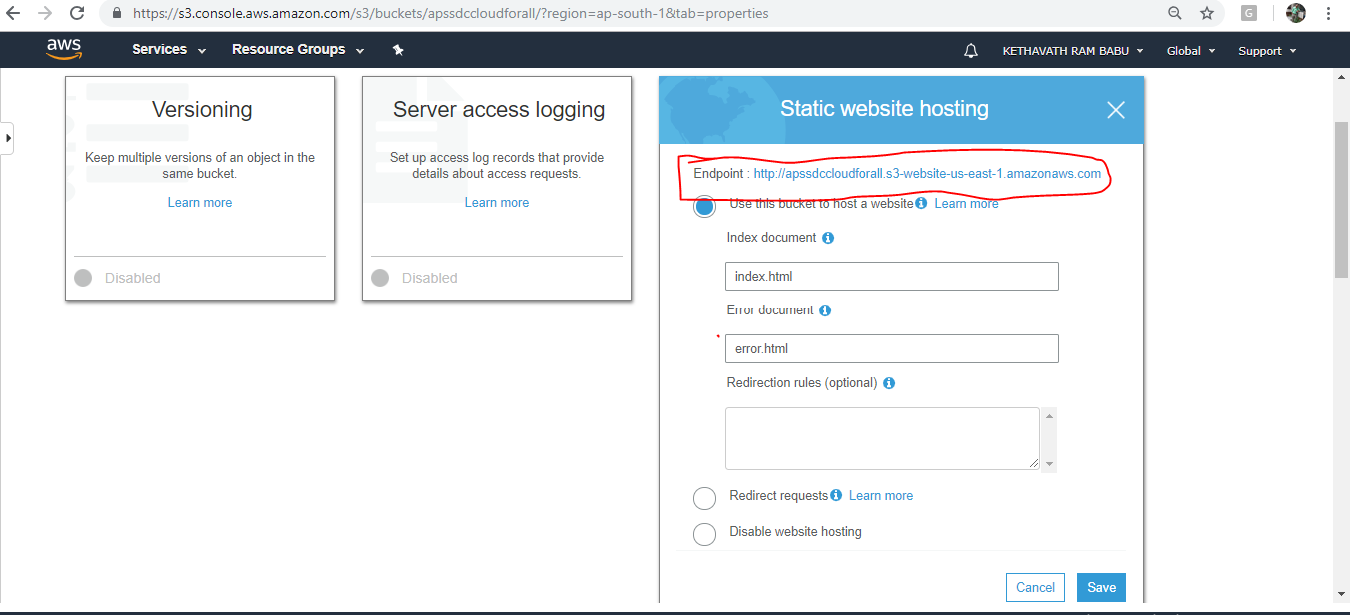

## **Step 2: Adding a Bucket Policy That Makes Your Bucket Content Publicly Available**

1. In the **Properties** pane for the bucket, choose **Permissions**.

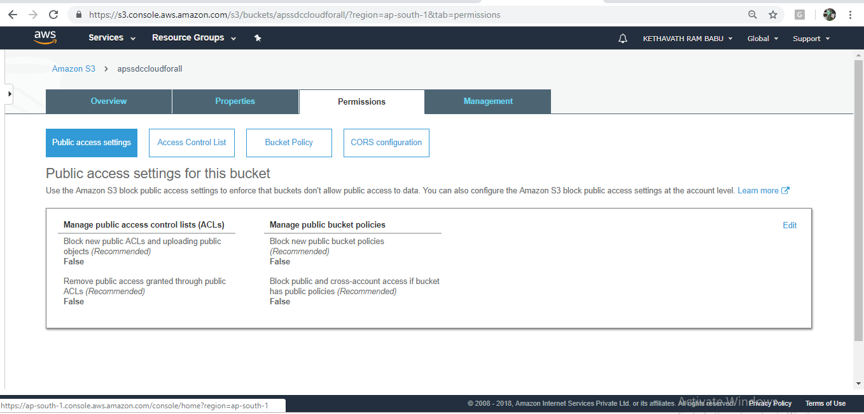

1. Choose **Add Bucket Policy**.

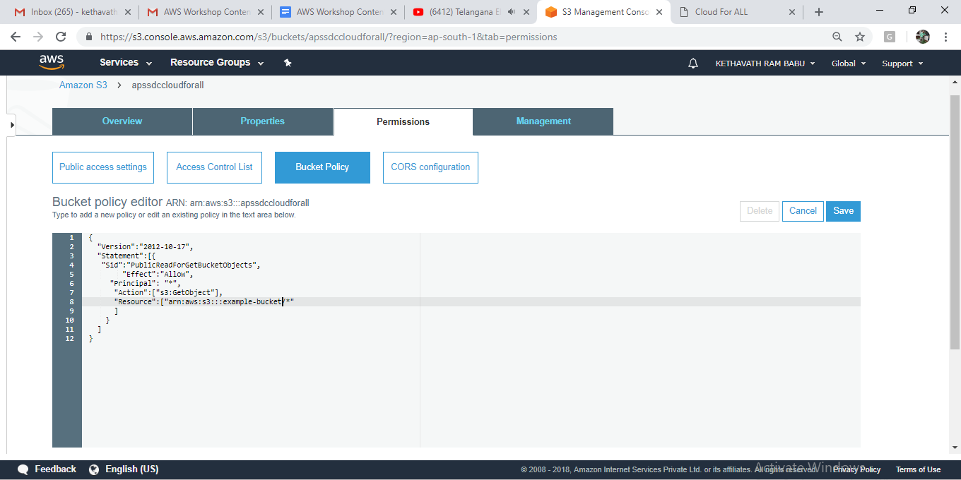

1. To host a website, your bucket must have public read access. It is intentional that everyone in the world will have read access to this bucket. Copy the following bucket policy, and then paste it in the Bucket Policy Editor.
2. {  
    "Version":"2012-10-17",  
    "Statement":[{  
    "Sid":"PublicReadForGetBucketObjects",  
    "Effect":"Allow",  
    "Principal": "*",  
    "Action":["s3:GetObject"],  
    "Resource":["arn:aws:s3:::*example-bucket*/*"  
    ]  
    }  
    ]  
    }

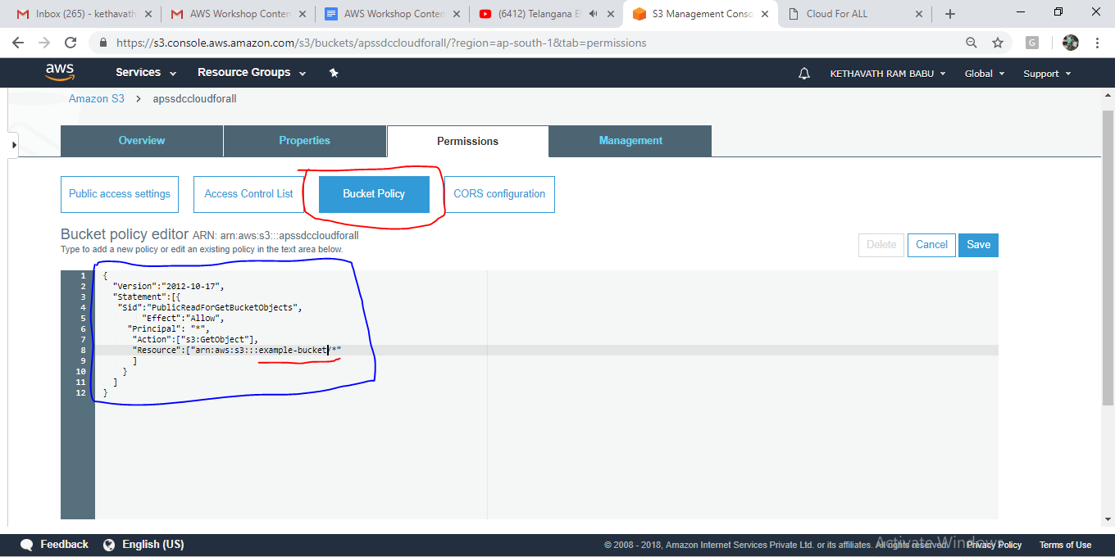

1. In the policy, replace *example-bucket* with the name of your bucket.
2. Choose **Save**.
3. **Testing Your Website**

Type the following URL in the browser, replacing *example-bucket* with the name of your bucket and *website-region* with the name of the AWS Region where you deployed your bucket.

* This is the Amazon S3-provided website endpoint for your bucket. You use this endpoint to test your website is running or not by pasting the Endpoint into your browser.

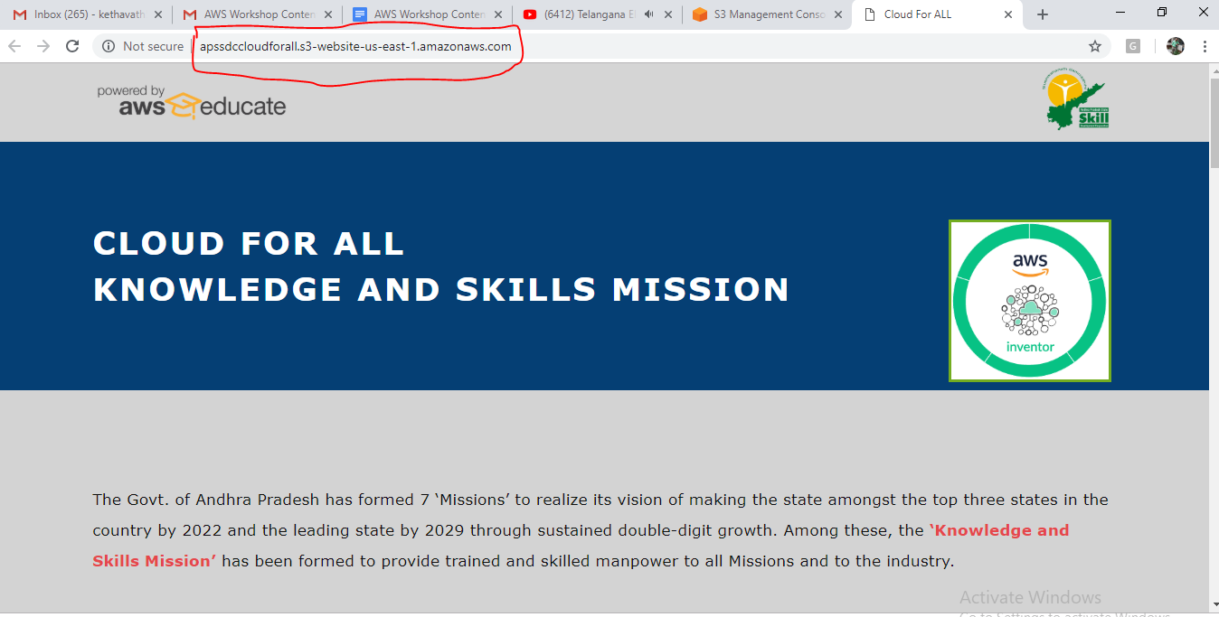

If your browser displays your index.html page, the website was successfully deployed.

**Note :** HTTPS access to the website is not supported.

You now have a website hosted on Amazon S3. This website is available at the Amazon S3 website endpoint. However, you might have a domain, such as example.com, that you want to use to serve the content from the website you created. You might also want to use Amazon S3 root domain support to serve requests for both http://www.example.com and <http://example.com>.

**Exercise 7. To Manage IAM User, Group and Policies**

Allow a **User** to **Manage IAM Users**. The following **policy** allows a **user** to perform all the tasks associated with **managing IAM users** but not to perform actions on other entities, such as creating **groups** or **policies**.

# 

# 

# **AWS IAM Overview**

* AWS Identity and Access Management (IAM) is a web service that helps you securely control access to AWS resources for your users.
* IAM is used to control
  + **Identity** – who can use your AWS resources (authentication)
  + **Access** – what resources they can use and in what ways (authorization)
* IAM can also keep your account credentials private.
* With IAM, multiple IAM users can be created under the umbrella of the AWS account or temporary access can be enabled through identity federation with corporate directory.or third party providers
* I AM also enables access to resources across AWS accounts.

## **IAM Features**

* Shared access to your AWS account
  + Grant other people permission to administer and use resources in your AWS account without having to share your password or access key.
* Granular permissions
  + Each user can be granted with different set granular permissions as required to perform their job
* Secure access to AWS resources for applications that run on EC2
  + IAM can help provide applications running on EC2 instance temporary credentials that they need in order to access other AWS resources
* Identity federation
  + IAM allows users to access AWS resources, without requiring the user to have accounts with AWS, by providing temporary credentials *for e.g. through corporate network or Google or Amazon authentication*
* Identity information for assurance
  + CloudTrail can be used to receive log records that include information about those who made requests for resources in the account.
* PCI DSS Compliance
  + IAM supports the processing, storage, and transmission of credit card data by a merchant or service provider, and has been validated as being Payment Card Industry Data Security Standard (PCI DSS) compliant
* Integrated with many AWS services
  + IAM integrates with almost all the AWS services
* Eventually Consistent
  + IAM, like many other AWS services, is eventually consistent and achieves high availability by replicating data across multiple servers within Amazon’s data centers around the world.
  + Changes made to IAM would be eventually consistent and hence would take some time to reflect
* Free to use
  + IAM is offered at no additional charge and charges are applied only for use of other AWS products by your IAM users.
* AWS Security Token Service
  + IAM provide STS which is an included feature of the AWS account offered at no additional charge.
  + AWS charges only for the use of other AWS services accessed by the AWS STS temporary security credentials.

## **Identities**

IAM identities determine who can access and help to provide authentication for people and processes in your AWS account

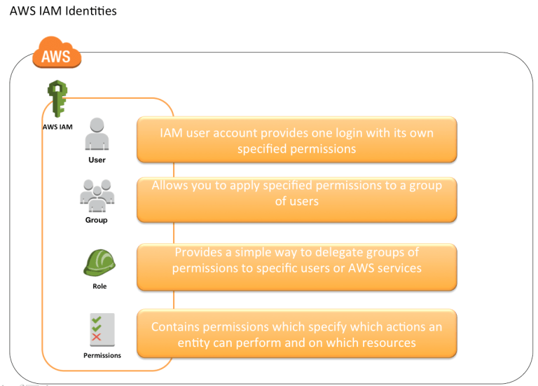

**To configure IAM with following task.**

Create IAM users, assign password and change password policy

Create IAM group

Add users to a group

Add policies to Groups and Users

Create your own policies.

Users Login to sign-in page.

Deleting users and groups.

**7.1 Creating an IAM role to login other users.**

Open AWS console select Security, identity & Compliance

Click on IAM service

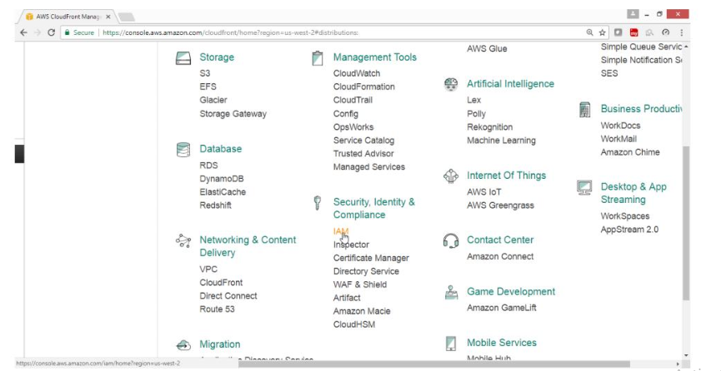

IAM Dashboard panel available

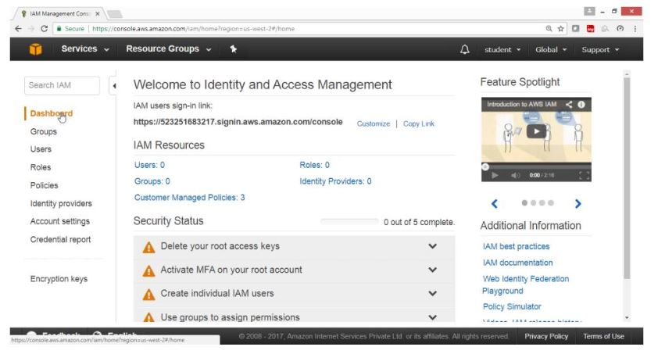

To Manage groups and apply policies

From IAM dashboard, select Groups

Click on Create New Group button

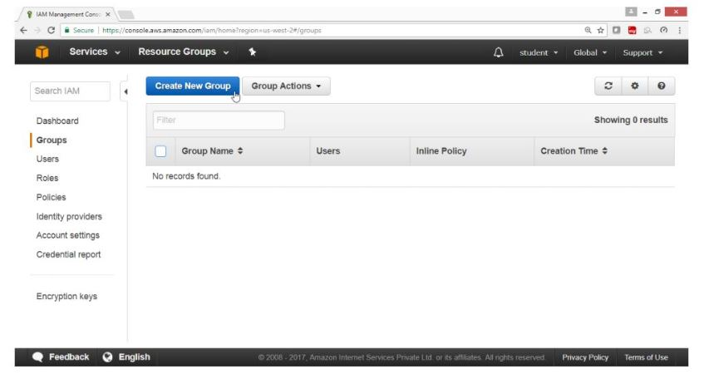

Give Group Name -> EC2admingroup

Click on Next Step button

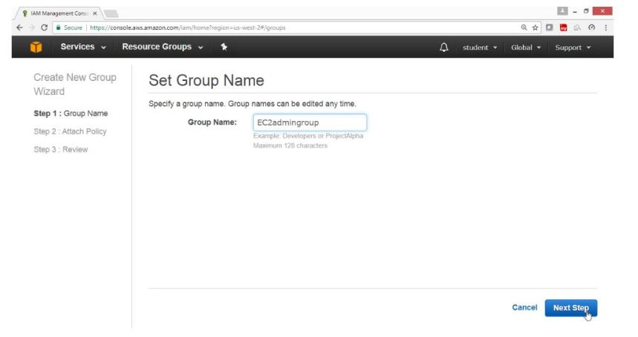

In Filter type -> EC2 Read Only access

Select check box for Amazon EC2 Read Only access

Click on Next Step button

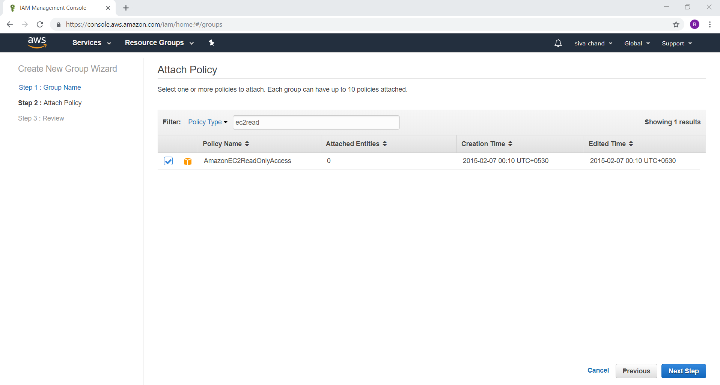

Click on Create Group

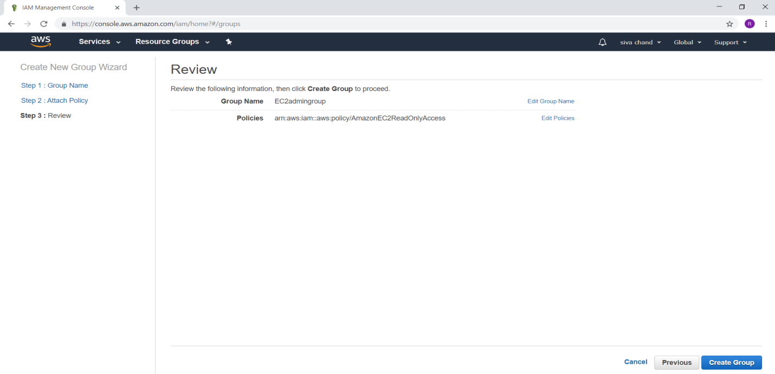

Verify

Group EC2admingroup got created with Amazon EC2 Read Only Access

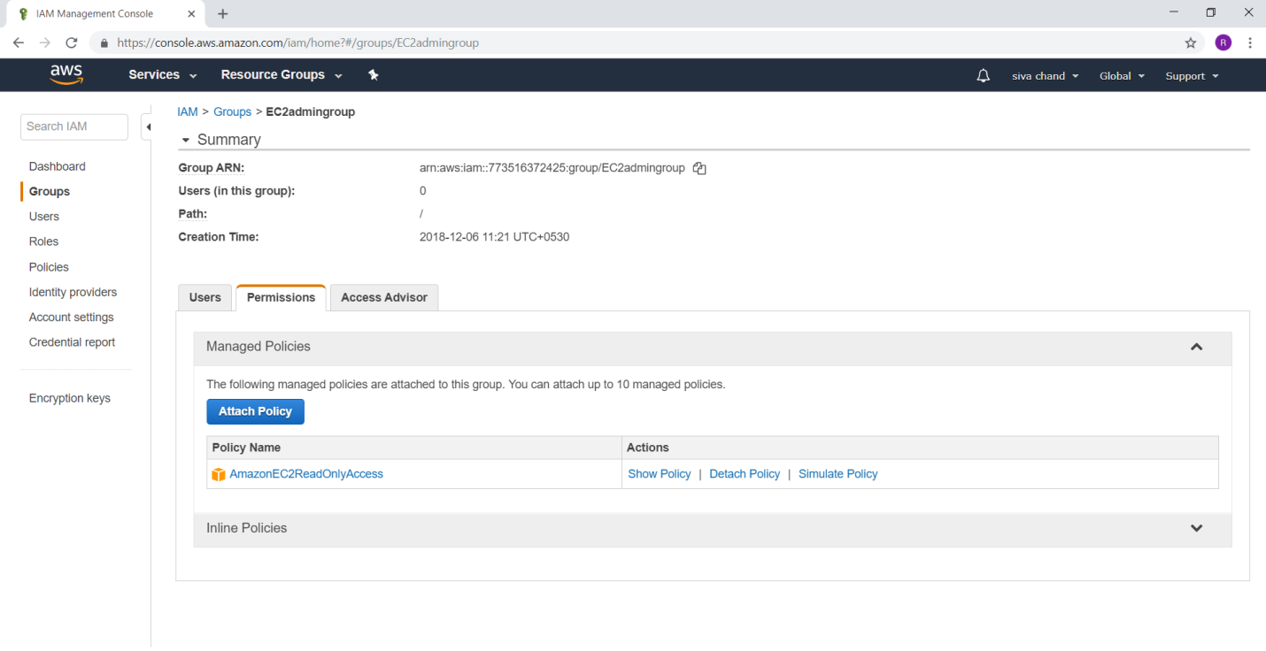

Now again create Another Group

Click on Create Group

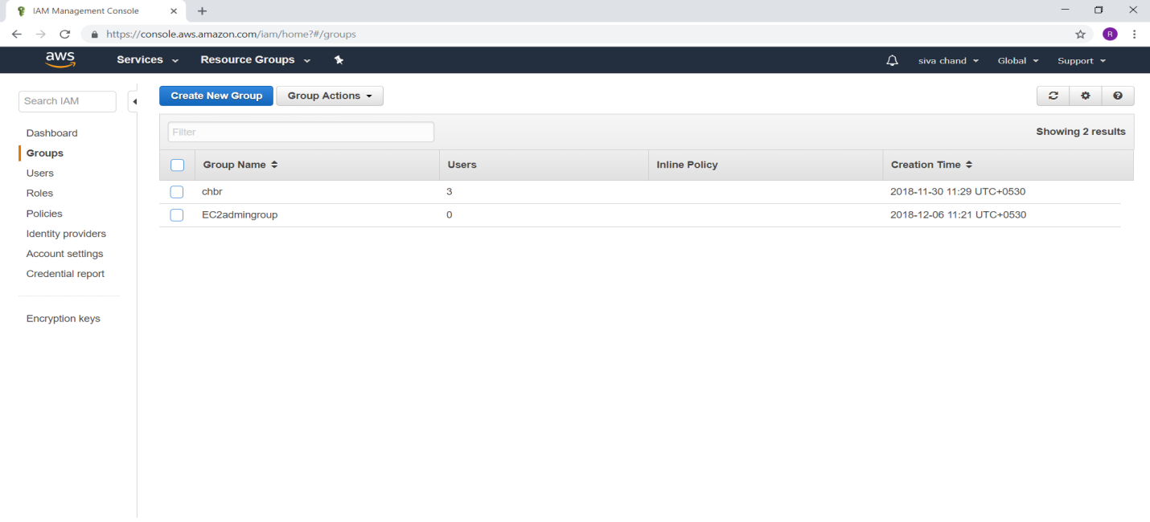

Give Group Name -> EC2admingroup1

Click on Next Step button

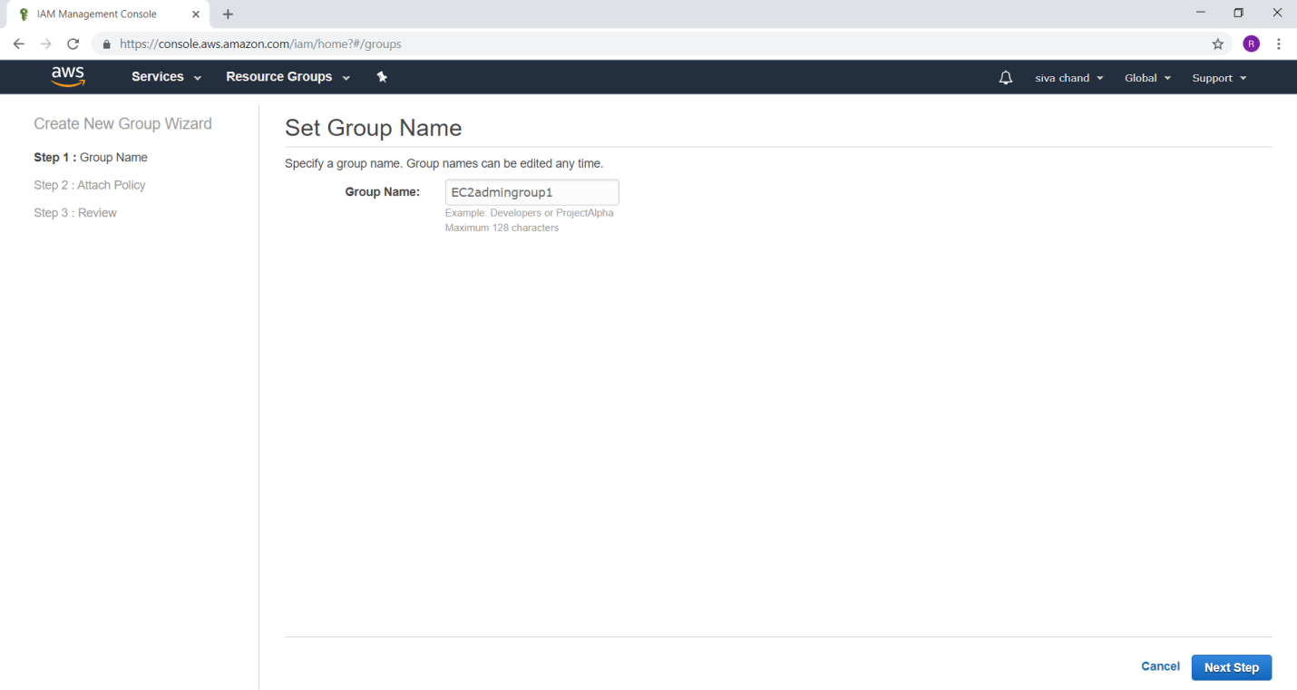

In Filter type -> EC2 FullAccess

Select check box for AmazonEC2FullAccess

Click on Next Step button

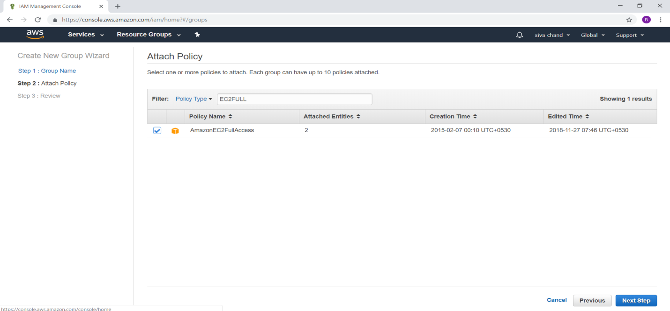

Click on Create Group

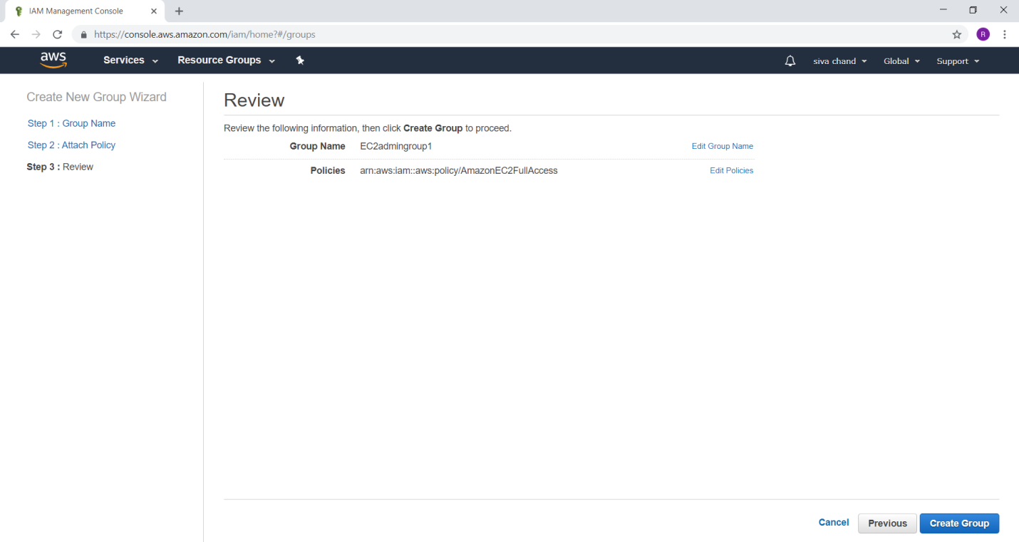

Verify

Group EC2admingroup1 got created with AmazonEC2FullAccess

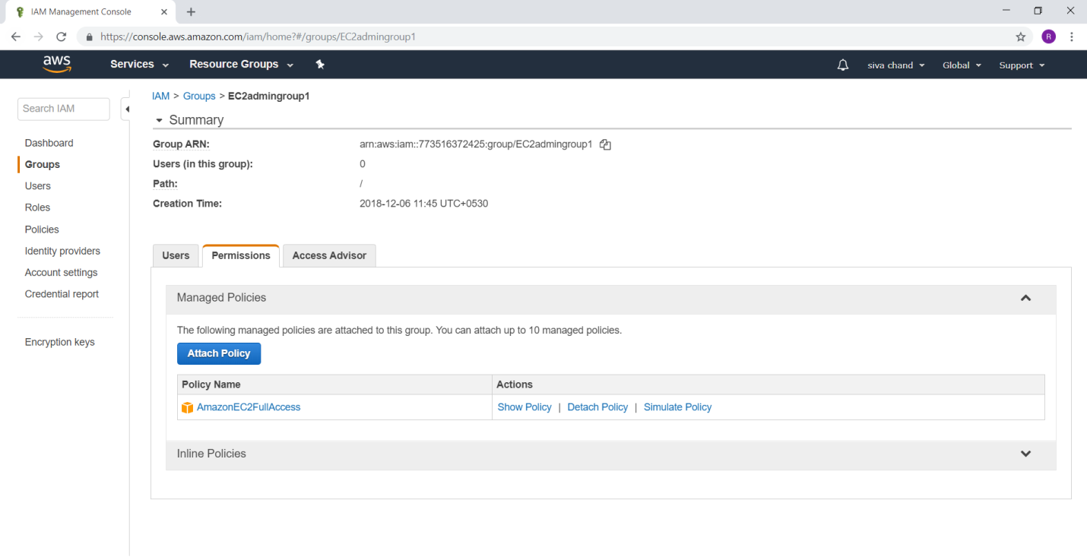

Create user ram & sdc to EC2admingroup

Create user ram & sdc join to EC2admingroup1

Create user apssdc add EC2 FullAccess and EC2 Read Only Access Policy

From IAM dashboard

Select Users

Click on ADD Users button

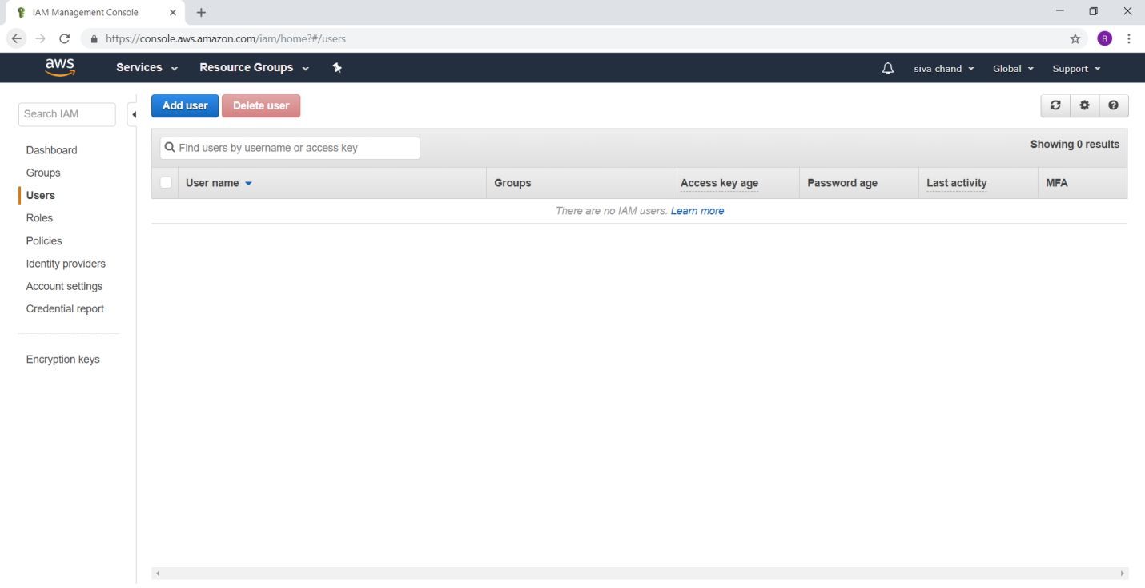

1)**Scenario**

Create user ram and sdc to EC2admingroup

For username -> ram

For Access type -> AWS Management Console access

Drag down

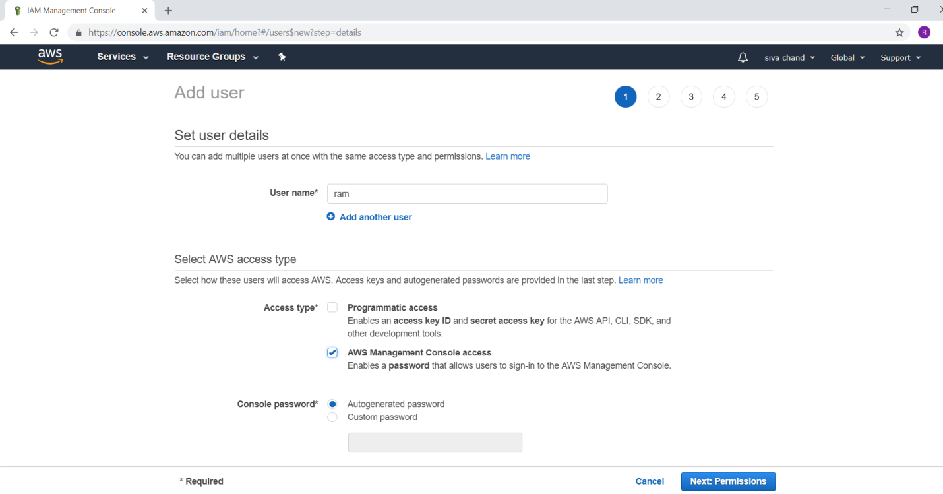

For Console password : *********

Click on Next Permission button

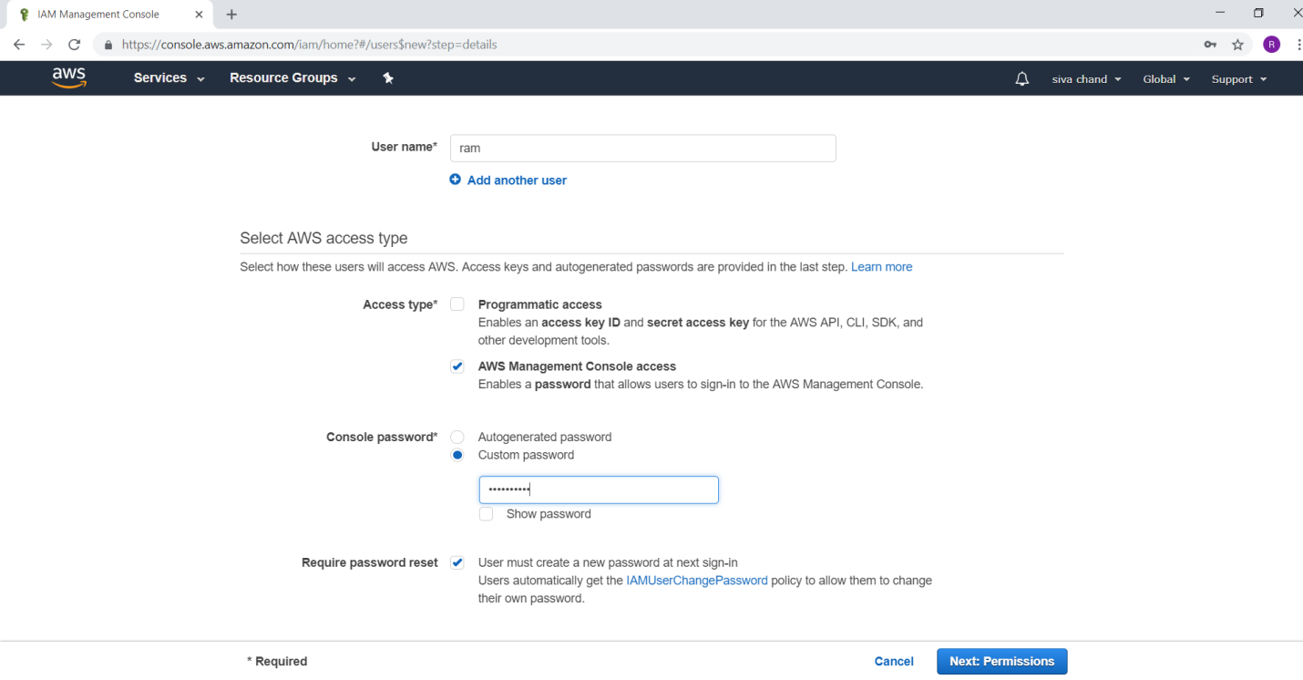

Under Group column

Select EC2admingroup

Click on Next Review

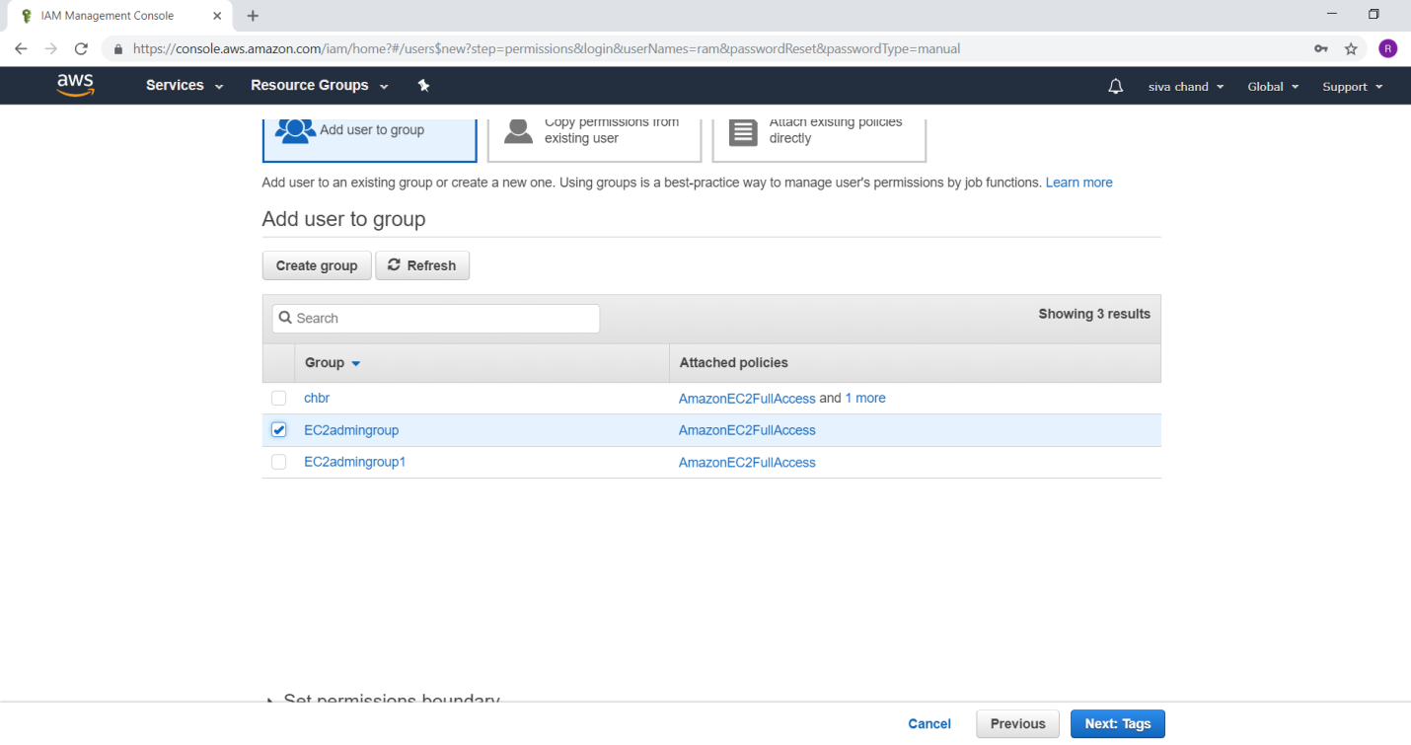

Verify users details

Click on Create user button

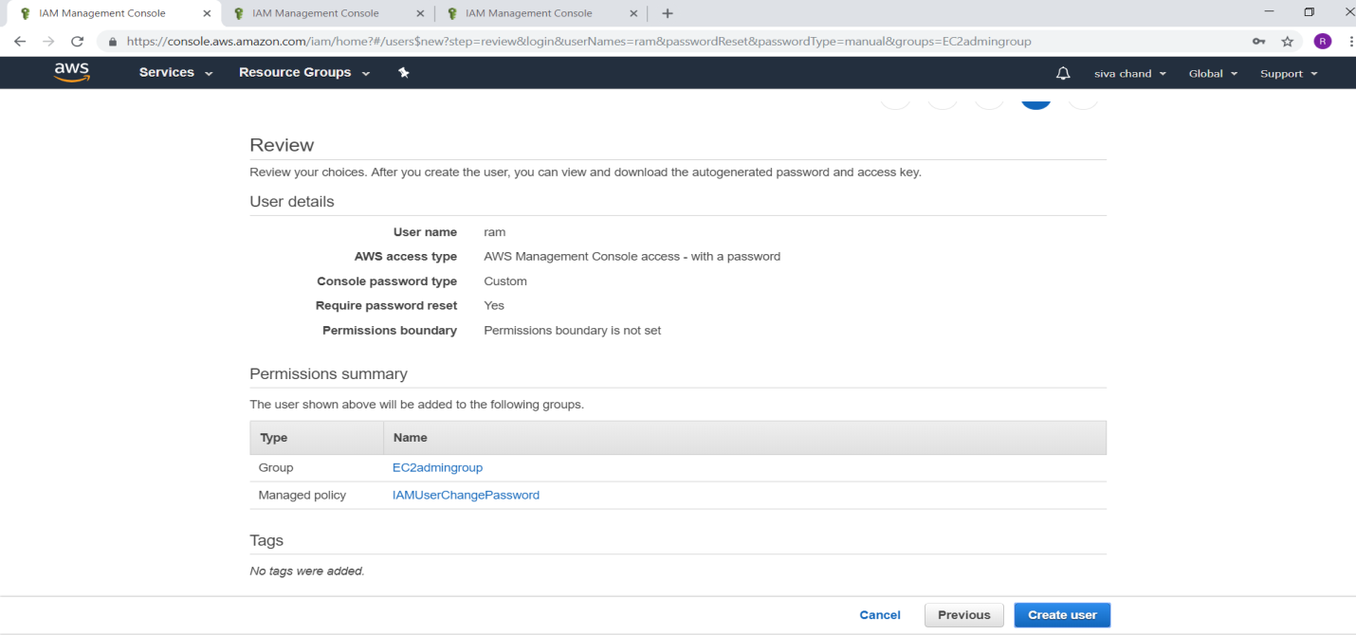

Click on close button

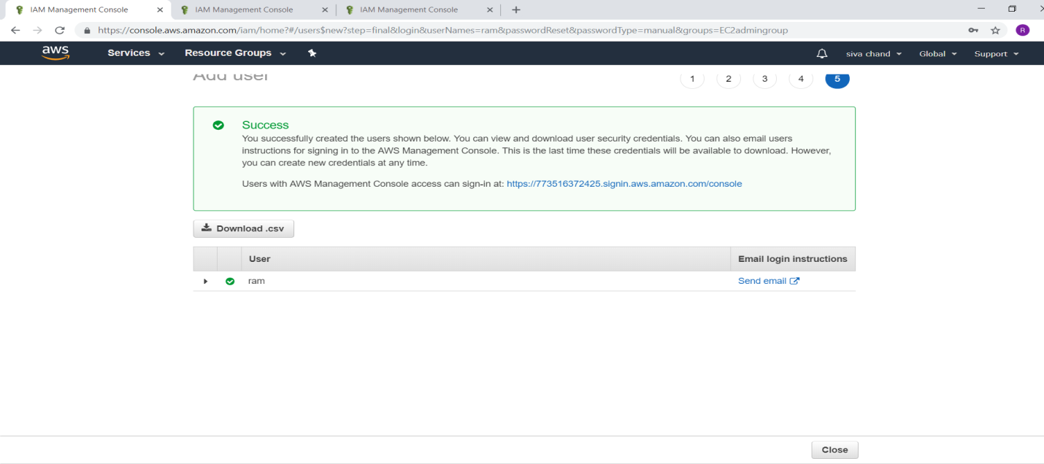

2)**Scenario**

Create user sdc to EC2admingroup1

Select user

Click on Add user button

For Console password : *********

Click on Next Permission button

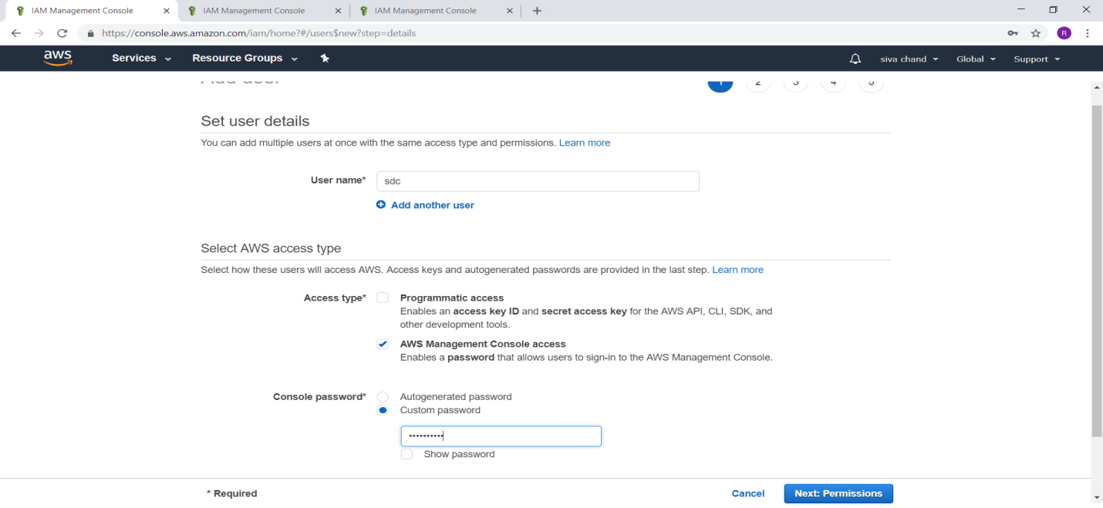

Under Group column

Select EC2admingroup1

Click on Next Review

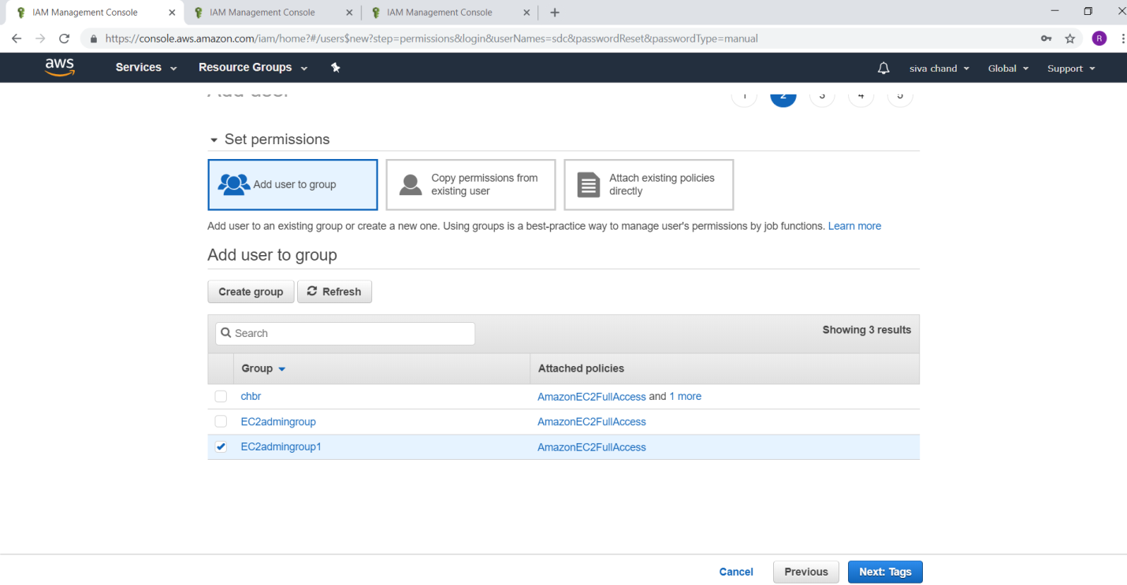

Verify users details

Click on Create user button

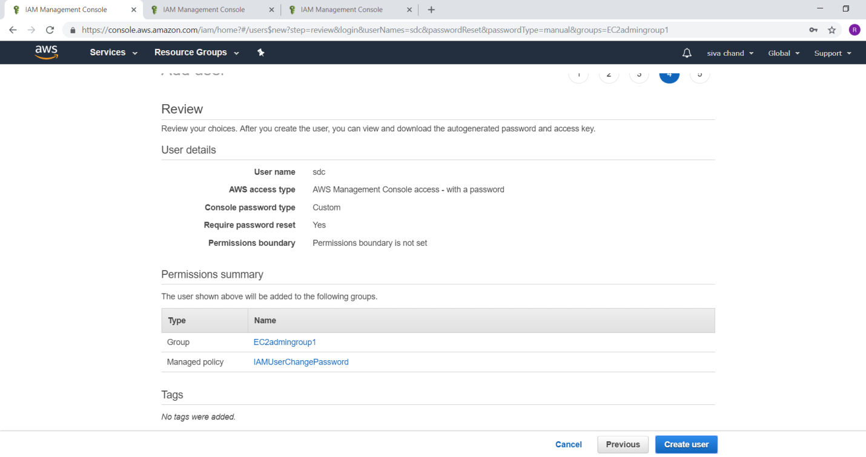

Click on close button

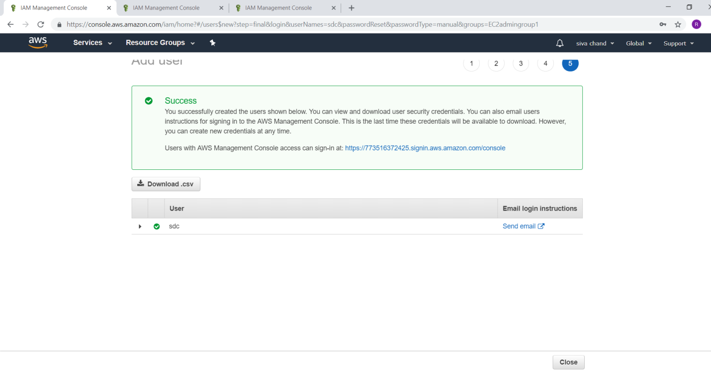

**7.2 Creating an IAM role to Access EC2 read only, Full access to only EC2**

To verify whether users can access particular Service

Login as ram user

Provide the following url in Browser

<https://773516372425.signin.aws.amazon.com/console>

Click on Sign in button

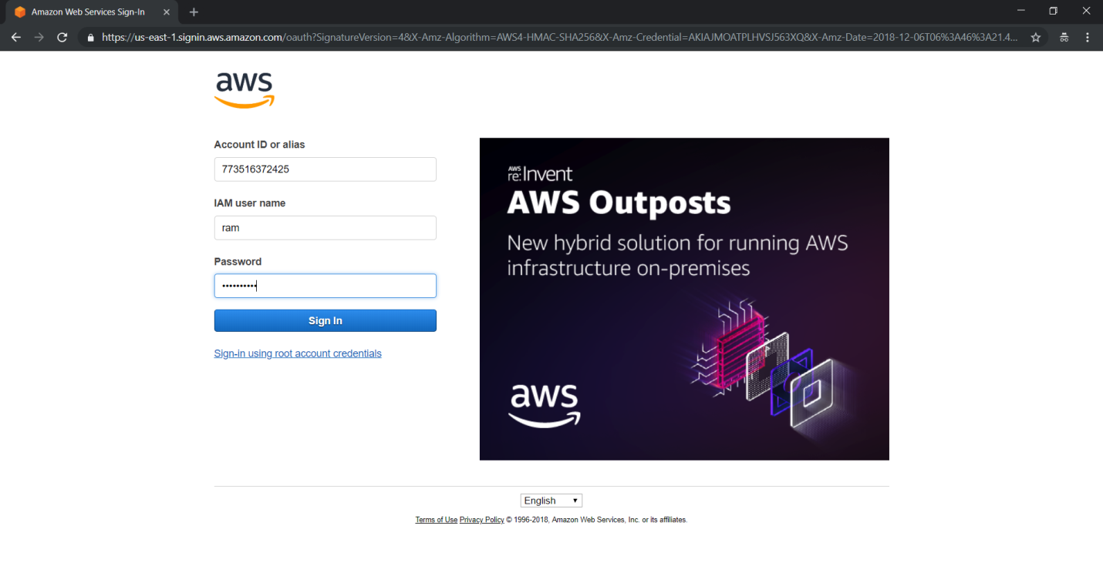

User ram is not having EC2 FullAccess

Click on EC2 verify the access

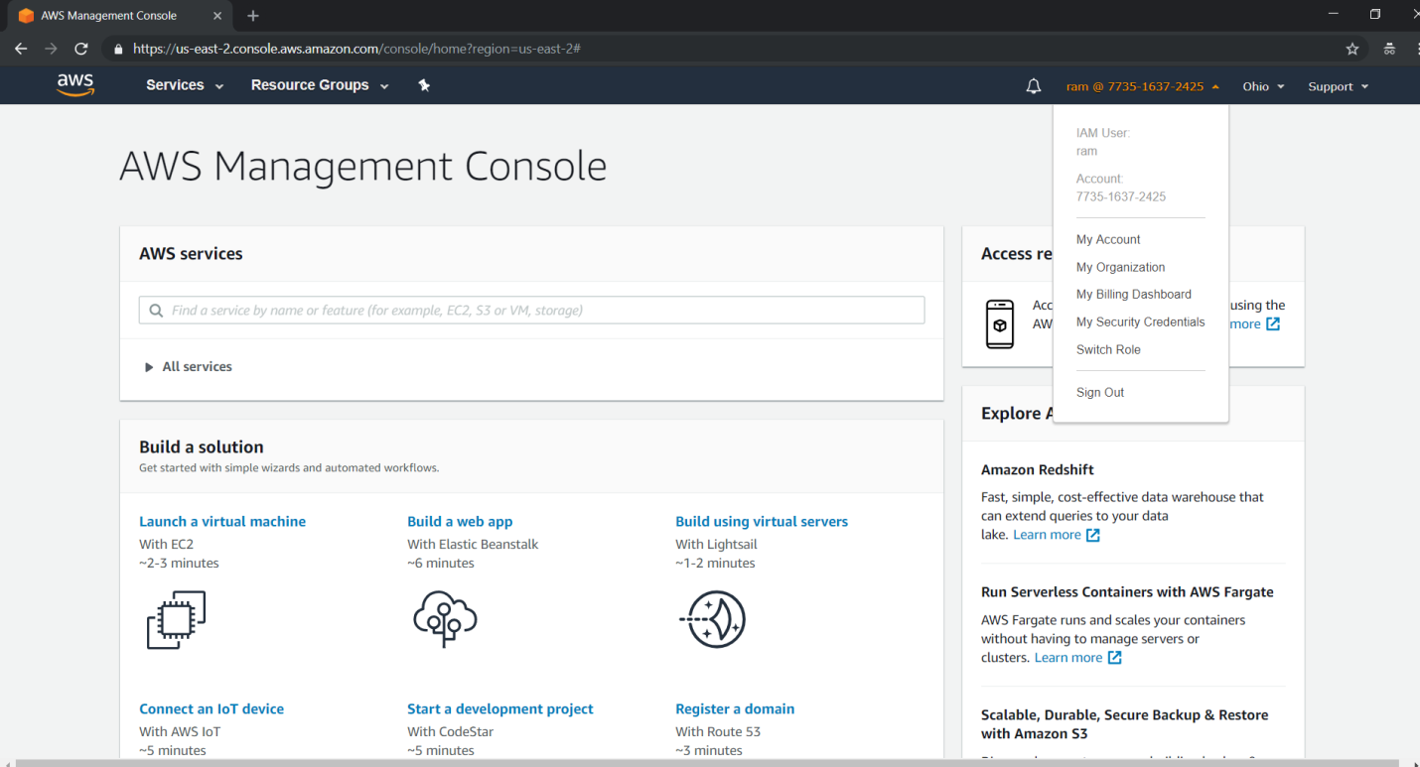

Verification

Click on EC2 verify the access

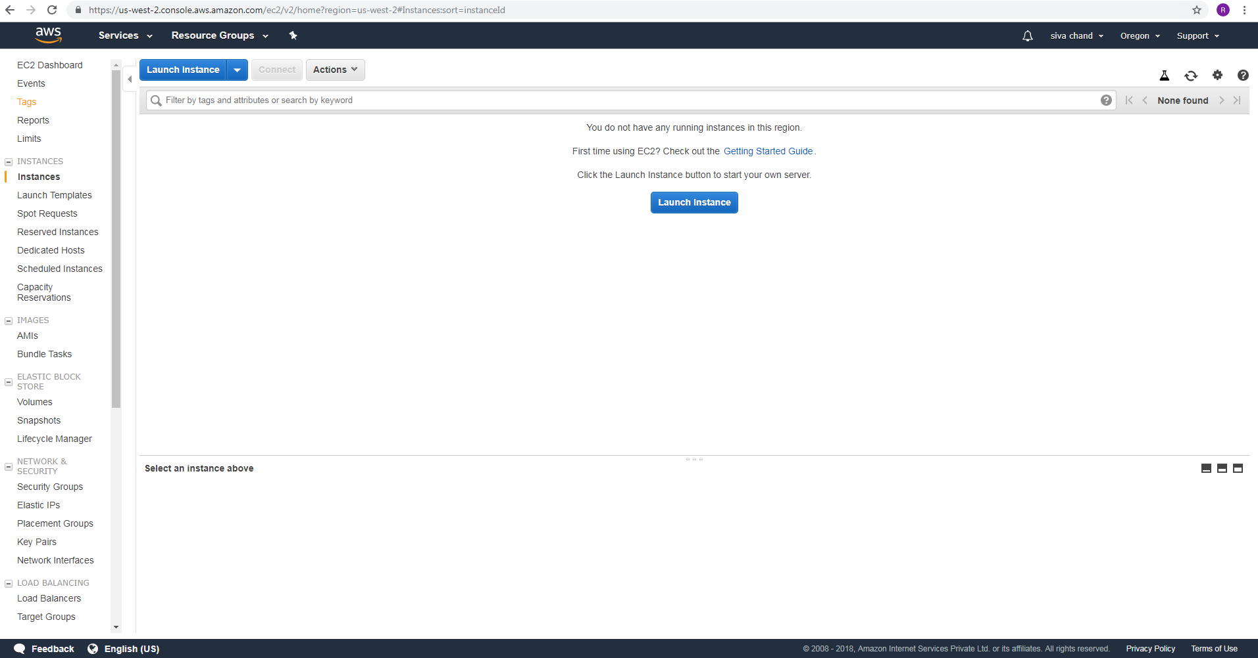

Click on S3 verify the access

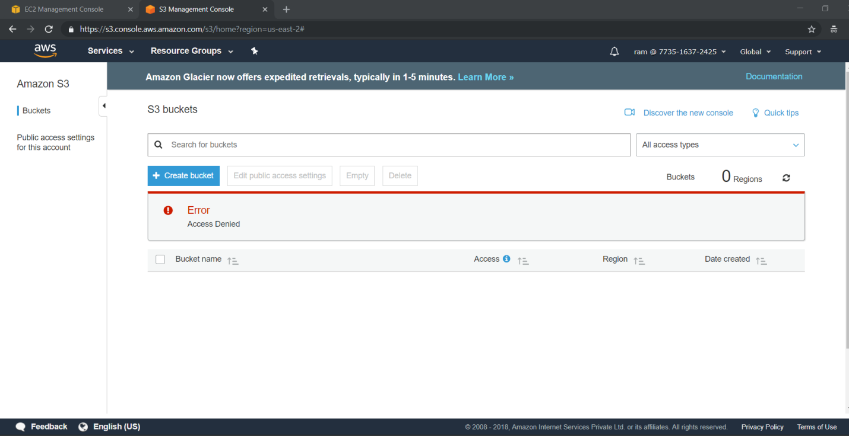

Now login as sdc user

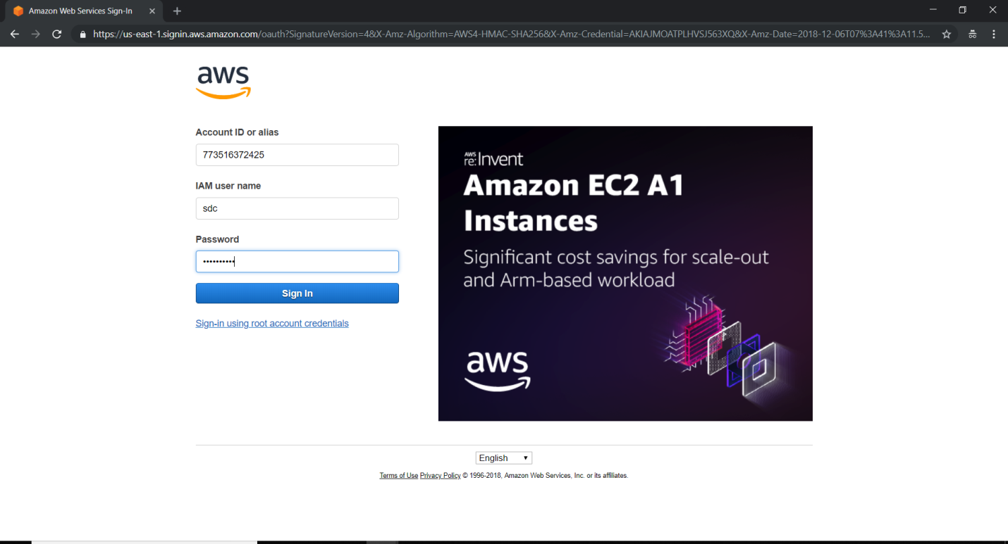

Verify user had successfully logged in

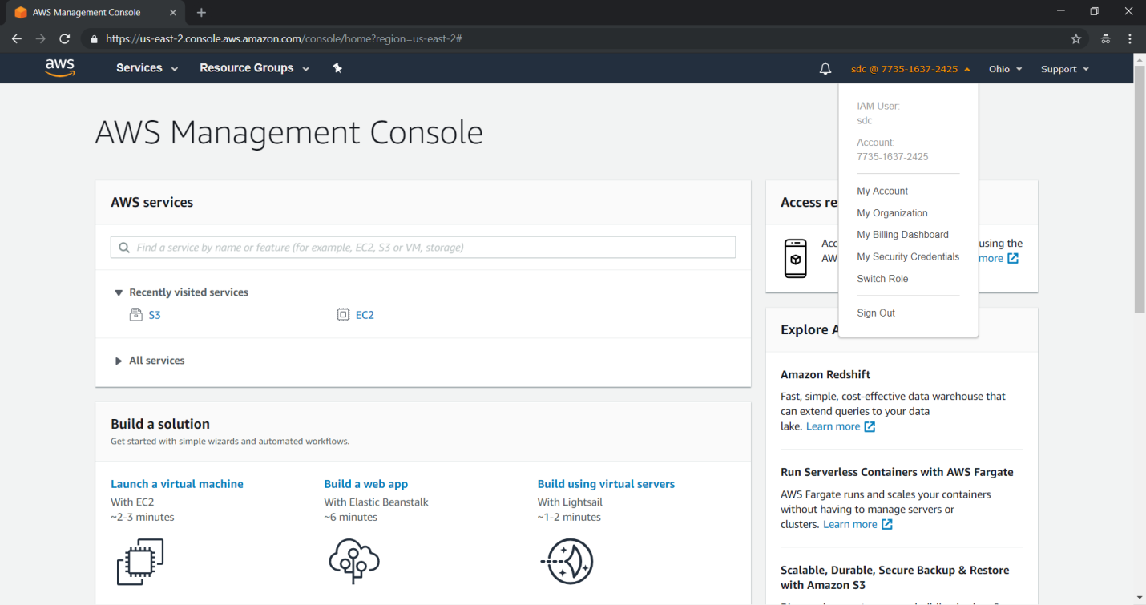

Verification

Click on EC2 verify the access



Click on S3 verify the access



**7.3 Creating an IAM role to provide access to particular bucket with full access.**

**Exercise 8. To configure Amazon S3 Glacier**

**Amazon S3 Glacier (Glacier),** a vault is a container for storing archives, and an archive is any object, such as a photo, video, or document that you store in a vault. An archive is the base unit of storage in Glacier.

-> Amazon S3 Glacier (Glacier), is a storage service optimized for infrequently used data, or "cold data".

The Amazon S3 Glacier (Glacier) data model core concepts include vaults and archives. Glacier is a REST-based web service. In terms of REST, vaults and archives are the resources. In addition, the Glacier data model includes job and notification-configuration resources. These resources complement the core resources.

**Topics**

* Vault
* Archive
* Job
* Notification Configuration

**Vault**

In Glacier, a vault is a container for storing archives. When you create a vault, you specify a name and choose an AWS Region where you want to create the vault.

Each vault resource has a unique address. The general form is:

https://*<region-specific endpoint>*/*<account-id>*/vaults/*<vaultname>*

For example, suppose that you create a vault (examples vault) in the US West (Oregon) Region. This vault can then be addressed by the following URI:

https://glacier.us-west-2.amazonaws.com/111122223333/vaults/examplevault

In the URI,

* glacier.us-west-2.amazonaws.com identifies the US West (Oregon) Region.
* 111122223333 is the AWS account ID that owns the vault.
* vaults refers to the collection of vaults owned by the AWS account.
* examples vault identifies a specific vault in the vaults collection.

An AWS account can create vaults in any supported AWS Region. For list of supported AWS Regions, see Accessing Amazon S3 Glacier. Within a Region, an account must use unique vault names. An AWS account can create same-named vaults in different Regions.

You can store an unlimited number of archives in a vault. Depending on your business or application needs, you can store these archives in one vault or multiple vaults.

Glacier supports various vault operations. Note that vault operations are Region specific. For example, when you create a vault, you create it in a specific Region. When you request a vault list, you request it from a specific AWS Region, and the resulting list only includes vaults created in that specific Region.

**Archive**

An archive can be any data such as a photo, video, or document and is a base unit of storage in Glacier. Each archive has a unique ID and an optional description. Note that you can only specify the optional description during the upload of an archive. Glacier assigns the archive an ID, which is unique in the AWS Region in which it is stored.

Each archive has a unique address. The general form is as follows:

https://*<region-specific endpoint>*/*<account-id>*/vaults/*<vault-name>*/archives/*<archive-id>*

The following is an example URI of an archive stored in the example vault vault in the US West (Oregon) Region:

https://glacier.us-west-2.amazonaws.com/111122223333/vaults/examplevault/archives/NkbByEejwEggmBz2fTHgJrg0XBoDfjP4q6iu87-TjhqG6eGoOY9Z8i1_AUyUsuhPAdTqLHy8pTl5nfCFJmDl2yEZONi5L26Omw12vcs01MNGntHEQL8MBfGlqrEXAMPLEArchiveId

You can store an unlimited number of archives in a vault.

In addition, the Glacier data model includes job and notification-configuration resources. These resources complement the core vault and archive resources.

**Job**

Glacier jobs can perform a select query on an archive, retrieve an archive, or get an inventory of a vault. When performing a query on an archive, you initiate a job providing a SQL query and list of Glacier archive objects. Glacier Select runs the query in place and writes the output results to Amazon S3.

Retrieving an archive and vault inventory (list of archives) are asynchronous operations in Glacier in which you first initiate a job, and then download the job output after Glacier completes the job.

**Note**

Glacier offers a cold storage data archival solution. If your application needs a storage solution that requires real-time data retrieval, you might consider using Amazon S3.

To initiate a vault inventory job, you provide a vault name. Select and archive retrieval jobs require that both the vault name and the archive ID. You can also provide an optional job description to help identify the jobs.

Select, archive retrieval, and vault inventory jobs are associated with a vault. A vault can have multiple jobs in progress at any point in time. When you send a job request (initiate a job), Glacier returns to you a job ID to track the job. Each job is uniquely identified by a URI of the form:

https://*<region-specific endpoint>*/*<account-id>*/vaults/*<vault-name>*/jobs/*<job-id>*

The following is an example of a job associated with an example vault vault.

https://glacier.us-west-2.amazonaws.com/111122223333/vaults/examplevault/jobs/HkF9p6o7yjhFx-K3CGl6fuSm6VzW9T7esGQfco8nUXVYwS0jlb5gq1JZ55yHgt5vP54ZShjoQzQVVh7vEXAMPLEjobID

For each job, Glacier maintains information such as job type, description, creation date, completion date, and job status. You can obtain information about a specific job or obtain a list of all your jobs associated with a vault. The list of jobs that Glacier returns includes all the in-progress and recently finished jobs.

## 

## **Notification Configuration**

Because jobs take time to complete, Glacier supports a notification mechanism to notify you when a job is complete. You can configure a vault to send notification to an Amazon Simple Notification Service (Amazon SNS) topic when jobs complete. You can specify one SNS topic per vault in the notification configuration.

Glacier stores the notification configuration as a JSON document. The following is an example vault notification configuration:

{  
 "Topic": "arn:aws:sns:us-west-2:111122223333:mytopic",   
 "Events": ["Archive Retrieval Completed", "Inventory Retrieval Completed"]   
}

Note that notification configurations are associated with vaults; you can have one for each vault. Each notification configuration resource is uniquely identified by a URI of the form:

https://*<region-specific endpoint>*/*<account-id>*/vaults/*<vault-name>*/notification-configuration

Glacier supports operations to set, get, and delete a notification configuration. When you delete a notification configuration, no notifications are sent when any data retrieval operation on the vault is complete.

**EXERCISE 8: To configure Amazon S3 Glacier**

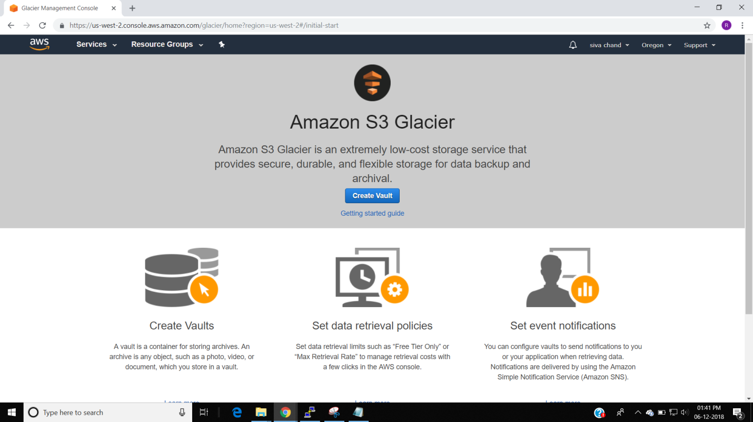

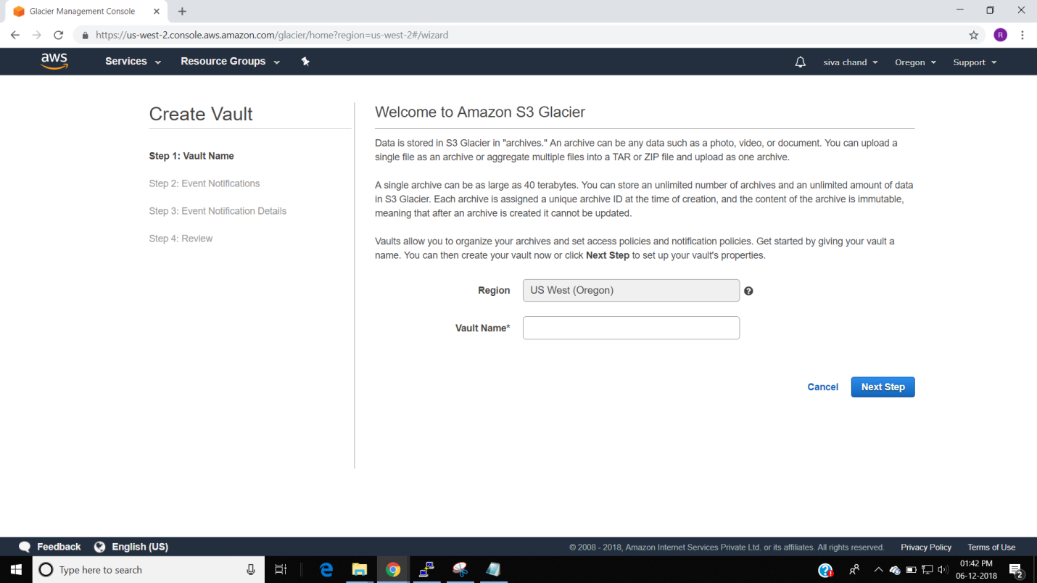

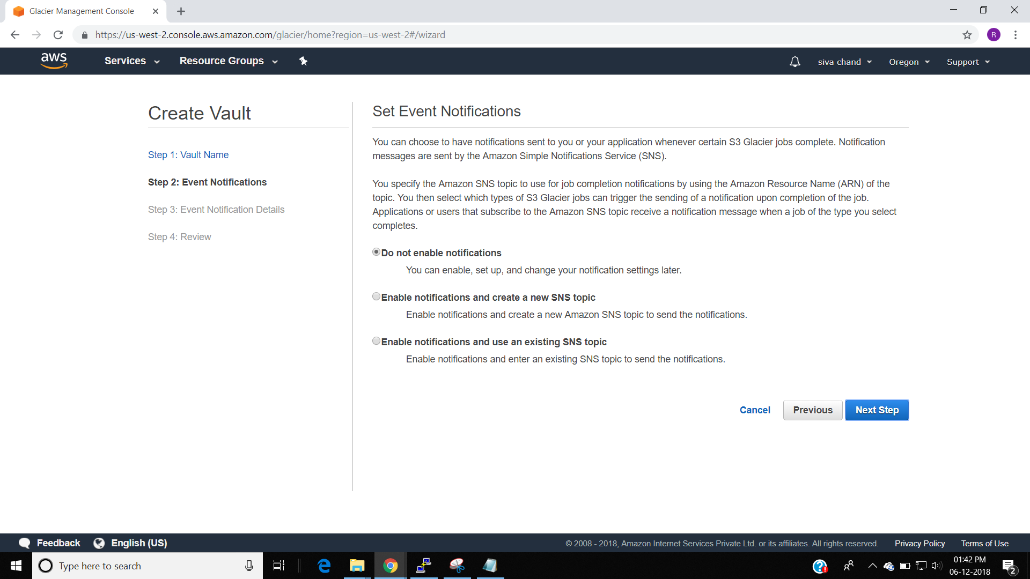

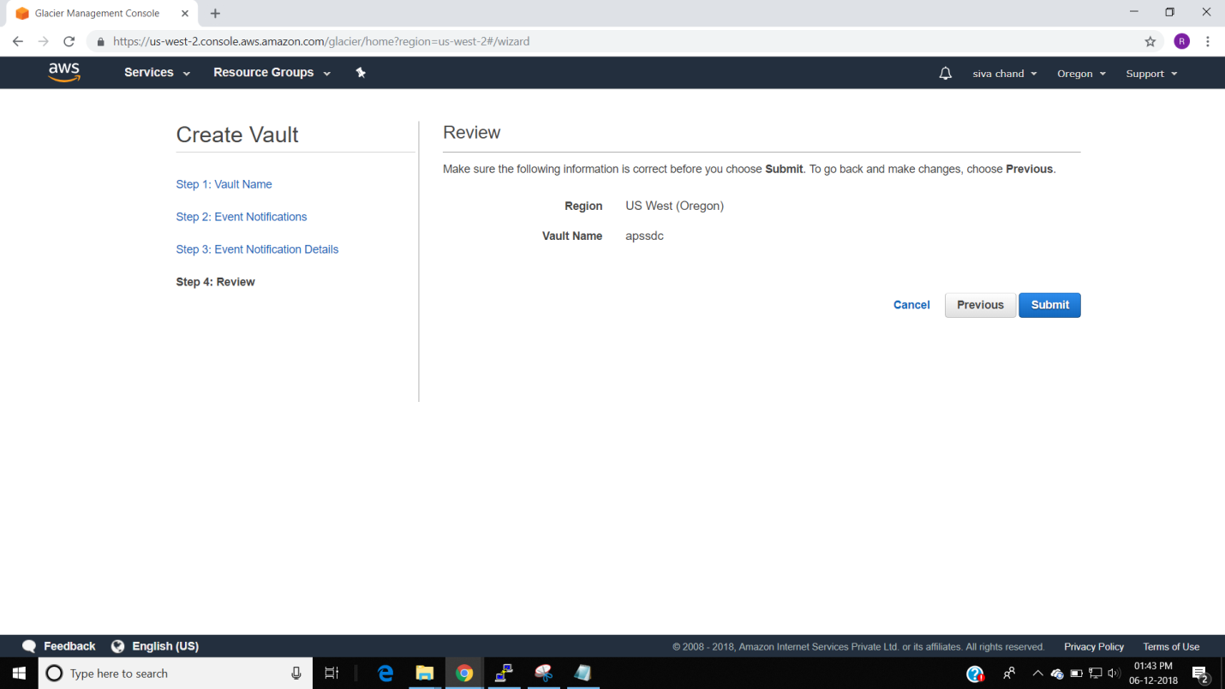

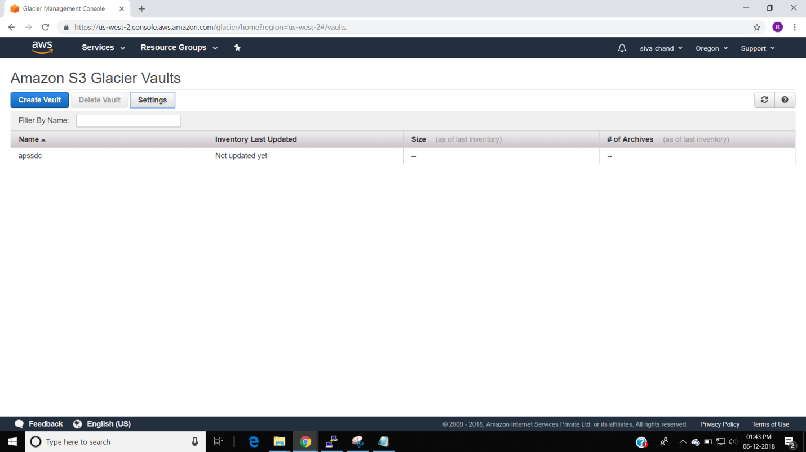

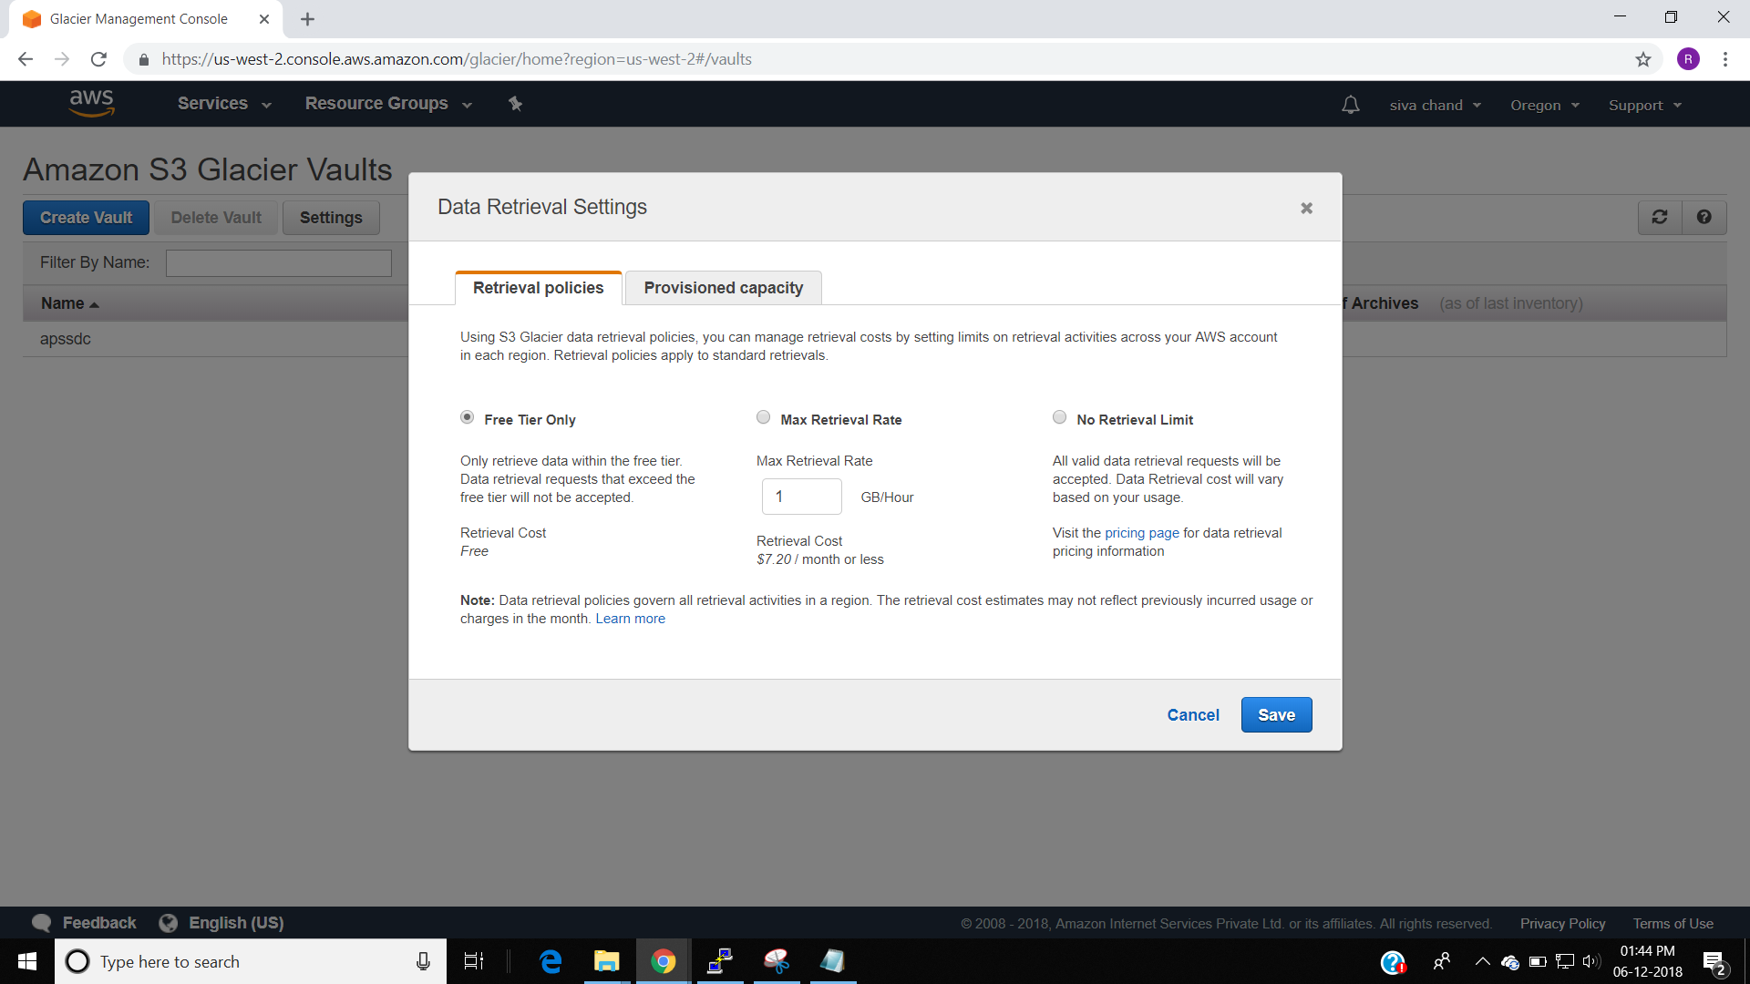

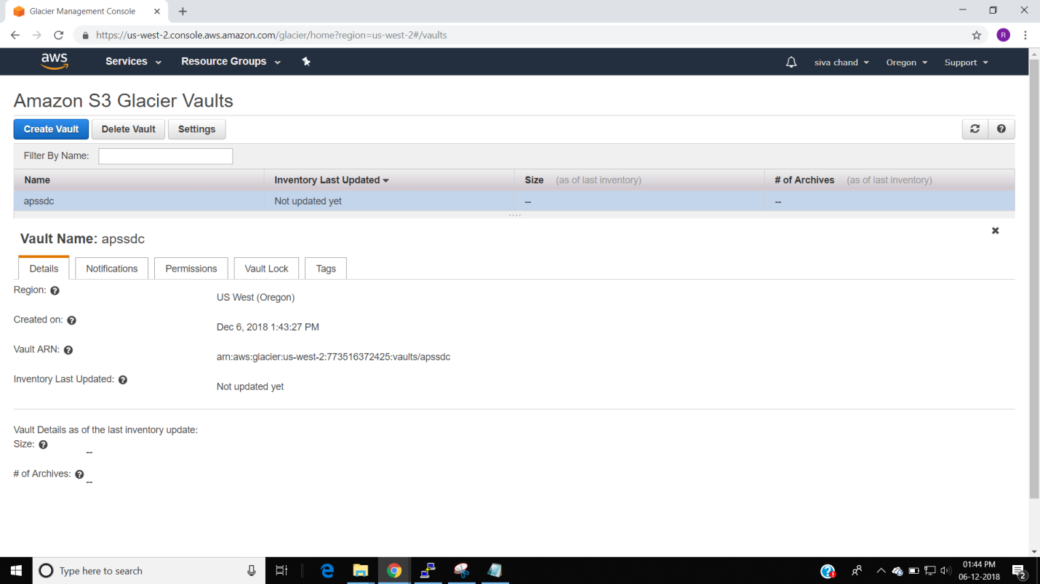

**Exercise 9. To Configure Amazon Glacier**

**Amazon Glacier** is an [online file storage](https://en.wikipedia.org/wiki/Online_file_storage) [web service](https://en.wikipedia.org/wiki/Web_service) that provides storage for data archiving and backup

Glacier is part of the [Amazon Web Services](https://en.wikipedia.org/wiki/Amazon_Web_Services) suite of [cloud computing](https://en.wikipedia.org/wiki/Cloud_computing) services, and is designed for long-term storage of data that is infrequently accessed and for which retrieval latency times of 3 to 5 hours are acceptable. Storage costs are a consistent $0.004 per gigabyte per month, which is substantially cheaper than Amazon's own [Simple Storage Service (S3)](https://en.wikipedia.org/wiki/Amazon_S3)

To configure and use AWS Glacier Service.

TOPOLOGY:

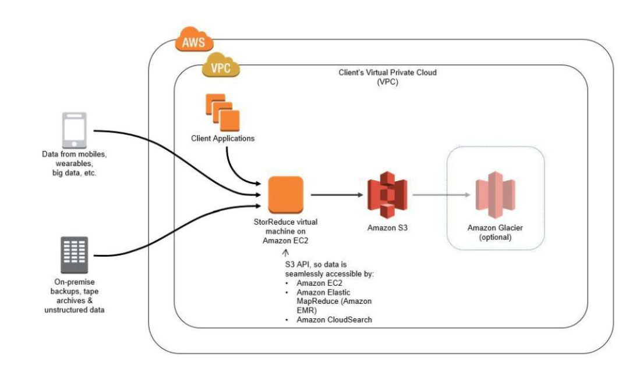

To configure Glacier with following task

Transfer file from S3 to Glacier

Note: Amazon does not allows files to be directly loaded on glacier

Select S3 bucket

Select the bucket,

Go to properties

Click on Lifecycle

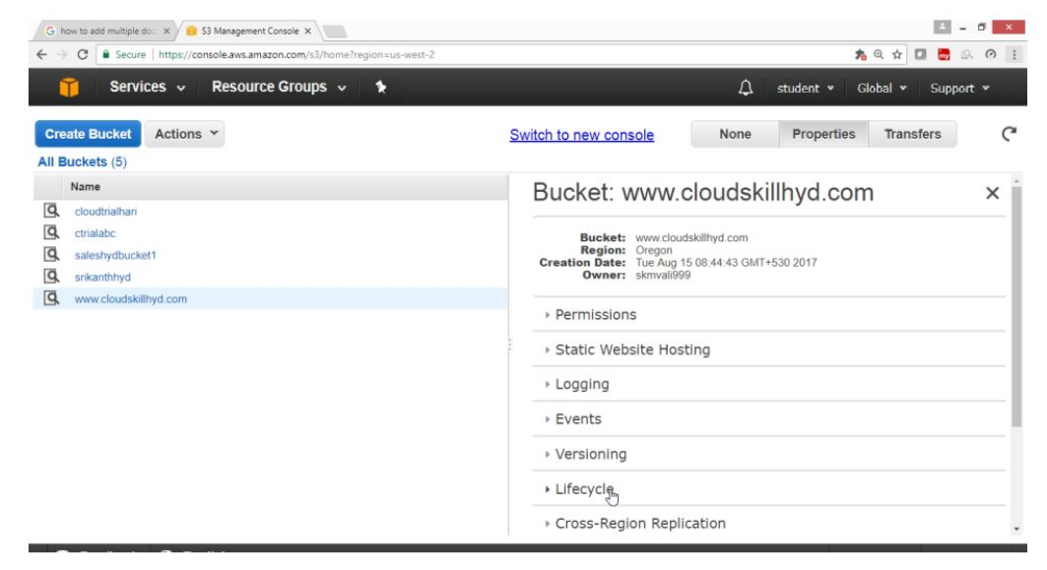

Click on Add rule

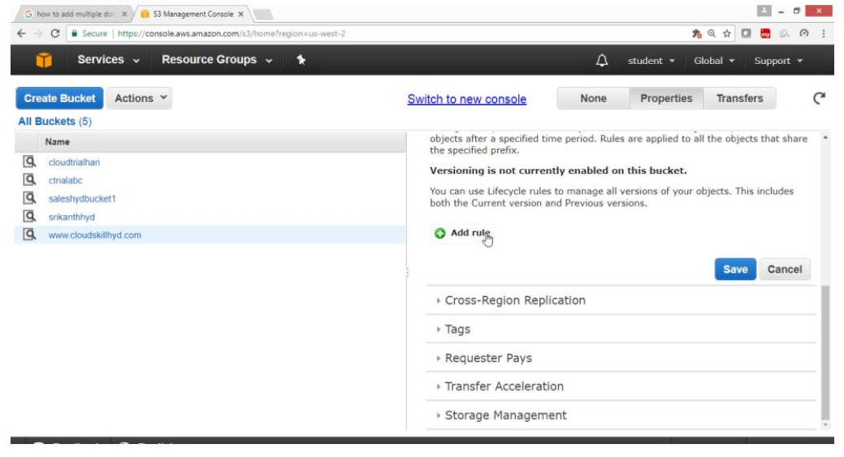

Under Lifecycle Rules

Select Choose Rule Target

Apply the rule to -> Whole Bucket

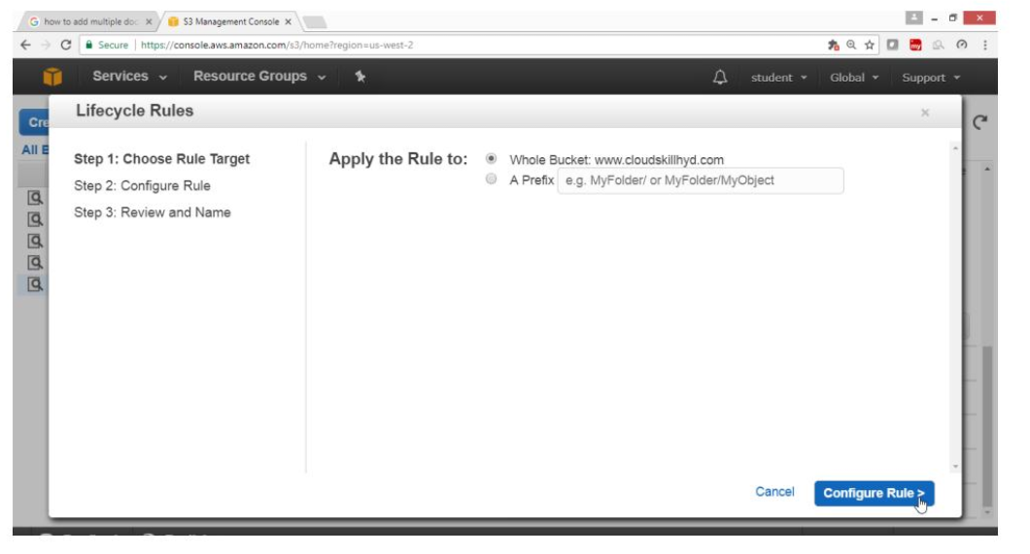

Select checkbox Archive to the Glacier Storage class ->7

Select the checkbox Permanently Delete ->372

Click on Review

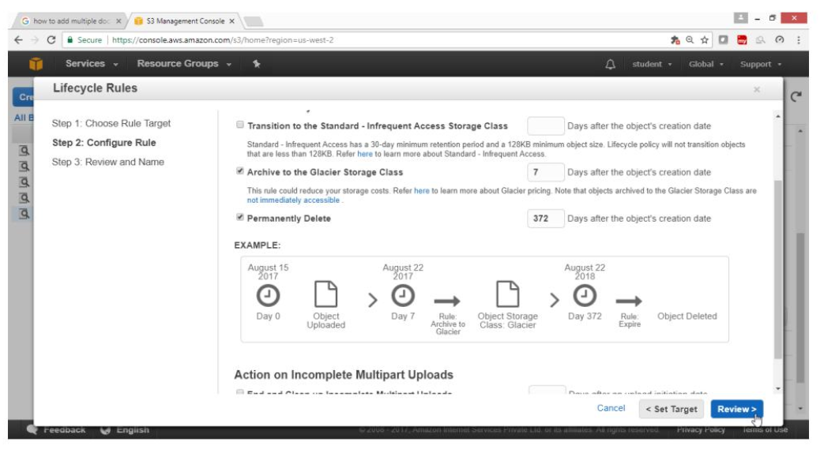

Provide Rule Name -> Testbackup

click on “Create and Activate Rule” button

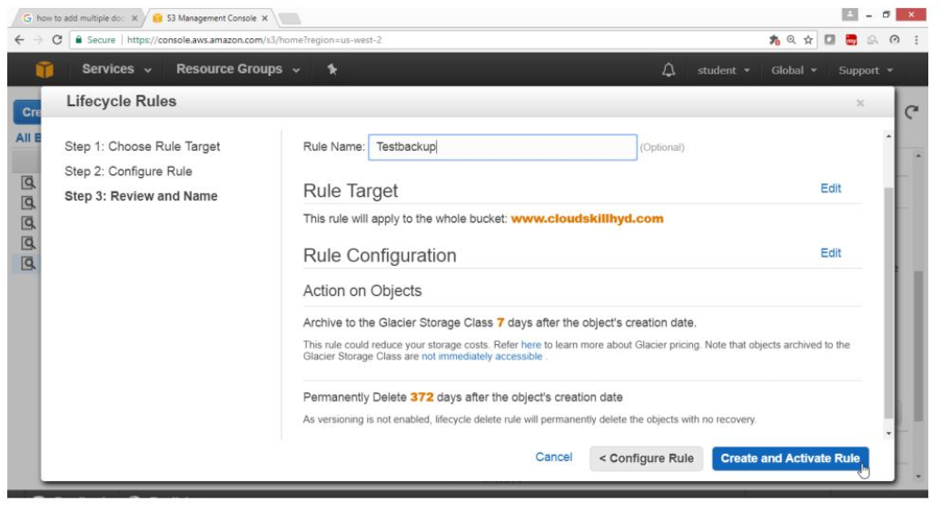

Click on save button

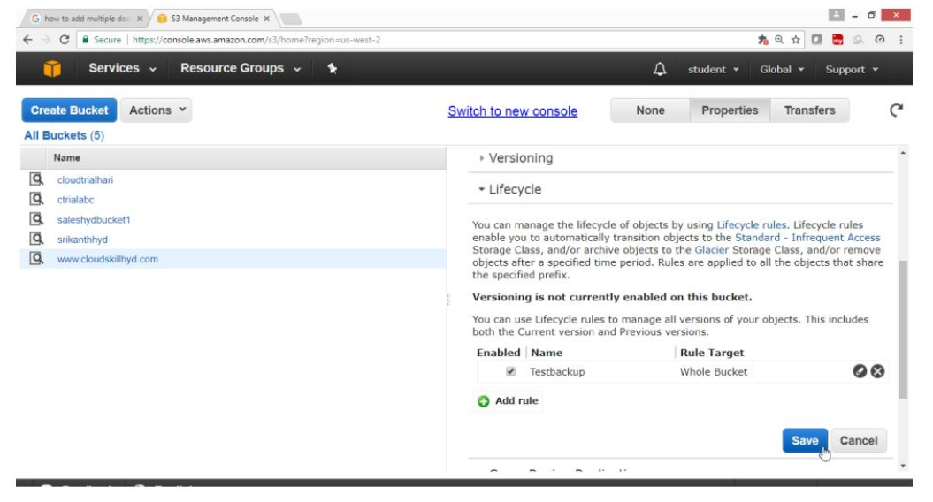

Verify Storage class is Standard

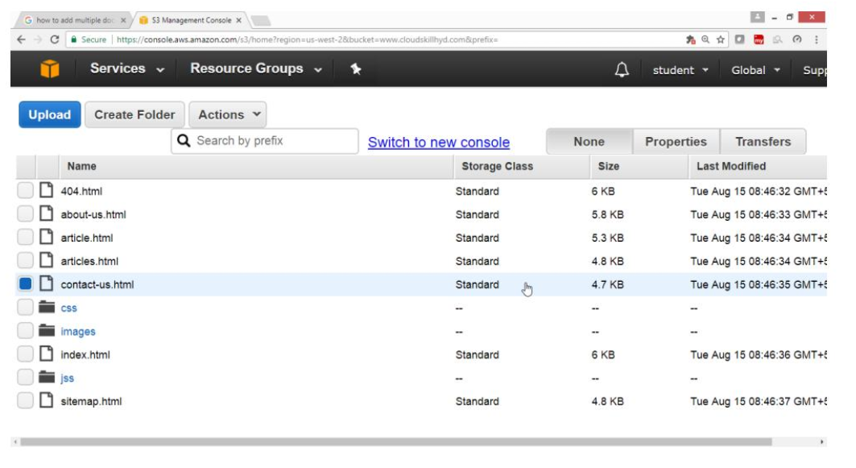

Verify Once the file goes to Glacier then Storage class is Glacier

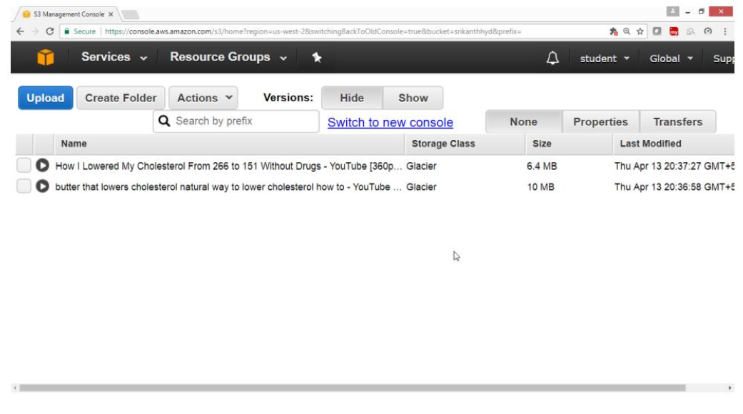

To Restore go to the bucket select the file

Right click and select initiate Restore

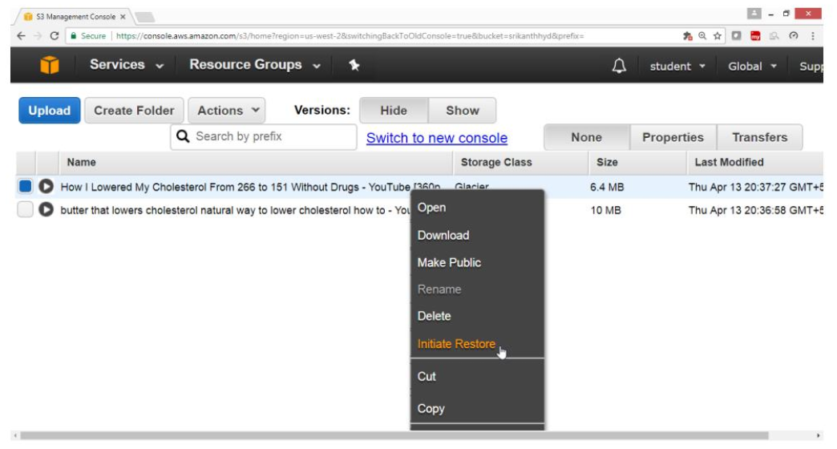

Provide number of days -> 1

Click on ok

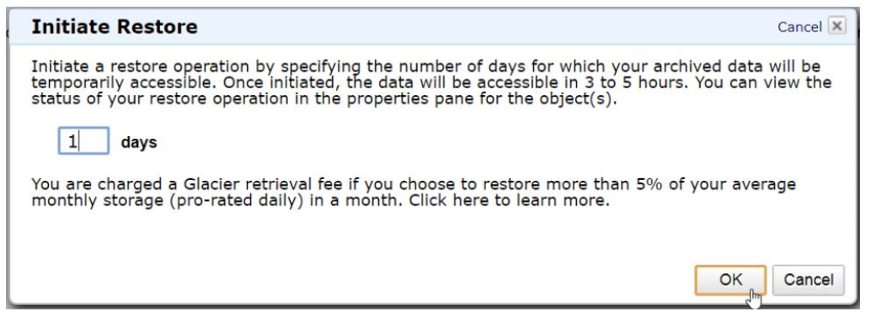

Verify

File will get restored after 1 Day

Storage class will become Standard.

**Exercise 10. To Configure Amazon EFS**

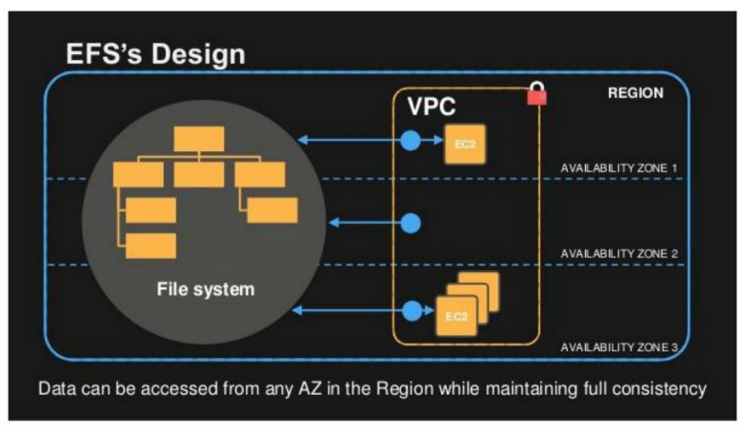

**To configure EFS with following task.**

Create a security group for EFS access

Create Your Amazon EFS File System

Launch Your EC2 Instance

Create Your Amazon EFS File System

Mount the Amazon EFS File System in your linux launch instance

1) Create a security group for EFS access

Open AWS Console go for EC2 Service

Click on EC2

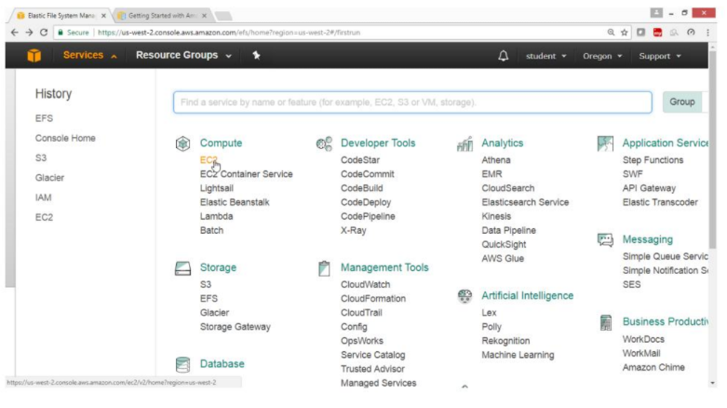

Under EC2 Dashboard go for Network & Security

Select Security Groups

Click on Create Security Group

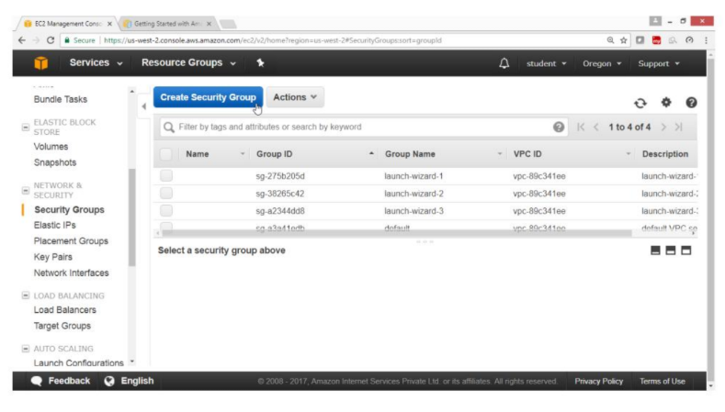

Under “Create Security Group” wizard

Give Following values

Security group name -- NFS security2

Description -- NFSrule2

VPC -- take default

Select Inbound

Type -- All traffic

Source -- Anywhere

Click on Create button

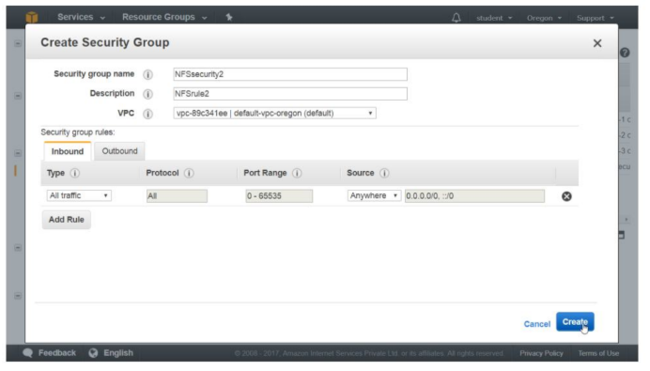

2) Create your Amazon EFS File System

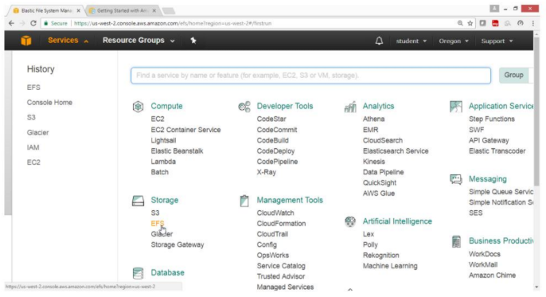

Click on “Create file system” button

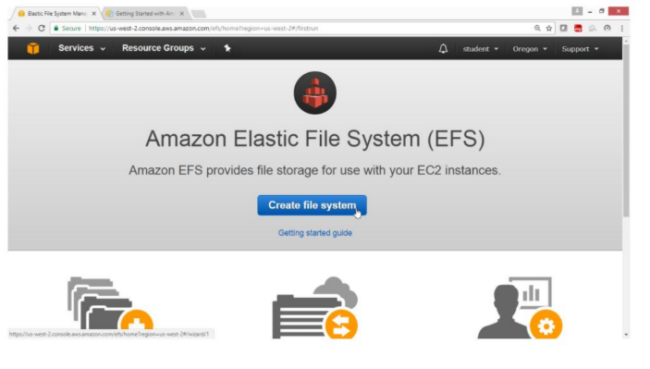

Select Default VPC

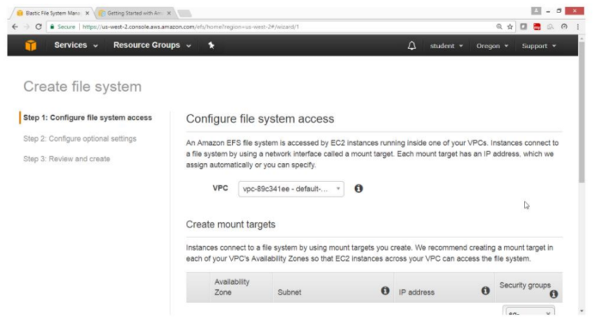

Remove all Security Groups

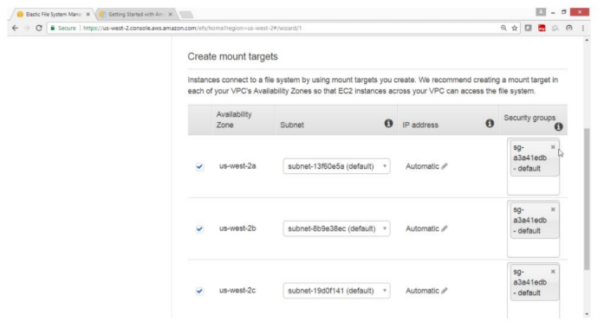

Verify that all security groups go deleted

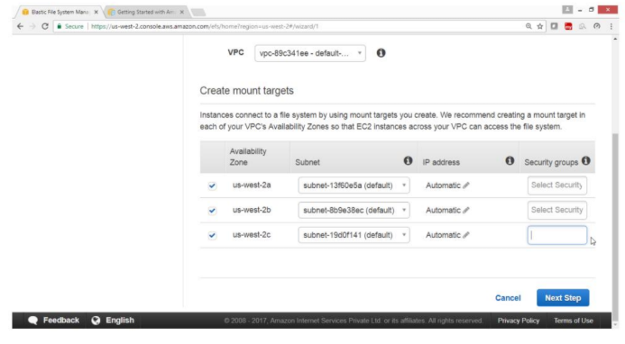

Now Add NFS Security group in all A.Z

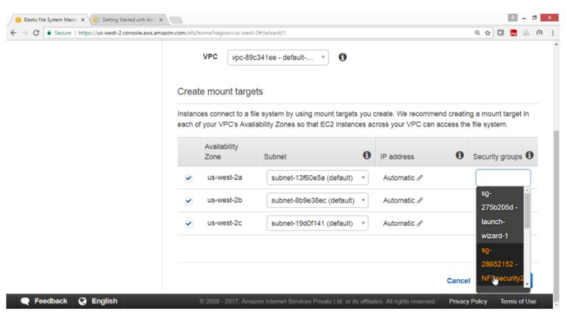

Verify that all Security Groups are added.

Click on Next Step

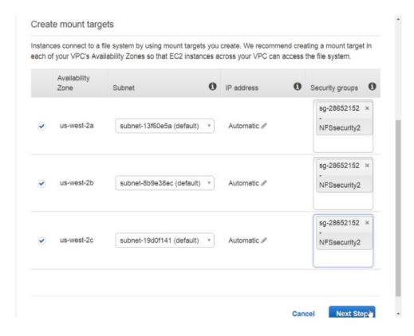

Provide tags

Key -- Name

Value -- NFS hyd1

Drag Down

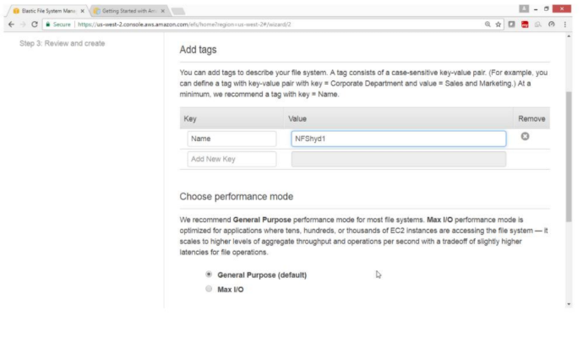

Select General Purpose

Click on Next Step

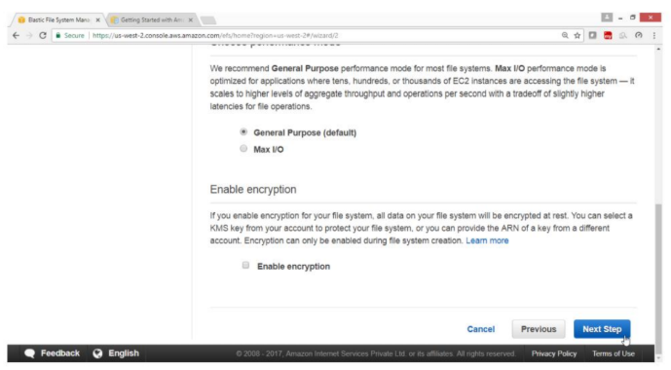

NFS hyd1 filesystem got selected

Click on Create File System

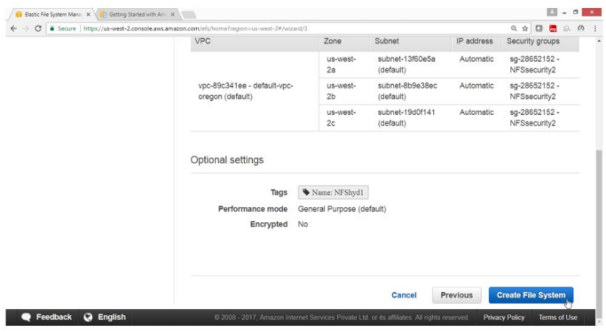

Verify

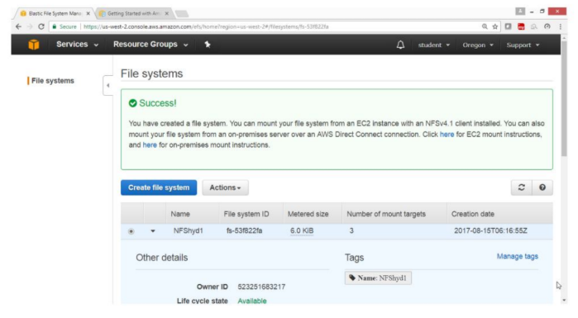

Drag Down

Verify that Life cycle state is Creating, it takes few minutes.

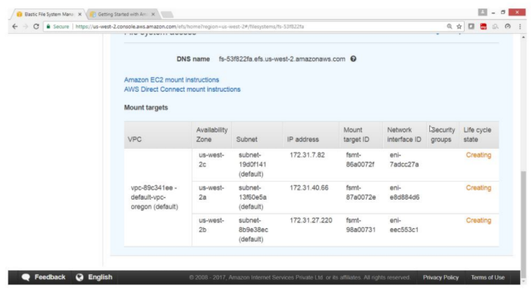

Verify that Life cycle state is Available

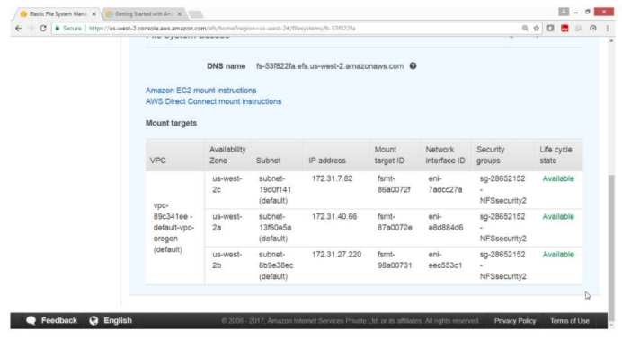

Step 3. Now launch linux instance & Mount the Amazon EFS File System.

Login to linux instance by using putty

Run the following commands

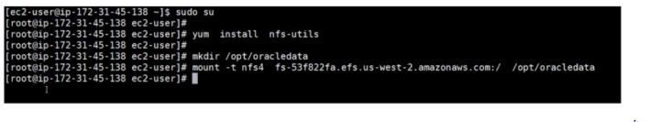

Verify is it mounted

Check the last line

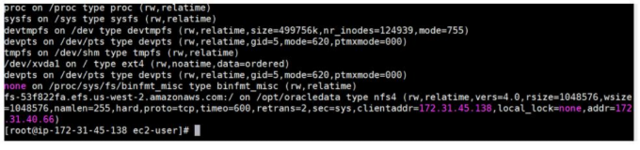

**Exercise 11. To Configure Amazon Virtual Private Cloud (VPC)**

Amazon Virtual Private Cloud (Amazon VPC) lets you provision a logically isolated section of the Amazon Web Services (AWS) cloud where you can launch AWS resources in a virtual network that you define. You have complete control over your virtual networking environment, including selection of your own IP address range, creation of subnets, and configuration of route tables and network gateways. You can use both IPv4 and IPv6 in your VPC for secure and easy access to resources and applications. You can easily customize the network configuration for your Amazon Virtual Private Cloud.

**For example:**

you can create a public-facing subnet for your web servers that has access to the Internet, and place your backend systems such as databases or application servers in a private-facing subnet with no Internet access. You can leverage multiple layers of security, including security groups and network access control lists, to help control access to Amazon EC2 instances in each subnet.

Features and Benefits

Multiple Connectivity Options

Secure

Simple

Use All the Scalability and Reliability of AWS

Cases

Host a simple, public-facing website

Host multi-tier web applications

Host scalable web applications in the AWS cloud that are connected to your

Datacenter

Extend your corporate network into the cloud

Disaster Recovery

**11.1. To Create your own VPC**

Amazon VPC enables you to launch AWS resources into a virtual network that you've

defined. If you have a default VPC, you can skip this section and move to the next task,

Create a Security Group.

Open AWS console

Click on Services

Select Networking and Content Delivery

Click on VPC

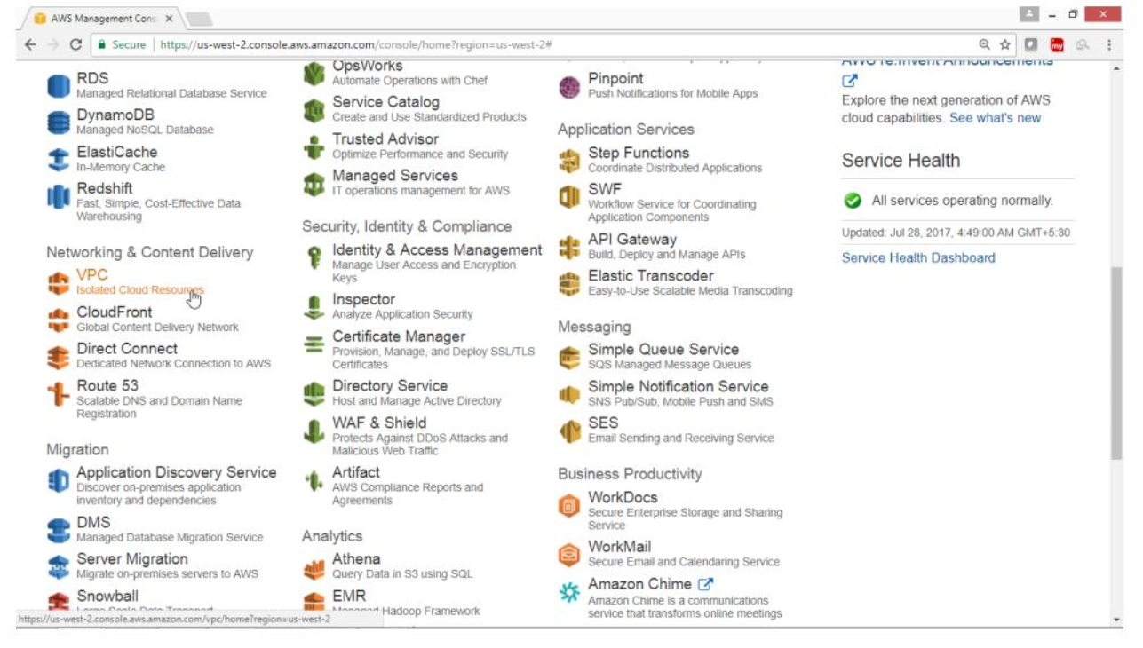

On VPC Dashboard panel

Click on Your VPC

Click on Create VPC button

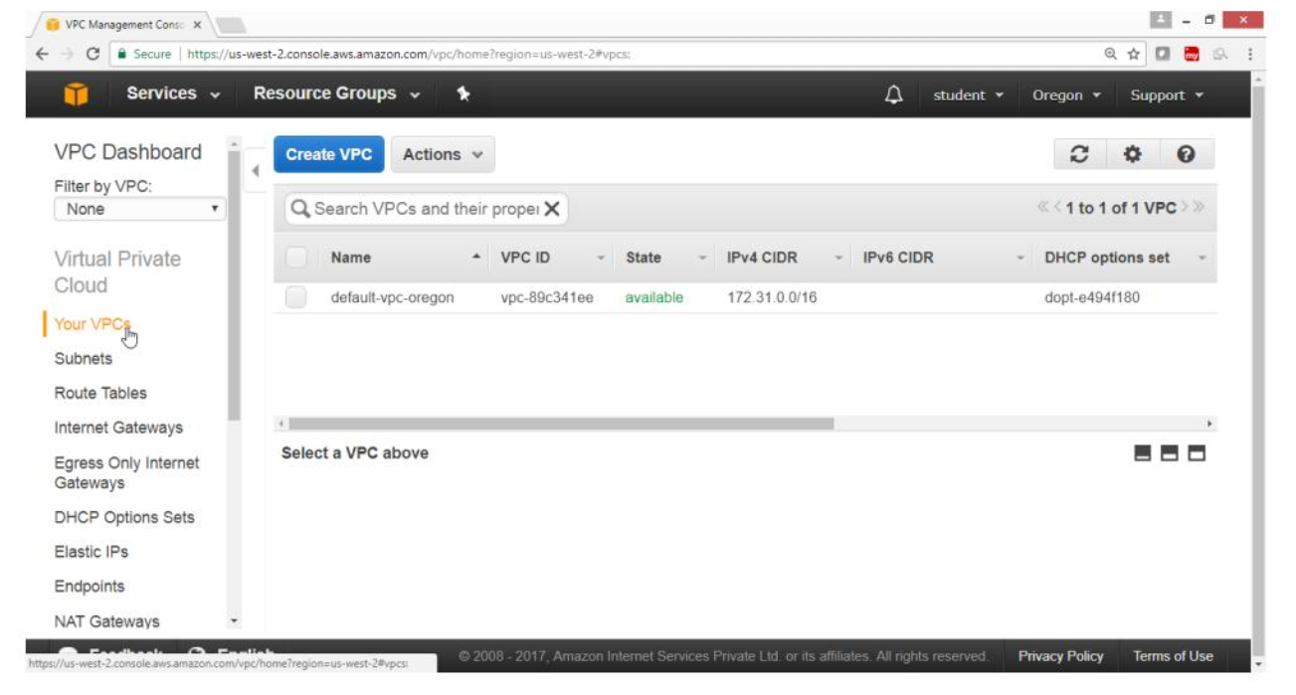

On “Create VPC”, page

For Name tag -> HYD VPC

For IPv4 CIDR block -- 192.168.0.0/16

Leave on “Yes Create” button

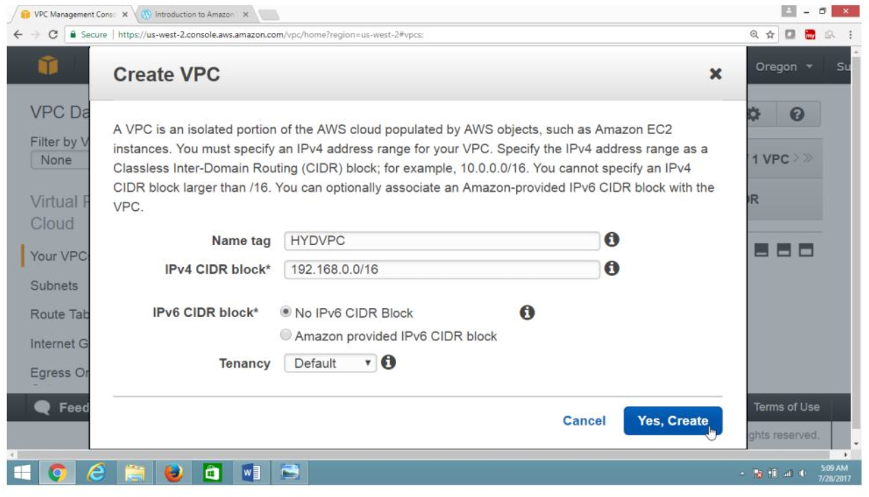

Verify

HYD VPC is created

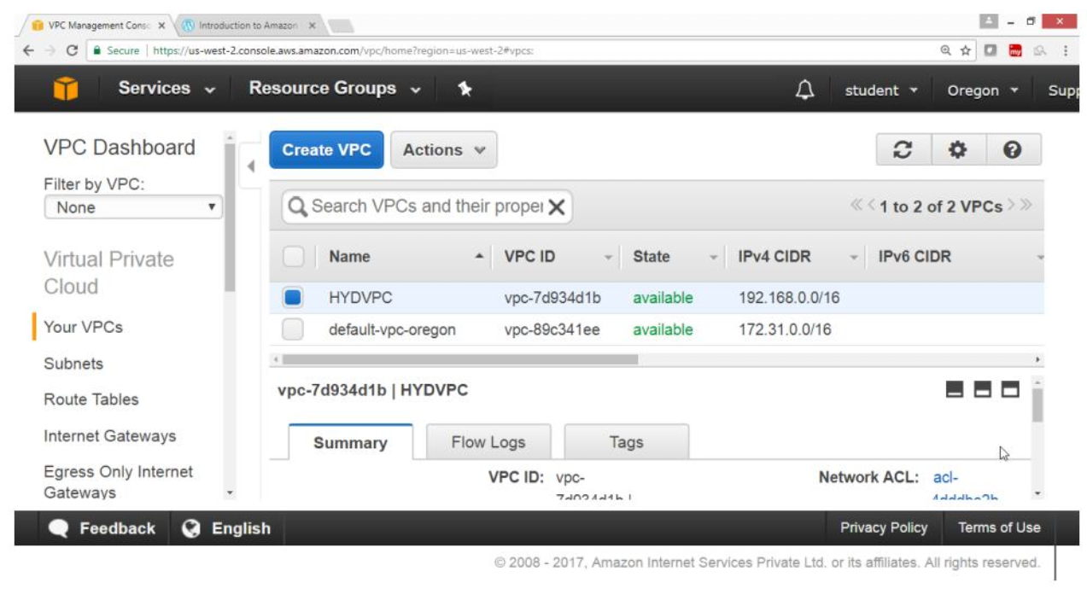

**11.2. To Create public subnet**

Click on Subnet

Click on Create Subnet button

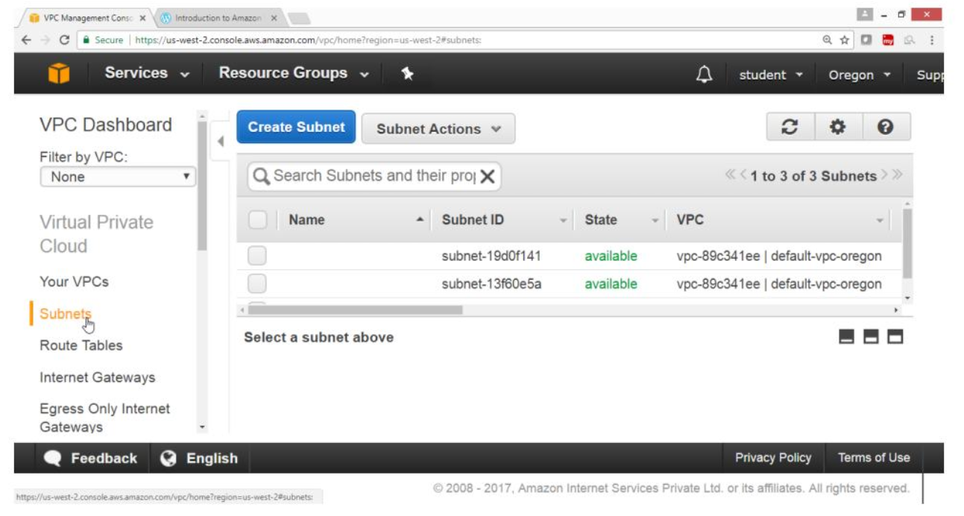

On Create Subnet, page

For Name tag -> hyd-pub-subnet

For VPC -> HYDVPC

For IPv4 CIDR block -> 192.168.10.0/24

Click on Yes Create button

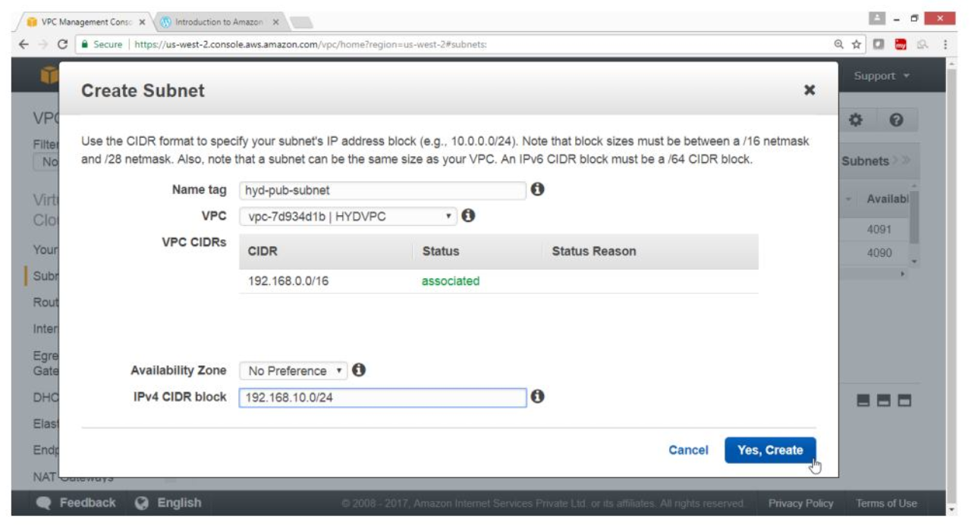

Verify

Hyd-pub-subnet got created

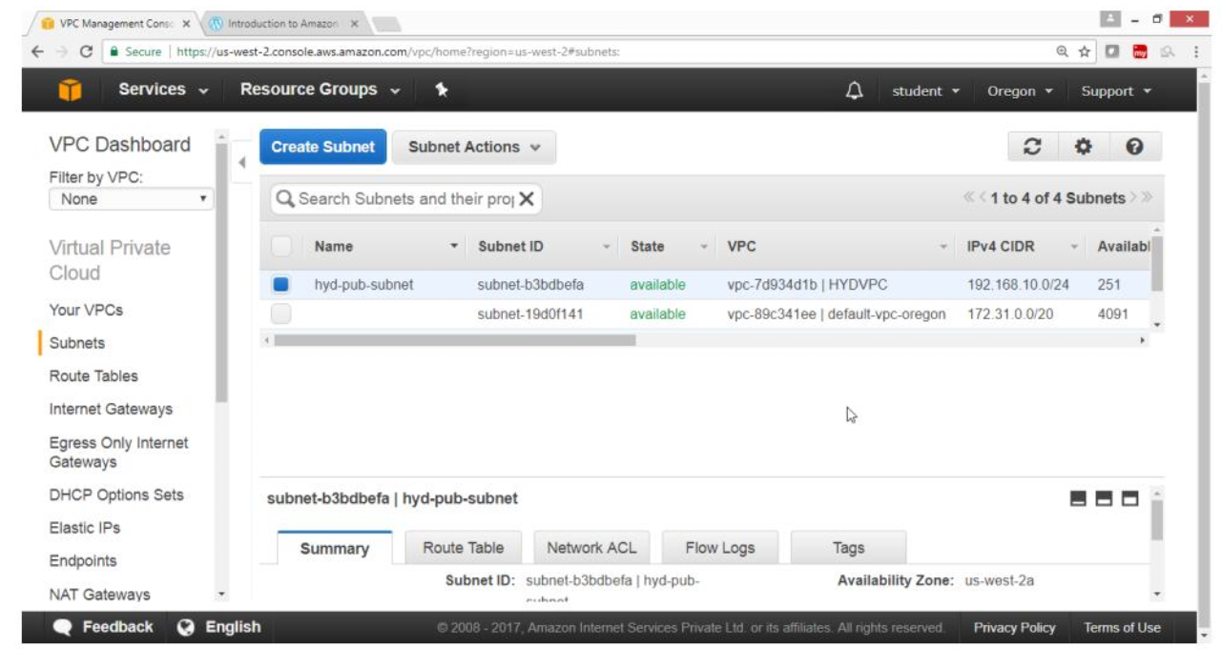

**11.3. To Create private subnet**

Click on Subnet

Click on Create subnet button

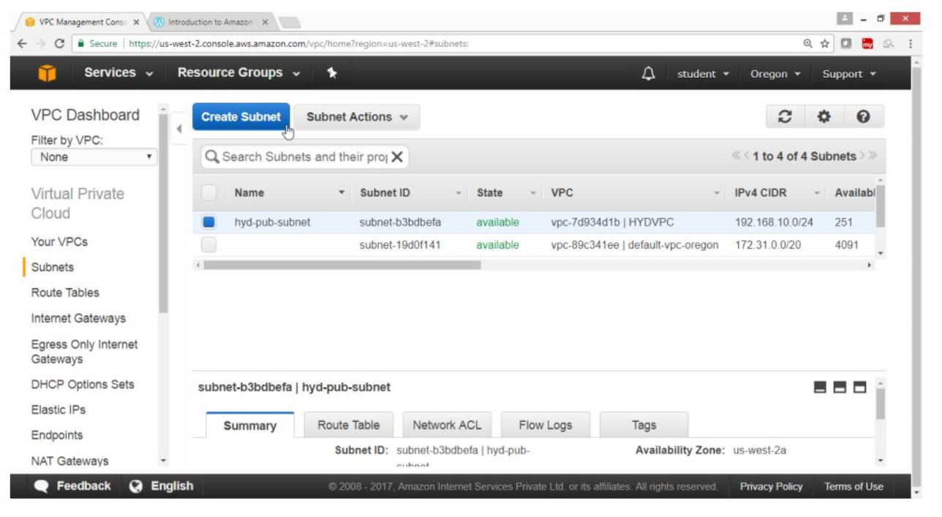

On create subnet page

For Name tag -> hyd-pvt-subnet

For VPC -> HYDVPC

For IPv4 CIDR block -> 192.168.20.0/24

Click on Yes Create button

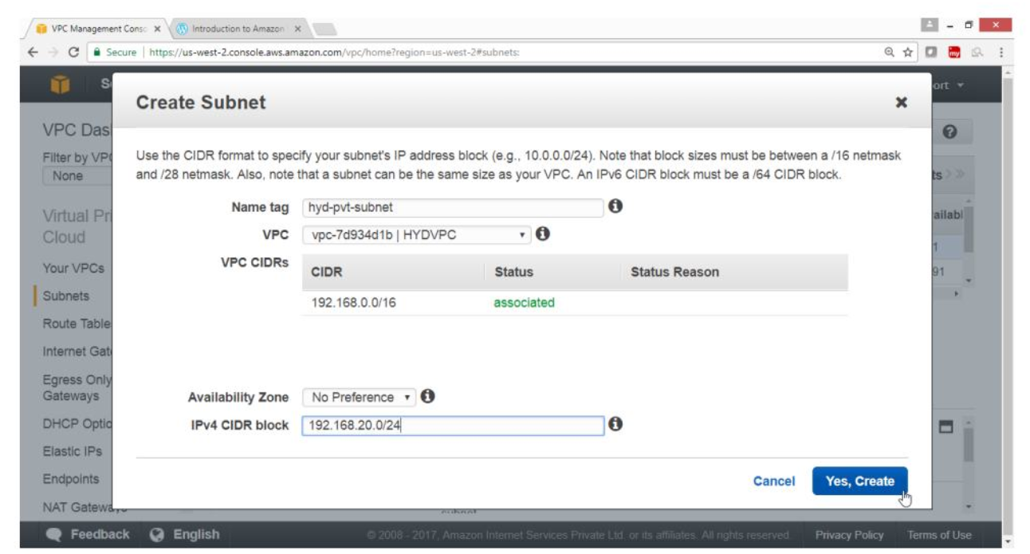

Verify

Hyd-pvr-subnet got created

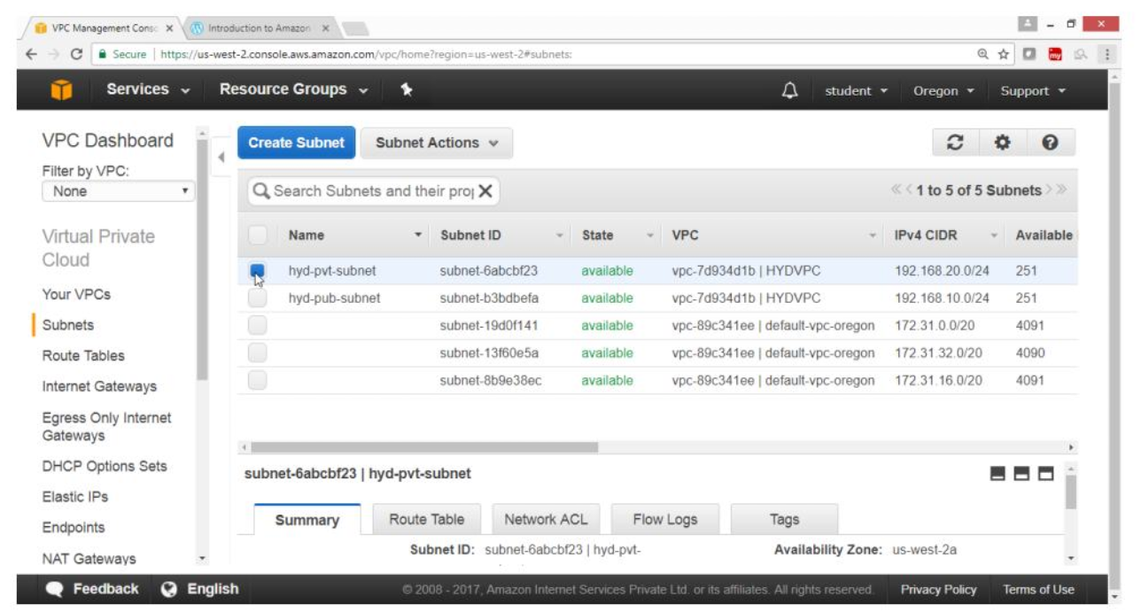

**11.4. Create a Internet gateway and attach to your VPC**

In VPC Dashboard panel

Click on Internet Gateway

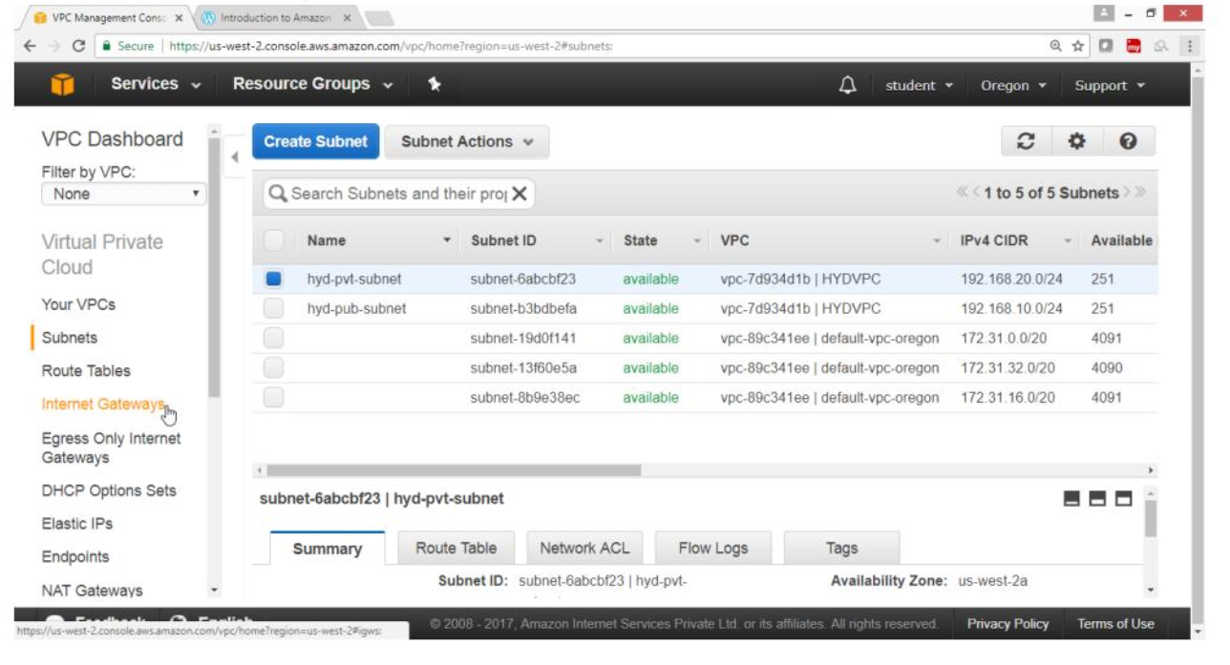

Click on Create Internet Gateway button

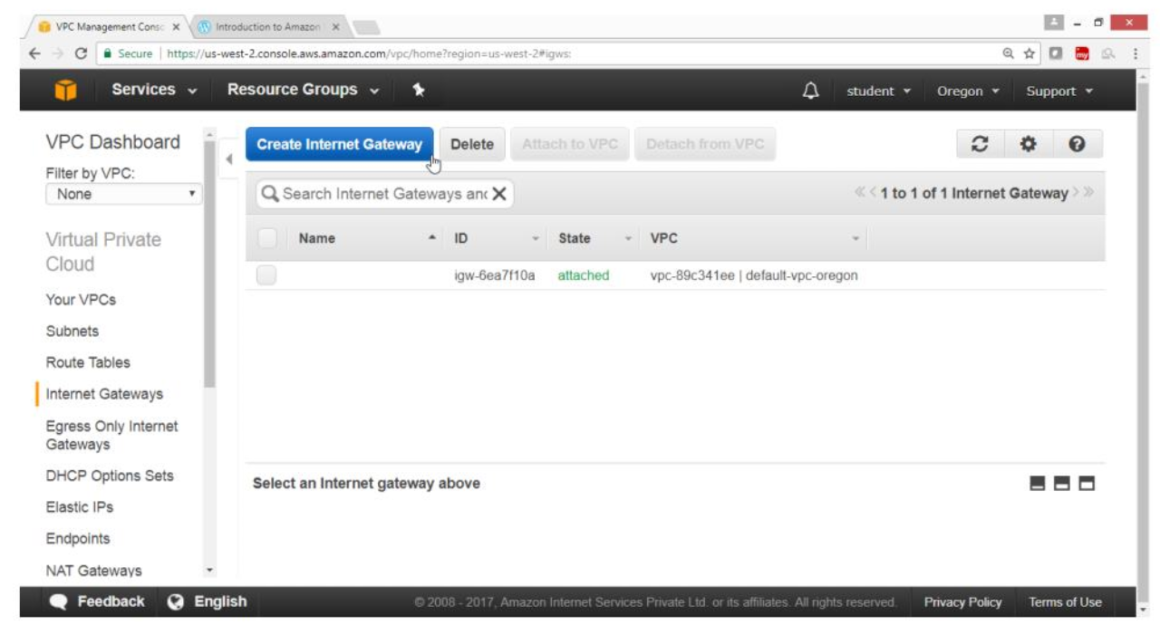

In Create Internet Gateway, box

For Name tag -> HYDIGW

Click on “Yes, create” button

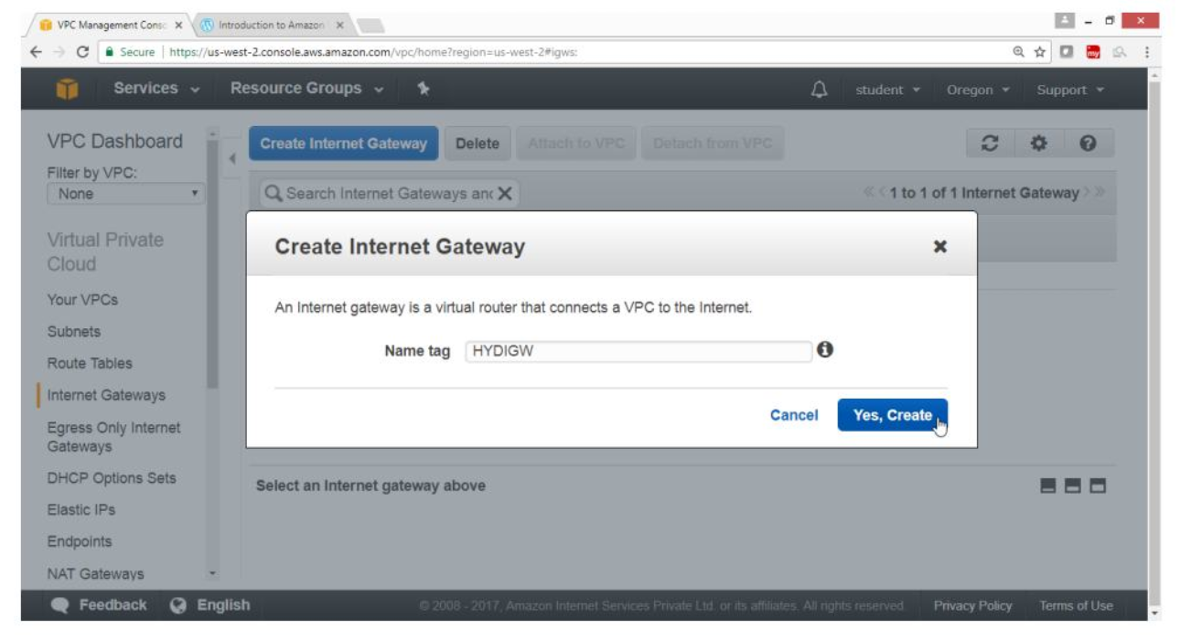

Verify

Internet gateway is created

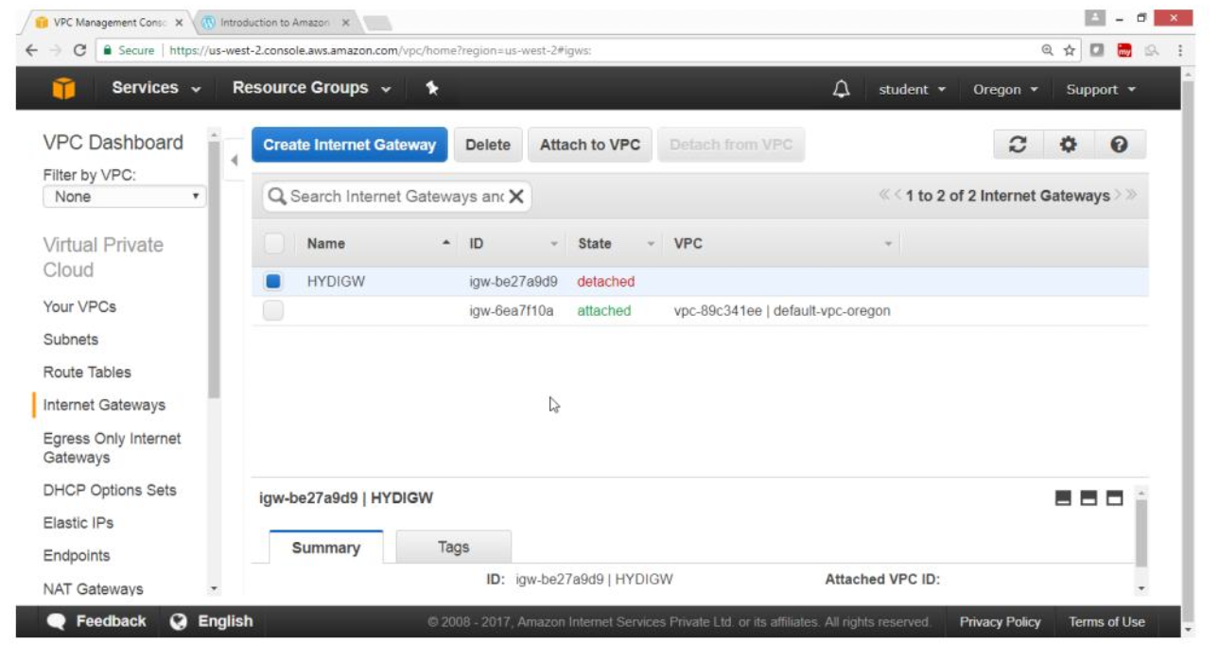

Select HYDIGW

Click “Attach to VPC”

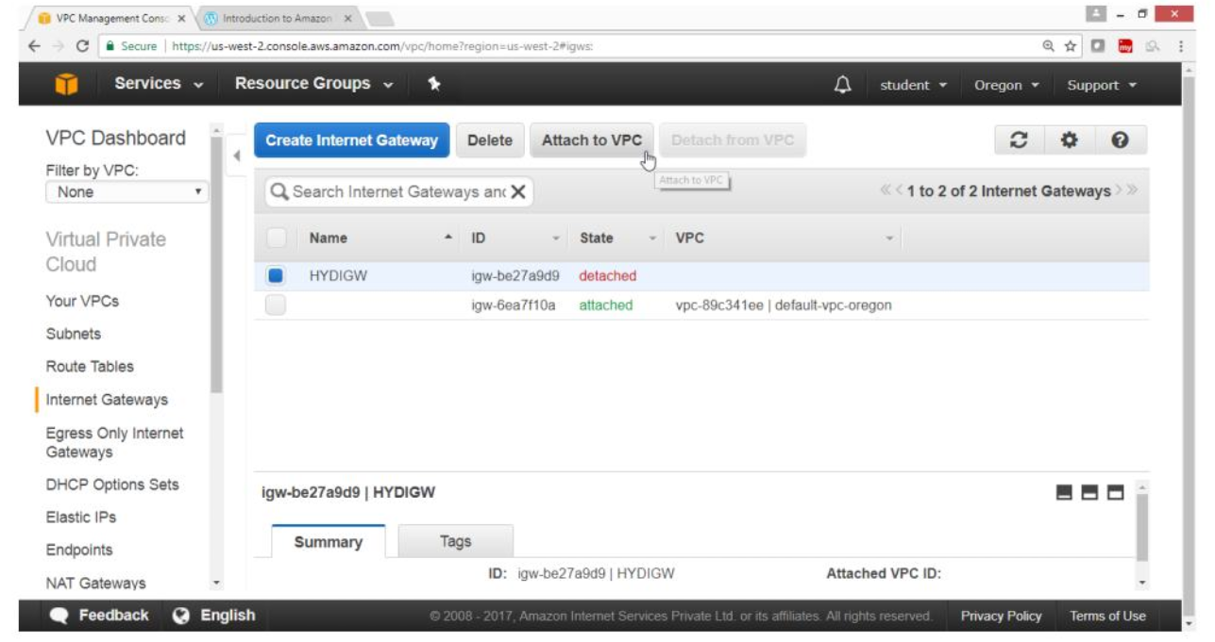

In “Attach to VPC” box

For VPC -> HYDVPC

Click on “Yes, Attach” button

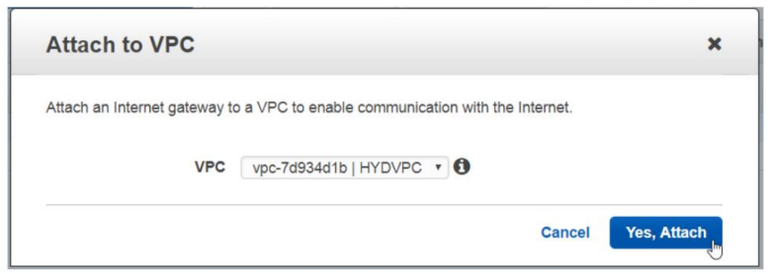

Verify

Internet gateway is connected to your VPC

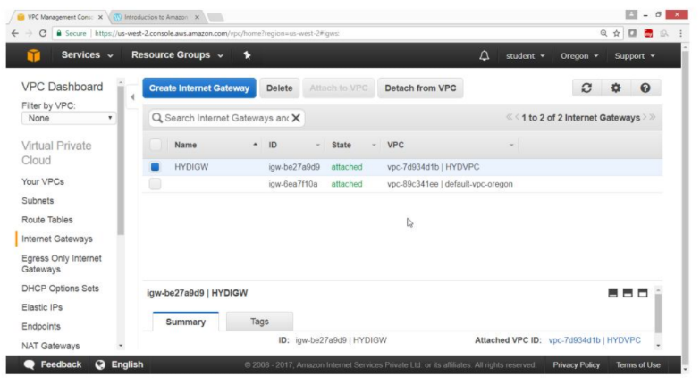

11.5. **Create Pubic Routing Table, associate subnet and add routing rules**

On VPC Dashboard panel

Click on Route Table

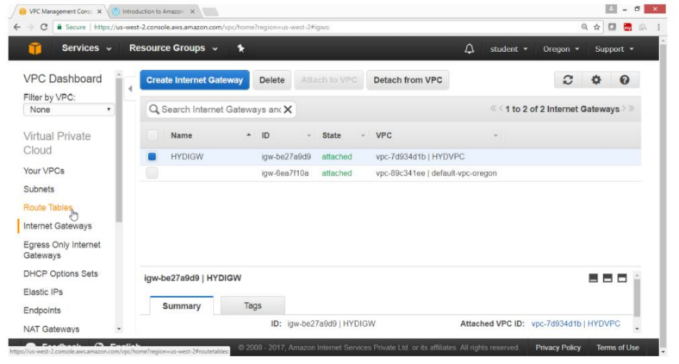

Click on “Create Route Table” button

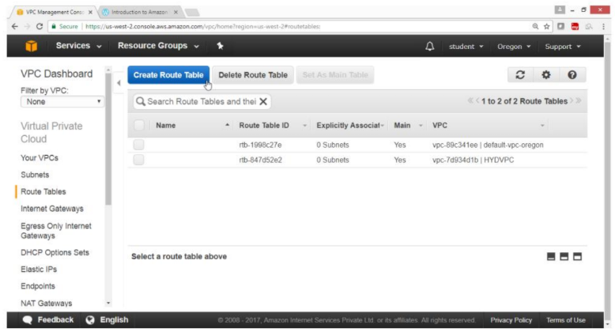

On “Create Route Table” box

For Name tag -> hyd-pub-route

For VPC -> HYDVPC

Click on “Yes, Create” button

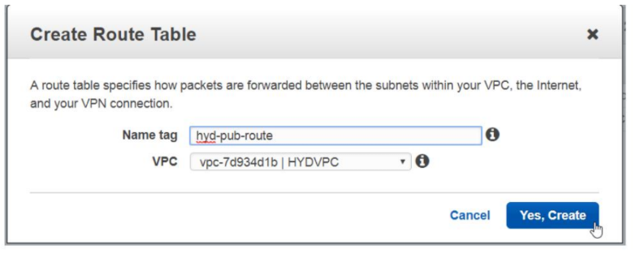

Verify

hyd-pub-route table is created

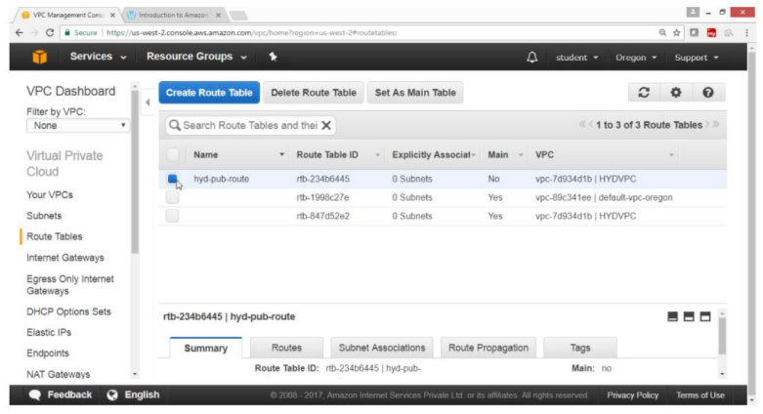

Click on “Subnet Association” button

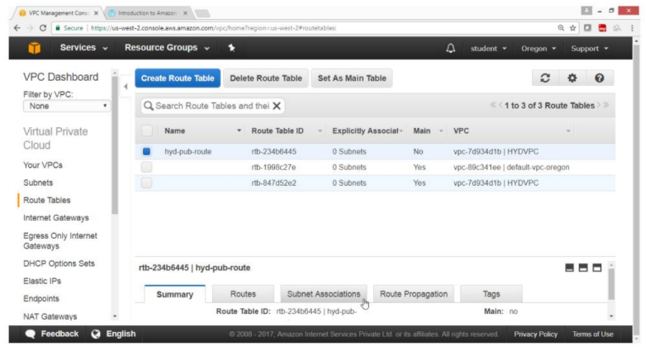

Click on Edit button

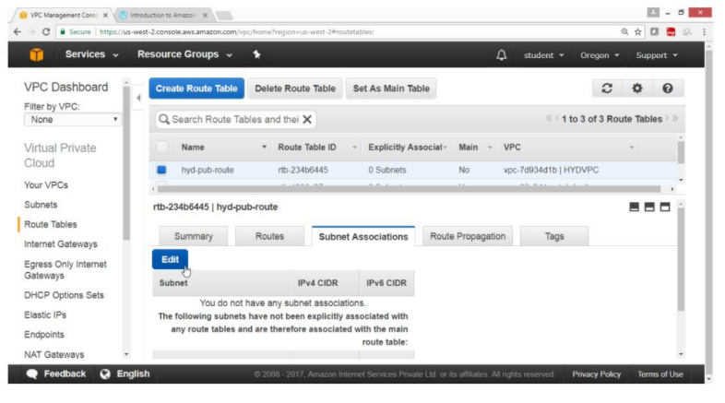

Select checkbox of hyd-pub-subnet -> 192.168.10.0/24

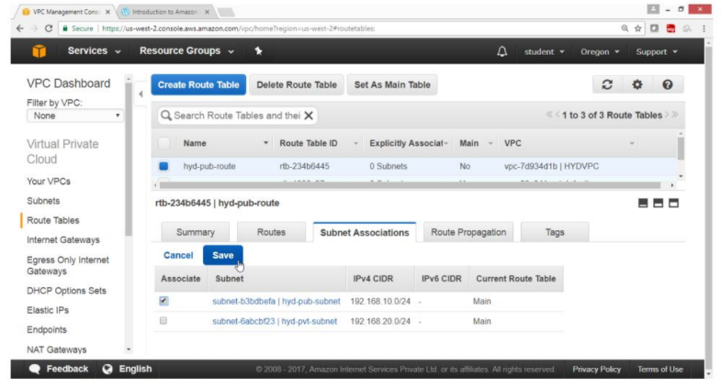

Verify

hyd-pub-subnet is associated with routing table

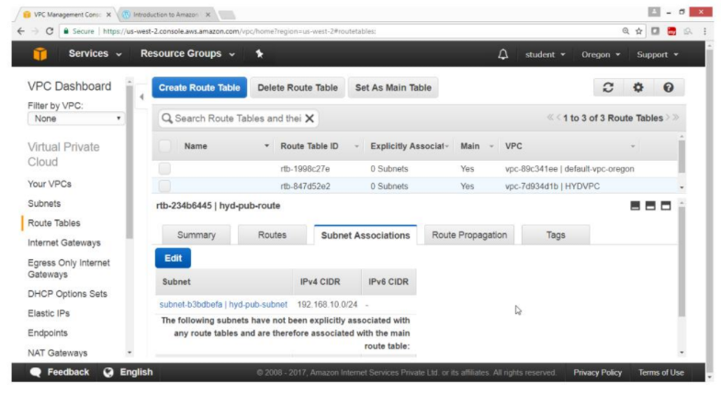

Click on Route button

Click on Edit button

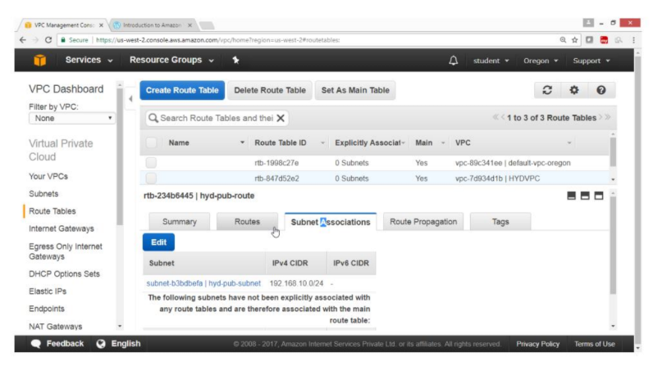

Click on ”Add another route” button

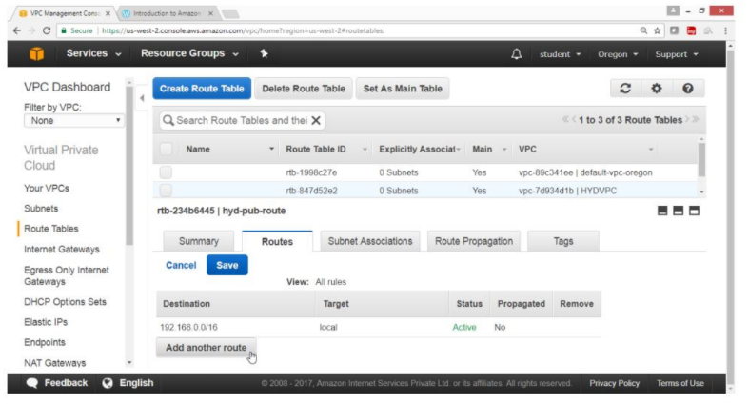

For Destination -> 0.0.0.0/0

For Target ->select HYDIGW

Click on Save button

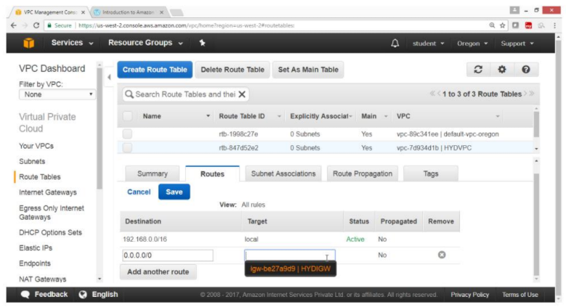

Verification

Public route is added through internet gateway

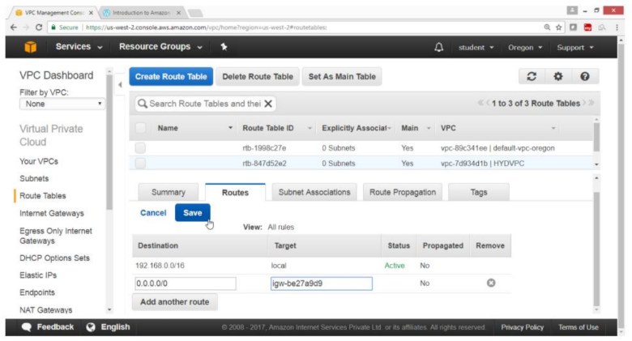

Verify

Status column show Active

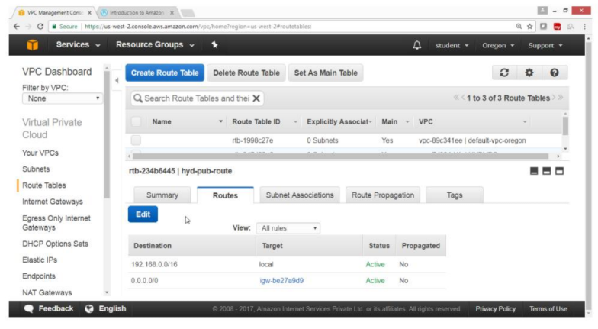

11.6. **Create Private Routing Table, associate subnet and add routing rules**

On VPC Dashboard panel

Select Route table

Click on “Create Route Table”

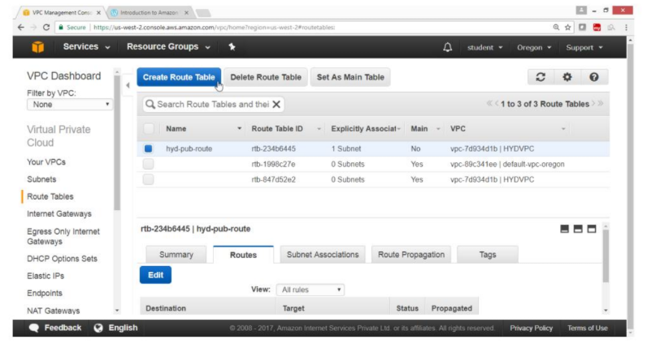

On “Create Route Table” box

For name tag -> hyd-pvt-route

For VPC -> HYDVPC

Click on “Yes, Create button”

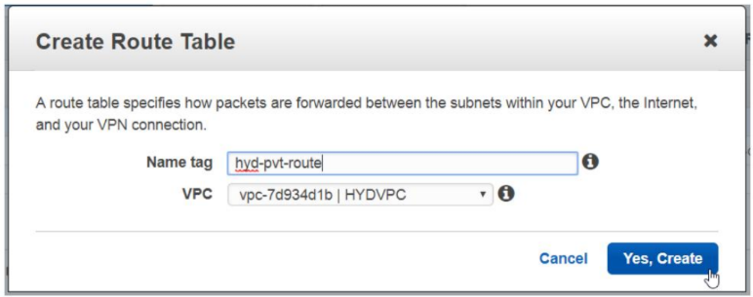

Verify

Hyd-pvt-route table is create

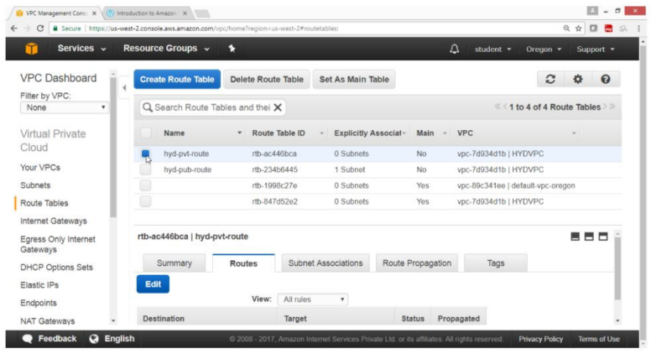

Click on Subnet Association button

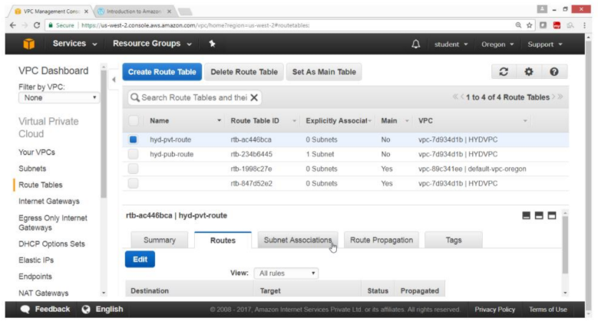

Click on Edit button

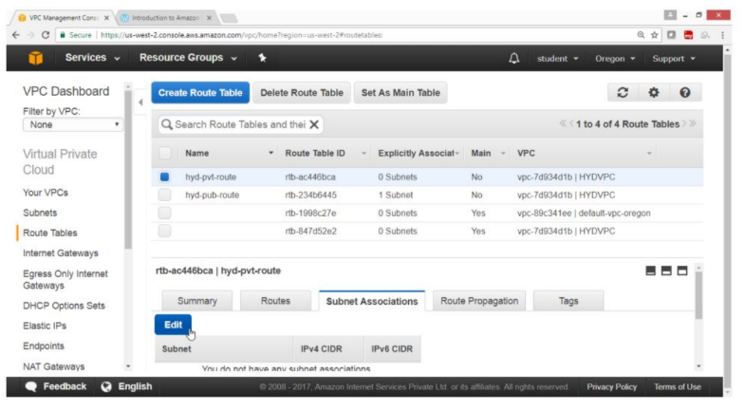

Select Checkbox hyd-pvt-subnet -> 192.168.20.0/24

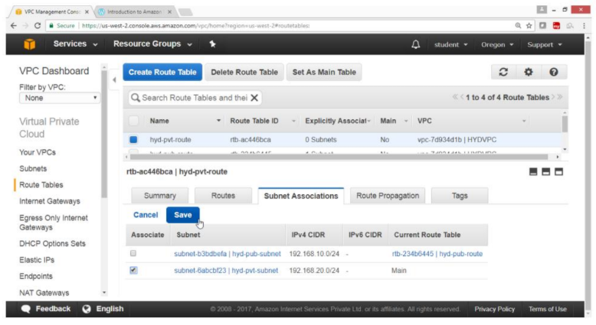

Click on Save button

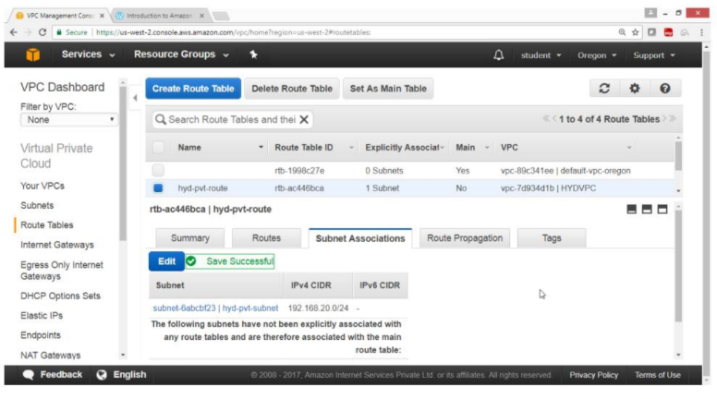

Verify

Hyd-pvt-subnet is associated with hyd-pvt-route table

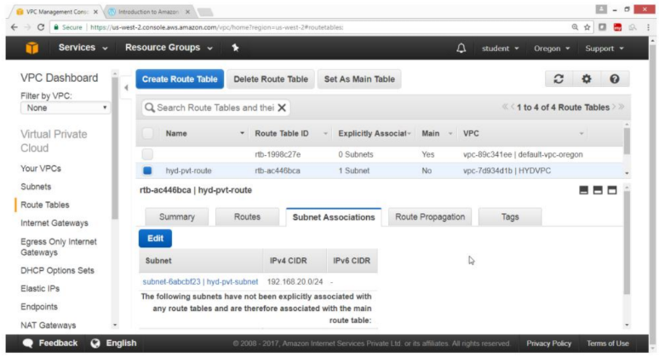

Click on Route button

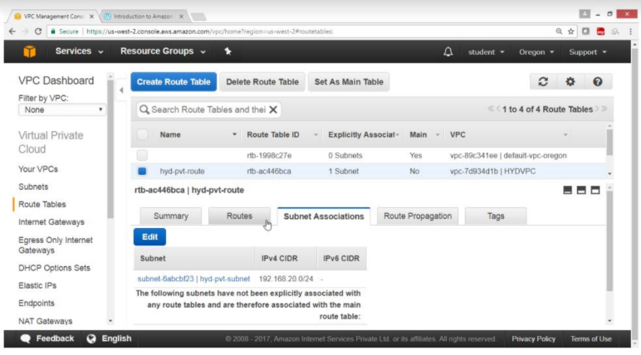

Note: No need to add IGW in pvt route

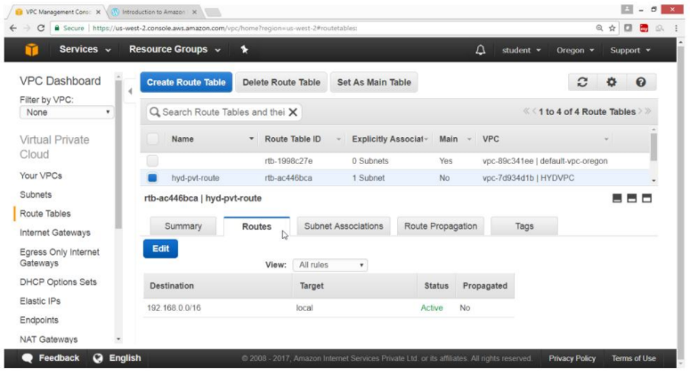

11.7. **To launch Windows instance in Public subnet**

Open the AWS Console

Click on Services

Click on EC2 Service

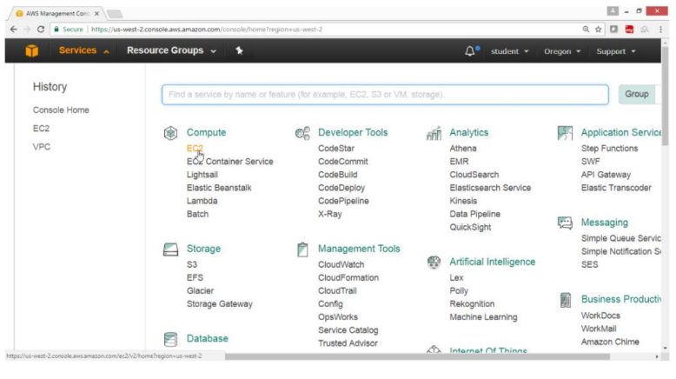

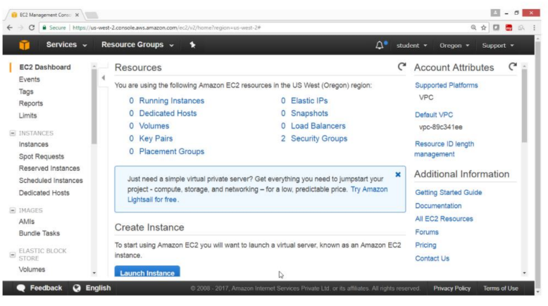

On the EC2 Dashboard panel

Click on Instance

Click on Launch Instance button

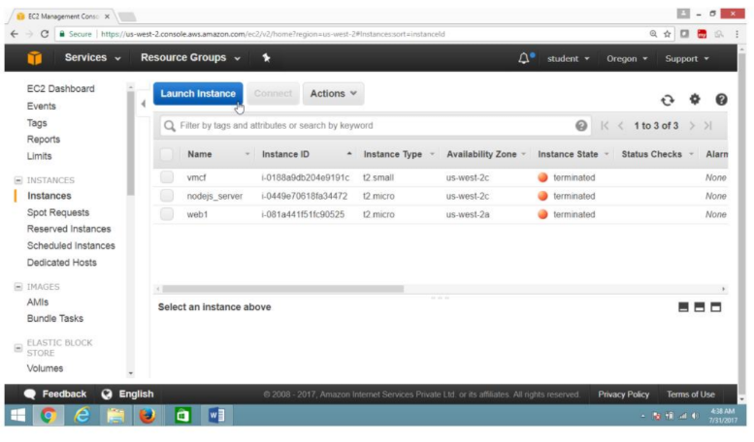

Select IAM “Microsoft windows server 2012 Base -ami-a1c1ddd8”

Free tier eligible

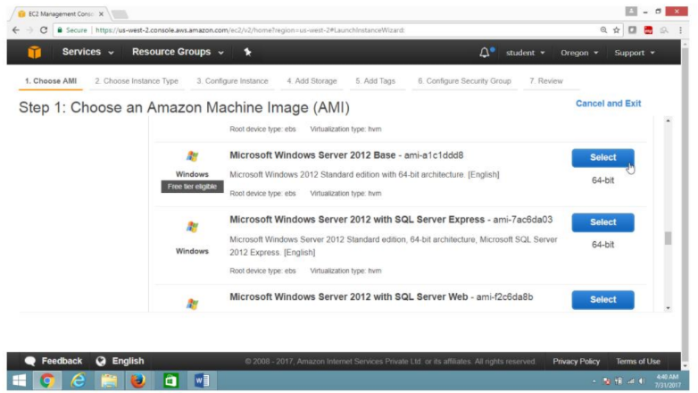

On the “Choose an Instance Type” page

Select “General purpose t2.micro”

Click on “Next Configure Instance Details” button

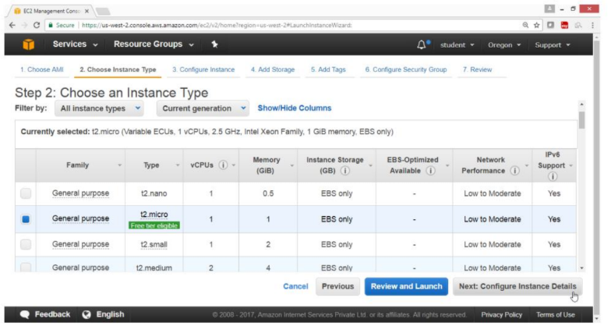

On the “Configure Instance Details” page

For “Number of instances” -> 1

For “Network” -> HYDVPC

For “Subnet” -> hyd-pub-subnet

For Auto-assign Public IP -> Enable

Click on “Next: Add Storage” button

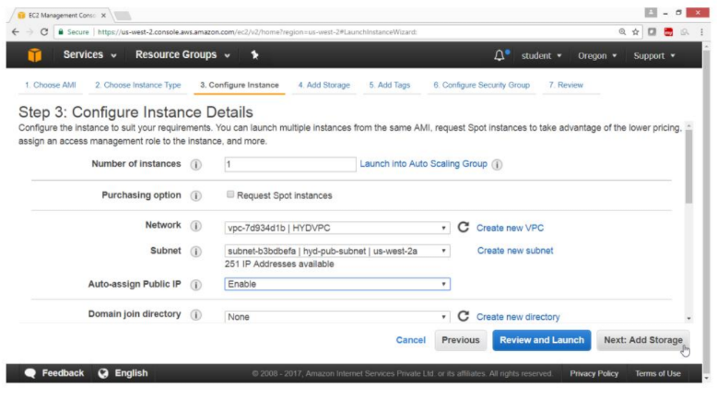

On the “Add storage” page

Take default values

Click on “Next: Add tags” button

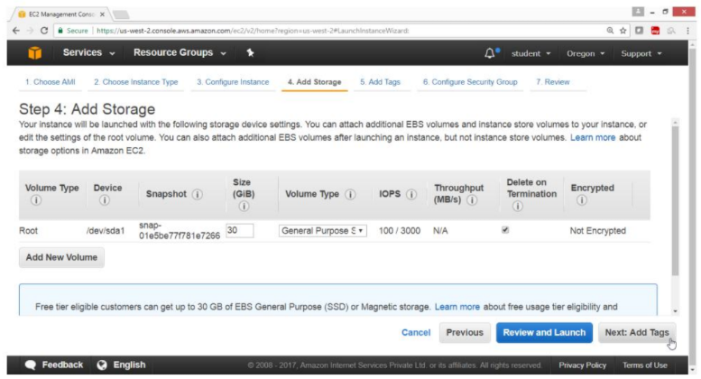

Click on “Add tag” button

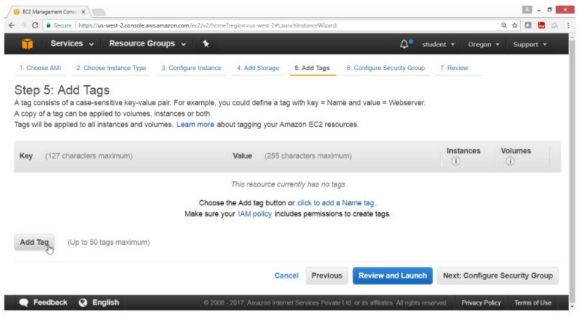

For “Key” -> Name

For Value -> Winpubvm

Click on “Next:Configure Security Group”

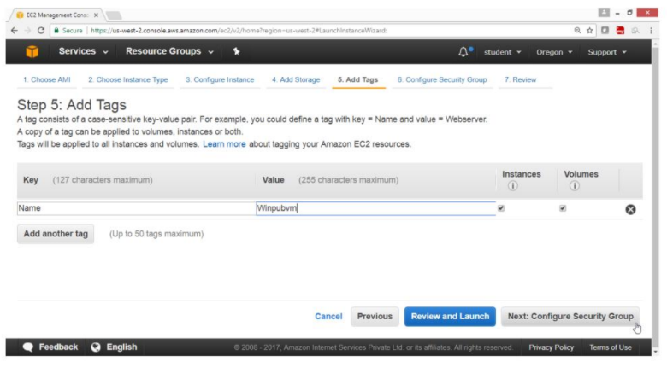

On the “Configure security group” page

Take Default values

Click on “Review and Launch” button

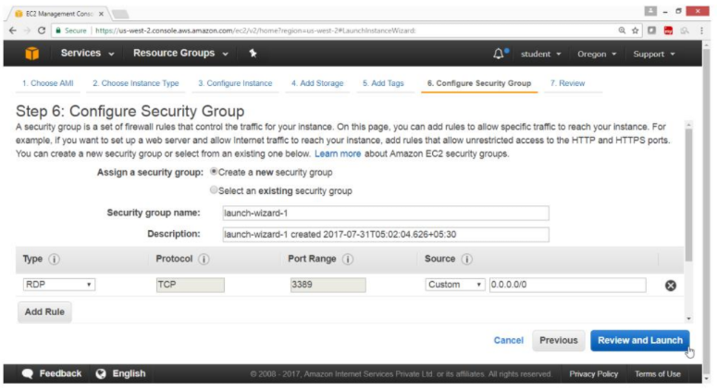

Click on “Launch button”

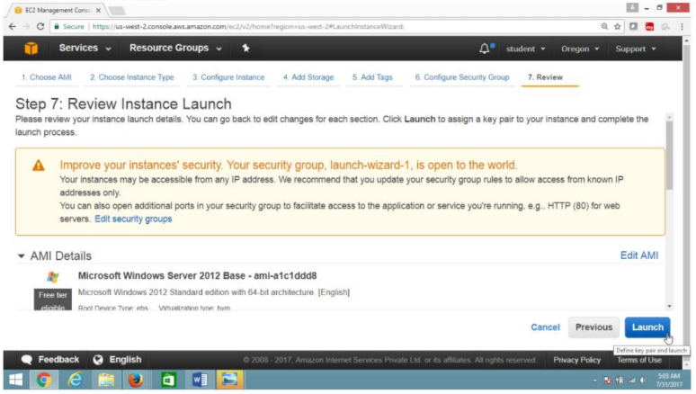

Select “Create a new key pair”

For “Key Pair name” -> winkey

Click on “Download Key Pair” button

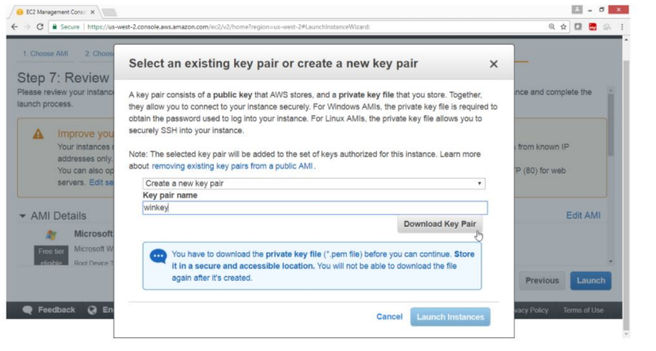

Click on “Launch instance button”

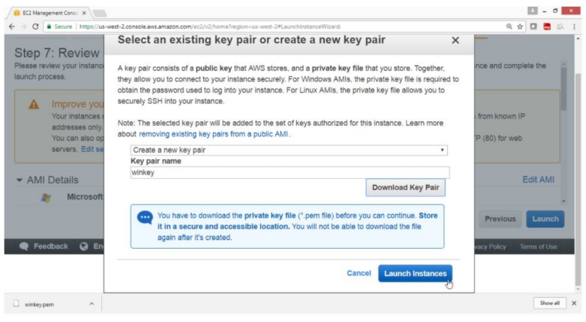

Check summary, Drag down

Click on “View instance” button

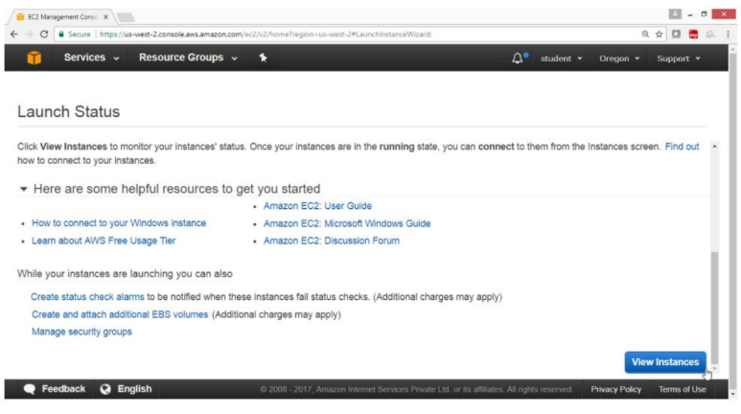

Verify the instance is Running

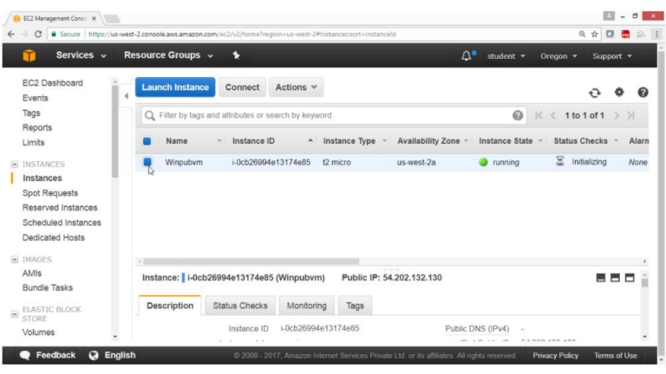

**11.8. To launch Windows instance in private Subnet under your VPC**

Open the AWS Console

Click on Services

Click on EC2 Service

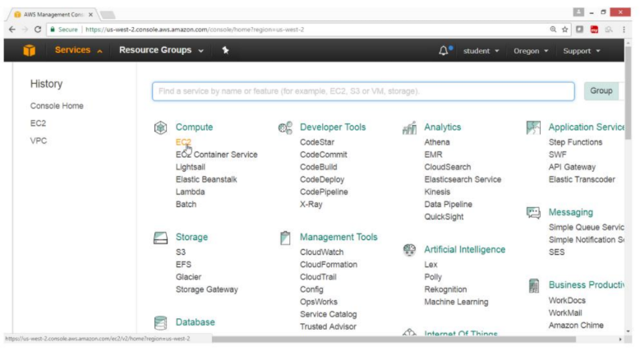

On the EC2 Dashboard Panel

Click on instance

Click on “Launch instance” button

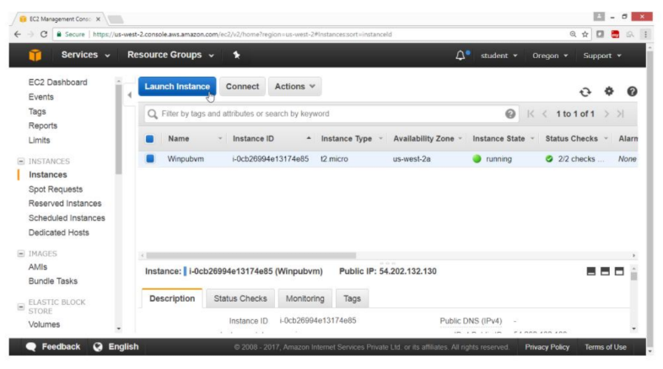

On the “Choose an Amazon Machine Image(AMI)” page

Select AMI “Microsoft Windows Server 2012 R2 Base - ami a1c1 dd8”

Free tier eligible

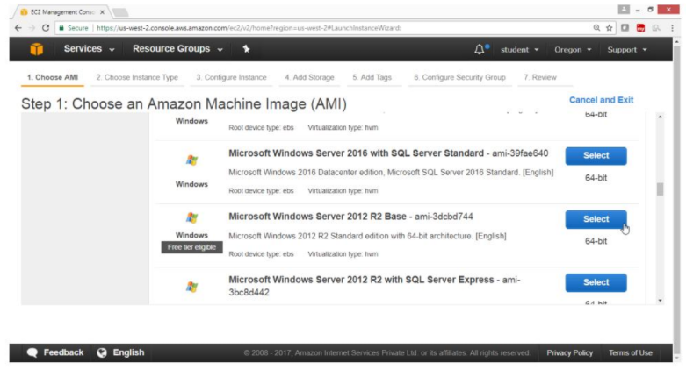

On the “Choose an Instance Type” page

Select “General purpose t2.micro”

Click on”Next Configure Instance Details” button

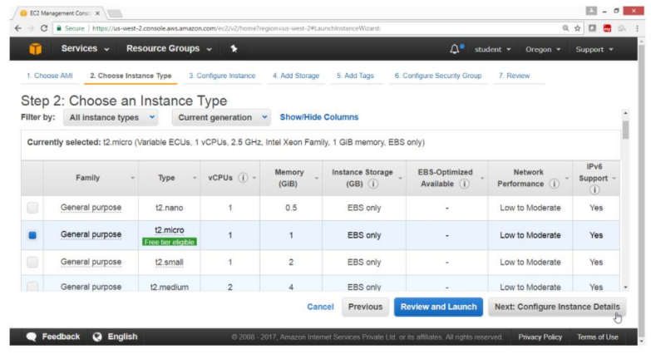

On the “Configuration Instance Details” page

For “Number of instances” -> 1

For “Network” -> HYDVPC

For “Subnet” -> hyd-pvt-subnet

For “Auto-assign Public IP” -> Disabled

Click on “Next: Add Storage” button

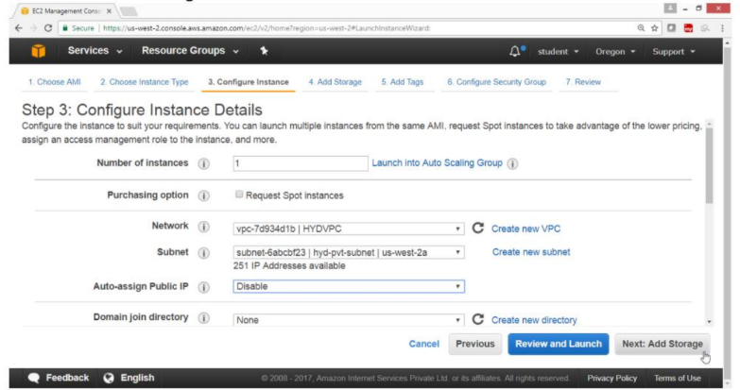

On the “Add Storage” page

Take default values

Click on “Next: Add tags” button

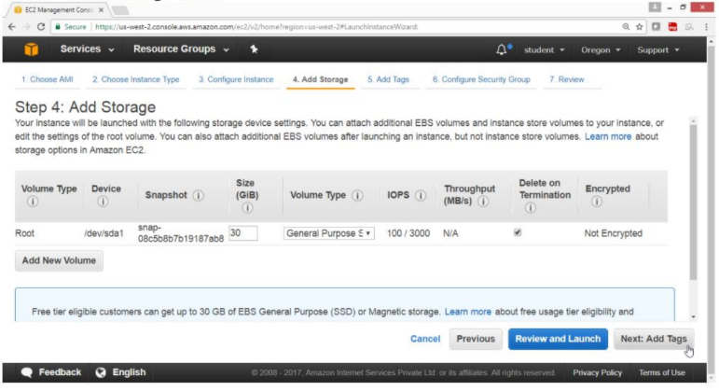

Click on “Add tag” button

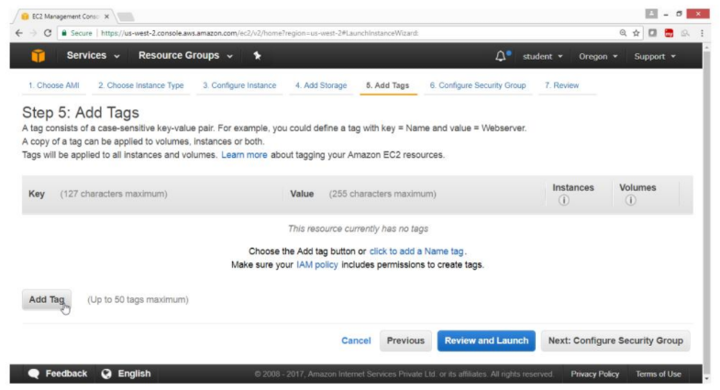

For “Key” -> Name

For Value -> Winpvtvm

Click on “Next: Configure Security Group” button

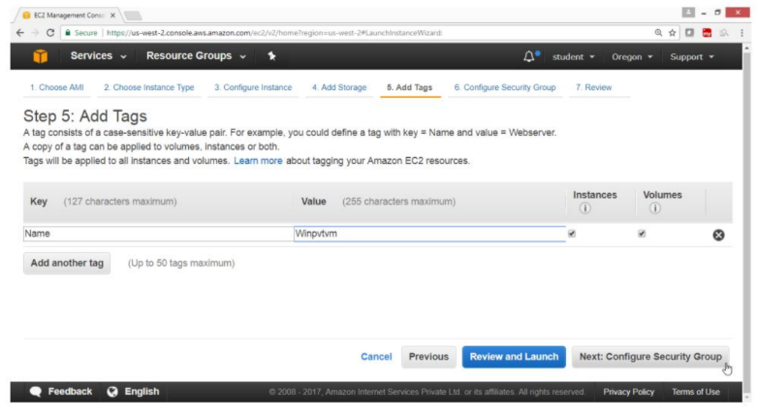

Take Default Values

Click on “Review and Launch” button

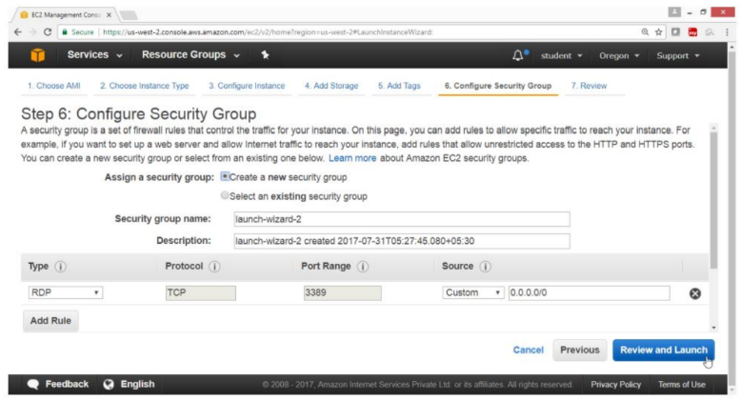

Drag down

Click on “Launch” button

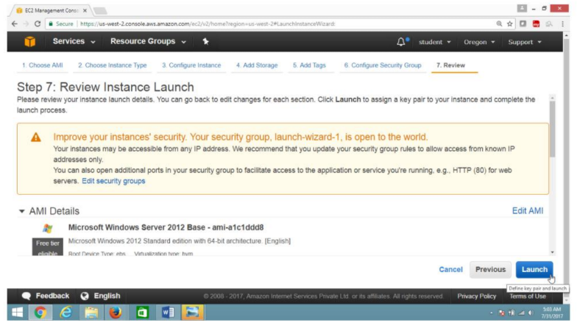

Select “Choose an existing key pair”

For “Key pair name” -> winkey

Select I acknowledge check box

Click on “Launch Instance” button

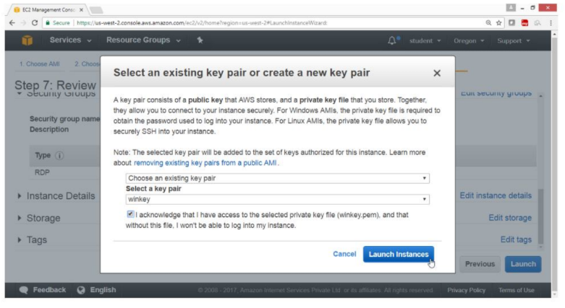

Check summary, Drag down

Click on “View Instance” button

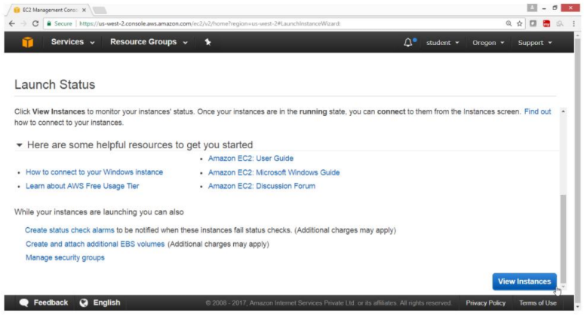

Verify that instance is Running

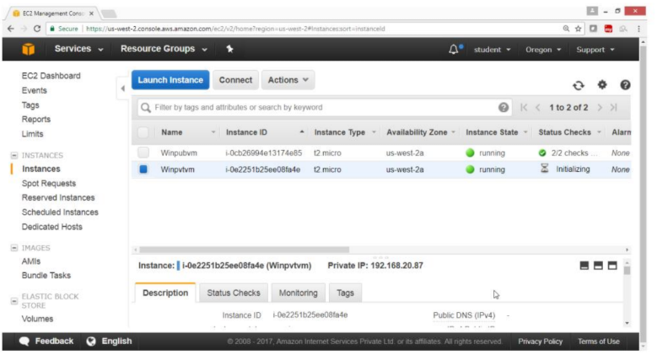

Verification

Output shows that both instances in public & private subnet are running.

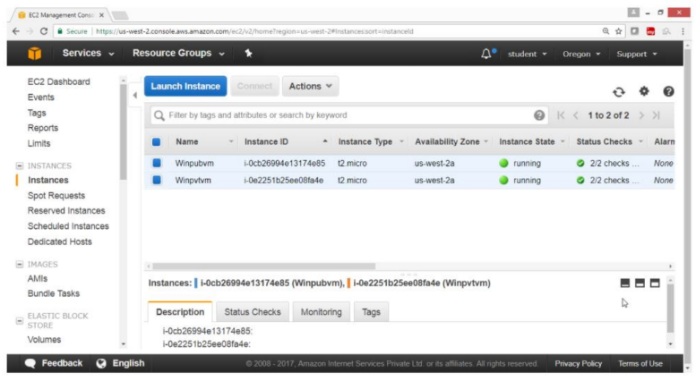

Now to connect an instance in private subnet first connect an instance in public network then from there connect to an instance in private subnet as shown in diagram

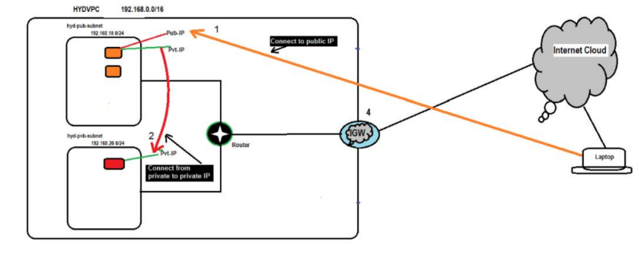

**11.9. To Connect to Public subnet instance**

First locate the public IP of a public instance

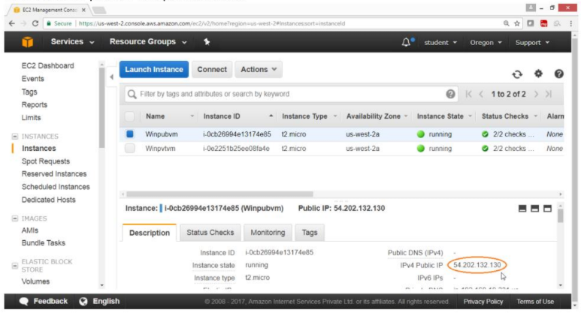

Click on “Connect” button

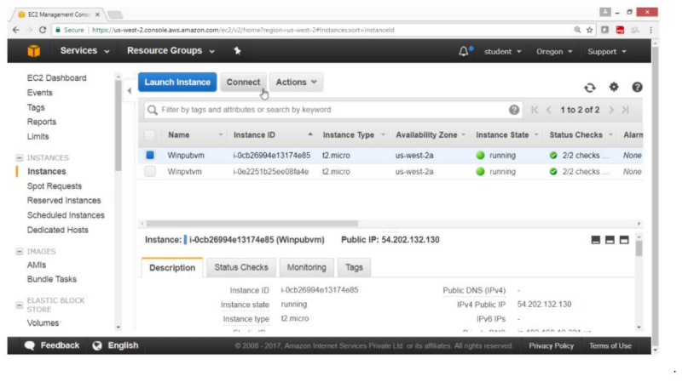

Click on “Download Remote Desktop file”

Click on “Get Password”

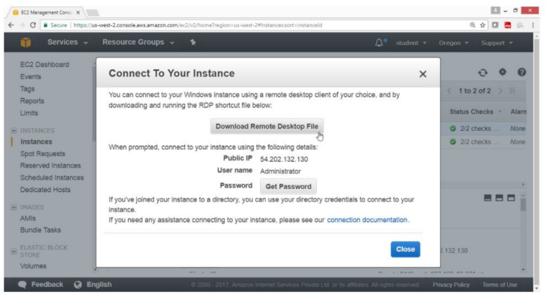

Provide the path of key file

Click on Choose file button

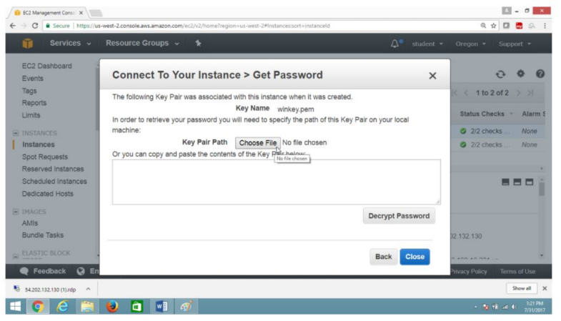

Select the key file

Click on Open button

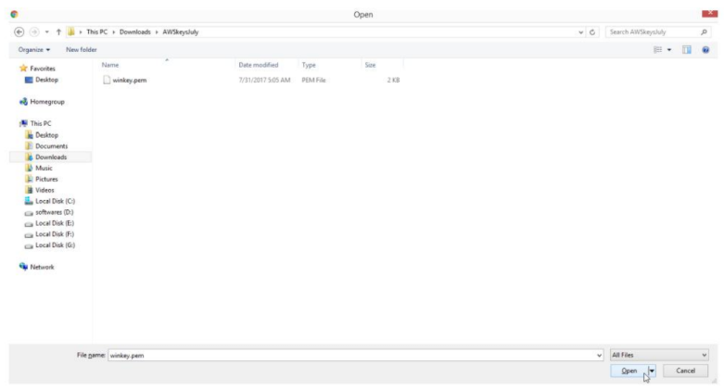

Now click on “Decrypt Password” button

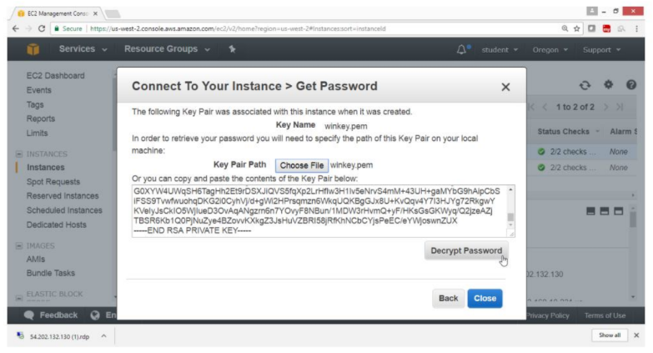

Verification

Password is generated copy in notepad

Click on Close button

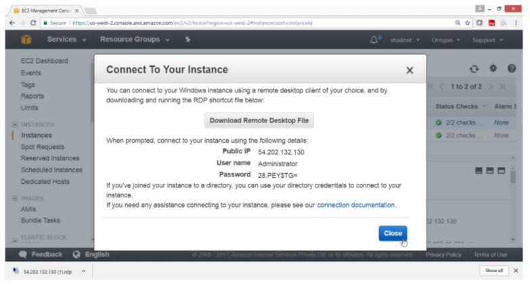

Double Click on RDP file

Provide Windows Username -> Administrator

Password -> “28.Y=$DEEP” , as shown above

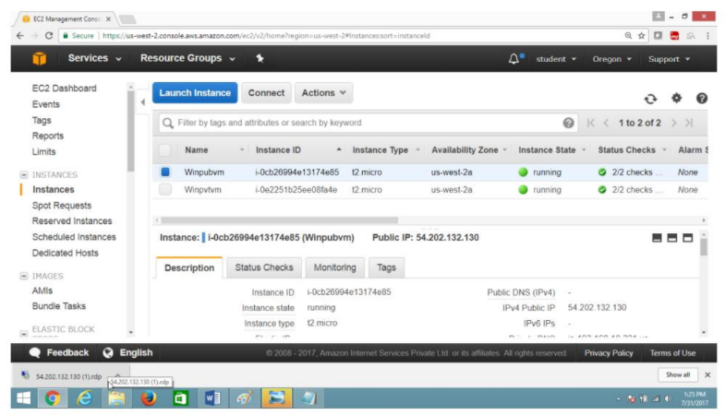

Click on “Connect” button

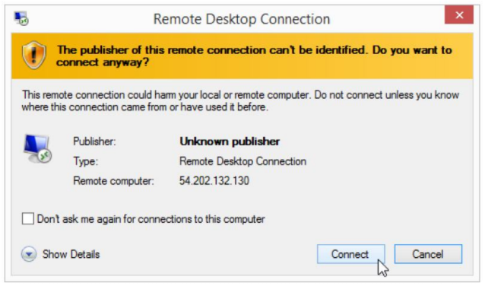

Paste the password

Click on OK button

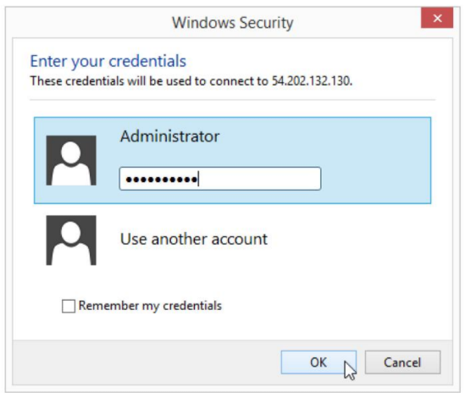

Click on Yes button

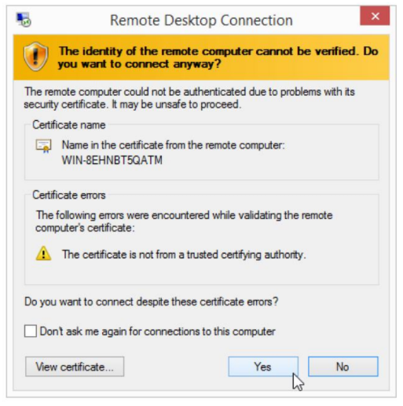

Verify

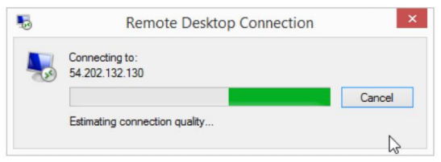

Verification

Now you are connected to Windows Public instance

On Windows Desktop public and private both IP’s are displayed

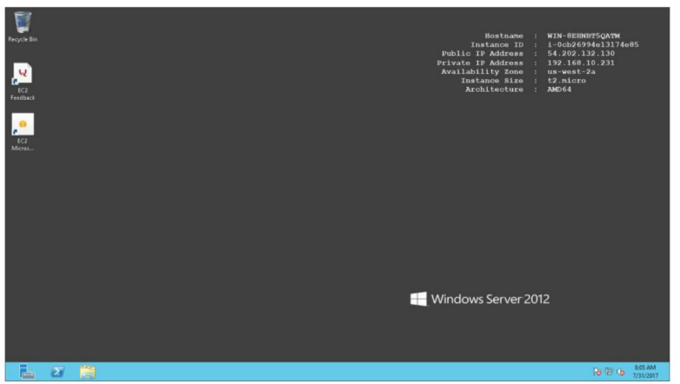

**11.10. To Connect to Private subnet instance**

Go to EC2 Dashboard

Select private instance

Get the private IP of the instance

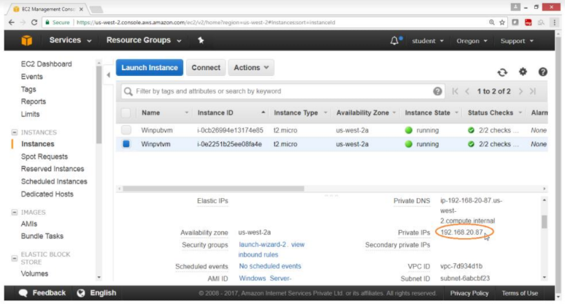

Click on Connect button

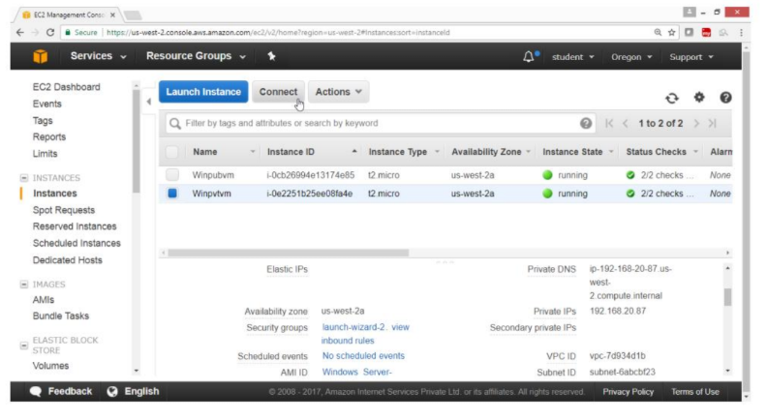

To get the password

Click on “Get Password” button

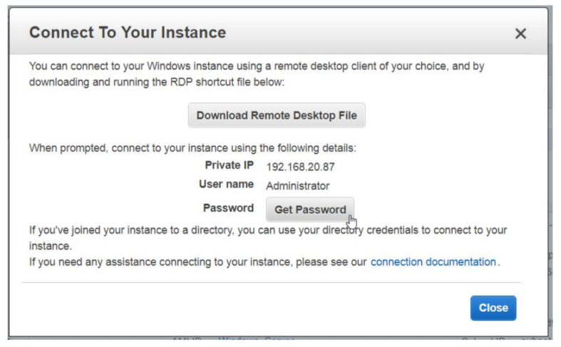

Click on “Decrypt Password”

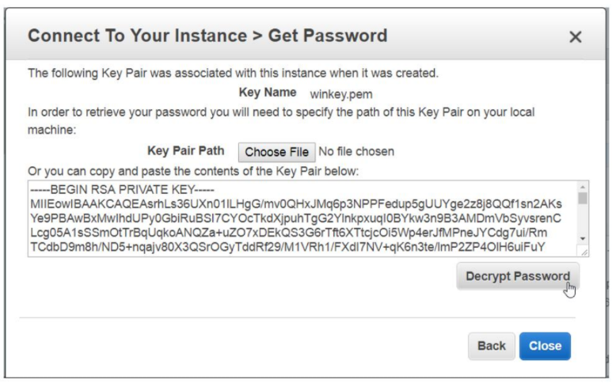

Verify

IP and password of private subnet instance is provided

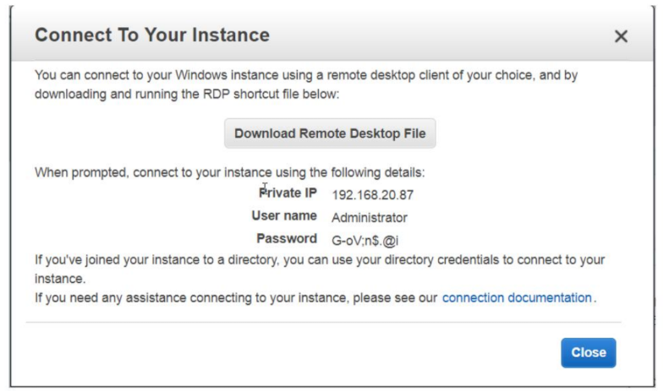

Now logging to public instance

Open Run and type mstsc to connect to window private instance

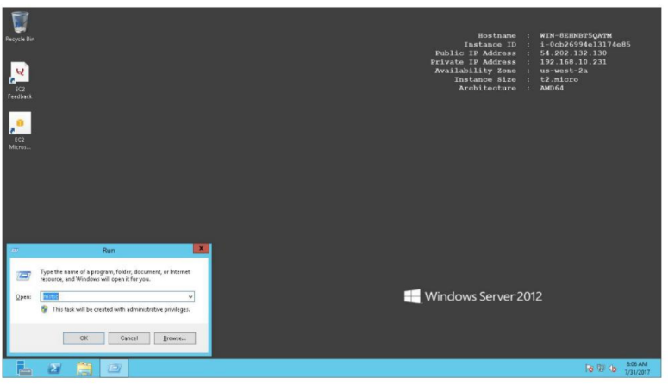

Provide private instance

Private IP -> 192.168.20.87

Username -> Administrator

Password -> Go-,@17

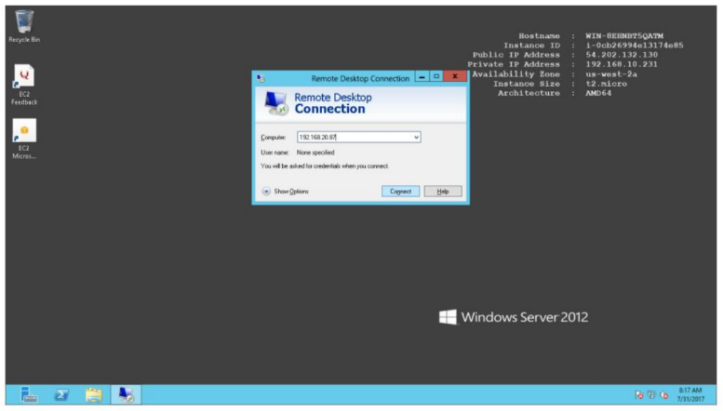

Now Provide Username & password

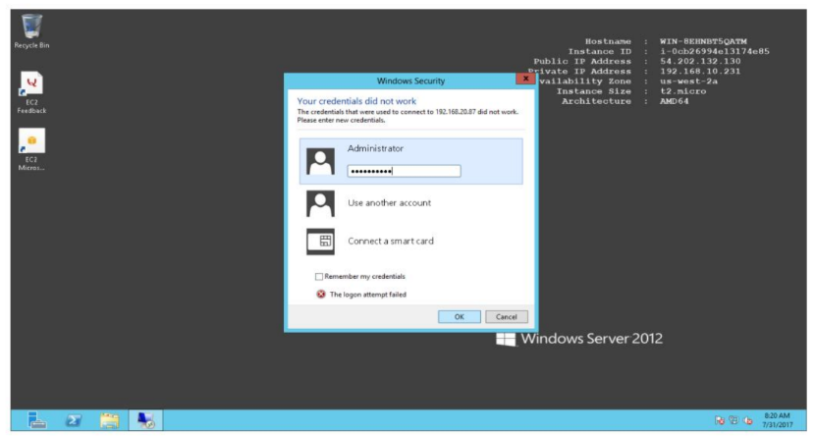

Verification

Check private IP at Right top corner

Now you are connected to windows private instance.

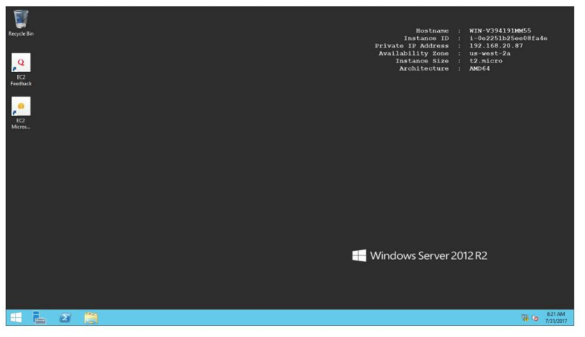

**11.11. To Connect linux instance in private subnet**

Launch linux instance in public subnet -> hyd-pub-subnet

Open the AWS console

Click on Services

Click on Instances

Click on “Launch Instance” button

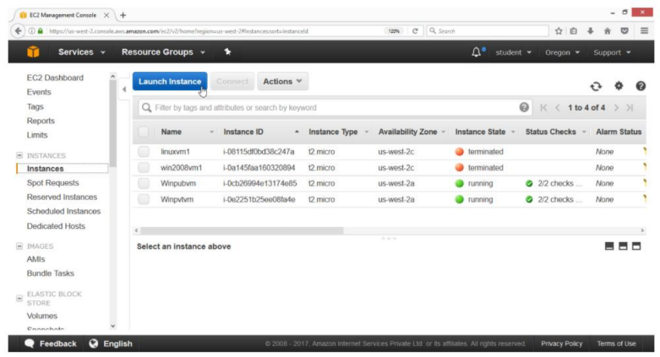

On the “Choose an Amazon Machine Image (AMI)” page

Select AMI “Amazon Linux AMI 2017.03.1 (HVM)”, SSD Volume Type -ami-6df1e514

Click on select button

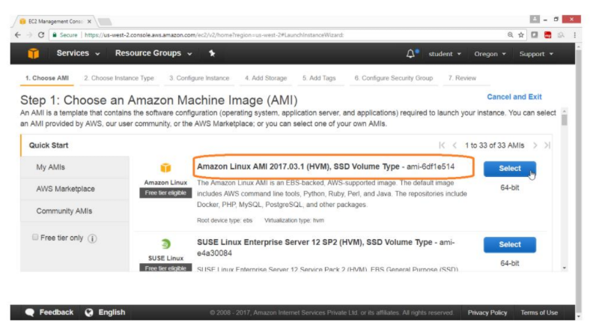

On the “Choose an instance Type” page

Select “General purpose”

Type -> t2.micro

Click on “Next: Configure Instance Details”

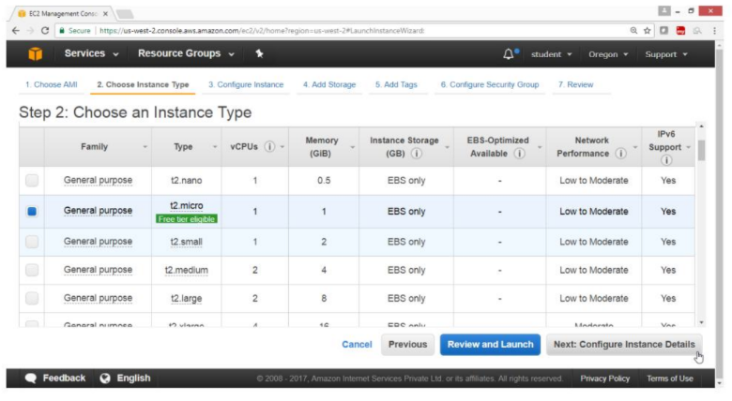

On the “Configuration Instance Details” page

Number of instances -> 1

Network -> HYDVPC

sUBNET -> HYD-PUB-SUBNET

Auto-assign Public IP -> Enable

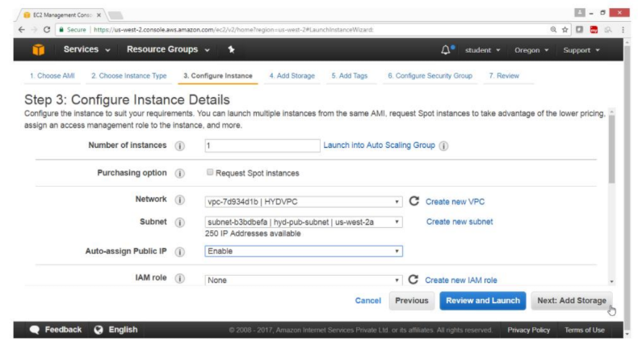

On the “Add storage” page

Leave the values as default

Click on “Next: Add Tags” button

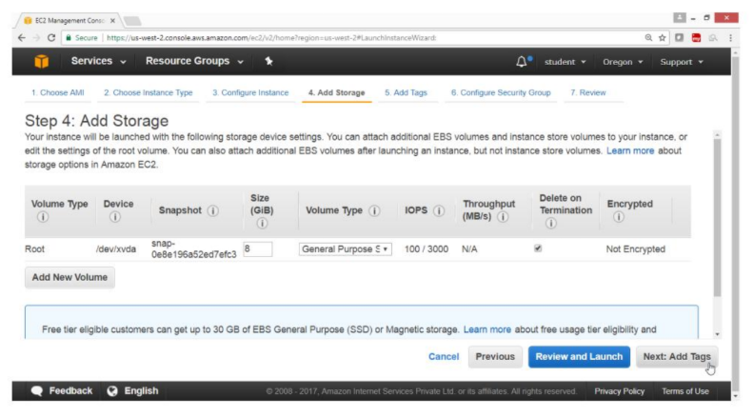

On the “Add Tags” page

Key -> Name

Value -> Linux Pubvn

Click on “Next Configuration Security Group” button

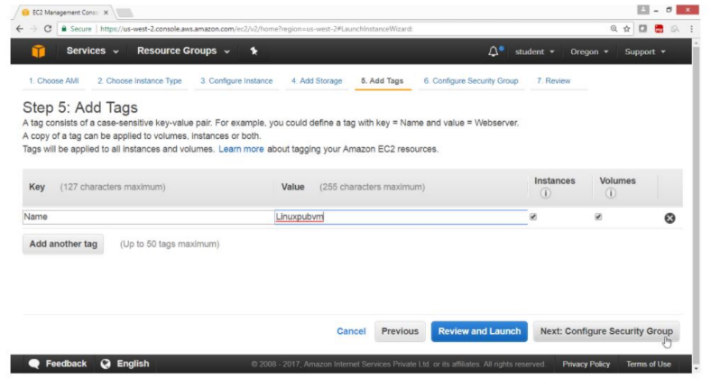

On the “Configuration Security Group” page

Assign a security group -> Create a new security group

Leave remaining values as default

Click on Review and Launch button

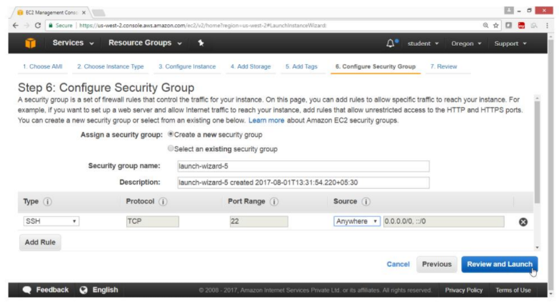

On the “Review Instance Launch” page

Click on Launch button

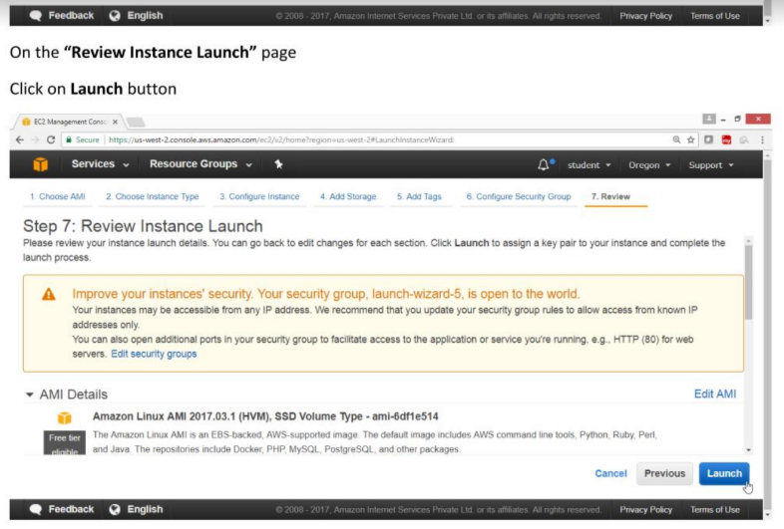

On the “Select an existing key pair or create a new key pair” page

Select Create a new key pair

Key pair name -> linux vm key1

Click on “Launch Instance” button

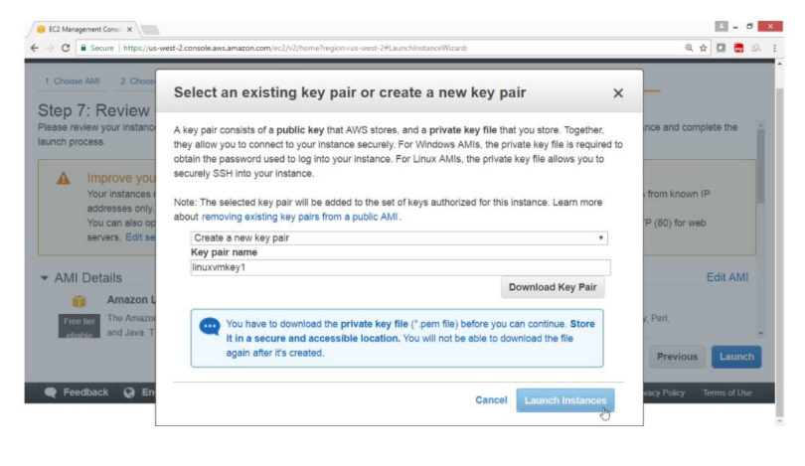

Click the summary

Click on View Instance button

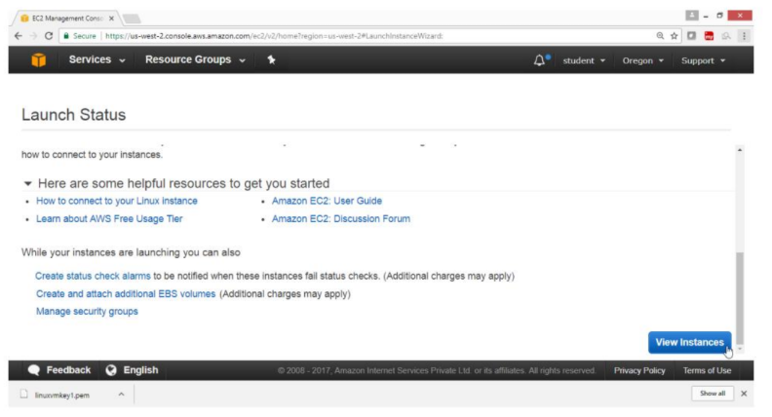

Verification

Linux instance in public subnet is launched

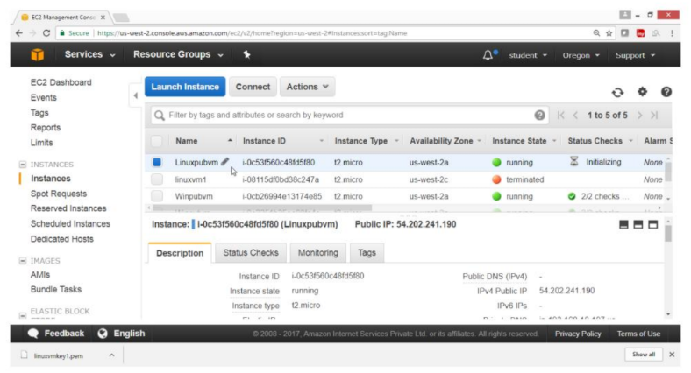

**11.12. To Connect linux instance in public subnet**

Launch linux instance in private subnet -> hyd-pvt-subnet

Open the AWS console

Click on Services

Click on Instances

Click on “Launch Instance” button

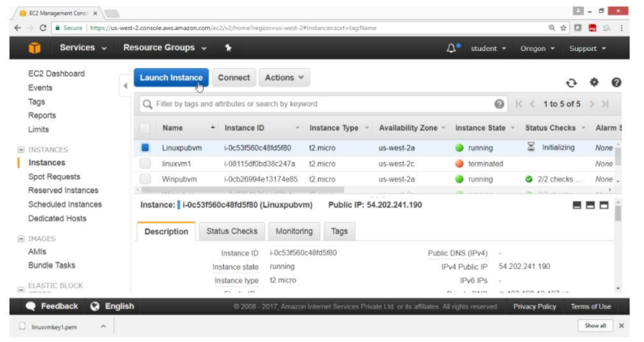

On the “Choose an Amazon Machine Image (AMI)” page

Select AMI “Amazon Linux AMI 2017.03.1(HVM)”, SSD Volume Type -ami-6df1e514

Click on Select button

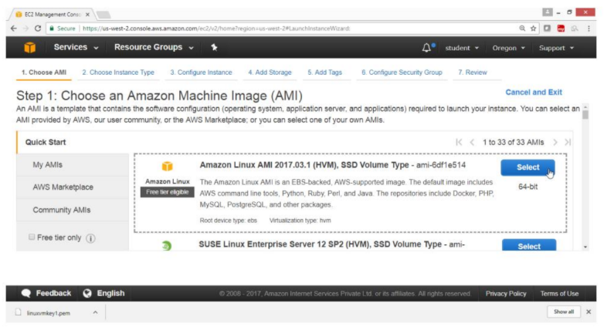

On the “Choose an instance Type” page

Select “General purpose”

Type -> t2.micro

Click on “Next: Configure Security Group” button

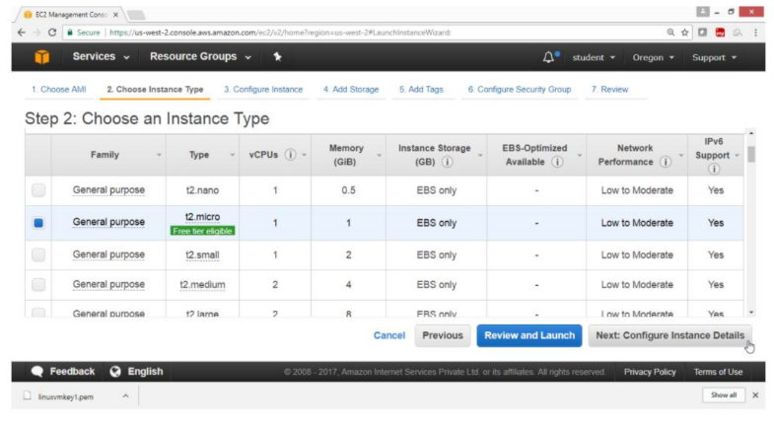

On the “Configuration Instance Details” page

Number of instances -> 1

Network -> HYDVPC

Subnet -> hyd-pvt-subnet

Auto-assign Public IP -> Disable

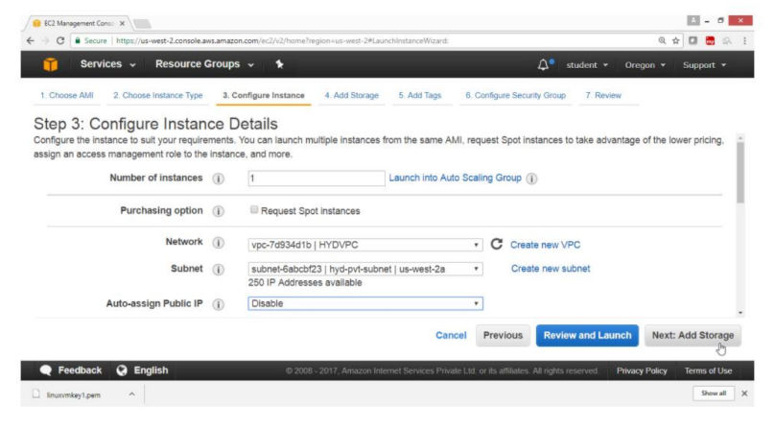

On the “Add Storage” page

Leave the value as default

Click on “Next : Add Tags” button

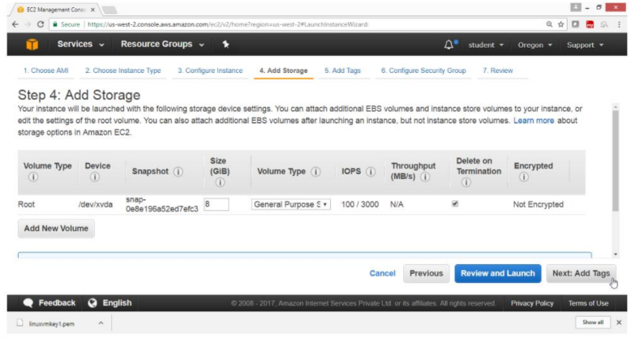

Click on Add Tag

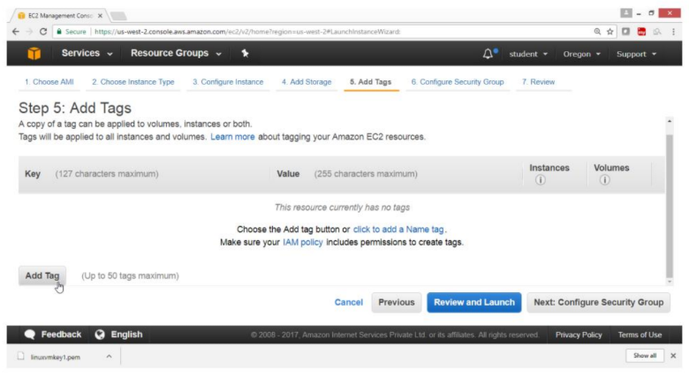

On the “Add Tags” page

Key -> Name

Value -> Linuxpvtvm

Click on “Next: Configure Security Group” button

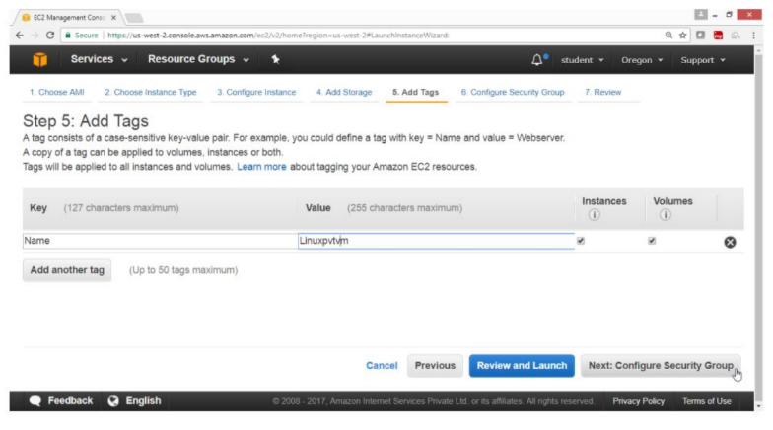

On the “Configuration Security Group” page

Assign a security group -> Create a new security group

Leave remaining values as default

Click on “Review and Launch” button

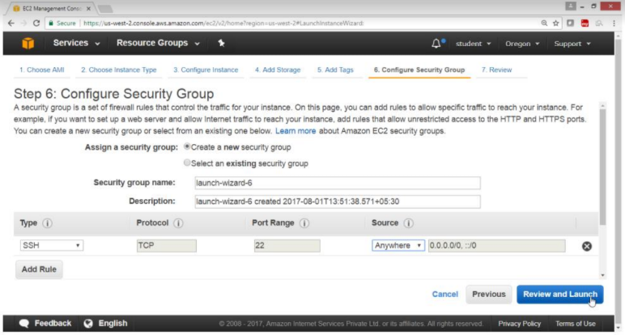

On the “Review Instance Launch” page

Click on Launch button

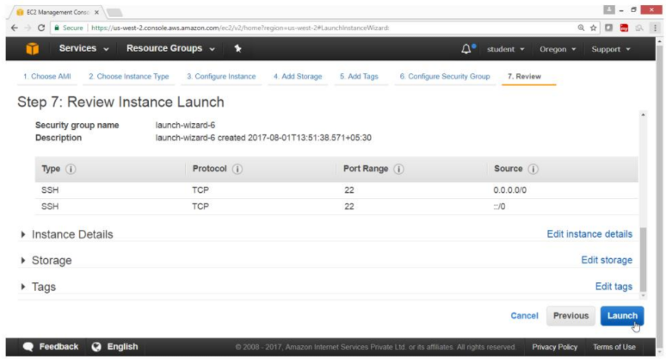

On the “Select an existing key pair or create a new key pair” box

Select Create a new key pair

Key pair name -> linuxvmkey1

Click on “Launch Instance” button

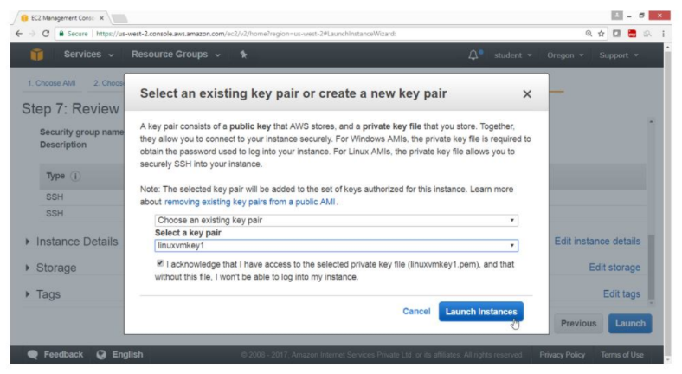

Check the summary

Click on View Instance button

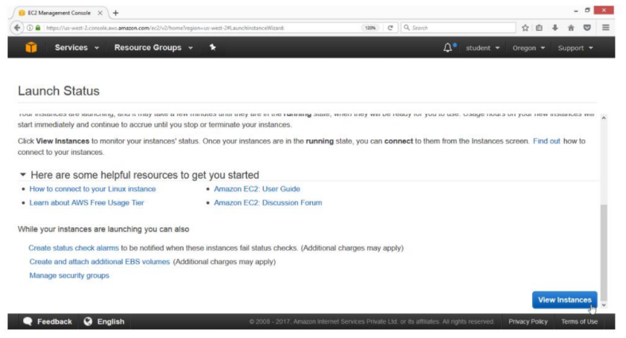

Verification

Linux instance in public subnet is launched

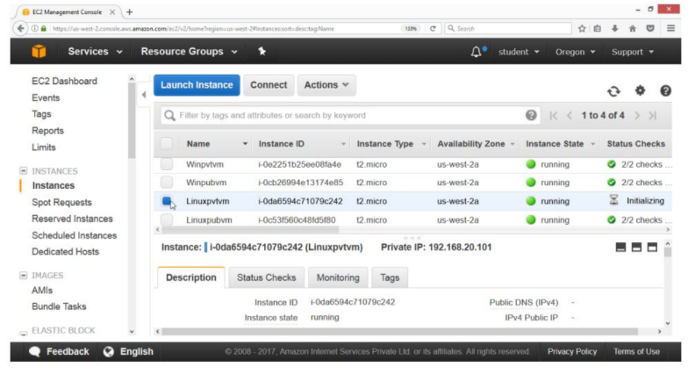

To connect to linux private instance

First copy the key to linux instance in public subnet

Now connect to linux instance in public

Then connect to linux instance in private

Select public linux instance and get public ip

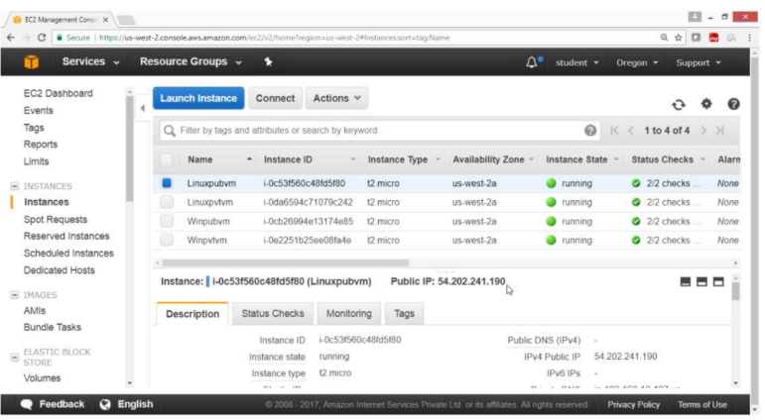

View the guide lines

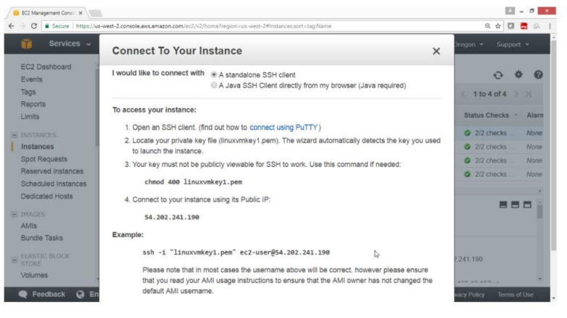

Now connect to public instance using ssh command

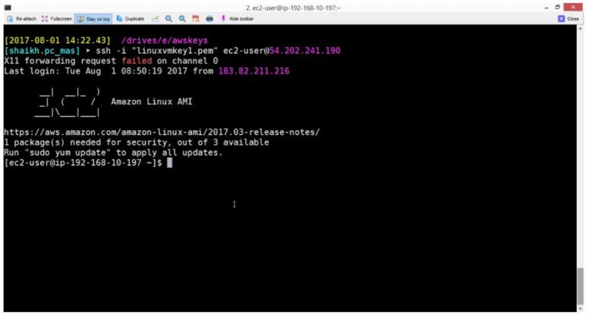

Select private instance and get private ip

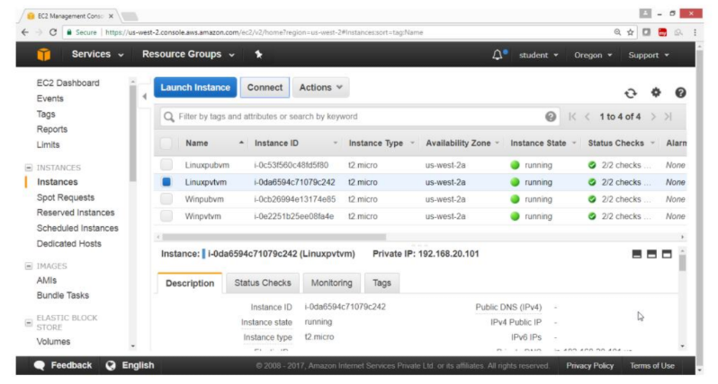

View the details of private instance

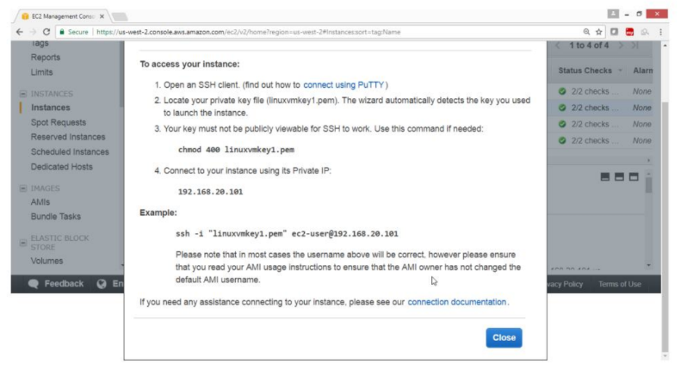

Verification

Run ssh command to login to private instance

Now you are connected to private instance in private subnet

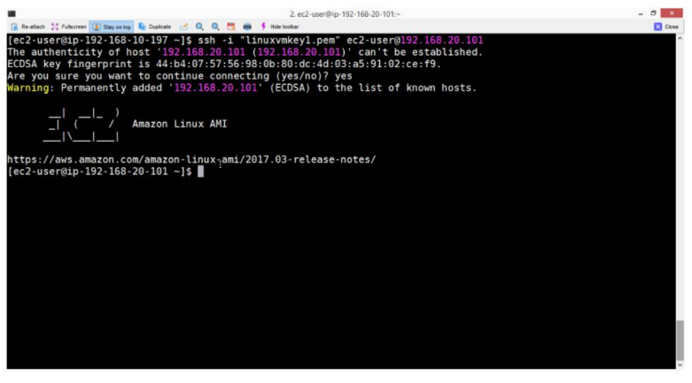

**Exercise 12. To configure Amazon cloud watch**

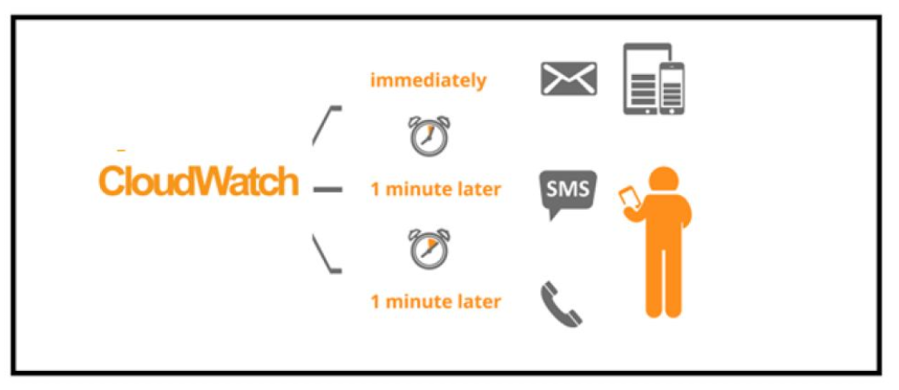

**TASK:**

i)Creating Alarm

ii)Select Notification

iii)Check mail to verify

1. **To Configure Amazon CloudWatch Service**

Launch a Amazon linux instance, then

Open AWS Console

Click on Save

In the Management Tools section

Click on CloudWatch

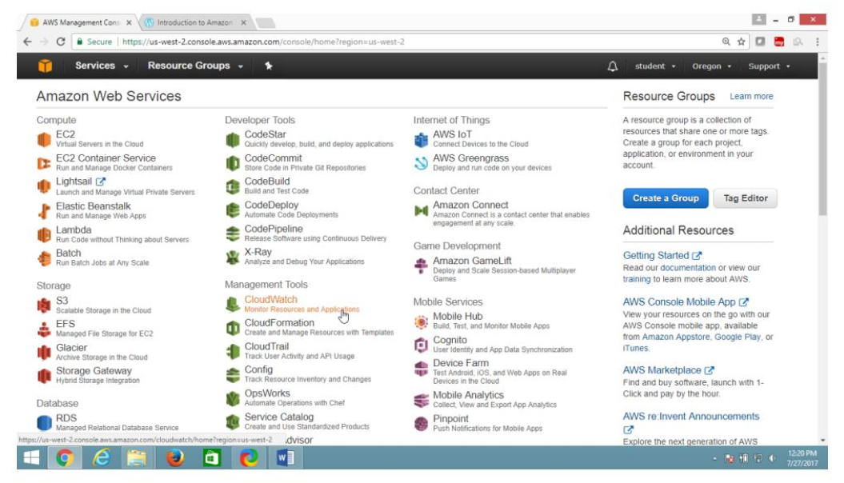

On “CloudWatch”, panel

Select Alarms

Click on “Create Alarm” button

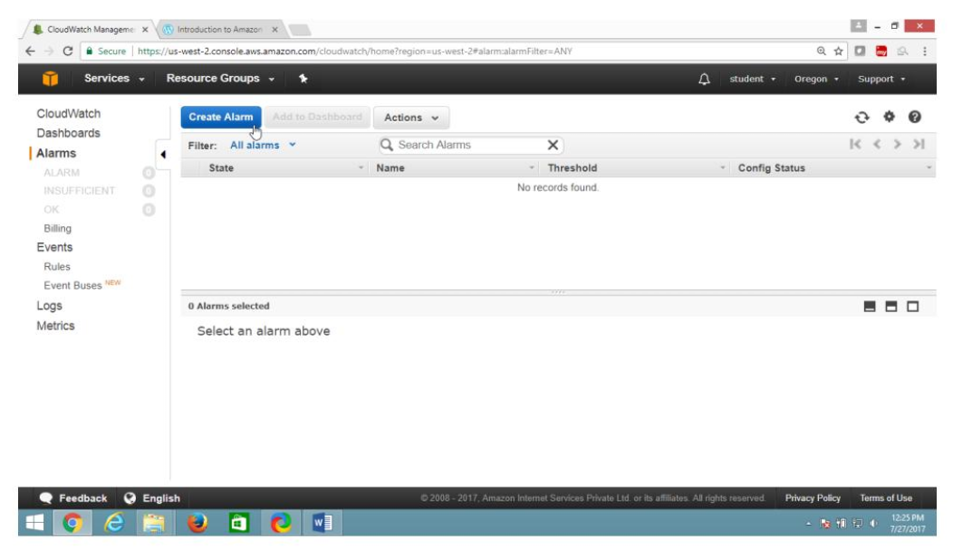

In “Create Alarm” page

Select “EC2 Metrics”

Click on “Pre-instance Metrics”

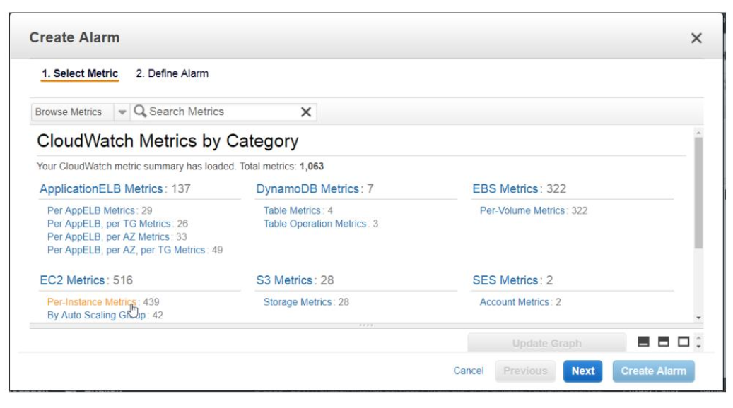

From “Create Alarm” page

Select “1. Select Metric”

In search box provide instance ID or Name

Under Metric Name, select CPU Utilization checkbox

Click on Next button

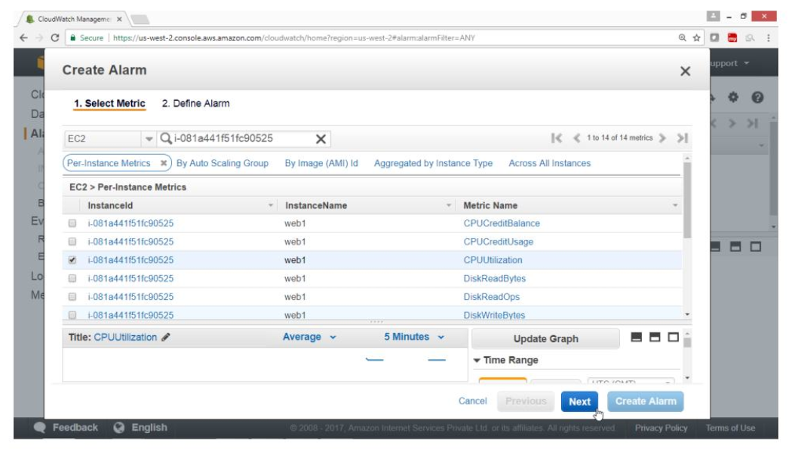

On Create Alarm page

**Select 2. “Define Alarm”**

Under Alarm Threshold

Name -> test cpu utilization

Description -> cpu test

Under Whenever CPU Utilization

Is >= 30

For 1 consecutive periods

Drag Down

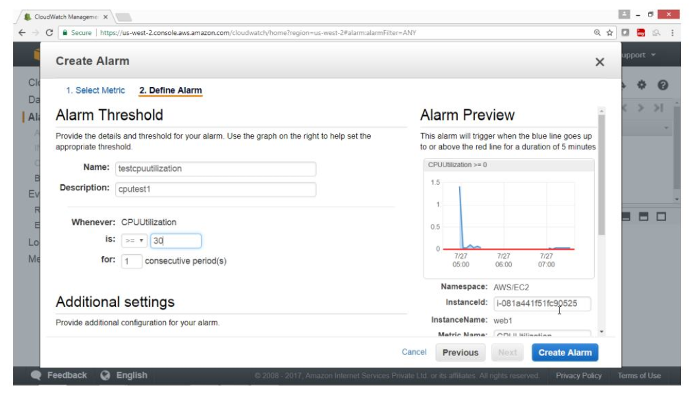

Under Action

Whenever this alarm -> State is Alarm

Send notification to -> Click on New list

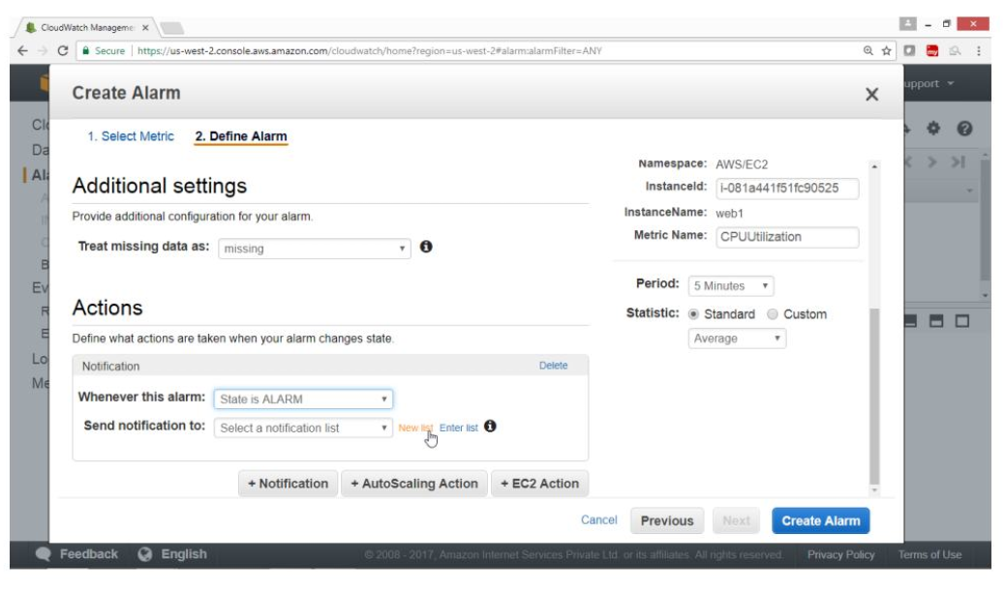

Send notification to -> CPUtopicabc

Email -> adminabc@abc.com

Click on “Create Alarm” button

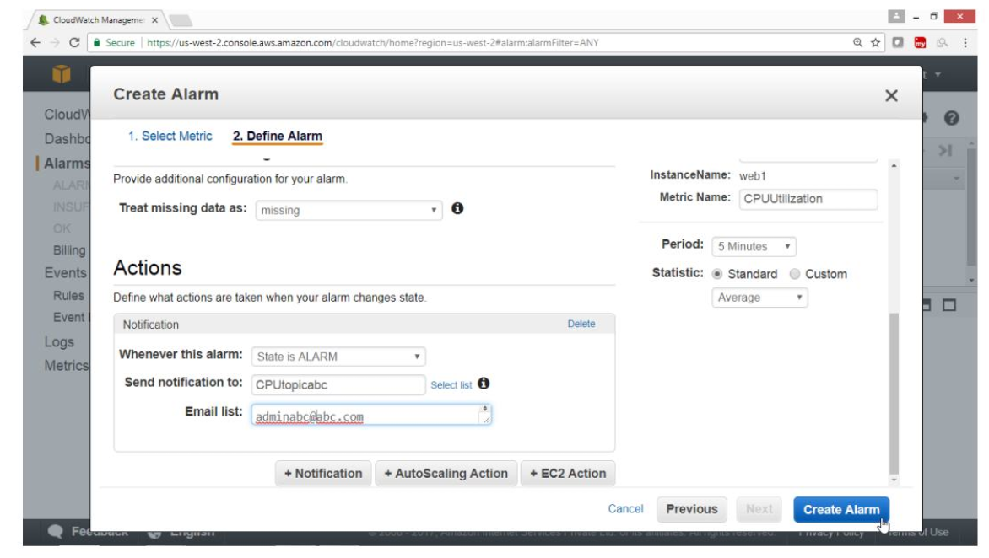

Click on “I will do it Later” button.

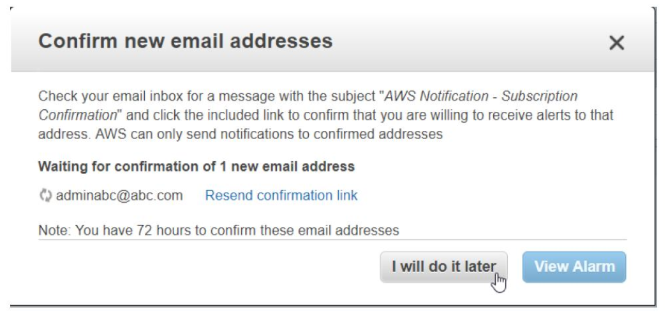

Go to your Email account and check the Mail

Once mail is been checked

Config status -> Pending confirmation

Verify the link from your Email

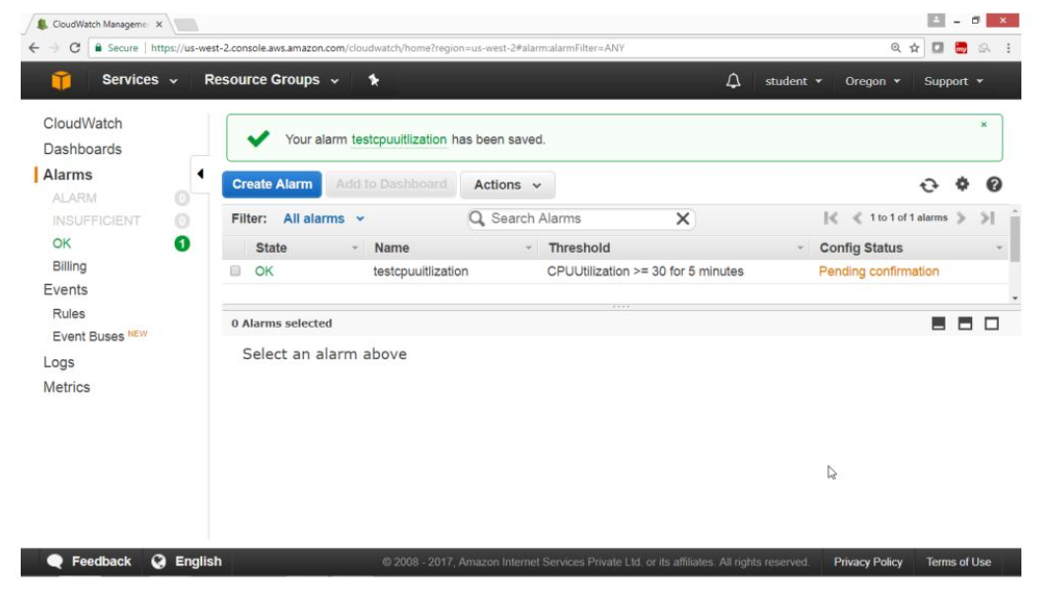

Open your Email

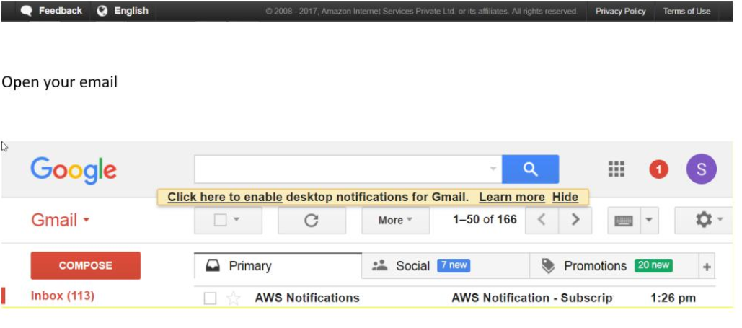

Click on “Confirm subscription”

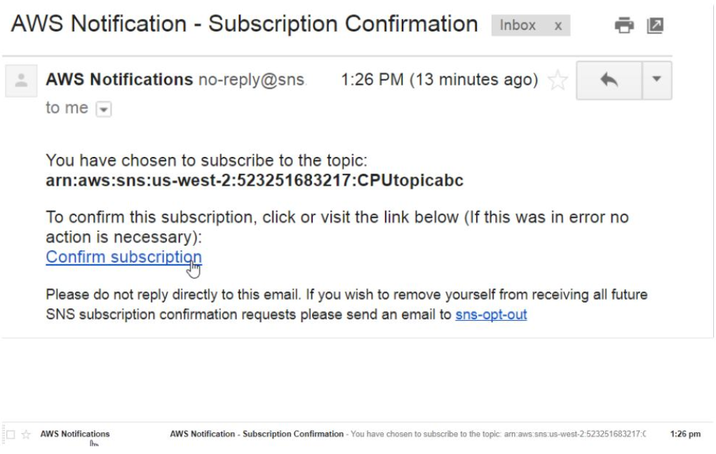

Verified by this output

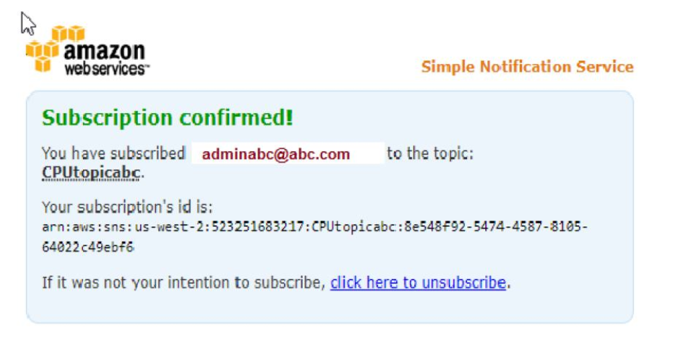

After confirmation from email Config Status has become blank

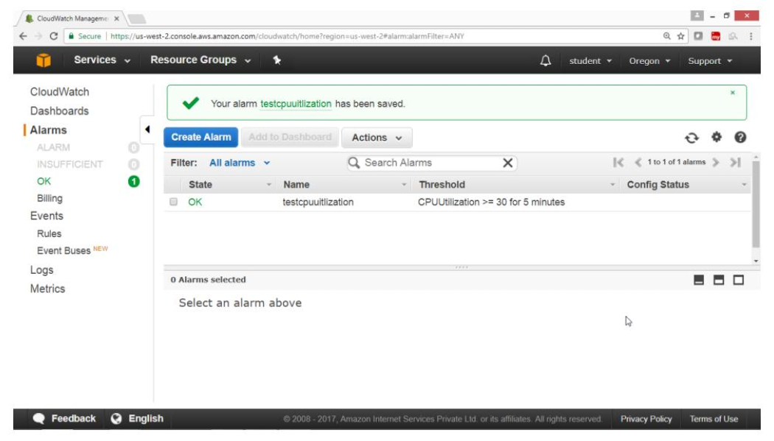

Now login to the instance using Ubuntu Operating system

Switch to root user and install stress command

$ sudo su

# sudo apt-get install stress

Login to another terminal-2

Run top command

#top

Verify output

CPU status is 100%idle

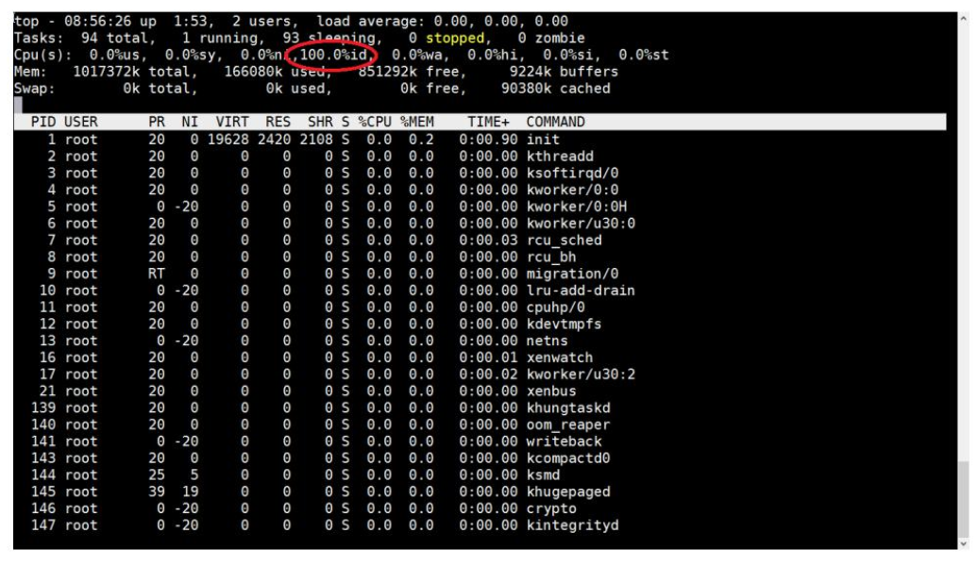

Run this command in terminal -1 which will increase the load

# stress --cpu 40 --timeout 1000



Now check the status in another terminal-2 by running top command

#top

Verify the output

CPU load is 100%

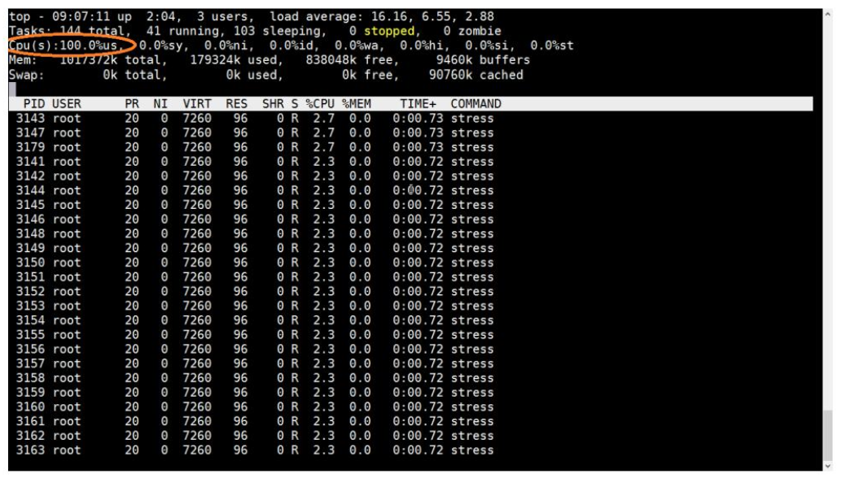

Go to CloudWatch service

Check the status

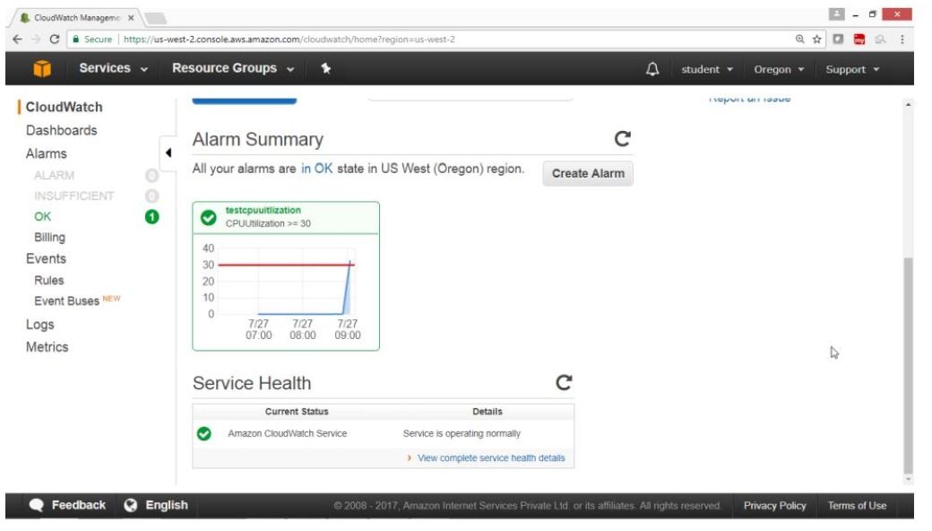

After 5 minutes Alarm is generated

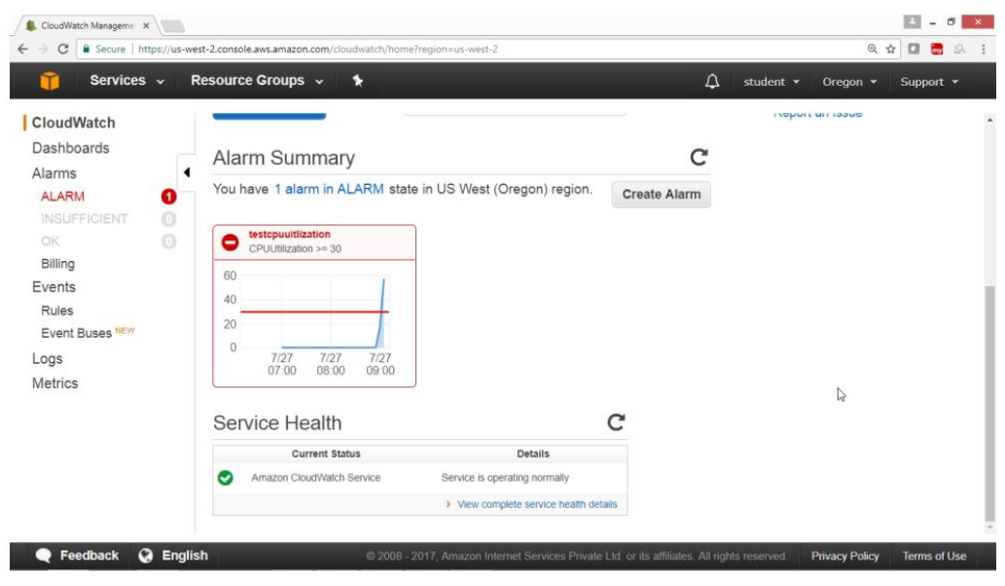

Go to Email and check mail

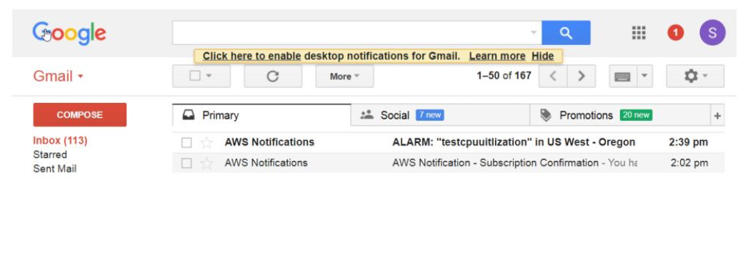

Click on mail

Verify Output

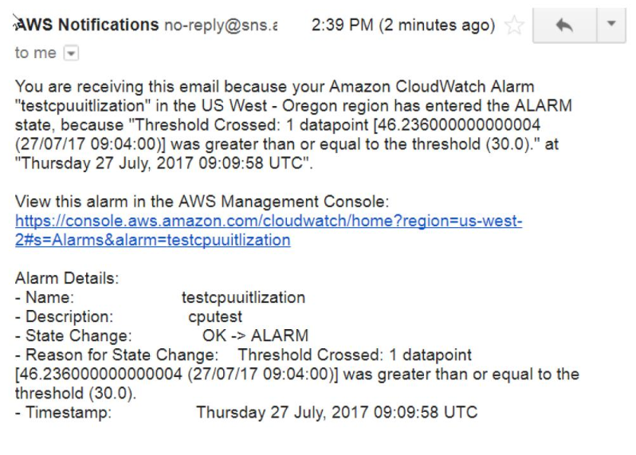

**Exercise-13 :To Configure Amazon Simple Notification Service(SNS)**

**OBJECTIVE**

To configure Amazon Simple Service(SNS)

**TOPOLOGY**

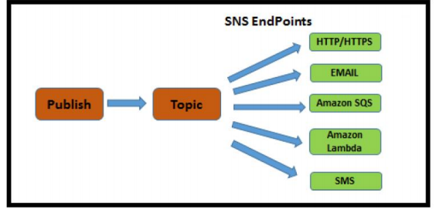

**Pre-Requisites**

User should have AWS account,or IAM user with AmazonSNSFullAcces

**TASK**

Create a Topic

Subscribe your topic

Verify in your mail account

1. **To configure Amazon Simple Notification Service(SNS)**

Open AWS console

Select **“Messaging”** service

Click on **“Simple Notification service”**

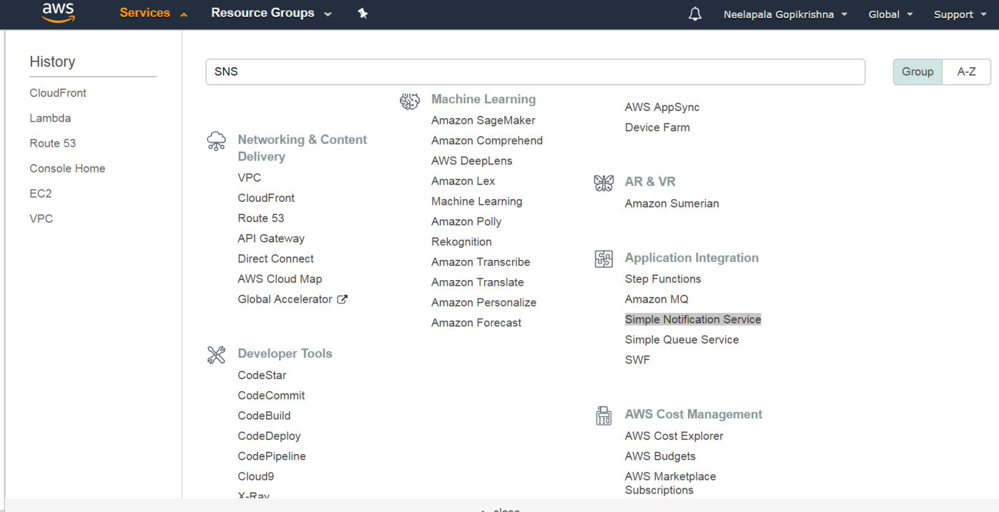

From **“SNS Dashboard”** panel

Select **Topic**

Click on **“Create new topic”** button

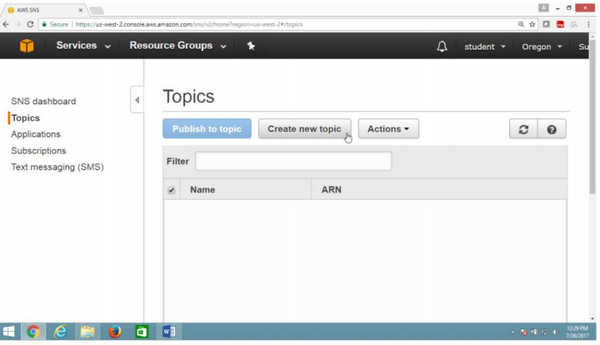

In “**create new topic**”box

Provide topic name and Display name

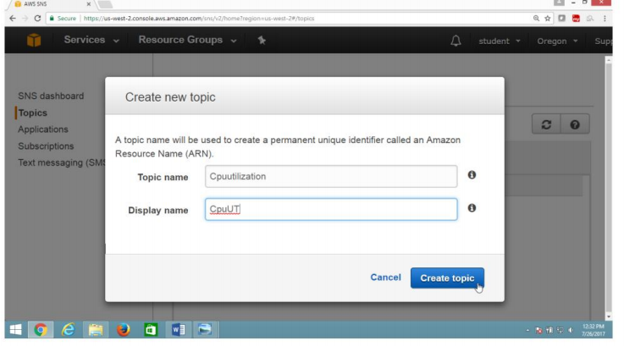

Click of ARN link

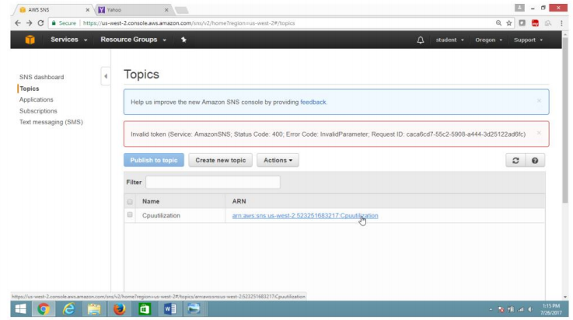

**2) To create Subscription**

Click on **“Create Subscription”** button

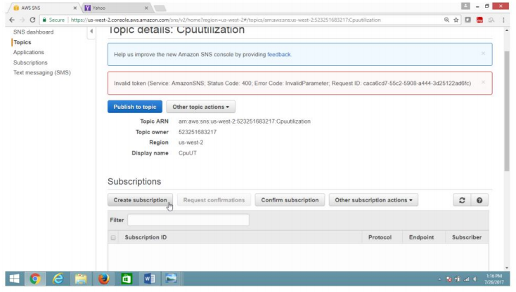

Provide values as

Protocal ->**EMAIL**

Endpoint ->[adminaws@abc.com](mailto:adminaws@abc.com)

Click **“Create Subscription”** button

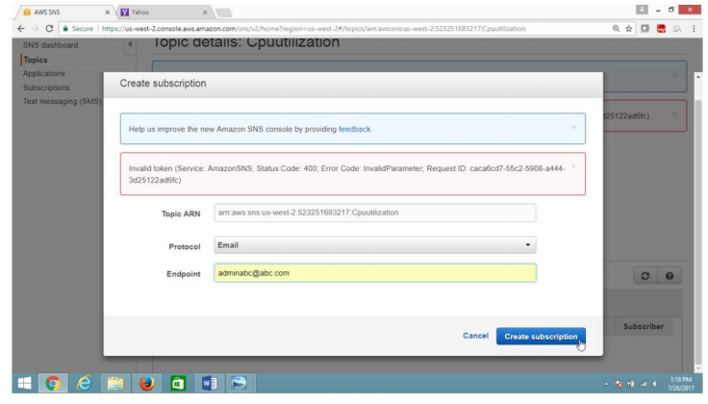

3) **Verification**

Now subscription is in pending state

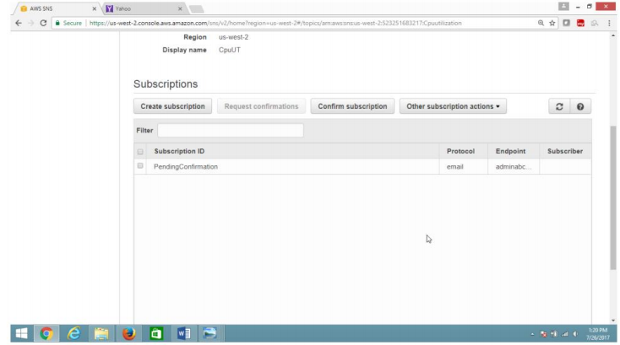

Go to your mail account

Click on the mail

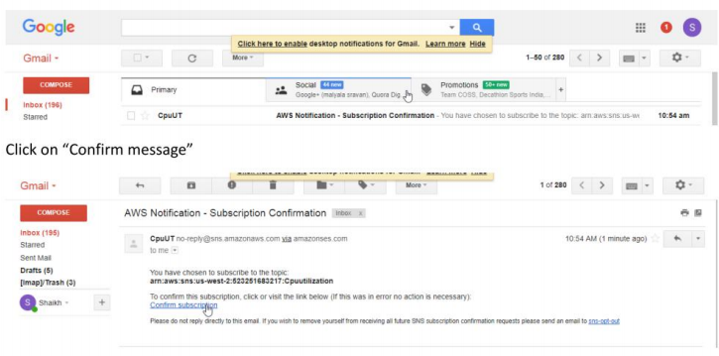

Now subscription is verified

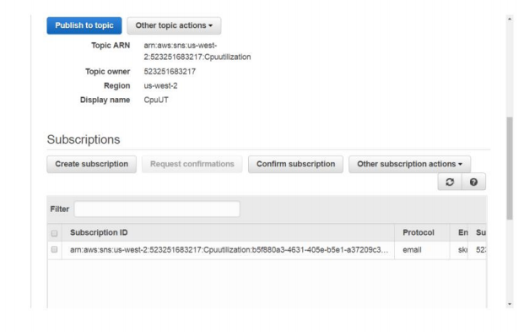

**Exercise 14. To configure Amazon Elastic Load Balancer**

**OBJECTIVE**

To configure Elastic Load Balancer in AWS

**Topology**

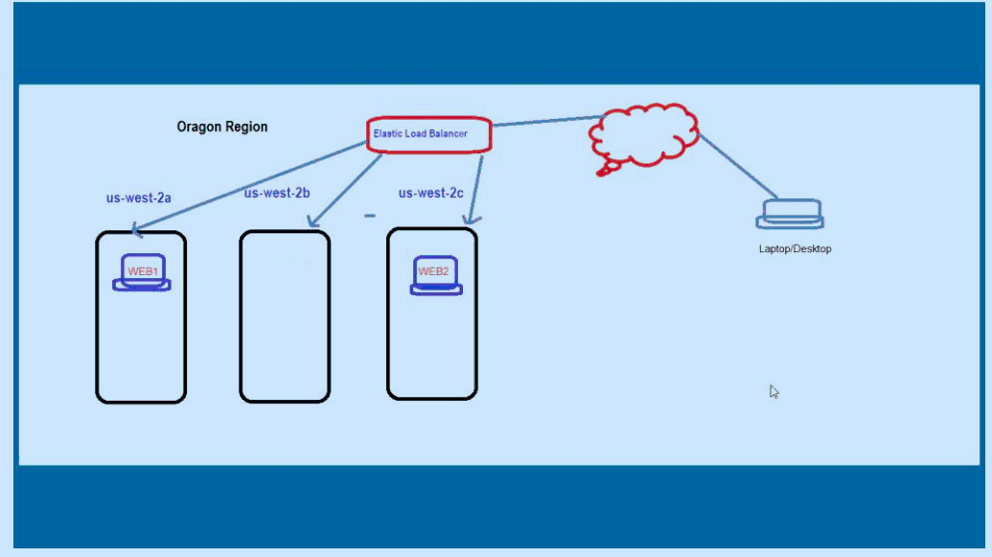

**Pre-Requisites**

User should have AWS Account ,or IAM user have EC2 FullAccess

**Task :**

Launch two instances in two different Availability Zones

Configure httpd(Apache2) Web Server in each instance

Verify web server from browser.

Configure Elastic Load Balancer.

Verify Web Server through ELB

1. **Launch two install with apache web server in two seperate Availability Zone,**

**For Example US-West-2a and US-West-2c**

**2) Check Websites are running**

Open the Browser

Provide public ip for both instances.

Verify both websites are running.

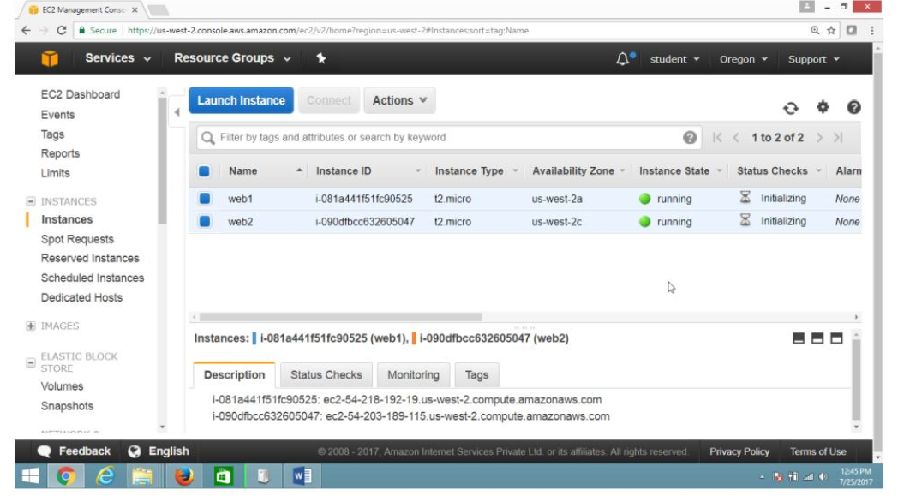

**Verify public IP of both instances**

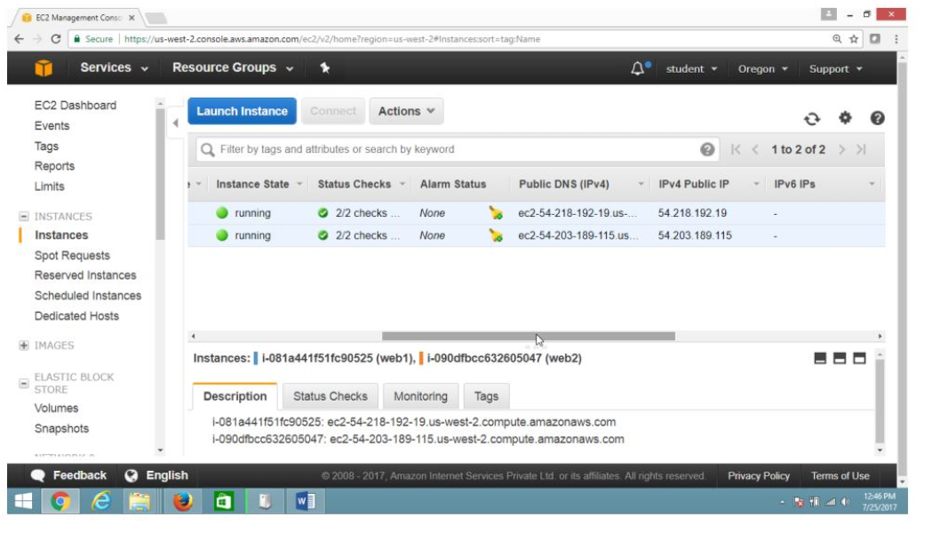

**Verify Output of Web Server one**

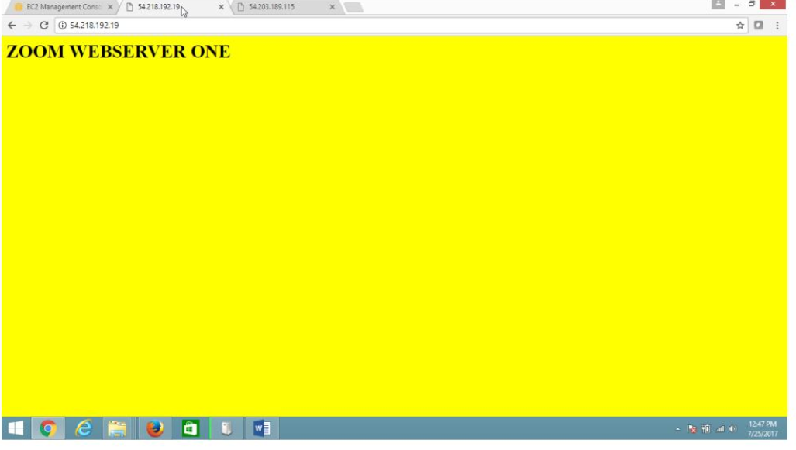

**Verify Output of Web Server two**

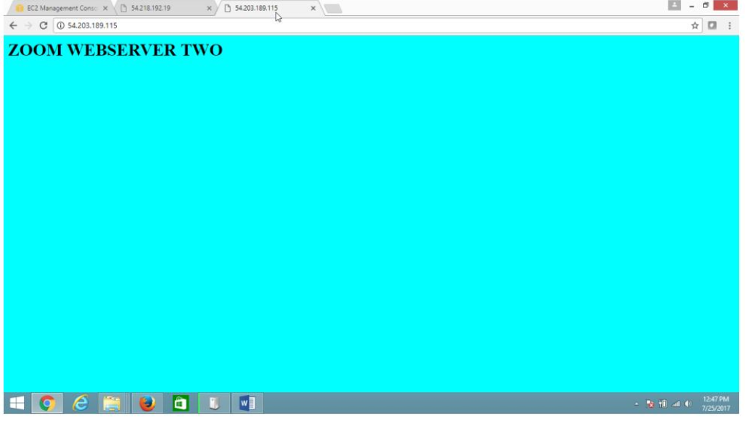

**3)To configure Elastic Load Balancer.**

Open the AWS console , On EC2 dashboard panel

Expanding **“Load Balancing”**

Select **“Load Balancer”**

Click on **“Create Load Balancer button ”**

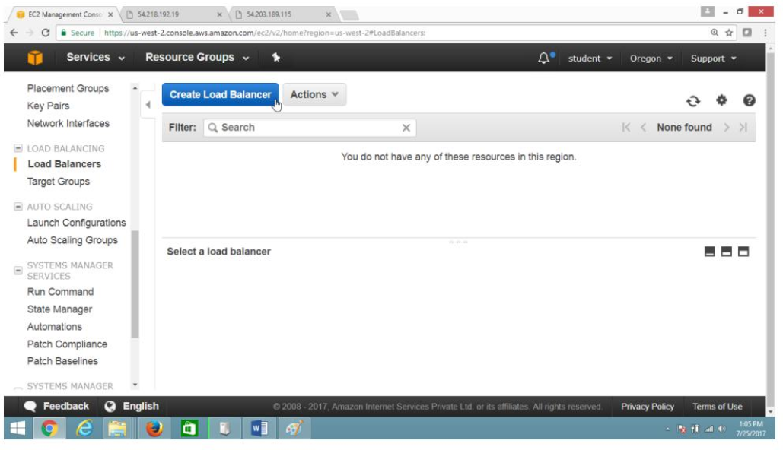

On **“Welcome to Elastic Load Balancing ”** page

Select **“Application load Balancer”,** Click **Continue** button.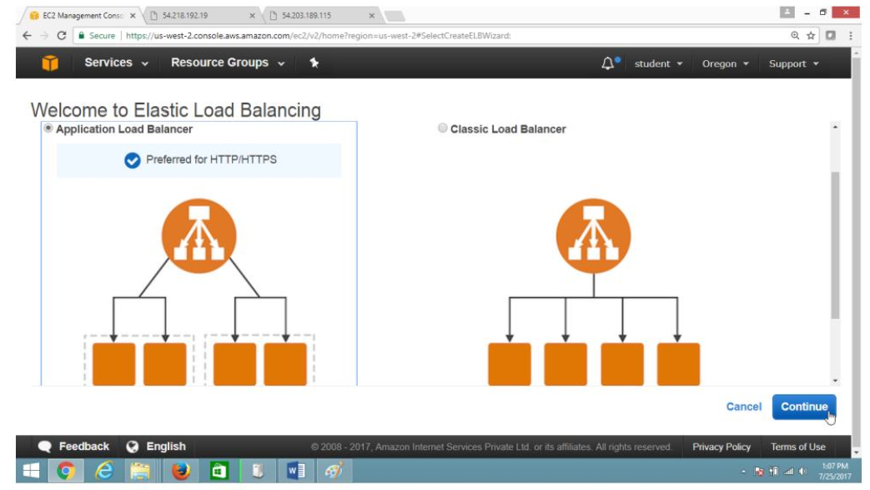

**Select load balancer type**

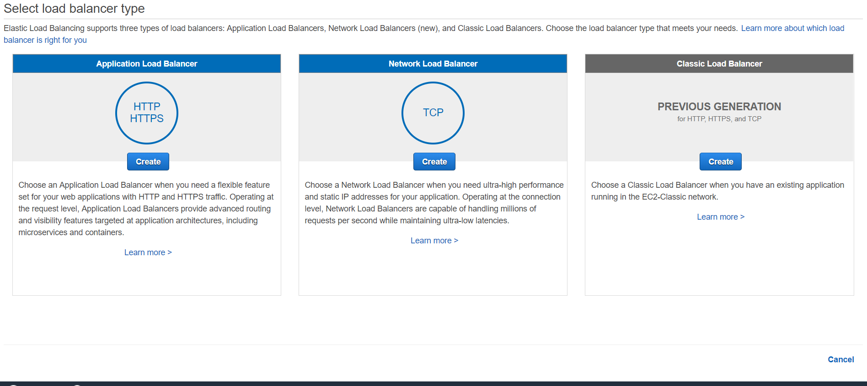

**Configure Load balancer**

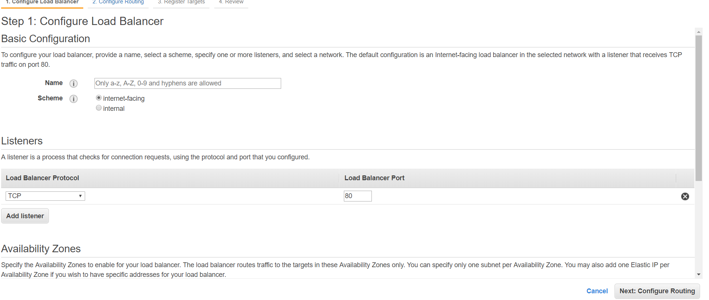

**Configure Routing**

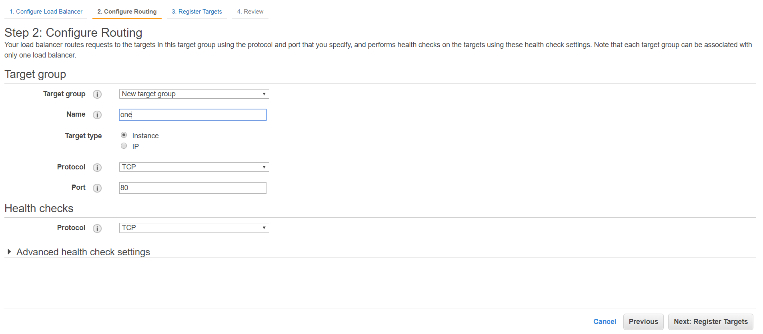

**Configure Security Groups**

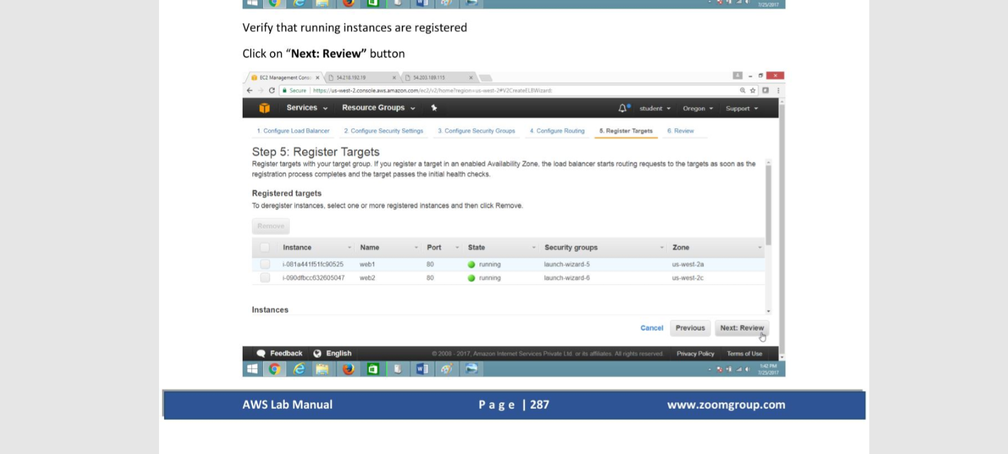

**Review**

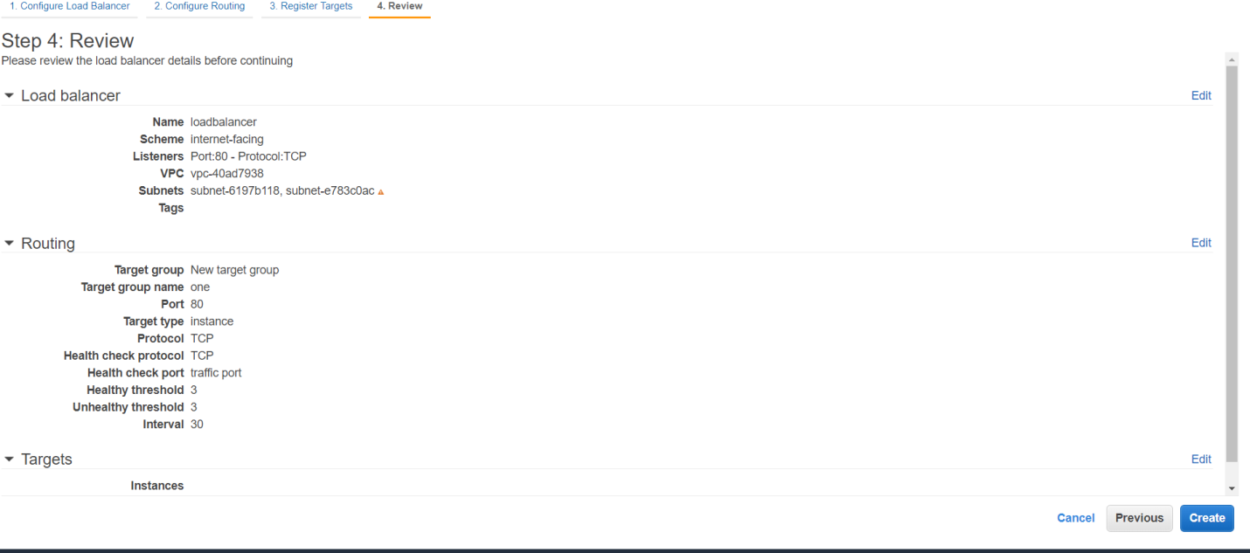

**Finally Created Load Balancer with DNS name**

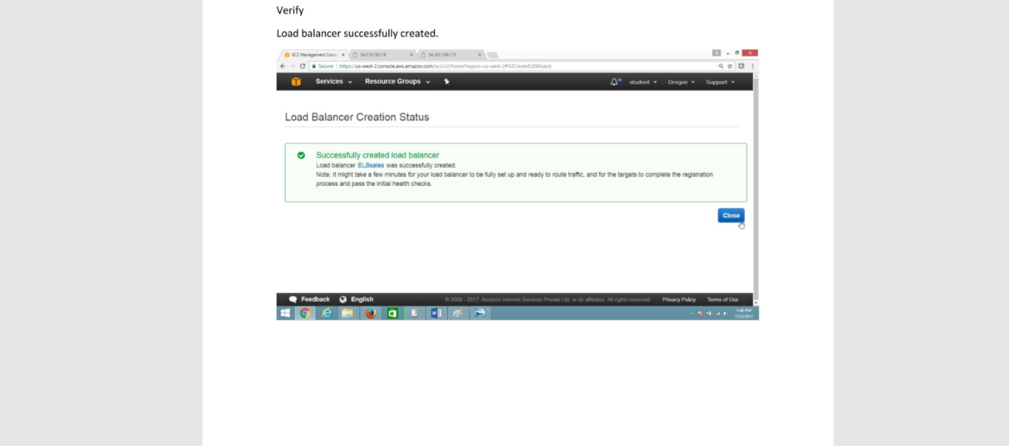

**Verification**

To verify websites are coming Through Load Balancer DNS name

Copy the DNS Name and paste in the URL

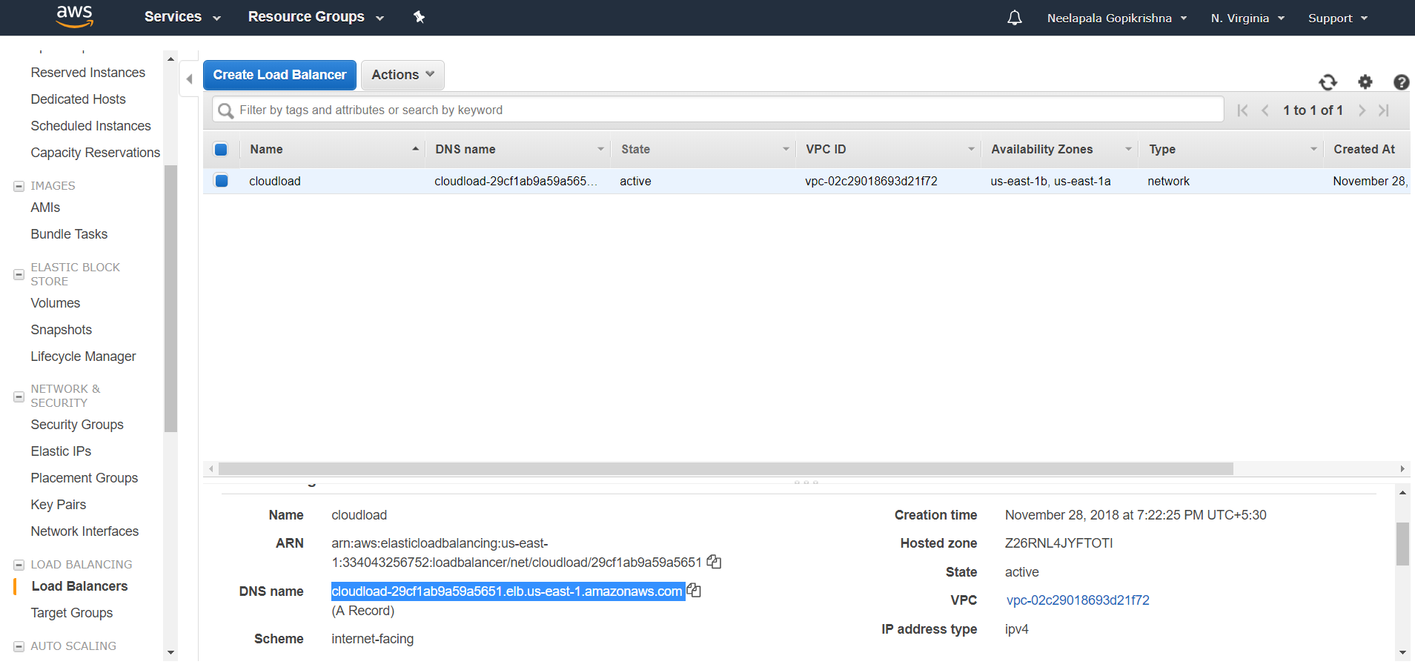

In Browser type Load Balancer DNS names

Verify website by frequently refreshing browser (press F5)

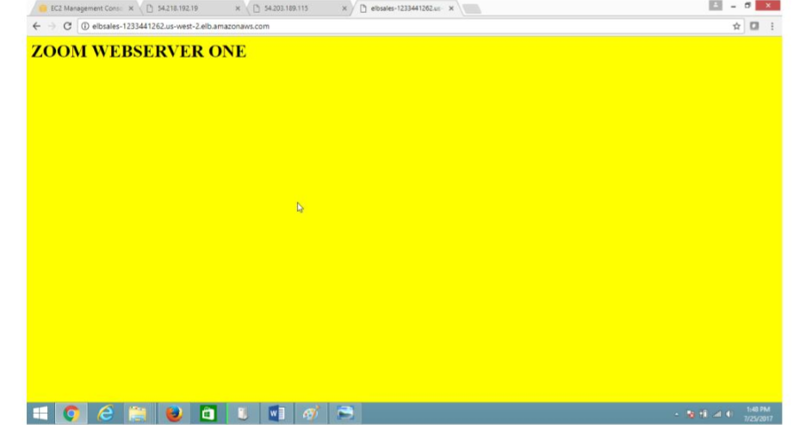

On each refresh one by one ,webserver1 and webserver2 will be displayed

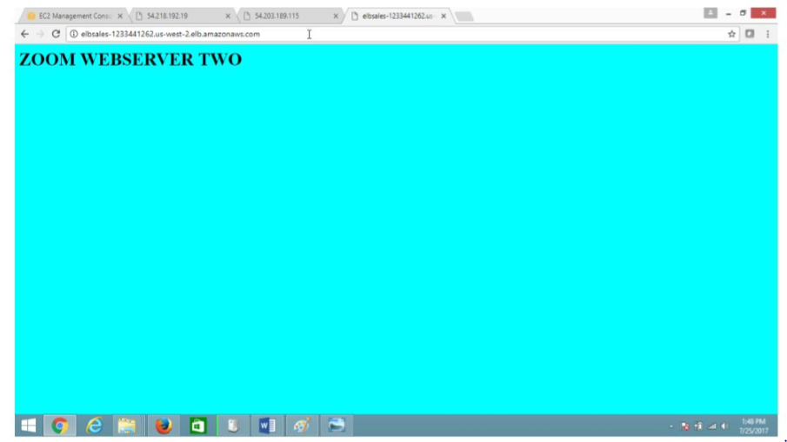

If you got this output , **Congratulation your ELB configuration is successful.**

**Exercise 15. To configure Amazon Auto Scaling with load balancer and snapshot**

**Amazon EC2 Auto Scaling**

Amazon EC2 Auto Scaling helps you ensure that you have the correct number of Amazon EC2 instances available to handle the load for your application. You create collections of EC2 instances, called *Auto Scaling groups*. You can specify the minimum number of instances in each Auto Scaling group, and Amazon EC2 Auto Scaling ensures that your group never goes below this size. You can specify the maximum number of instances in each Auto Scaling group, and Amazon EC2 Auto Scaling ensures that your group never goes above this size. If you specify the desired capacity, either when you create the group or at any time thereafter, Amazon EC2 Auto Scaling ensures that your group has this many instances. If you specify scaling policies, then Amazon EC2 Auto Scaling can launch or terminate instances as demand on your application increases or decreases.

For example, the following Auto Scaling group has a minimum size of 1 instance, a desired capacity of 2 instances, and a maximum size of 4 instances. The scaling policies that you define adjust the number of instances, within your minimum and maximum number of instances, based on the criteria that you specify.

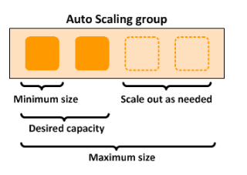

## **Auto Scaling Components**

The following table describes the key components of Amazon EC2 Auto Scaling.

**Groups**

Your EC2 instances are organized into *groups* so that they can be treated as a logical unit for the purposes of scaling and management. When you create a group, you can specify its minimum, maximum, and, desired number of EC2 instances.

**Launch configurations**

Your group uses a *launch configuration* as a template for its EC2 instances. When you create a launch configuration, you can specify information such as the AMI ID, instance type, key pair, security groups, and block device mapping for your instances.

**Scaling options**

Amazon EC2 Auto Scaling provides several ways for you to scale your Auto Scaling groups. For example, you can configure a group to scale based on the occurrence of specified conditions (dynamic scaling) or on a schedule.

**Auto Scaling Lifecycle**

The EC2 instances in an Auto Scaling group have a path, or lifecycle, that differs from that of other EC2 instances. The lifecycle starts when the Auto Scaling group launches an instance and puts it into service. The lifecycle ends when you terminate the instance, or the Auto Scaling group takes the instance out of service and terminates it.

**Note :** You are billed for instances as soon as they are launched, including the time that they are not yet in service.

The following illustration shows the transitions between instance states in the Amazon EC2 Auto Scaling lifecycle.

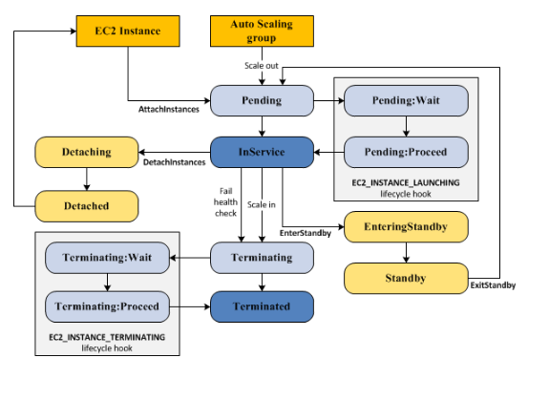

**PRE-REQUISITES**

You should have AWS account, or IAM user with EC2 Full access

**Task**

1. **Launch Amazon linux instance**
2. **Configure web server**
3. **Stop the instance**
4. **Create AMI image of above instance**
5. **Configure Auto Scaling launch configuration and Auto Scaling group**
6. **Configure load balancer auto scaling**

**Steps :**

1. **Launch Amazon linux instance and Configure web server, as same shown in Exercise 1 .**
2. **Stop the instance: To create AMI from this instance on ‘EC2 Dashboard Pane”, select the instance and click on action and select the instance state then stop.**

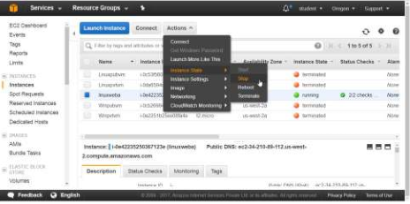

**Click on Yes,Stop.**

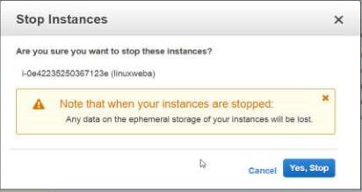

**Select the stopped instance and click on action button**

**Select Image and then click on create image button**

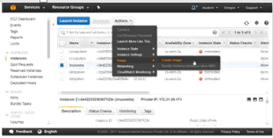

**Click on create Image**

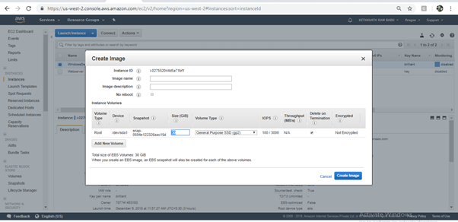

**Now, click on Close**

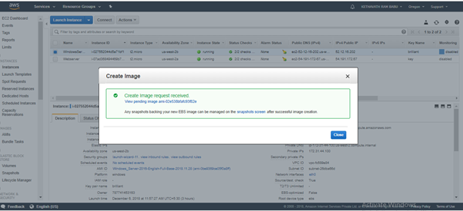

**Verify Ami is created on not in EC2 Dashboard panel**

**On the EC2 Dashboard panel, Select Images and Click on AMIs then check status is on Available state or Not,**

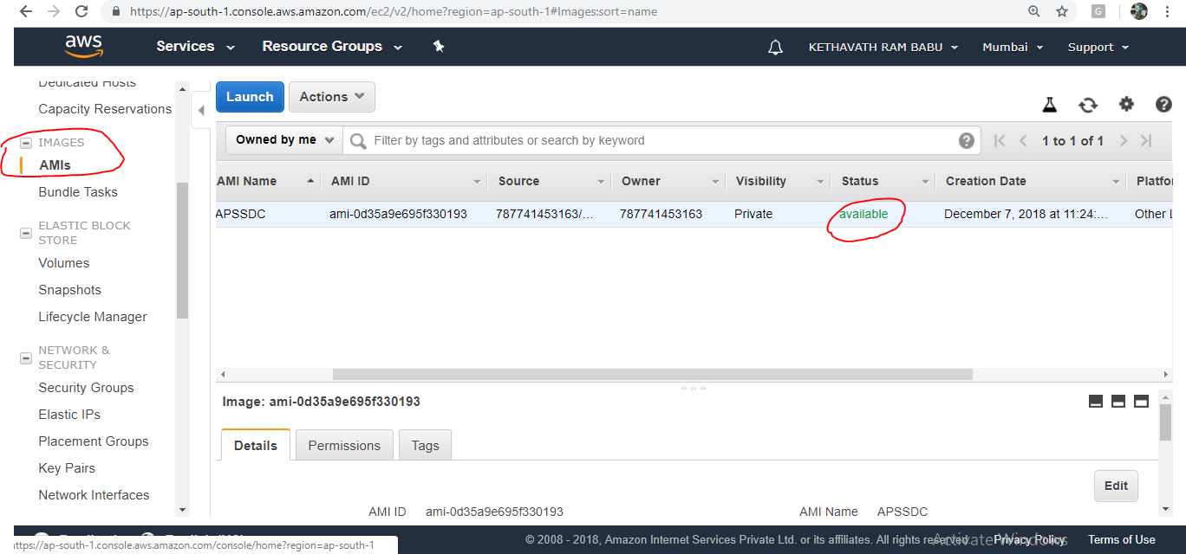

**-> Configure Auto Scaling launch configuration and Auto Scaling group**

**To configure Auto Scaling Group on the Ec2 Dashboard Panel**

**Select Auto Scaling**

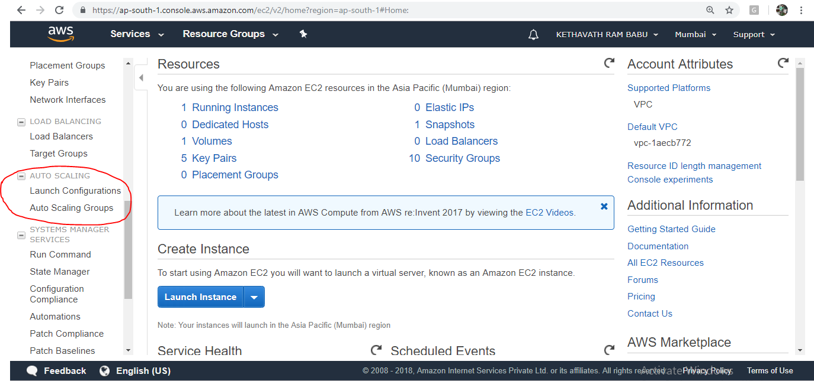

**Launch Configuration**

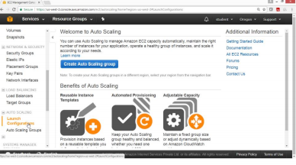

**Click Create Auto Scaling Group**

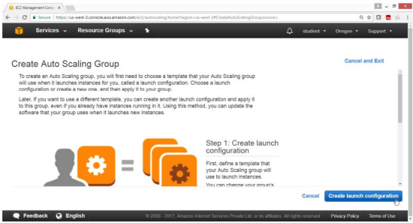

**Click on My AMIs**

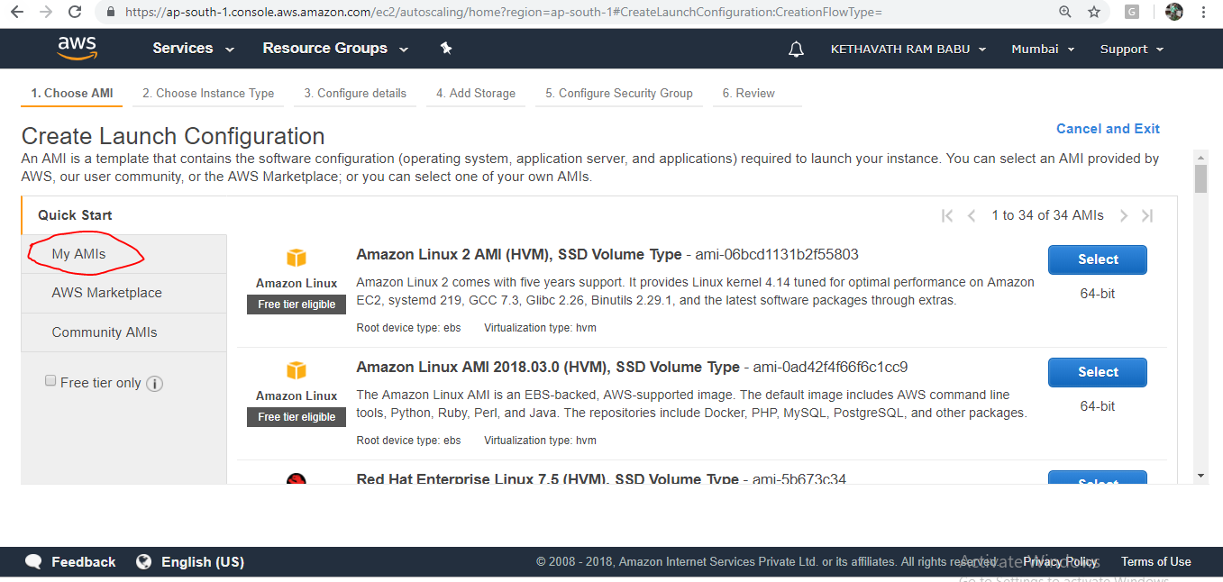

**Step 1:Choose Instance Type**

**Step2: General Purpose t2.micro**

**Step 3:Now Click on Next: Configure Details**

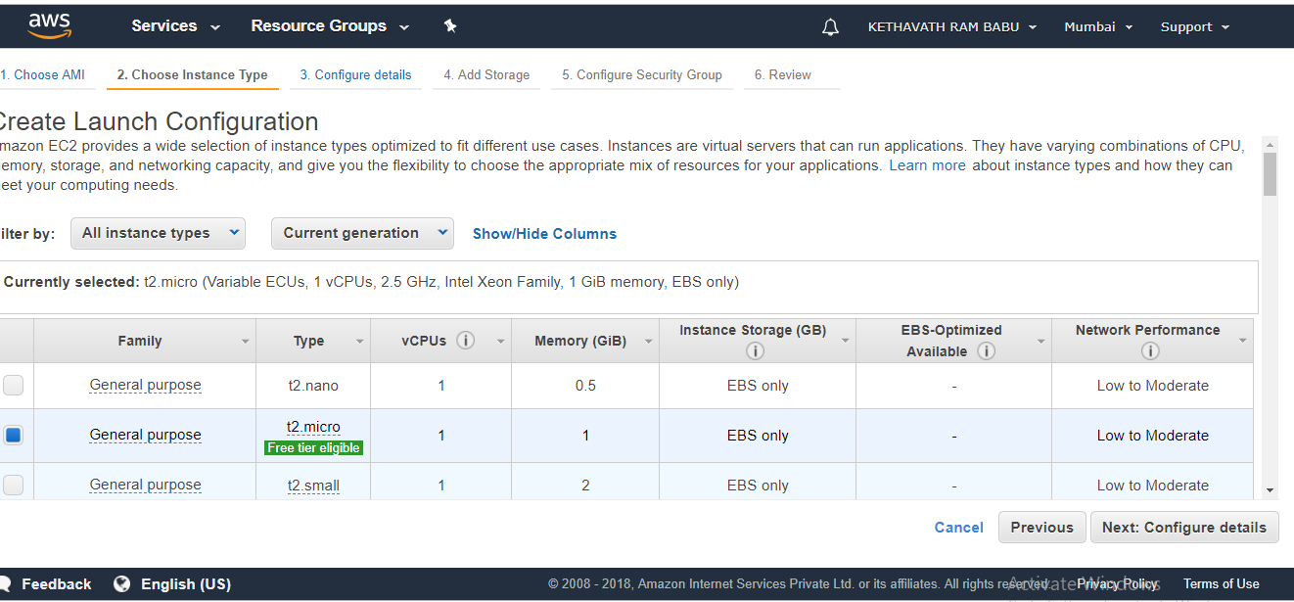

**In create launch configuration**

**Name: APSSDC( User Defined)**

**Monitoring : Enable Checkbox**

**Click on : Next, Add Storage**

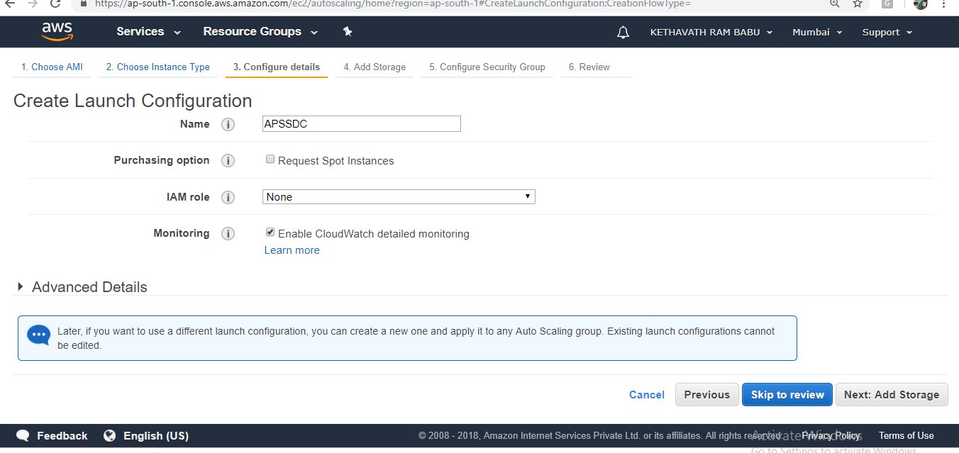

**By default linux takes 8 gb EBS Volume**

**Leave all values as default**

**Click On: Next, Configure Security group**

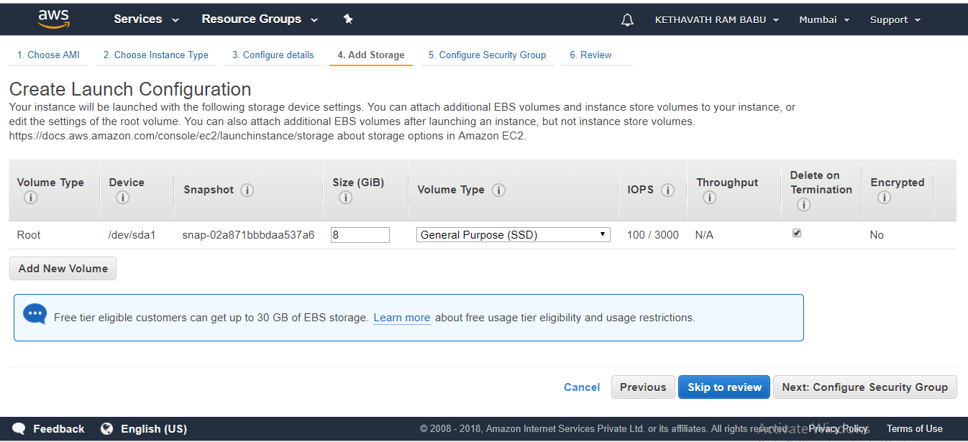

**Create a new security group and click on review**

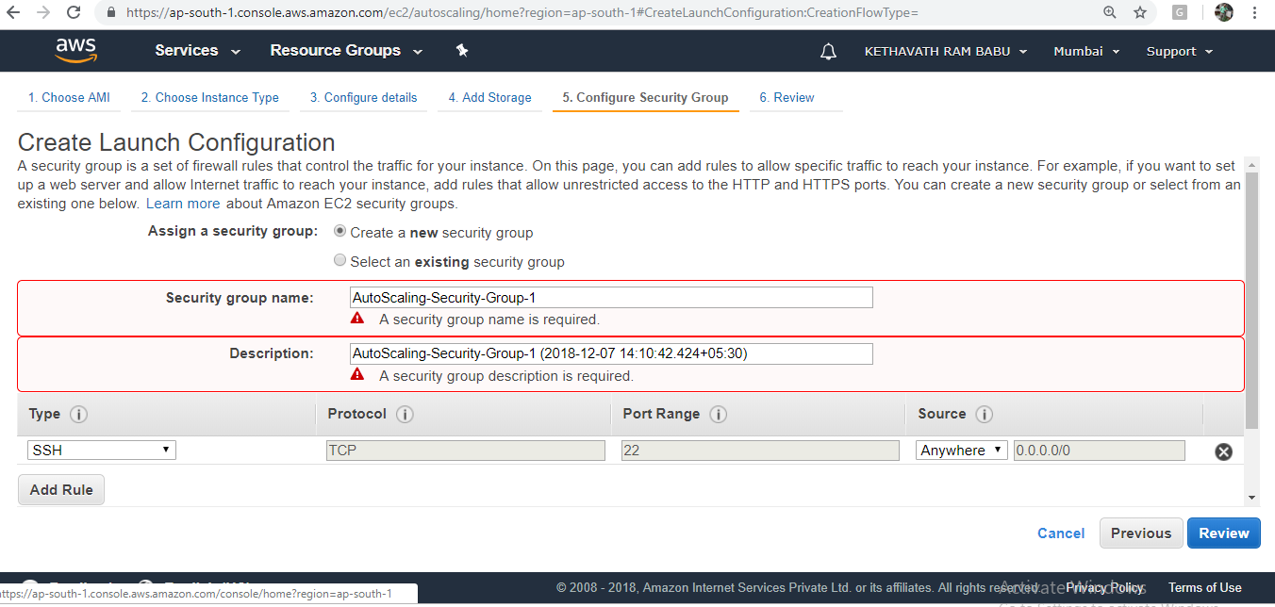

**Check the Summary**

**Click on Create launch Configuration**

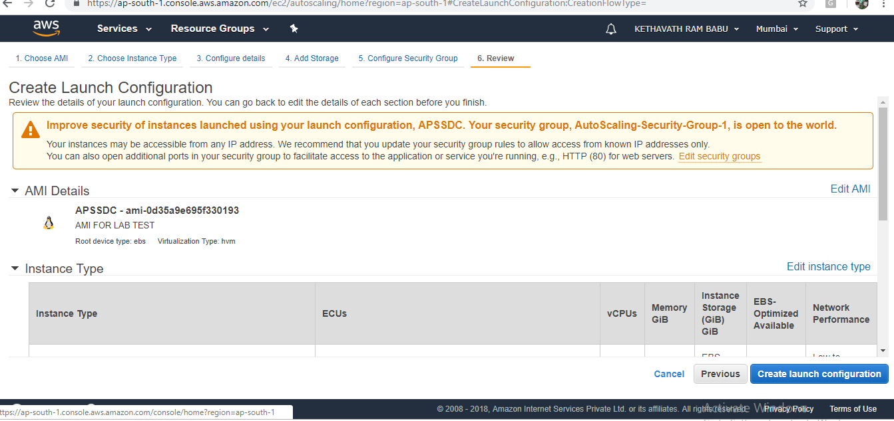

**In Select an existing key pair or create a new key pair tab**

**Choose an existing key pair**

**Select a Key Pair -> elb**

**Select Acknowledge check box**

**Click on “Create Launch Configuration”**

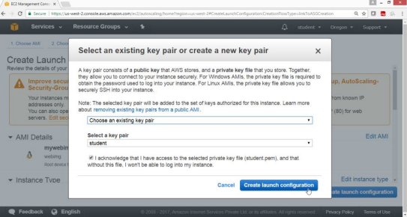

**Now you have successfully created launch configuration APSSDC**

**Click on Create Auto scaling group using**

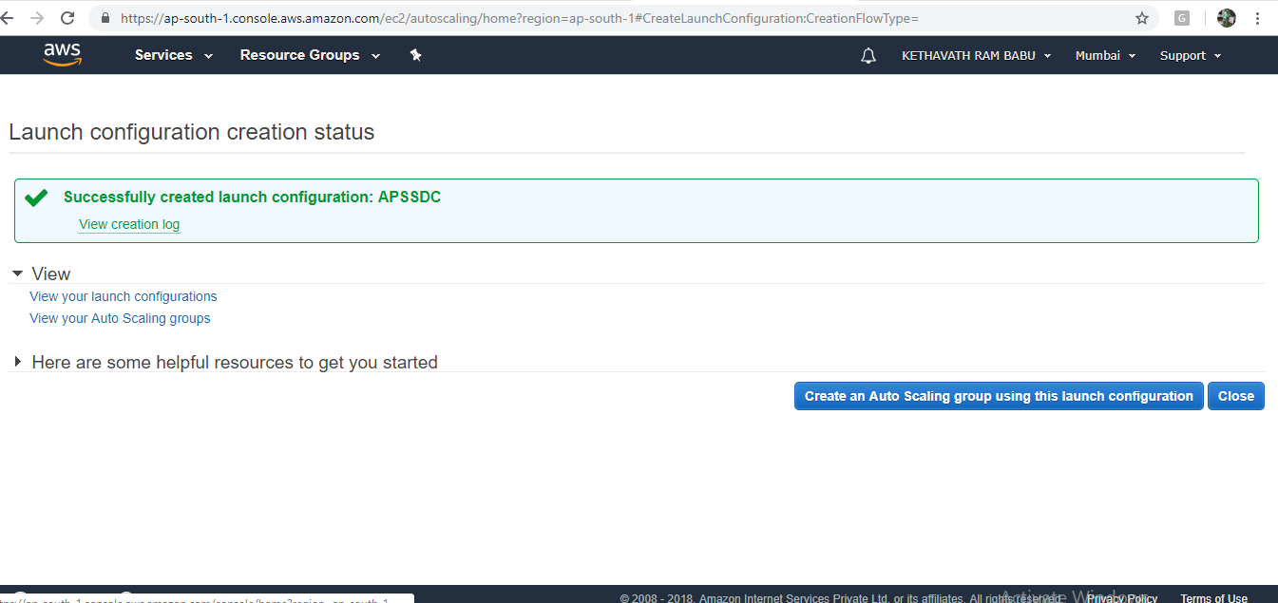

**On create auto scaling group**

**Group name-> apssdc group**

**Launch Configuration-> APSSDC**

**Network-> Default VPC or your own VPC which you launched server**

**Select all Subnet one by one**

**Click on “ Configure Scaling Policies”**

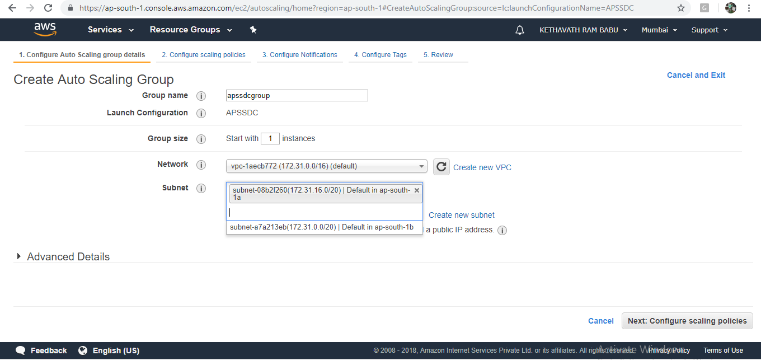

**Now, Select ->Use scaling policies to adjust the capacity of this group**

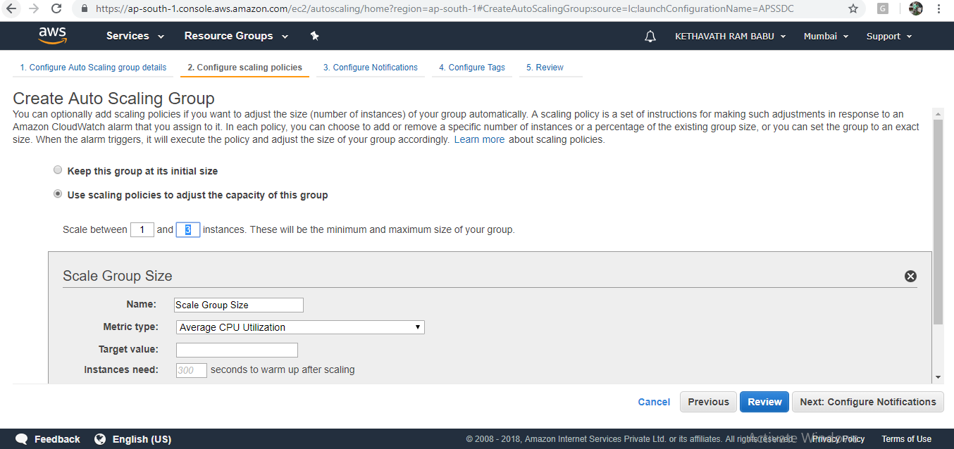

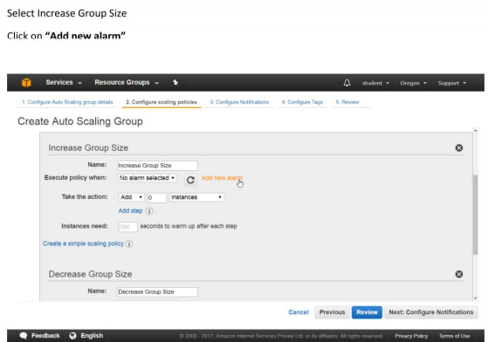

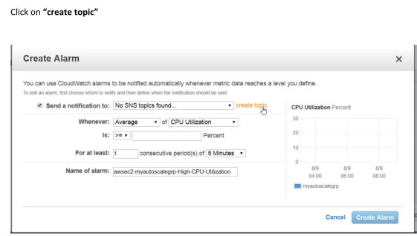

**On Create alarm box, give values as**

**Send notification to ->cpu utilization**

**With receipients ->** [**xxxxx@gmail.com**](mailto:xxxxx@gmail.com)**(assign your mail)**

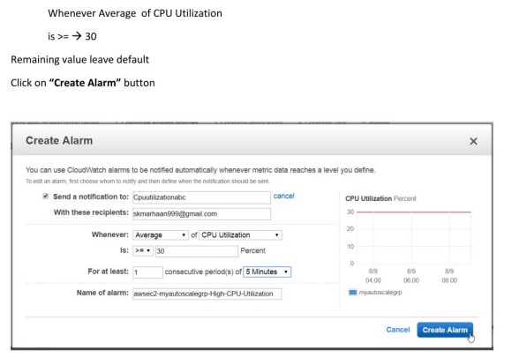

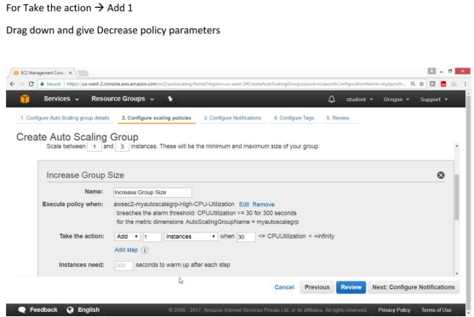

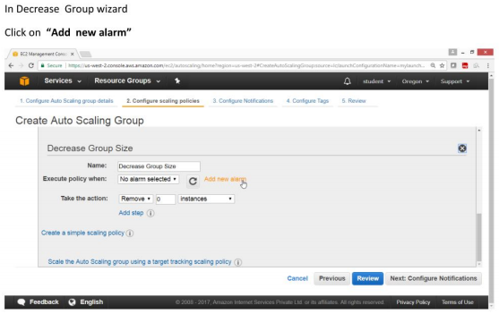

**Select the topic -> cpu utilization**

**Whenever an average CPU utilization is “<=”**

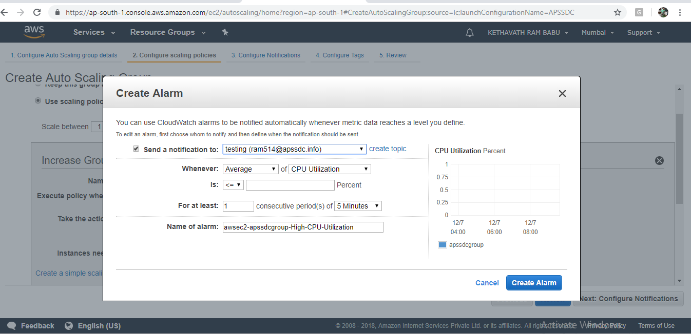

**Give value-> 20**

**Click Create Alarm**

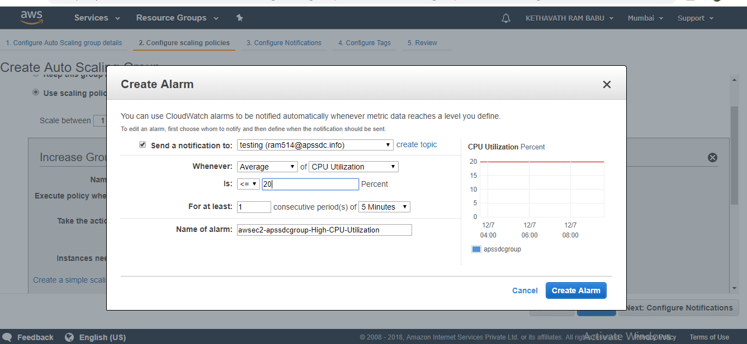

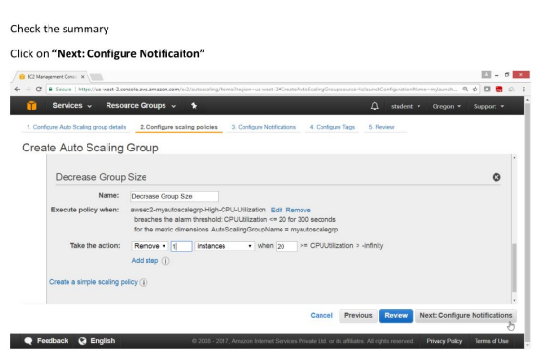

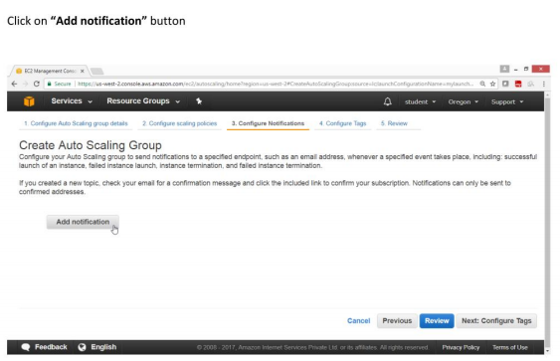

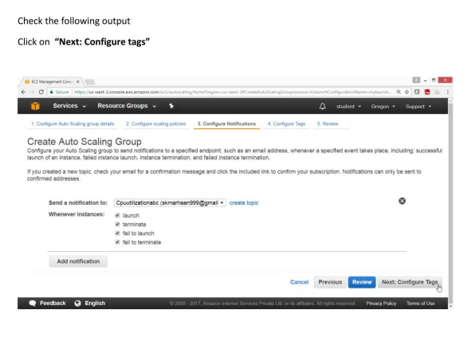

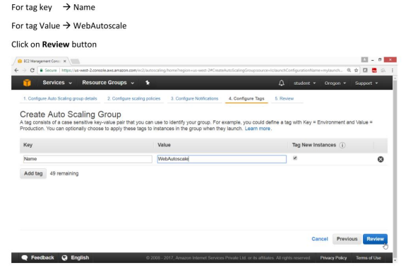

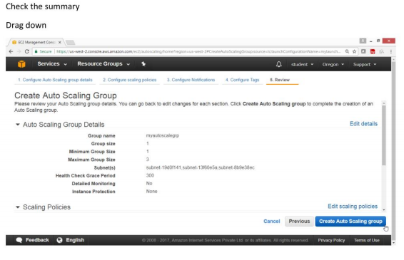

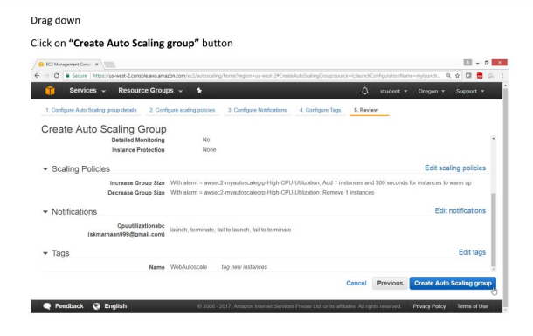

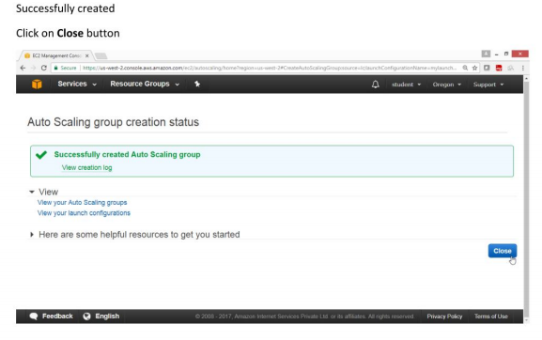

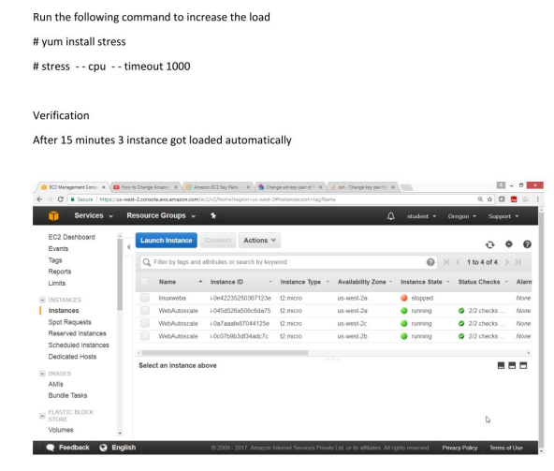

**Exercise 16. To configure an Elastic Beanstalk with Tomcat Application**

**OBJECTIVE**

TO configure Elastic Beanstalk in AWS

**TOPOLOGY**

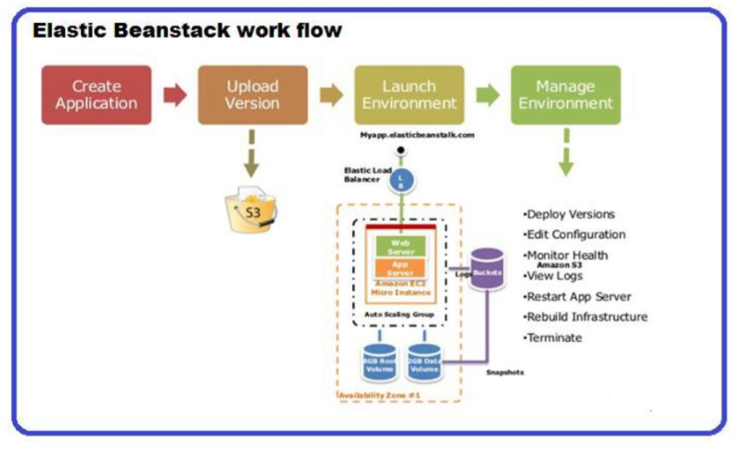

**PRE-REQUISITES**

User should have AWS account ,or IAM user with Elastic Beanstalk FullAccess

**TASK :**

Create Elastic Beanstalk Tomcat Application

Deploy java war files

Open Browser and check your web Application

**Practical Steps**

**1)To create Elastic Beanstalk Application**

Open **AWS** Console

Select **compute** services -> Click on **“Elastic Beanstalk”**

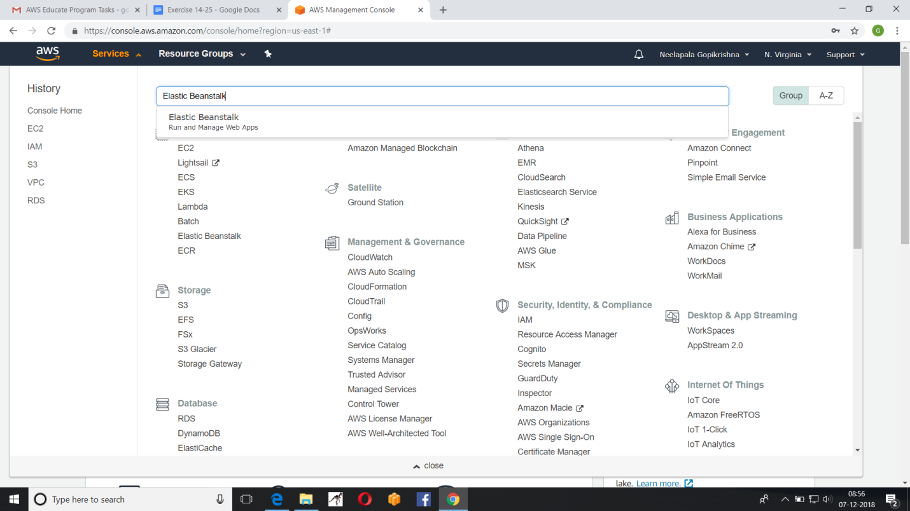

**“Welcome to Amazon Elastic Beanstalk”**page opens

Click on **Get started** button

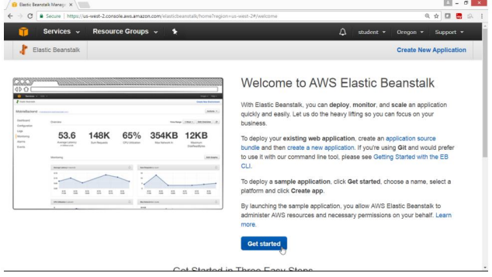

On “**Create a web app”,**page ,provide values

Application name ->Tomcat App

Environment name-> Tomcat Env and Drag down 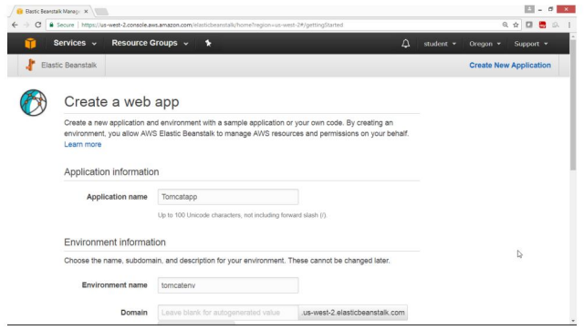

In platform box Choose **Tomcat**

Drag Down

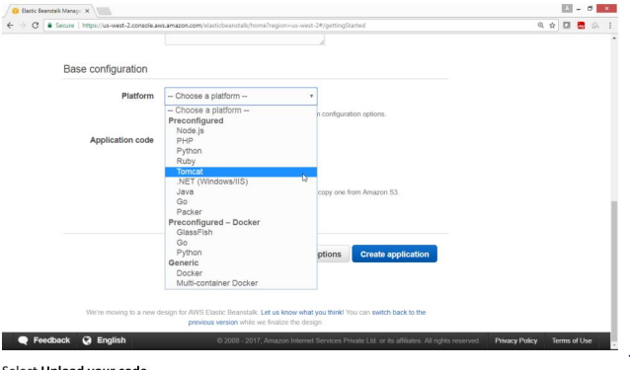

Select upload your code

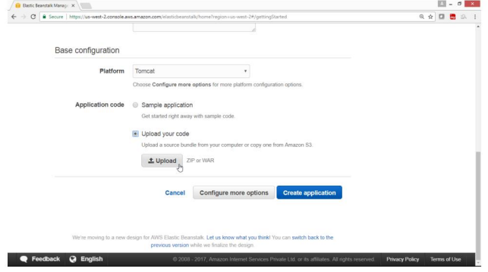

Upload calendar.war file

Click on upload button

Leave remaining fields as defaults

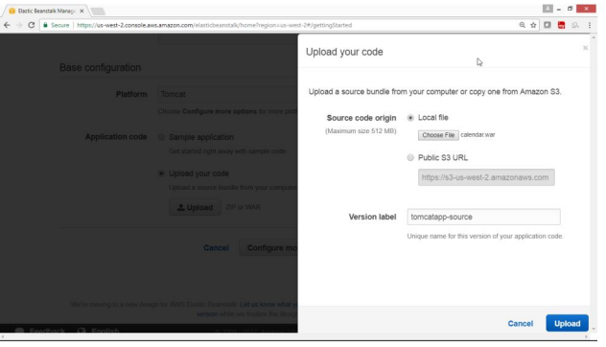

Verify that file is uploaded,beside **upload** button

Click “**Create Application”** Button

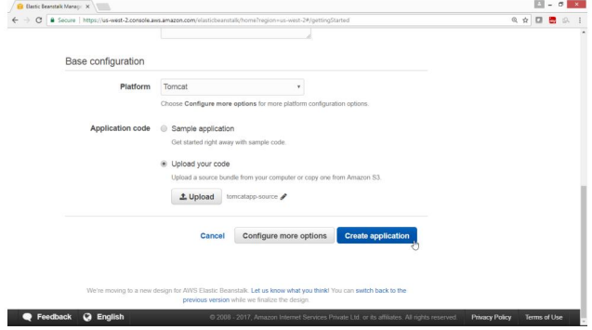

**Verification:**

Tomcat application at background is getting created,

Progress on screen are displayed

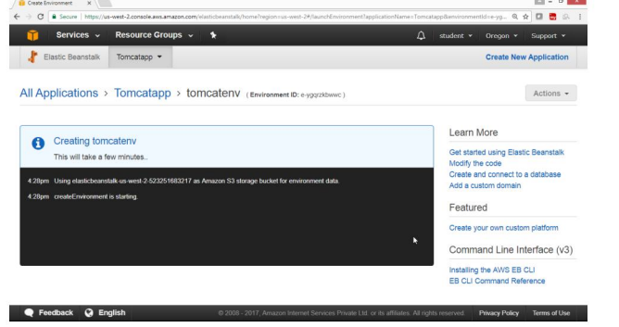

**Verify**

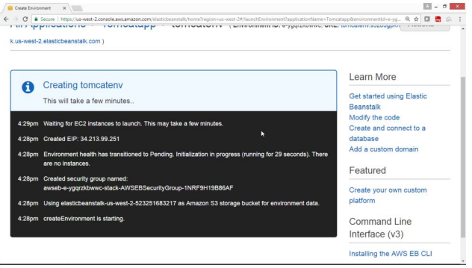

This will take few minutes to start.

Wait until the Tomcat screen is displayed on the screen

Click on the **URL** link

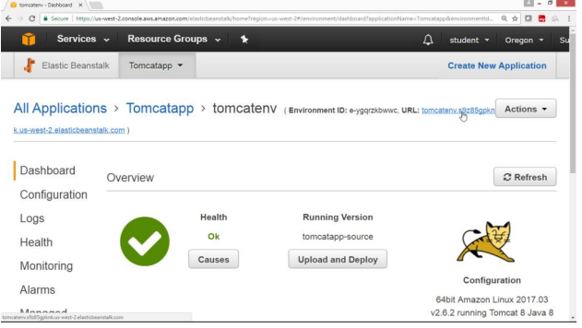

**Verification**

Open any Browser

Click on URL link

Website is open

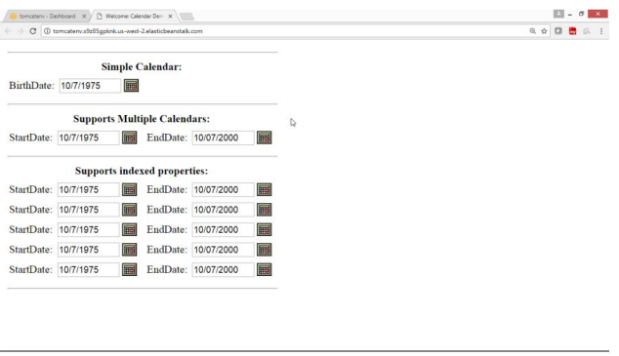

To remove **Elastic Beanstalk**

Select the **Action** button

Click **Delete Application button**

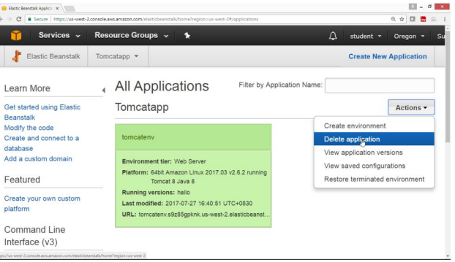

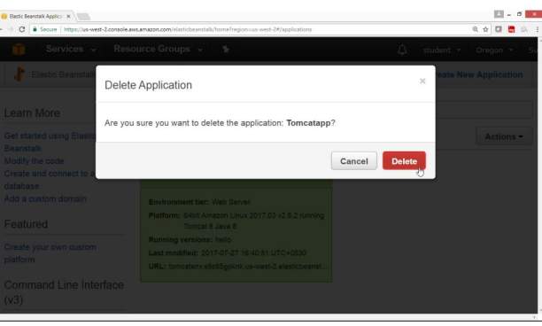

Application will now get Terminated

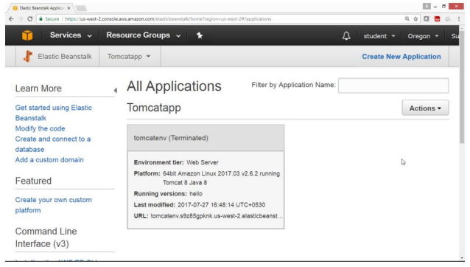

**Verification**

After Termination the Following screen will come

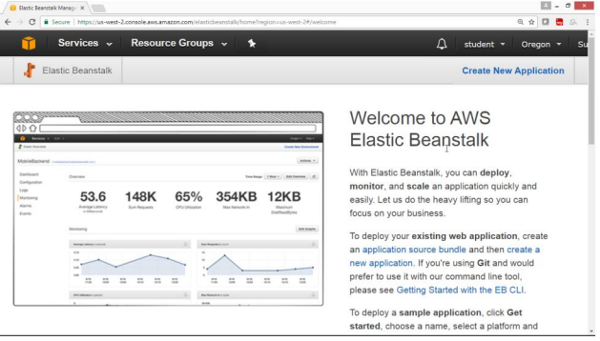

**To Delete Elastic Beanstalk bucket policy is created in S3 bucket**

S3 bucket is created by Elastic Beanstalk is not deleted automatically.

It could be charged ,after free usage is over,so manually delete the Beanstalk Bucket.

From Console select “storage”

Select S3

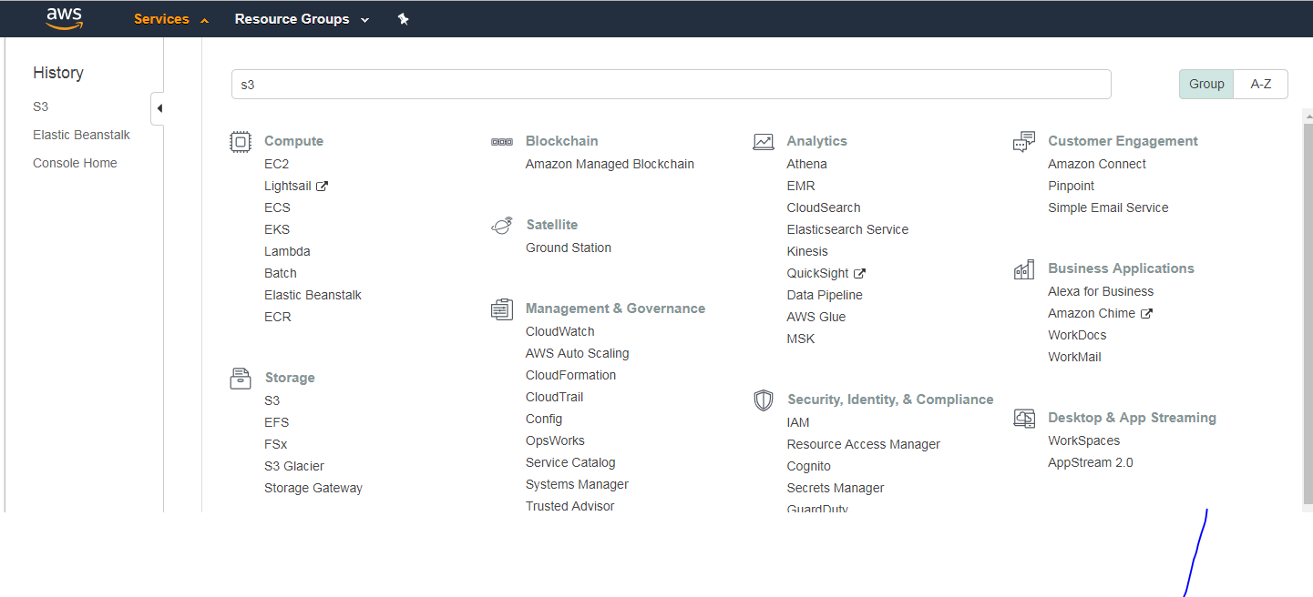

Select Elastic Beanstalk Bucket and click properties

Select permissions

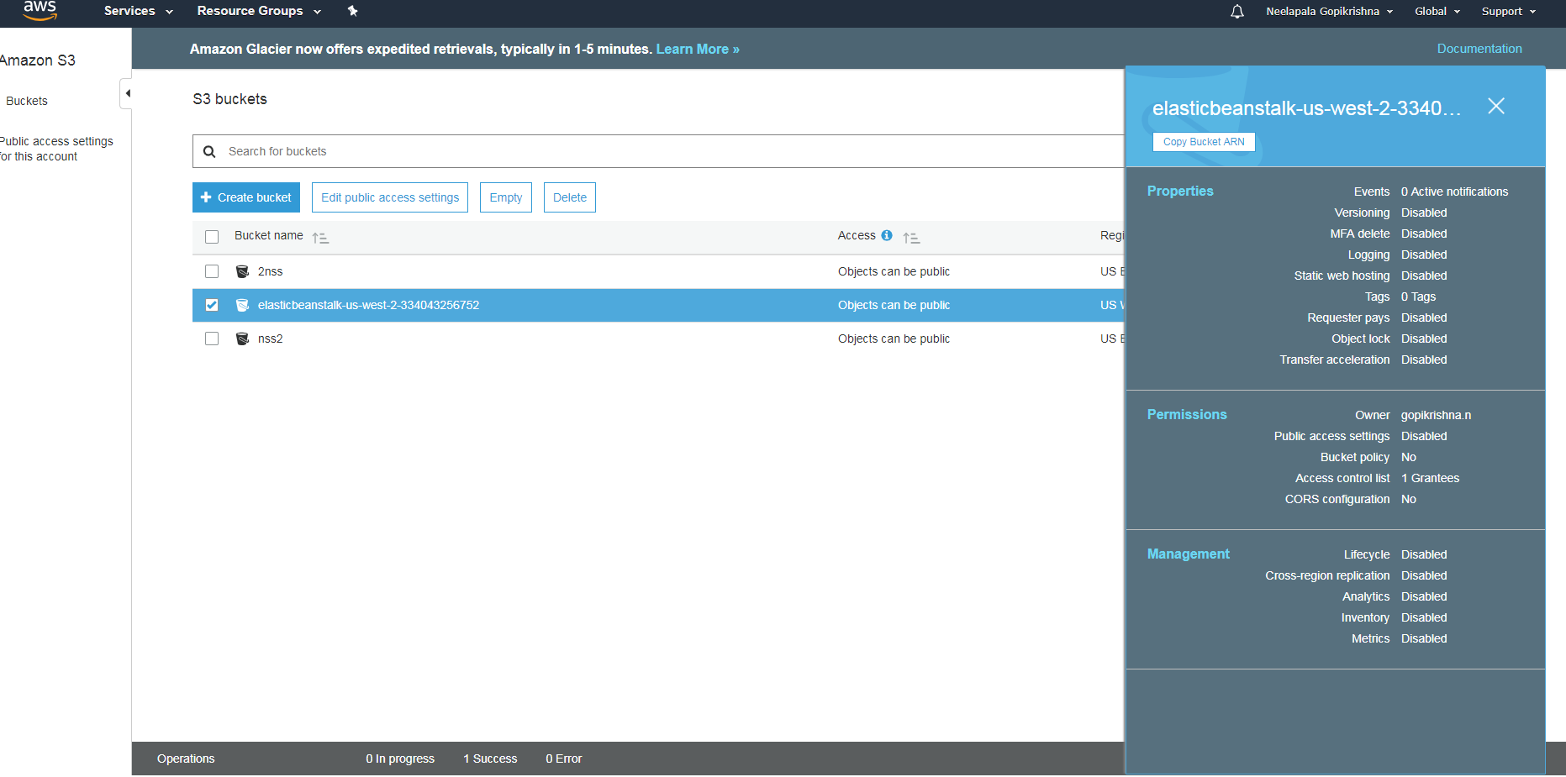

Select Bucket policy and edit bucket policy

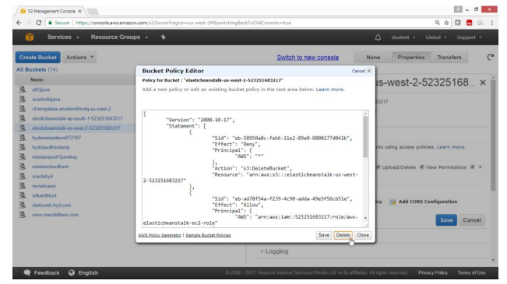

And press **save** Button

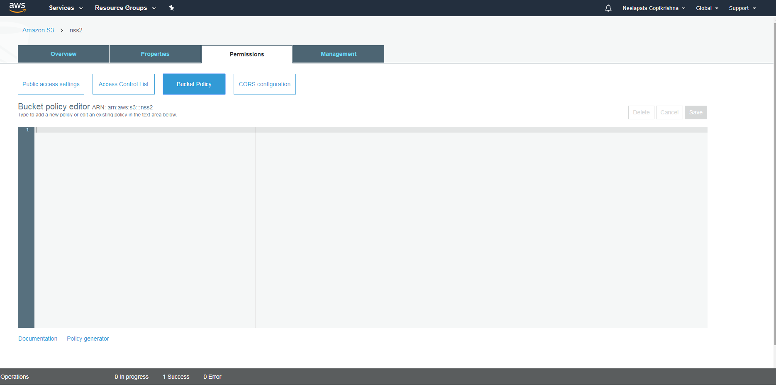

**Exercise 17**. **To configure an lightsail with apache2**

**Amazon Lightsail** is the easiest way to get started with AWS if you just need virtual private servers. Lightsail includes everything you need to launch your project quickly – a virtual machine, SSD-based storage, data transfer, DNS management, and a static IP – for a low, predictable price. After you create your instance, you can easily connect to it. You can manage your instances using the Lightsail console, Lightsail API, or Lightsail command line interface (CLI).

## Step 1: Sign up for AWS

Requires an AWS account. Sign up for AWS, or sign in to AWS if you already have an account.

## Step 2: Create a Amazon Linux 2018.03.0 instance in Lightsail

Get your Amazon Linux 2018.03.0 instance up and running in Lightsail.

Amazon Linux AMI (HVM / 64-bit). The Amazon Linux AMI is a supported and maintained Linux image provided by Amazon Web Services for use on Amazon Elastic Compute Cloud (Amazon EC2). It is designed to provide a stable, secure, and high performance execution environment for applications running on Amazon EC2. It also includes packages that enable easy integration with AWS, including launch configuration tools and many popular AWS libraries and tools. Amazon Web Services provides ongoing security and maintenance updates to all instances running the Amazon Linux AMI. The Amazon Linux AMI is provided at no additional charge to Amazon EC2 users.

-> You can add a shell script that will run on your instance the first time it launches.

1. Sign in to the Lightsail console. 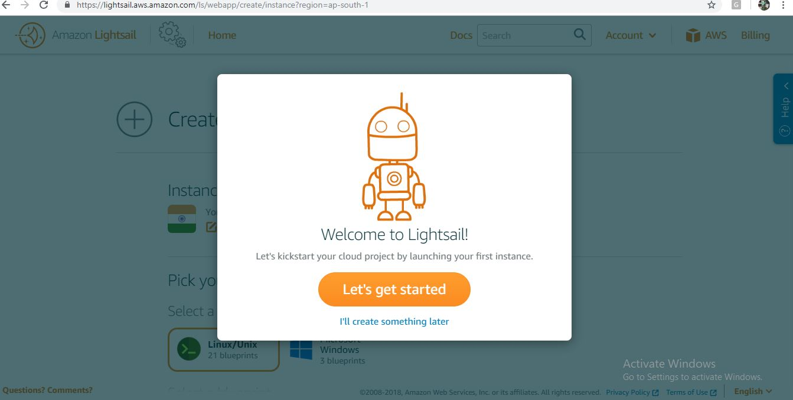
2. On the Instances tab of the Lightsail home page, choose Create instance.

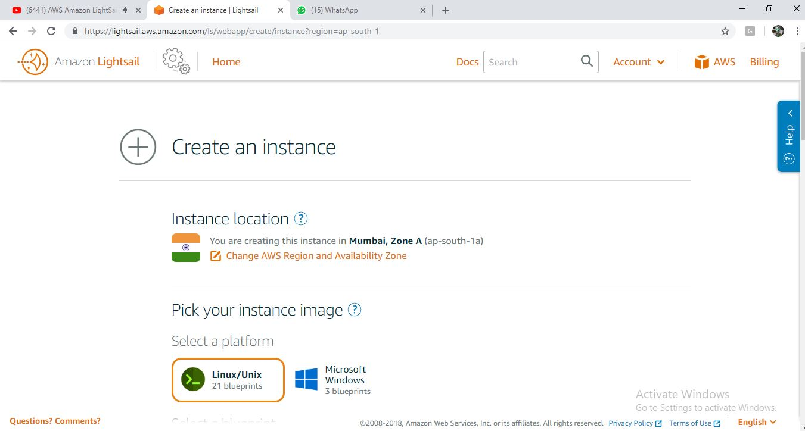

3. Select a location for your instance (an AWS Region and Availability Zone).

Choose Change Region and zone to create your instance in another location.

.

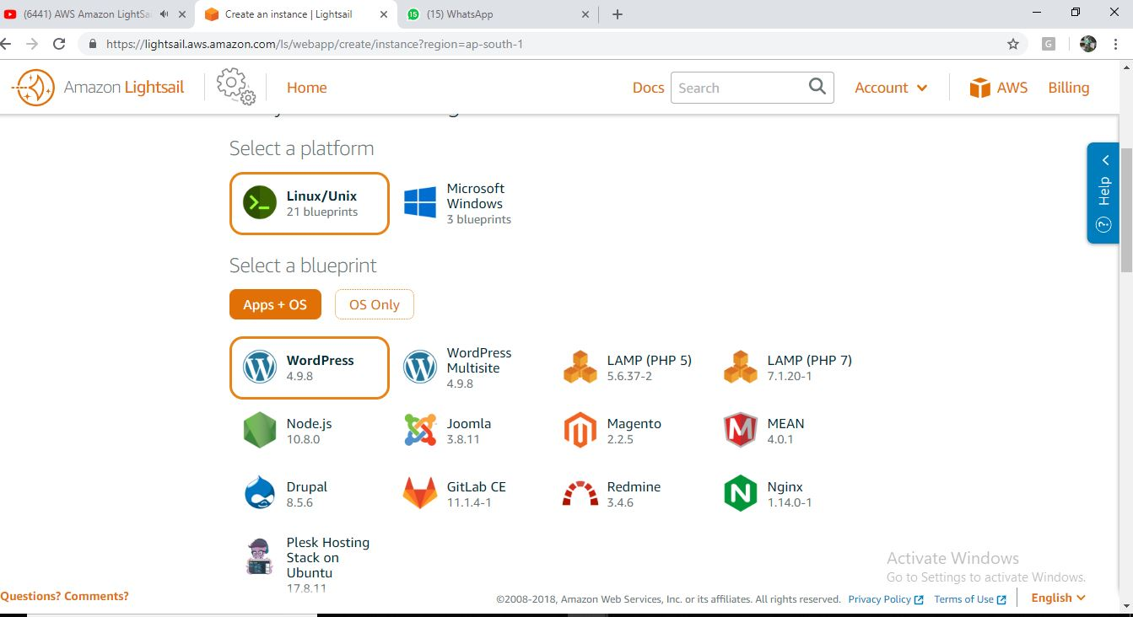

4. Optionally, you can change the Availability Zone. Choose an Availability Zone from the dropdown list.Choose the Linux platform.Pick an application (Apps + OS) or an operating system (OS Only).

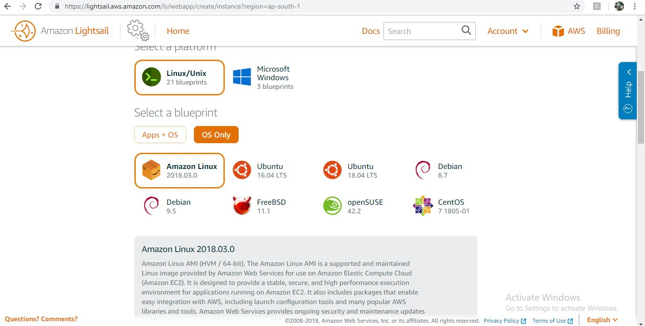

Choose your instance plan.You can try the $3.50 USD Lightsail plan free for one month (up to 750 hours).

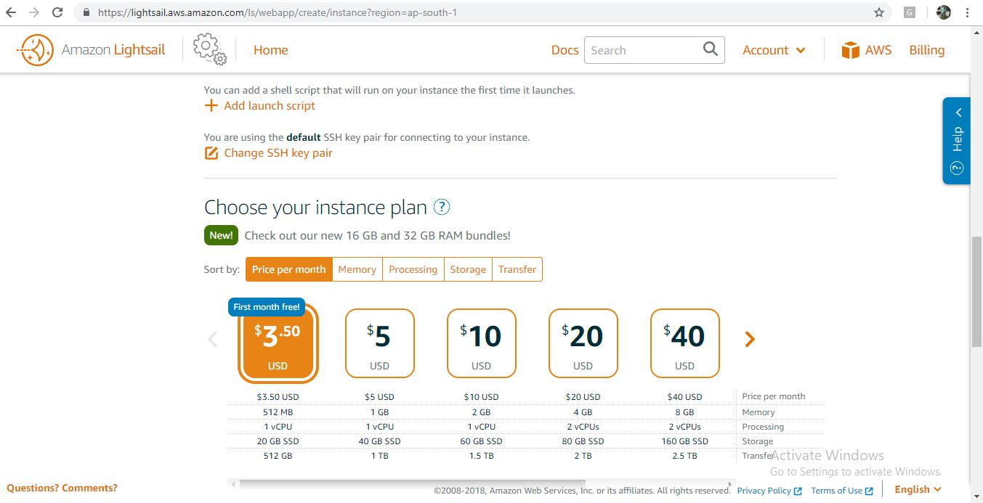

Enter a unique name for your instance.

Create a k**ey-value tag**, then enter a key into the Key text box, and a value into the Value text box. Choose Save when you’re done entering the tag, or choose Cancel to not add the tag.

Key-value tags can only be added one at a time. To add more than one key-value tag, repeat the previous steps.

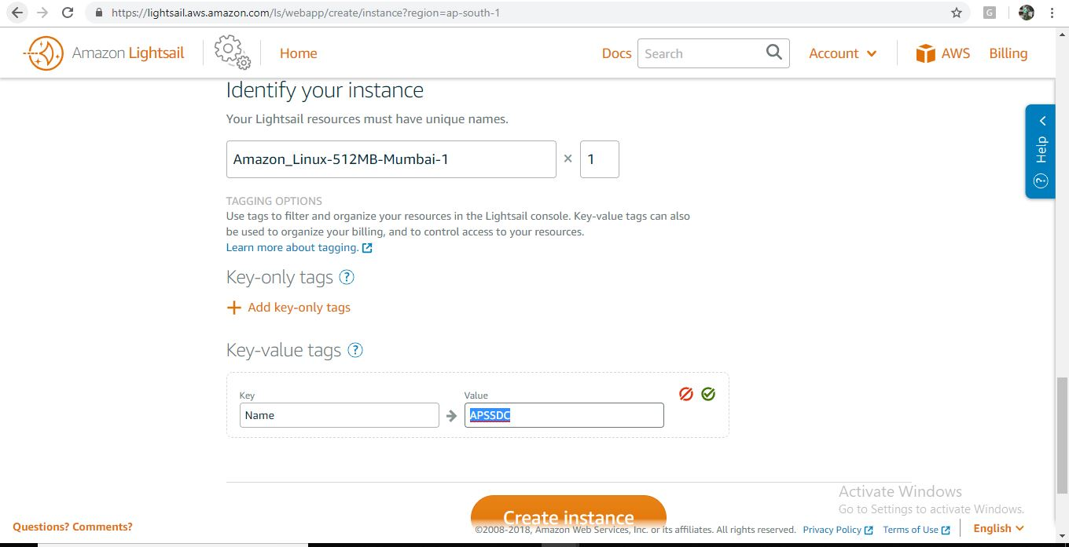

Choose Create instance.Within minutes, your Lightsail instance is ready and you can connect to it via SSH, without leaving Lightsail!.

Connect to your instance

1. On the Lightsail home page, choose the menu on the right of your instance's name, and then choose Connect

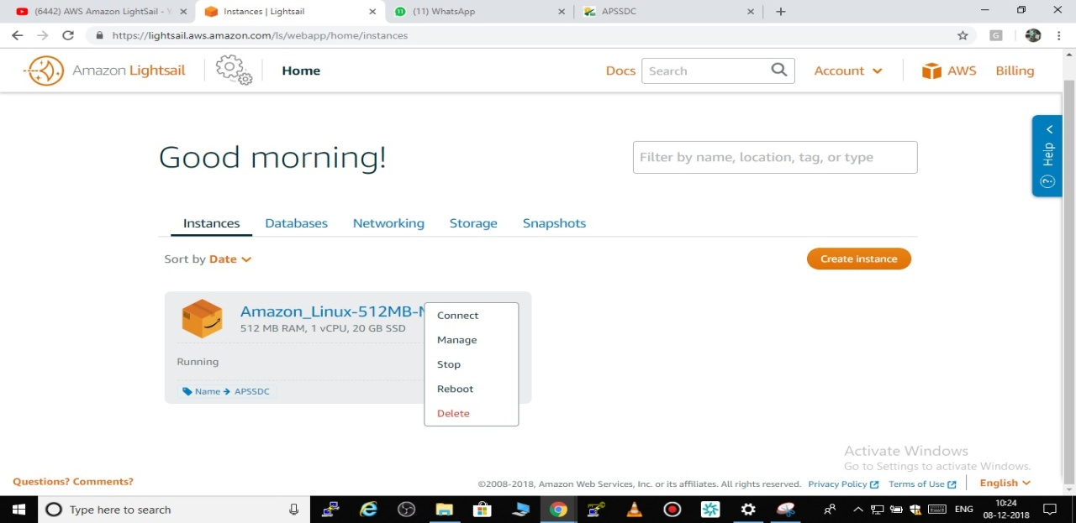

Alternately, you can open your instance management page and choose the Connect tab.

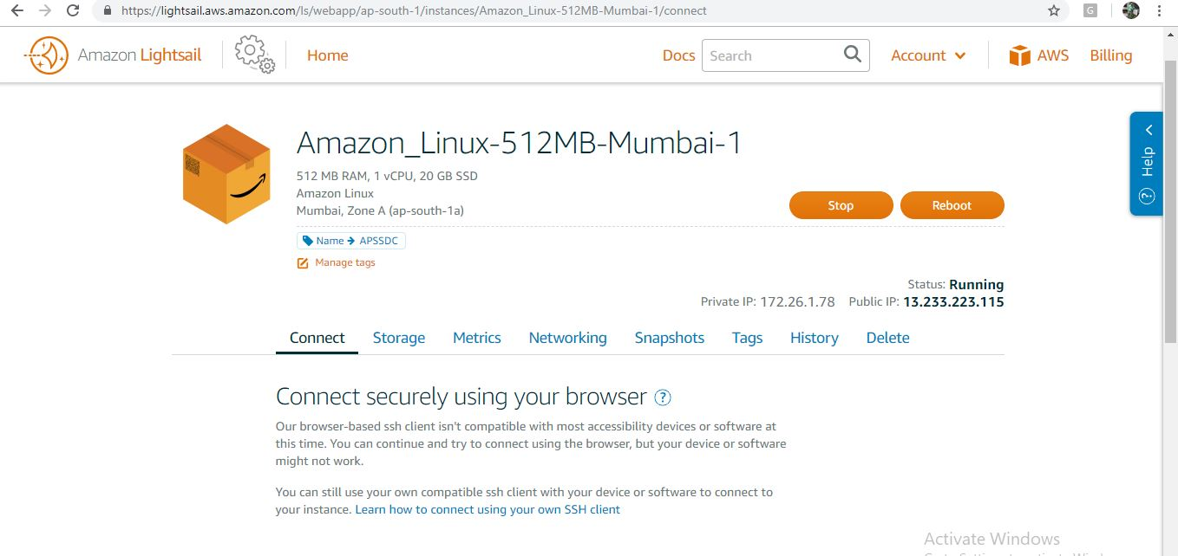

Note

You can also connect your instance using an SSH client such as PuTTy, by using private key files.

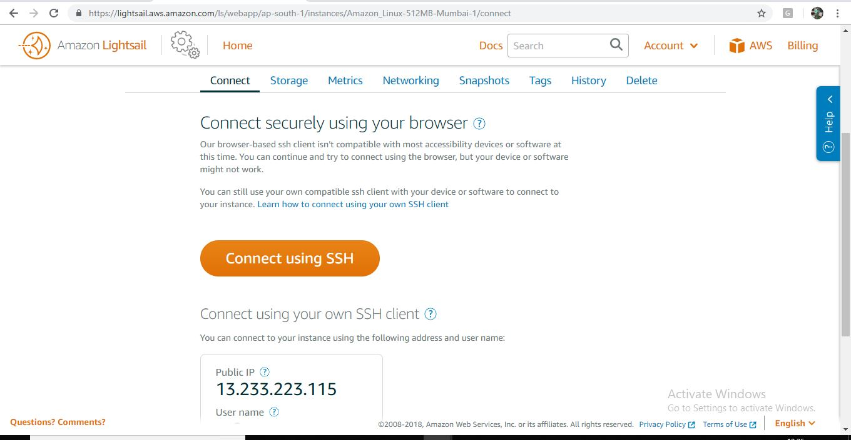

Now you can type commands into the terminal and manage your Lightsail instance without setting up an SSH client.

-> To update your instance you can use the below command

**$ sudo yum update -y**

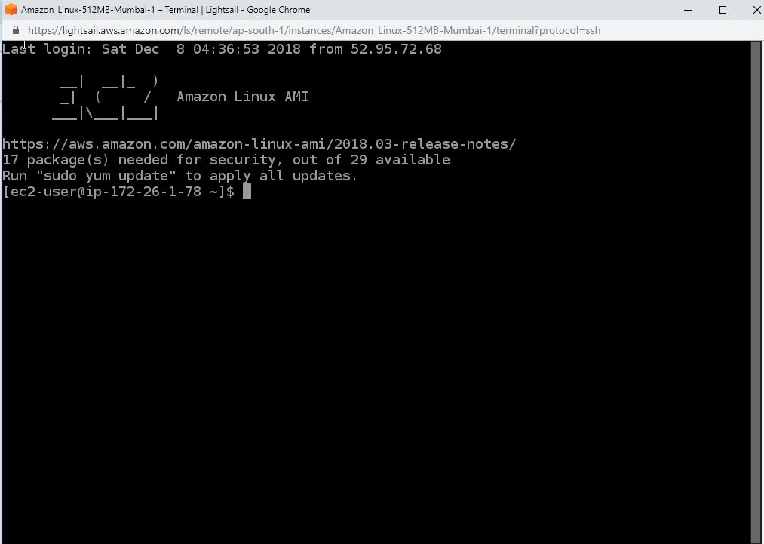

To install **apache2 into** your instance you can use the below command

**$ sudo yum install httpd -y**

**$ sudo service apache2 restart**

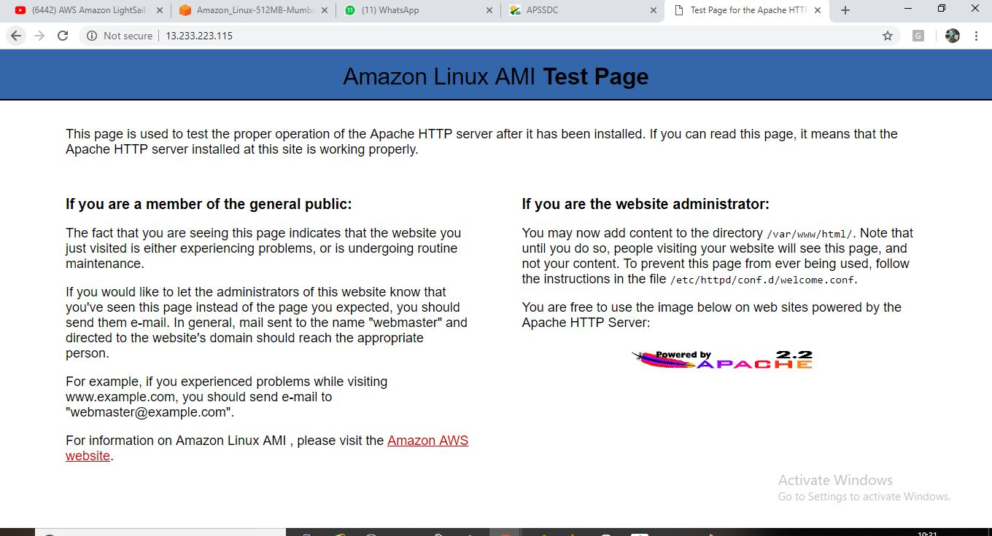

**Exercise 18. To configure Relational Database Service(RDS)**

**OBJECTIVE**

**To configure Amazon Relational Database Service**

**Topology:**

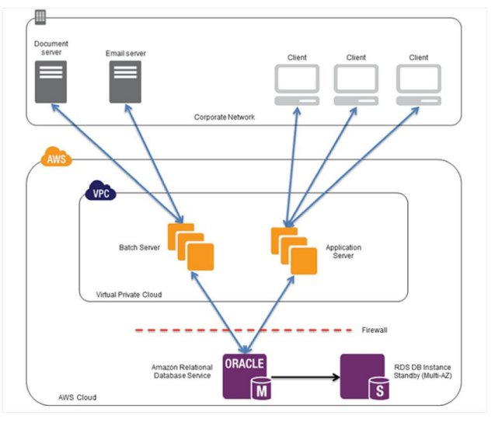

**Pre-Requisites:**

You should have AWS account, or IAM user with Amazon RDS FullAccess

**Task**

Create Amazon Relational Database Service

Verify Connection from mysql client command line tool

Verify connection using MYSQL workbench client application

**Practical steps**

**To create Amazon Relational Database service**

From the AWS Console

Select **Database**

Click on **RDS** Service

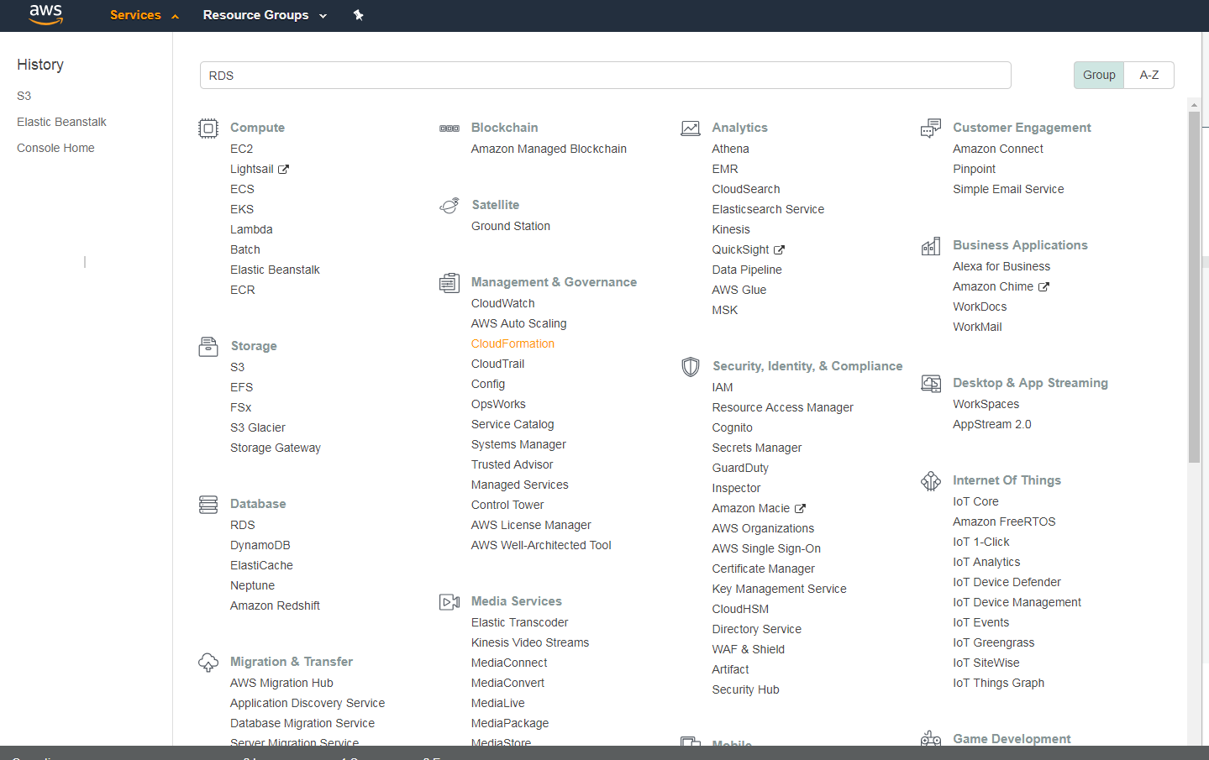

In **RDS** Dashboard

Click on **Create Database ,** button

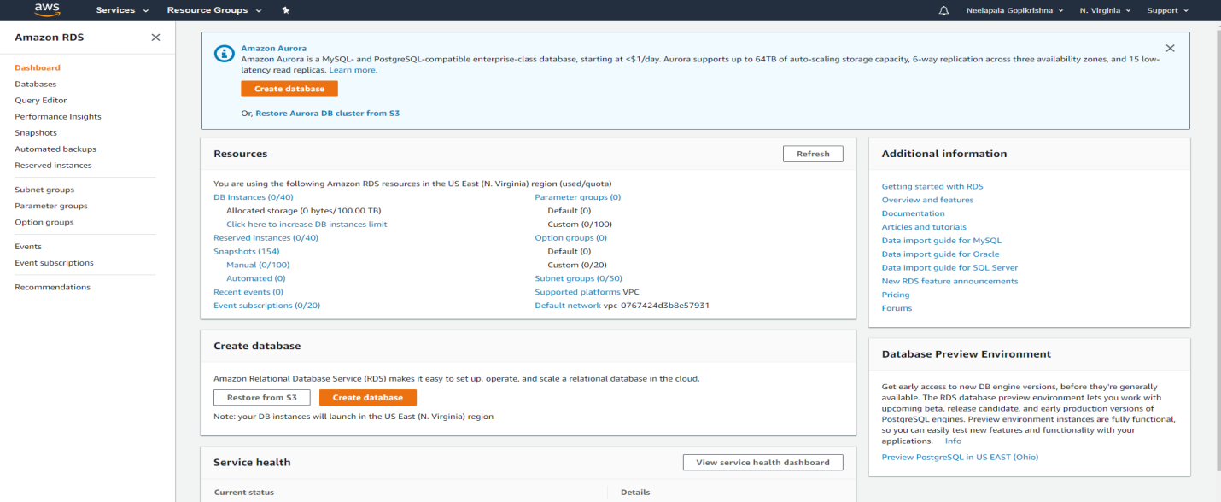

In **select Engine**,Wizard

Click on MySQL

Click on select button

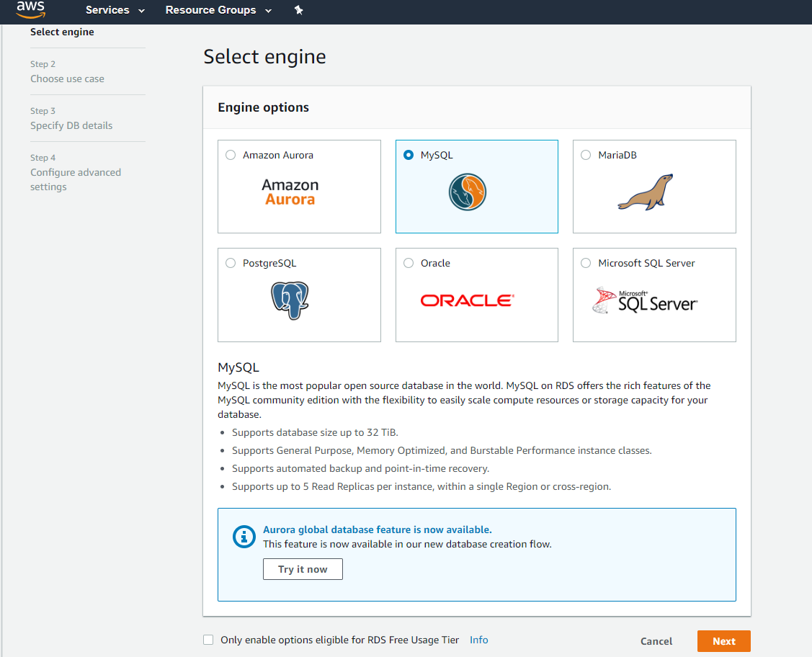

**In Production Wizard,**

Select Dev/Test ,choose **MySQL**

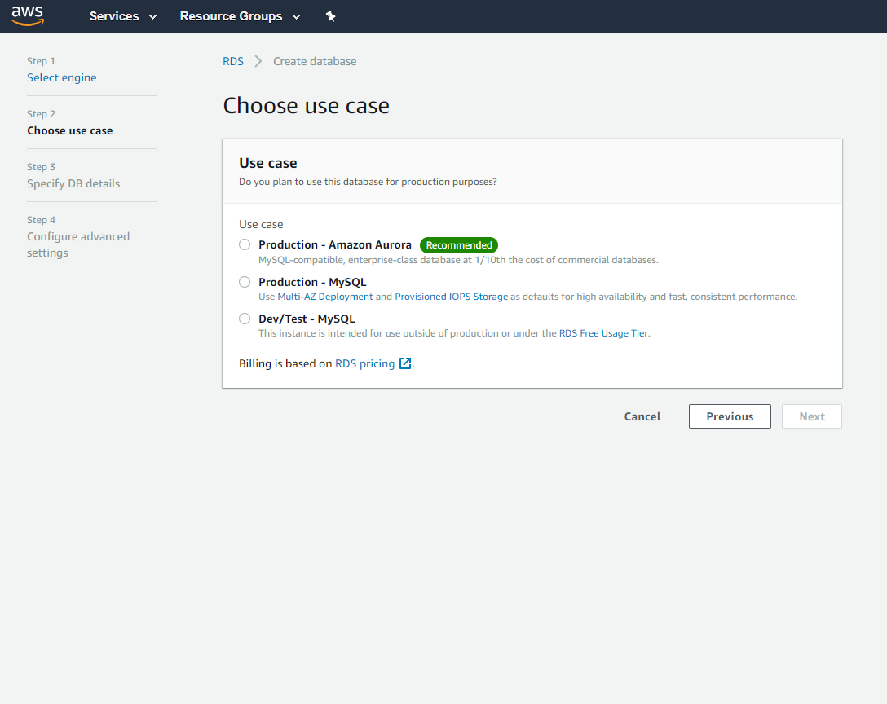

If **specify DB** details

**Instance Specifications**

For DB engine ->Mysql

For License Model ->general-public-license

For DB engine version ->5.6.40

Storage type ->General -purpose SSD

For allocated storage ->5GB

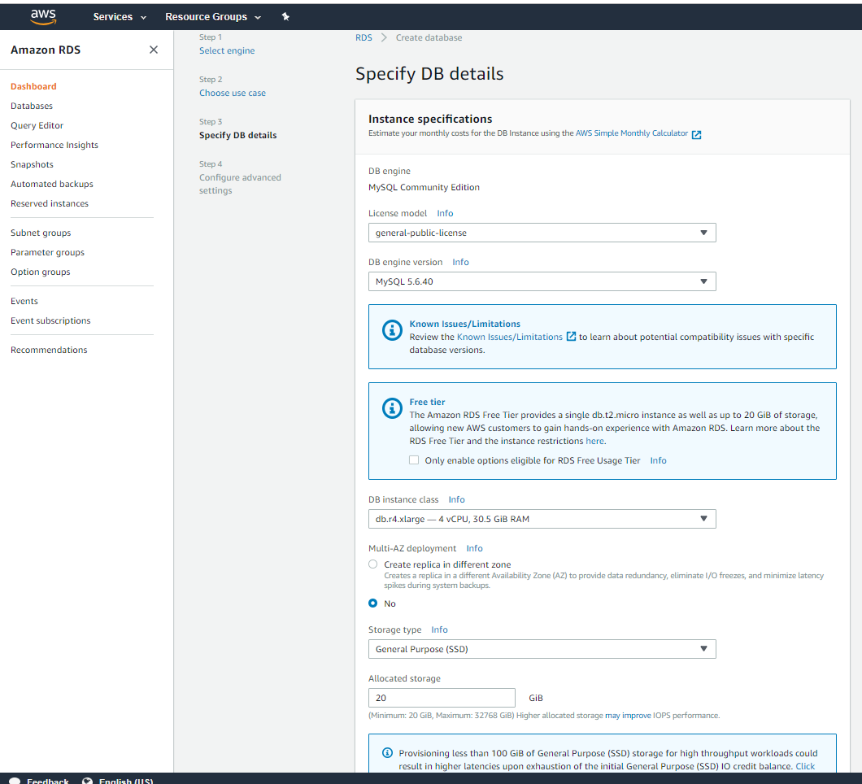

**Under settings**

DB instance Identifier ->rds database

Master username ->testuser

Master password ->**\*\*\*\*\*\*\*\*\*\***

Confirm password ->**\*\*\*\*\*\*\*\*\*\***

Click on **Next button**

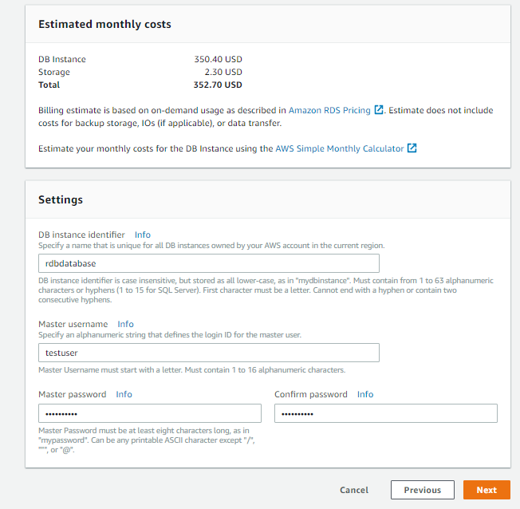

**Configure Advanced settings.**

Provide following values

VPC ->Default

Subnet Group ->Default

Publicly accessible -> yes

Availability zone -> No preference

VPC Security group ->**Create a new security group**

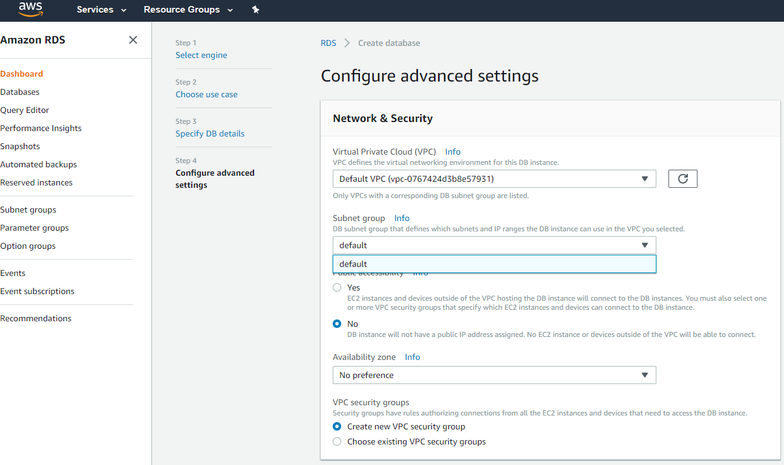

**Under Database Options**

Provide following values

Database name ->**gopi**

Database port->**3306**

DB parameter group-> **default.mysql5.6**

Option Group->**default.mysql5.6**

Copy tags to snapshots->**leave blank**

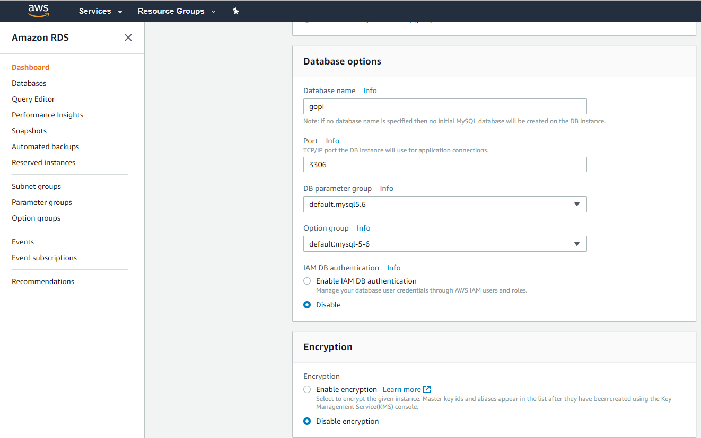

Provider following values

**Under Backup**

Backup retention period->7 days

Backup window->No preference

**Under Monitoring**

Enable Enhanced monitoring->No

**Under maintenance**

Auto minor version upgrade-> No

Maintenance window ->No preference

Click on **Launch DB Instance**

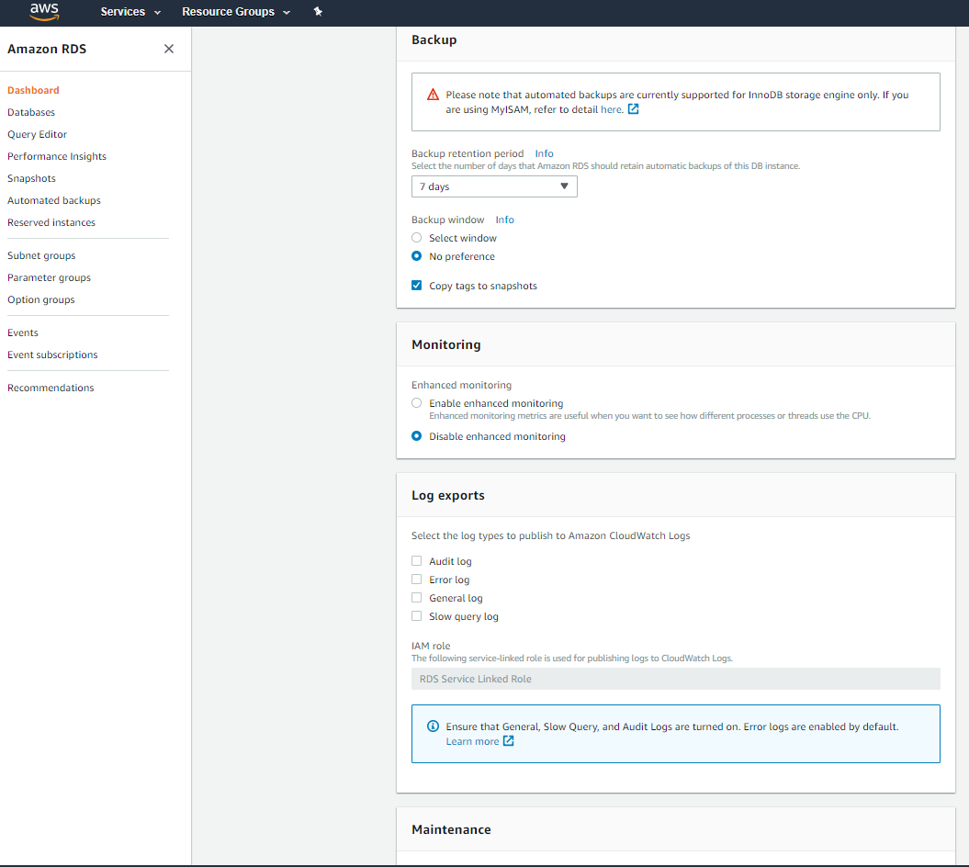

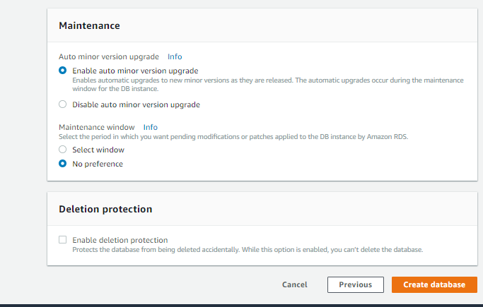

Your DB Instance is being created

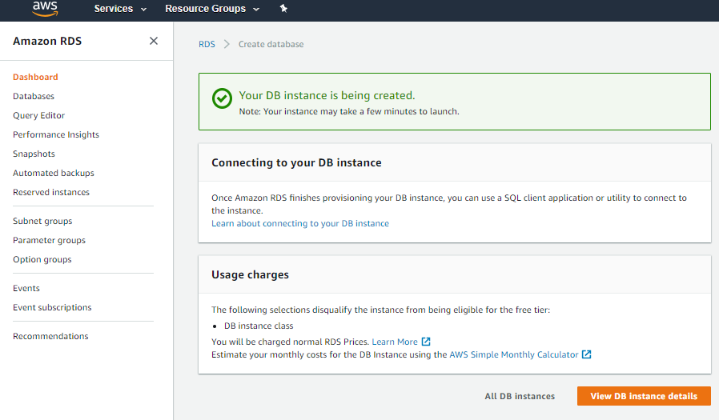

Click on **View your DB Instances** button

Under status column

Verify **creating**

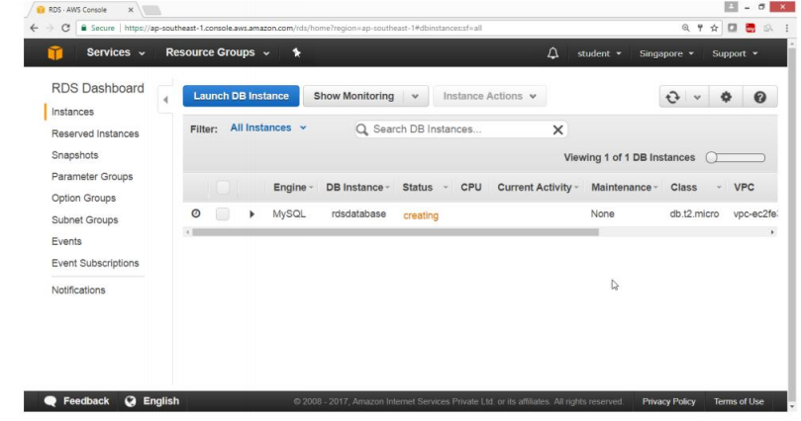

**Select MySQL Engine**

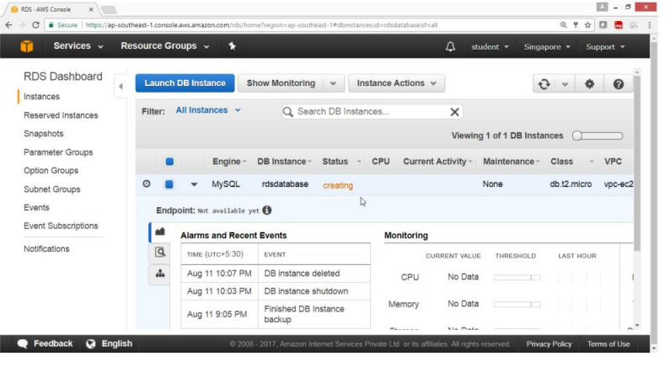

Under Status Column

Verify **Backing-up**

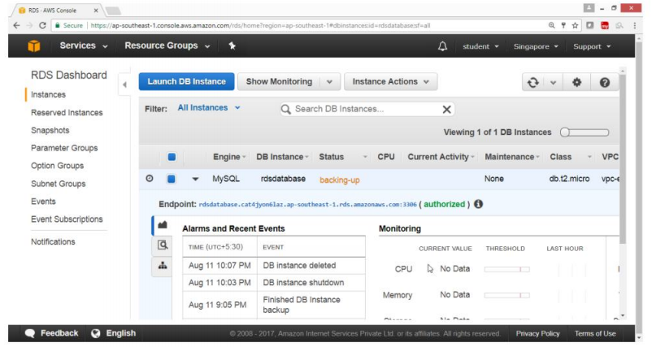

Under status column

Verify **available**

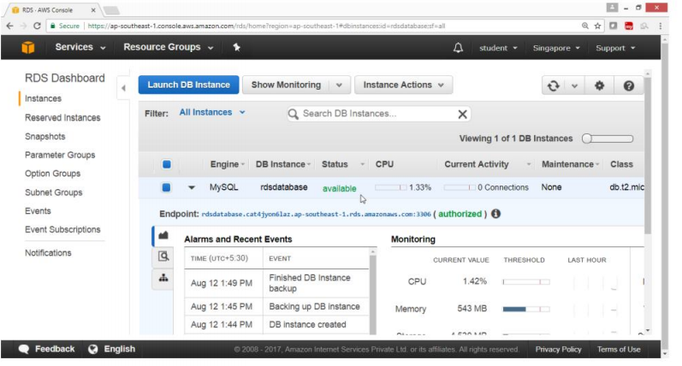

**Client side**

**Go to Linux box**

**Run MySQL client command to connect to RDS Database**

**Syt:$mysql -u<username> -h <End_point_of_RDS-Instance> -p <password>**

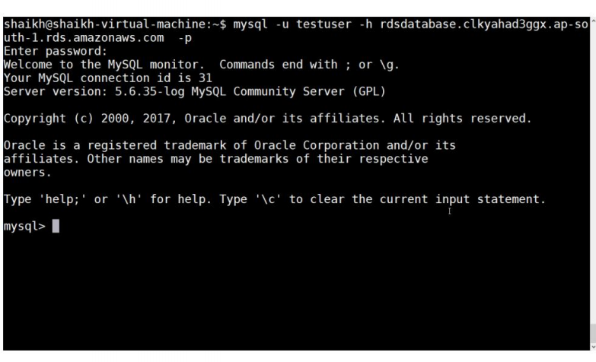

**To see the list of databases;**

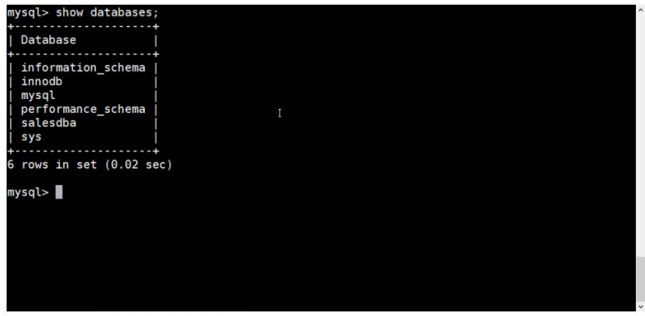

**Use the database**

**Create Table**

**Insert values in table**

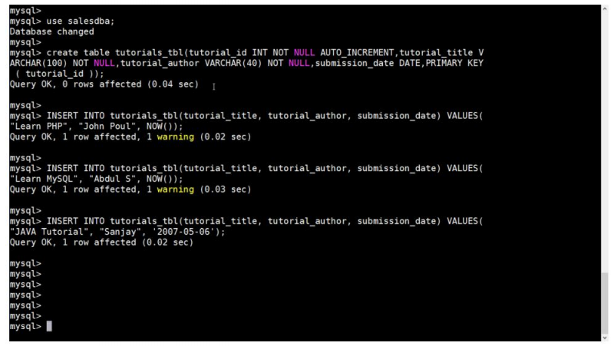

**To see the structure of the table;**

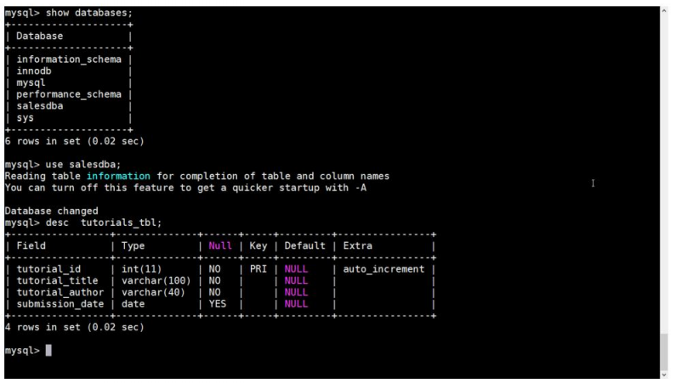

**To see records in the table;**

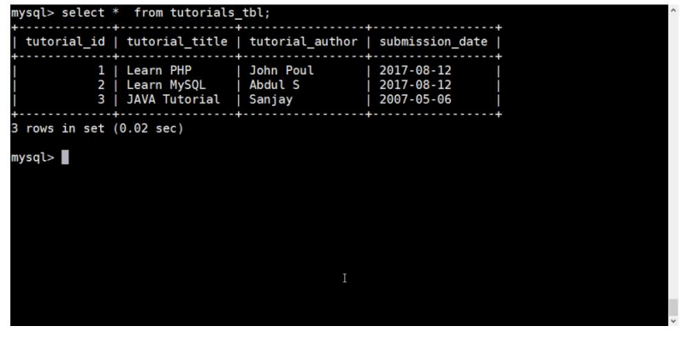

**To Access RDS Database through MYSQL WorkBench Client application**

Open MySQL WorkBench client application,provide following details

On MySQL Connection tag,click plus radio button

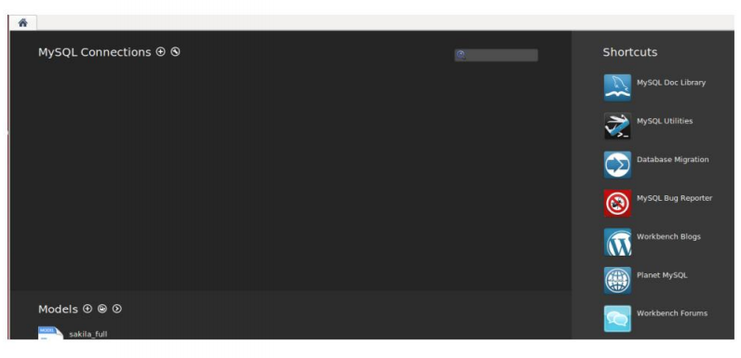

**Provide following values for**

Connection name: ->testcon1

Connection Method:->Standard (TCP/IP)

**Parameters**

Hostname ->copy RDS url

Port -> 3306

username->testuser

pasword->*********

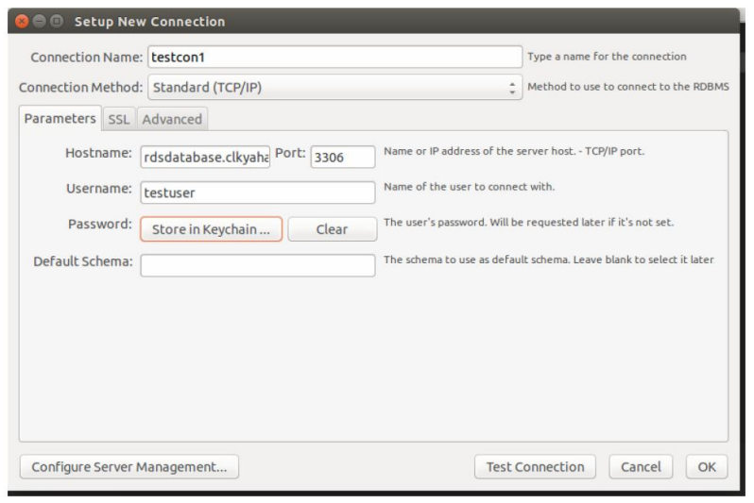

Verify

Connection is getting established.

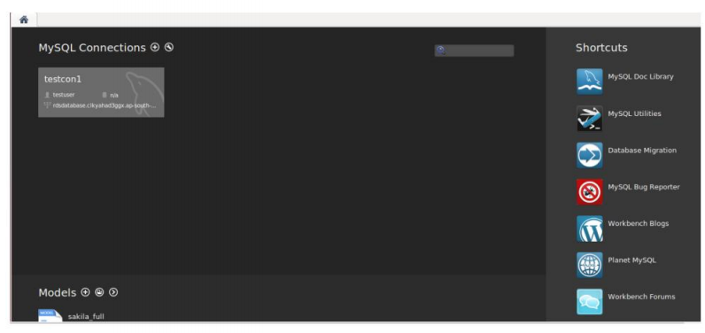

**So we can see that tables are listed in MySql clients.**

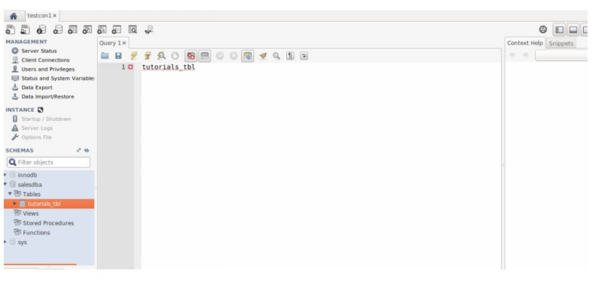

**To Delete The RDS Instance**

Open the RDS Dashboard,select instance

Drop down instance Action button,select delete

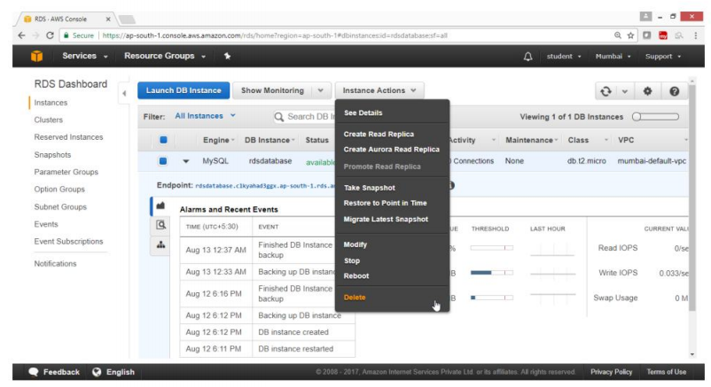

For create final snapshot -> No

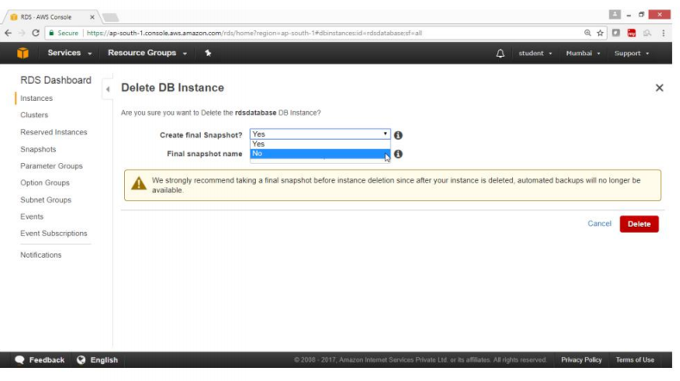

Select acknowledge check box

Click on Delete button

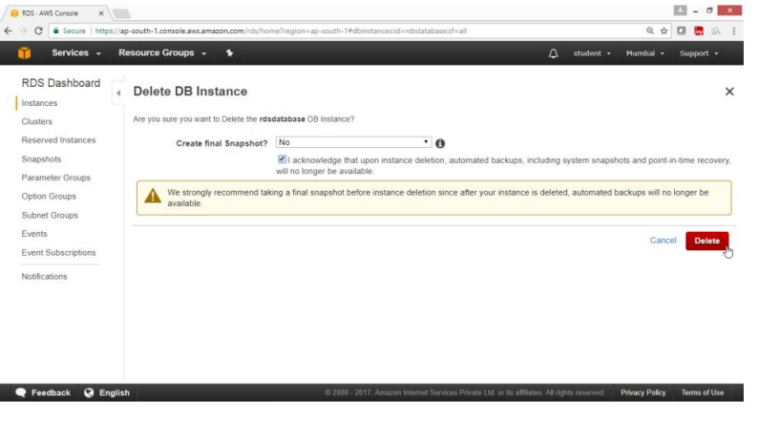

Verify

In status column ->deleting

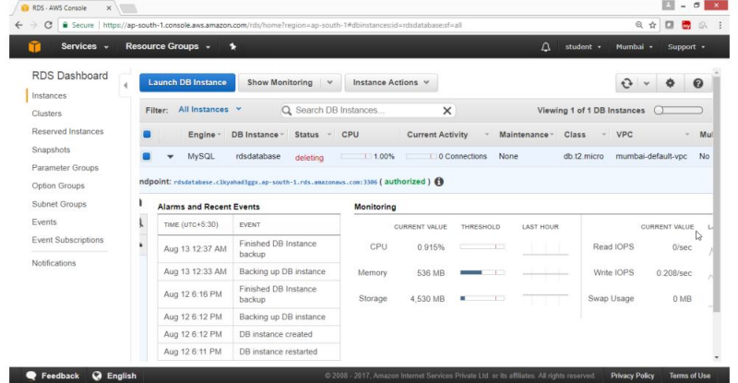

**Delete Confirmed**

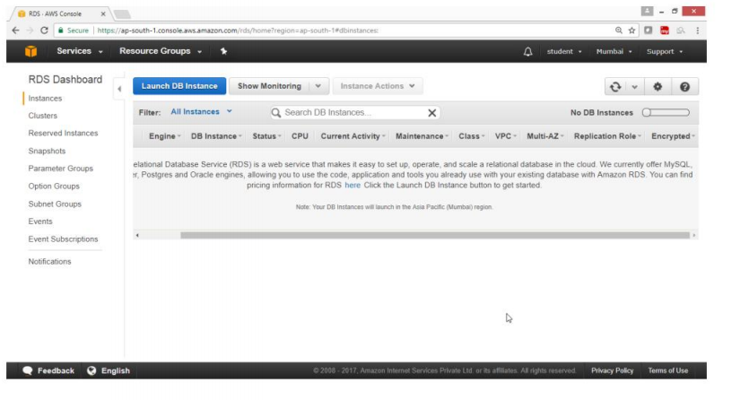

**Exercise-19:To Configure Amazon DynamoDB**

**OBJECTIVE**

**To configure a table create records in Amazon DynamoDB**

**TOPOLOGY**

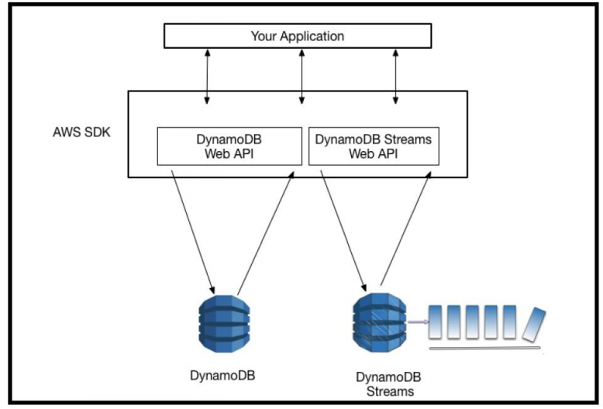

**Pre -Requisites**

User should have AWS account, or IAM user with Amazon DynamoDB FullAccess

**TASK**

Create DynamoDB table

Provide Provisioned Read/Write capacity

Add the values to a table

Scan the table

Query table

Delete the table

**1)To create an Amazon DynamoDB table**

**To Create table**

Open AWS console

Select services **Database**

Click on **DynamoDB**

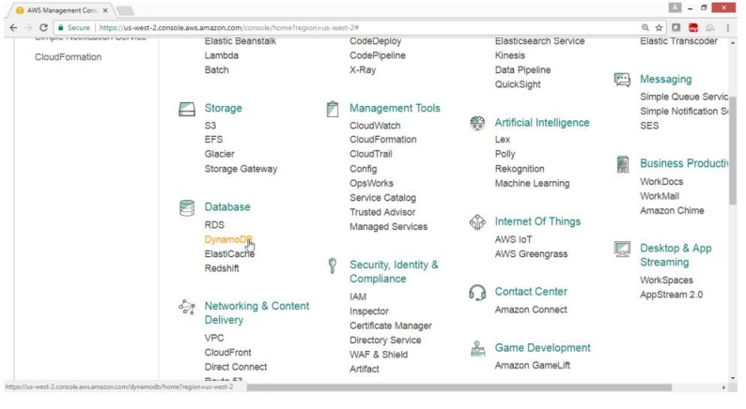

From DynamoDB Dashboard,Click on **Create table** button

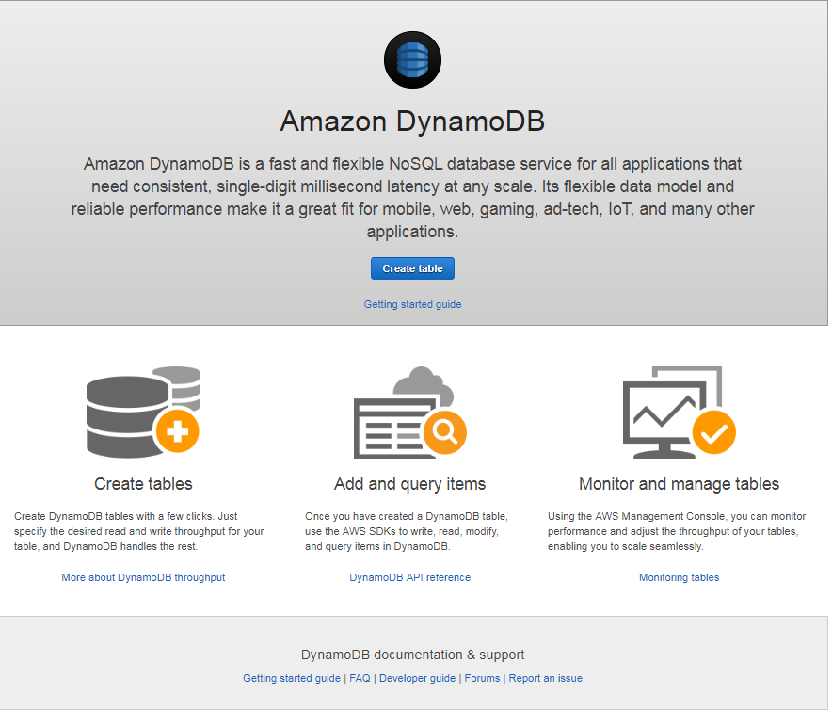

On **“Create DynamoDB table”** wizard

Provide following value

Table name* ->salestable

Partition Key ->**item no**,select **String**

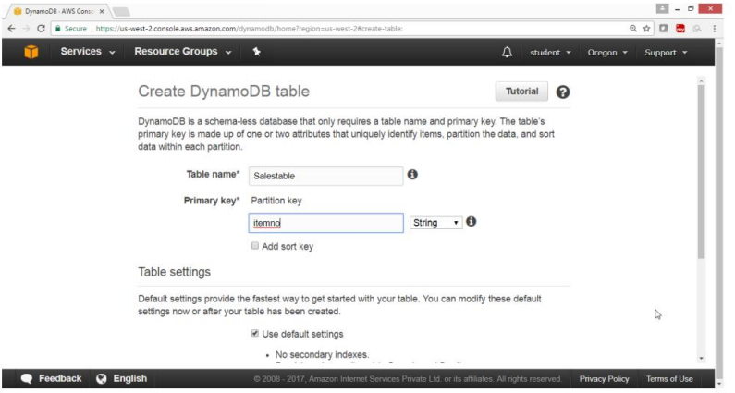

Under Table settings

Select **“Use default settings”** check box

Click on **Create** butt**on**

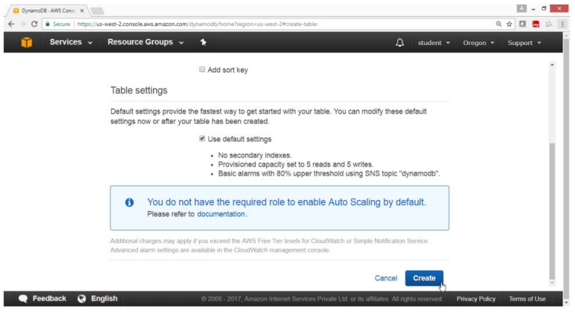

**Creating**

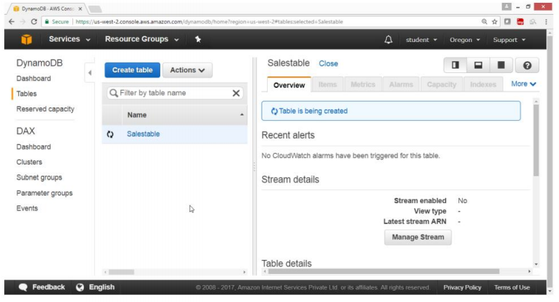

**Verification**

**Salestable is created**

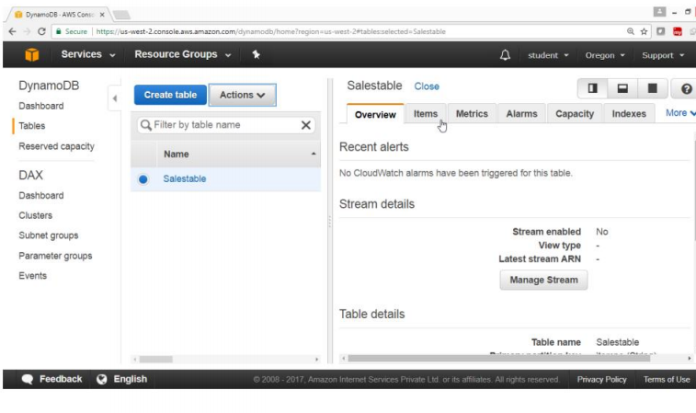

Select Capacity

Under **“Provisioned capacity”**

Provide the following values

Read Capacity ->2

Write Capacity units ->2

Click on **Save** button

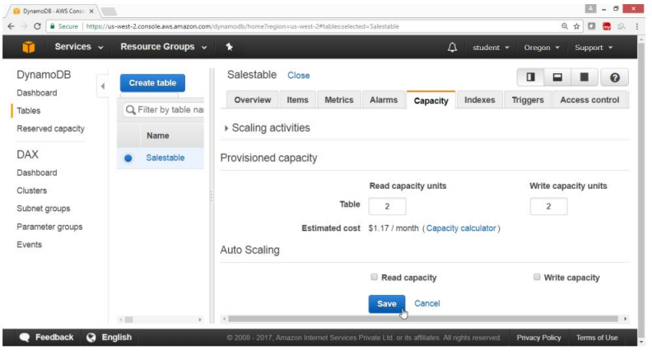

Select **item**

Click on **Create item**

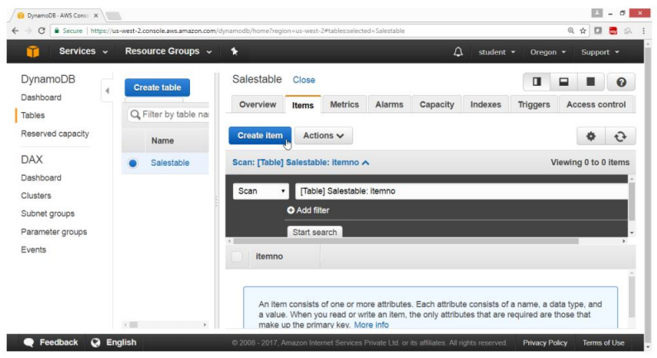

**To add,append,insert values in the table**

Open DynamoDB Dashboard,select tables

Select the tables from tables list

Check status,by clicking on

Overview

Items

Metrics

Alarms

Capacity

Indexes

Triggers

Access control

Select Items,add tables field

Click on **“Create Items”**

**On “create items”page**

Click on Tree

Click on plus radio button

Provide

**item no String 1**

Click on plus radio button

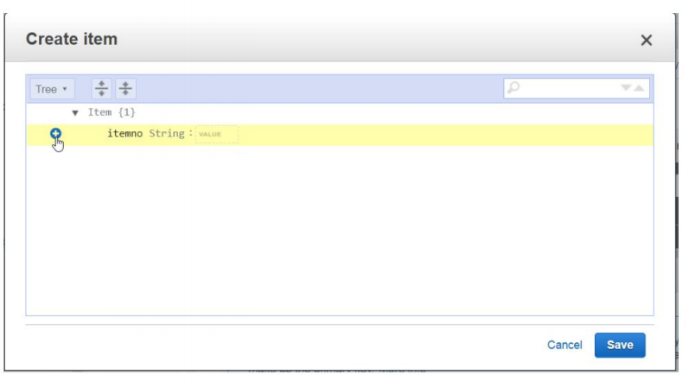

Select insert ,select string

ItemName String fruits

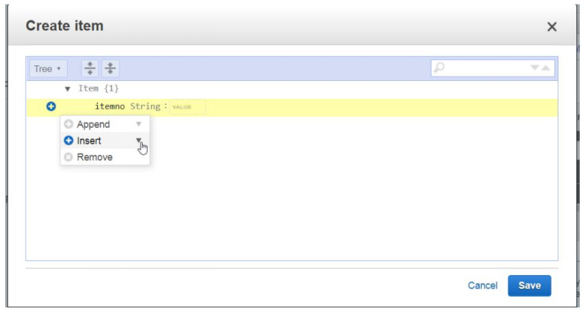

**Verify output**

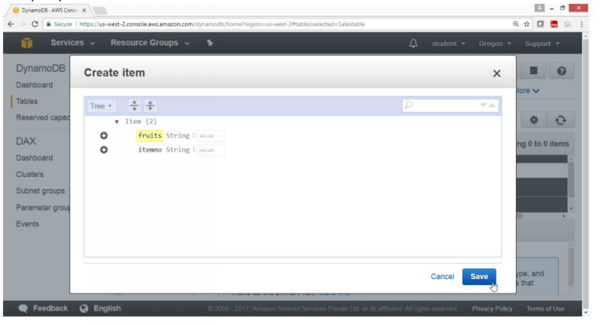

Click on plus radio button

Select insert,select number

Ph ->123456789

Click on **Save**

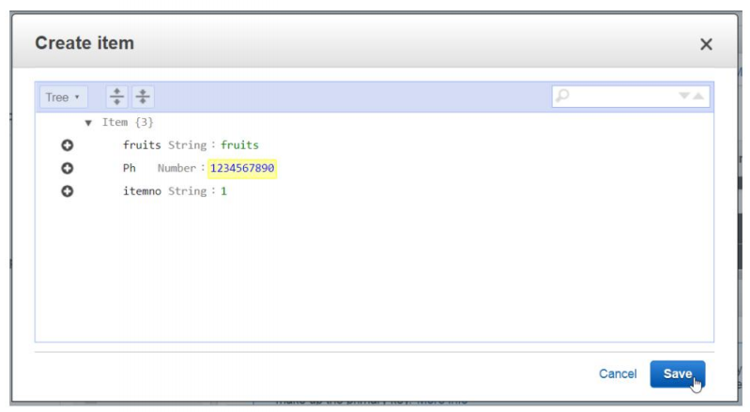

To View all entered data

Select scan,click start search

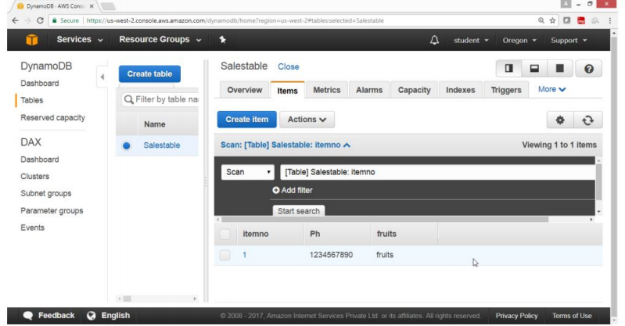

To add values in the created fields

Select the Table row,click **Action** button

Select **Duplicate**

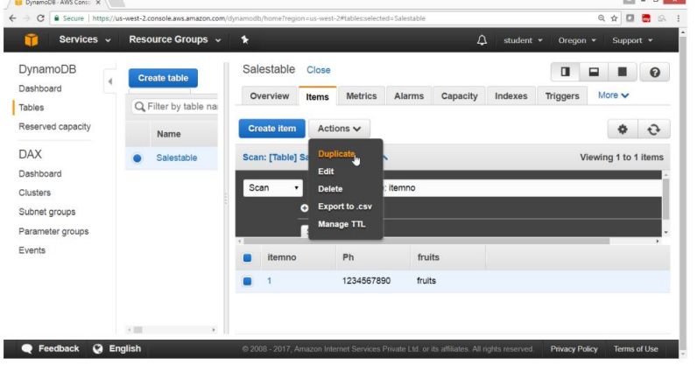

Now modify the values of the field

New row will be created

Click on save

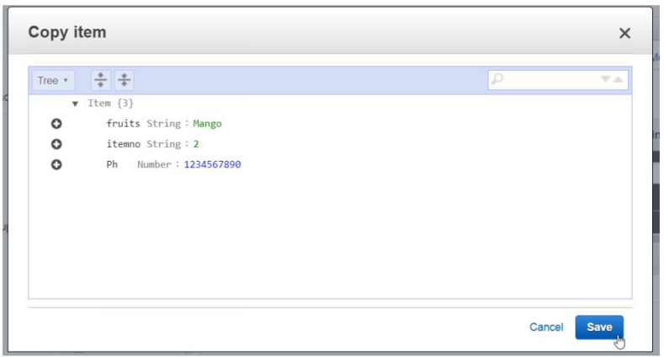

Verify

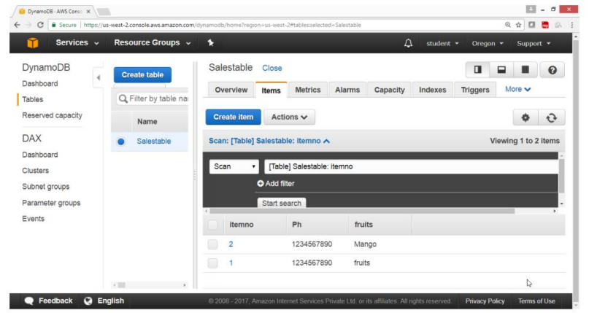

**To Delete the table permanently for DynamoDB**

From the AWS console

Select services **Database**

Choose **DynamoDB**

Under **Tables**,select the table for the list

Click on Action button

Select **“Delete table”**

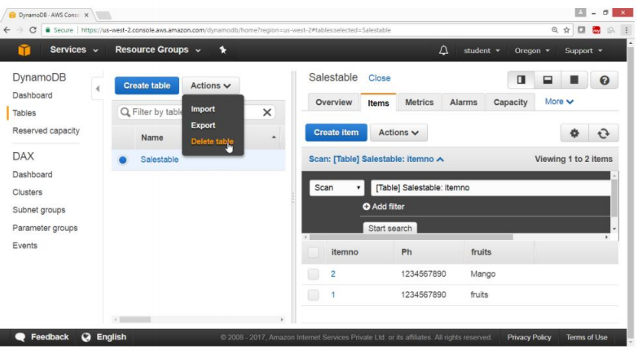

Click on **Delete** button

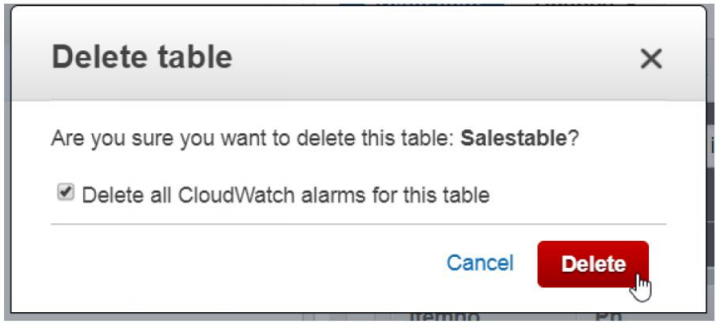

Verify Table is deleted.

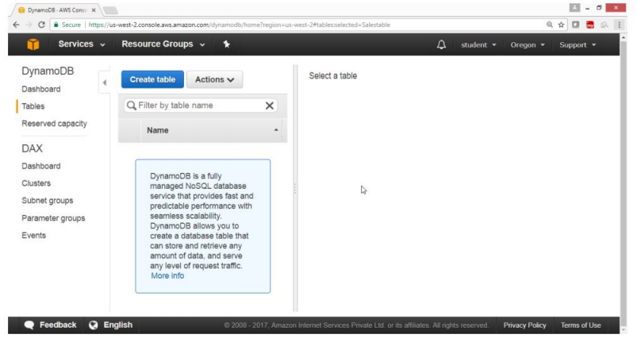

**Exercise-20:To Configure Amazon CloudFormation**

**Objective**

**To configure AWS CloudFormation**

**Topology**

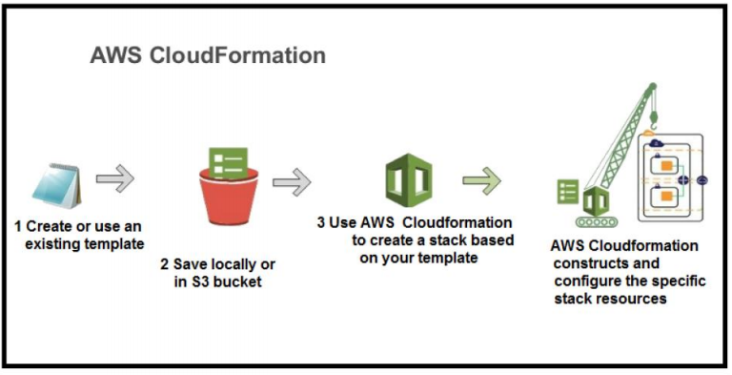

**PRE-REQUISITES**

User should have AWS account ,or IAM user with CloudFormation fullaccess

**TASK**

Creating EC2 instance using CloudFormation

Deleting all resources from CloudFormation

**Practical Steps**

1. **To launch Amazon EC2 instance in a security group using CloudFormation**

Open **AWS** Console

Click on **Services**

In **Management tools** services

Click on **CloudFormation** service

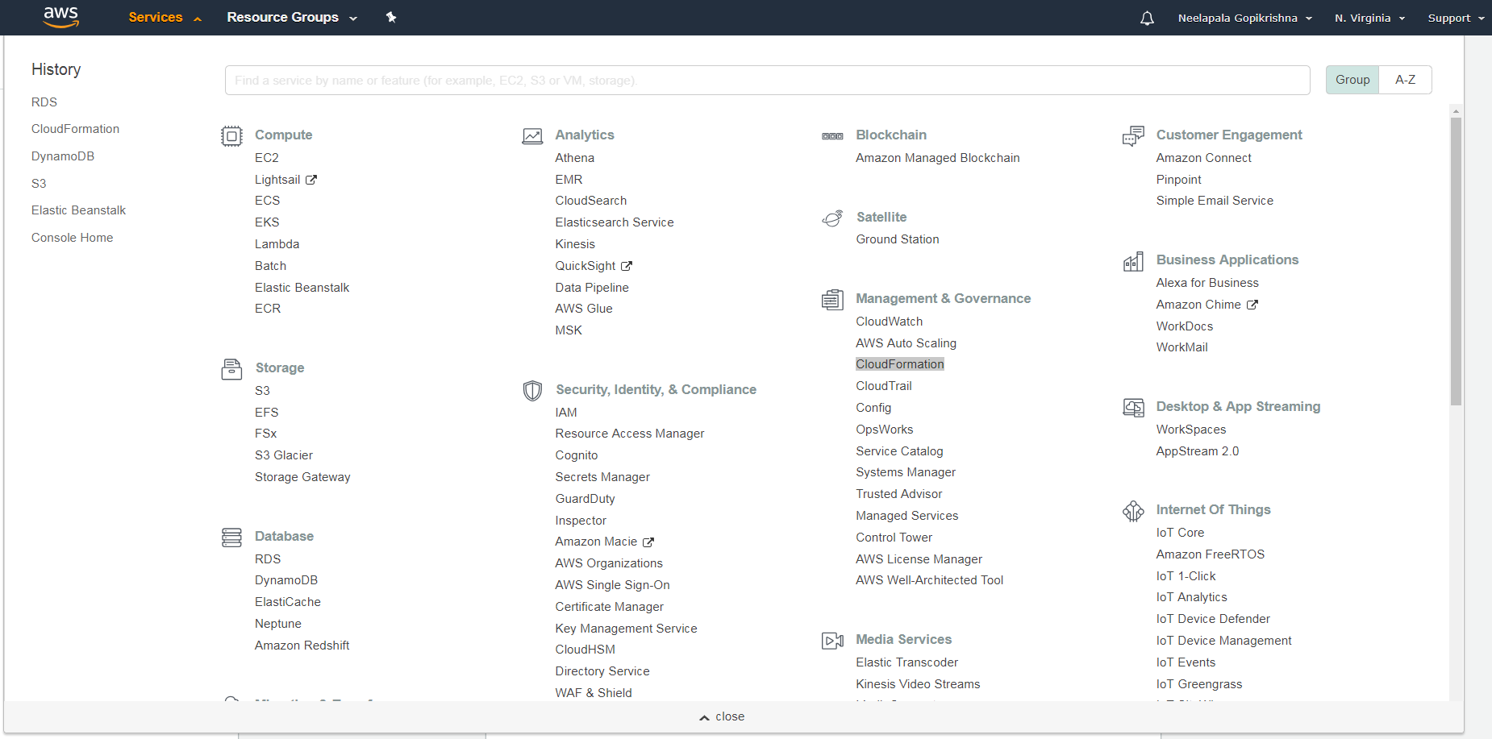

**To create a new stack**

On “Create Stack” , page

Click on **“Create New Stack”** button

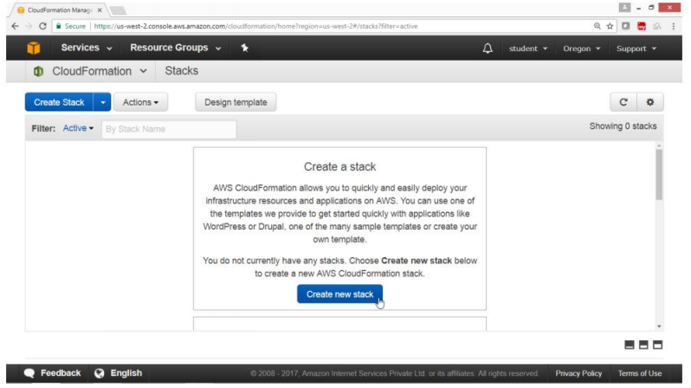

Under “Choose a template”

Select **“Select a sample template”**

On **Create stack** page

Select the **“Sample template”**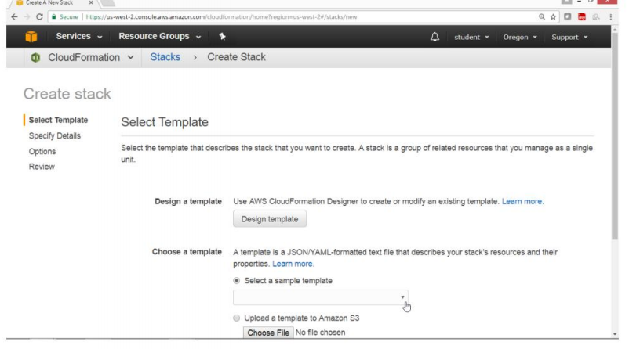

In the Drop Down box

Choose **“Sample templates”**option

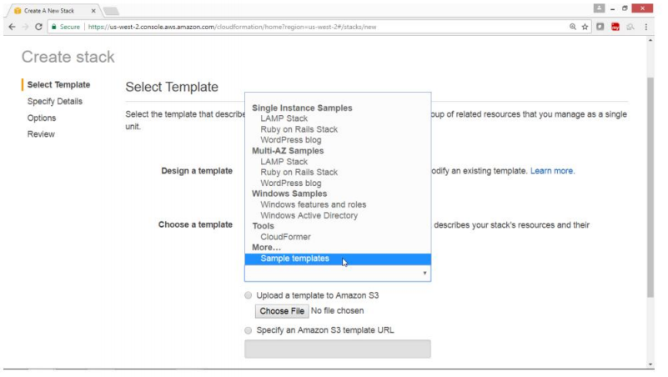

On **“AWS CloudFormation Templates”** page

Click on **“sample templates”**

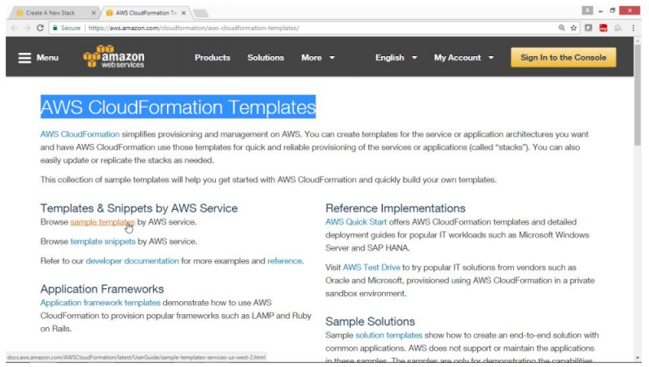

**Under Topics**

**Select Amazon EC2**

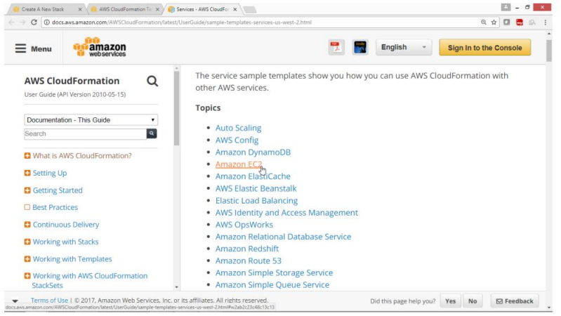

Select **“Amazon EC2 instance in a security group” ,**

Click on **“Launch stack”**

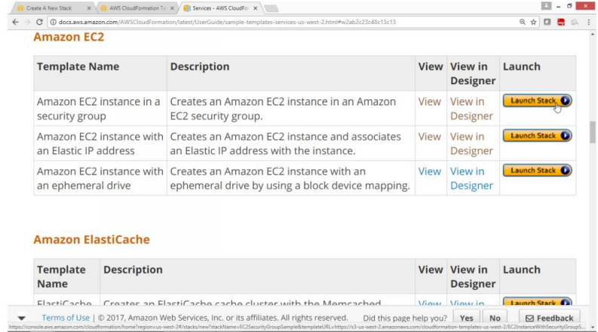

In option **“Specify an amazon S3 template URL”**

Verify template is loaded in S3

Click on **Next** button

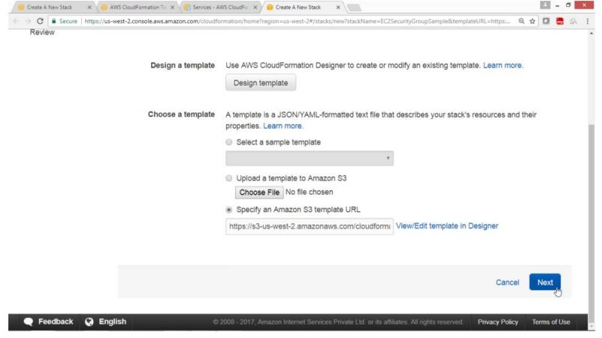

On Specify Details page

Key Name ->”key*.pem”

Click on Next button

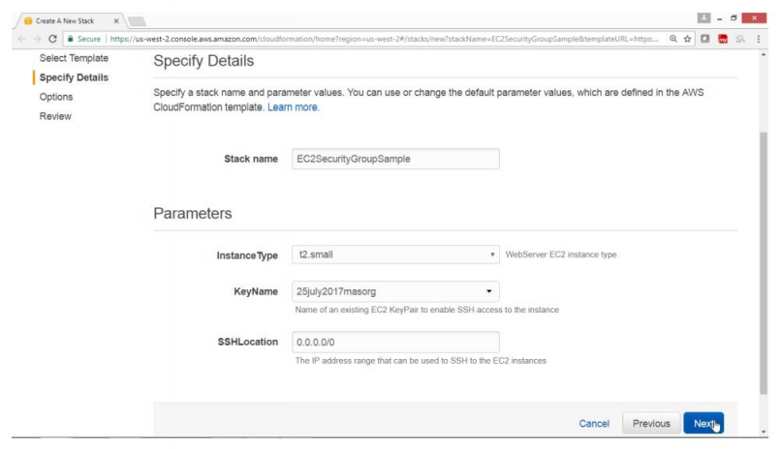

Under Option Tag,provide values for

Key ->Nameweb

Value ->web

Drag Down

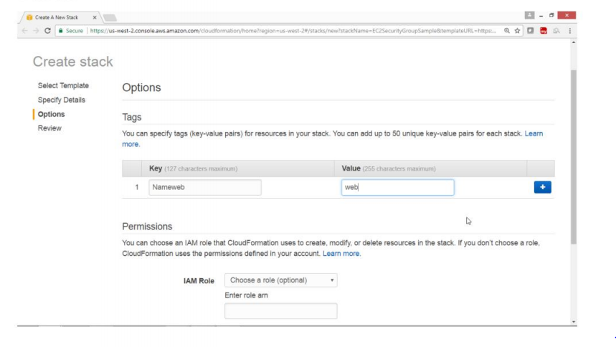

Click on **Next**

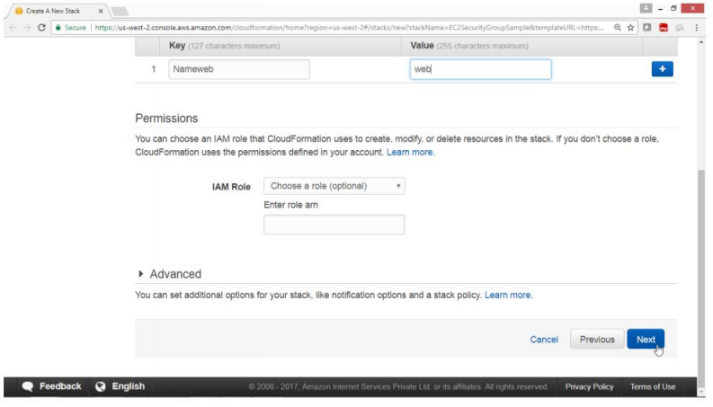

**Review ,** check the summary

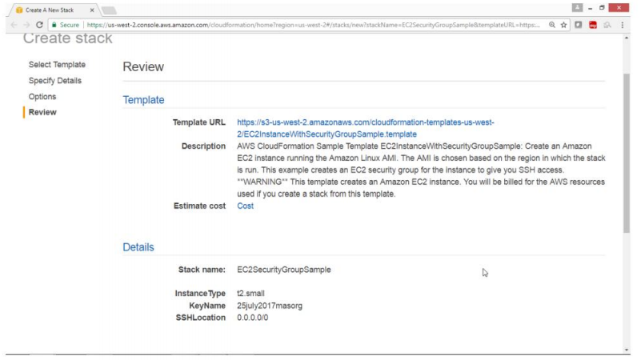

Click **Create button**

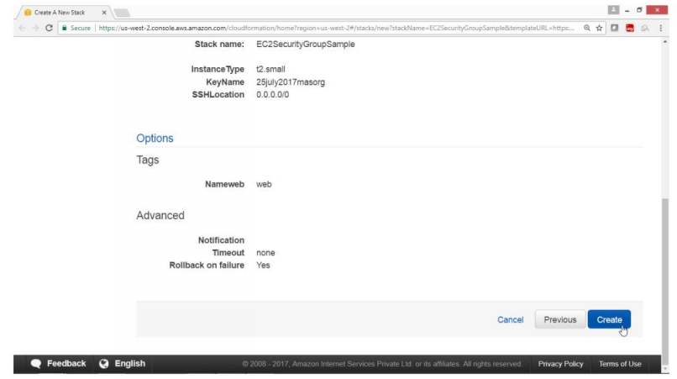

Check the status

CloudFormation is in progress state.

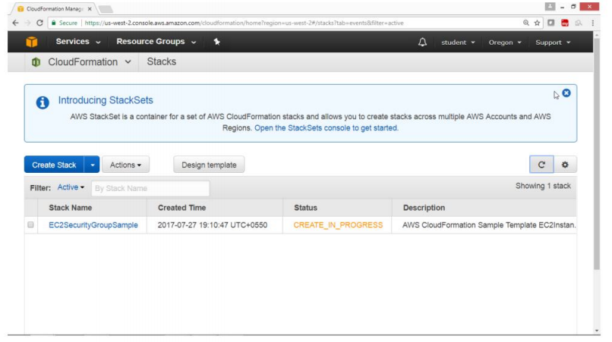

Verify

Status is Created_Complte

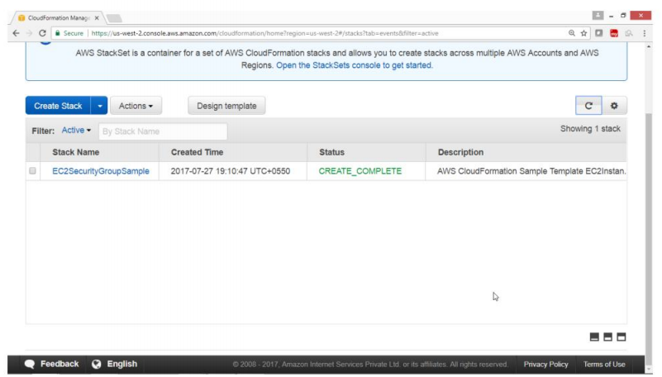

Go to EC2 service

Check the instances

An instance with the Name **“web”** is launched

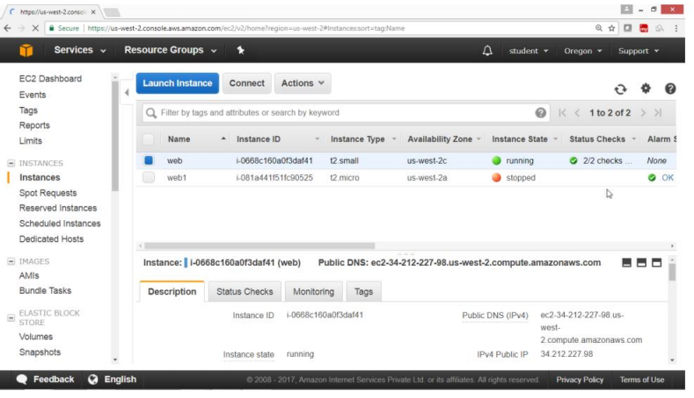

**3) To remove the Instance created by CloudFormation**

From AWS console

Select services **Management tools**

Select **CloudFormation**

Select the Stack Name check box

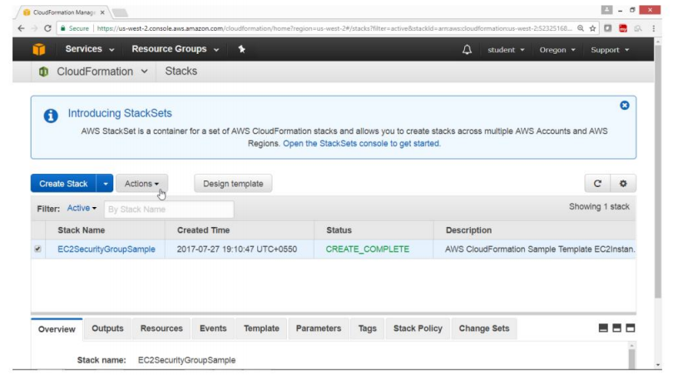

Click on **Actions** button

Select **“Delete stack”**

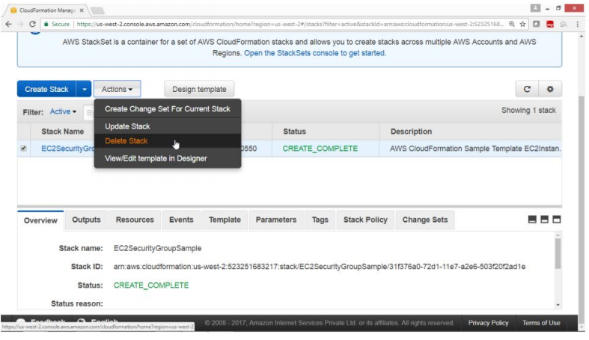

Click on **“Yes,Delete”**

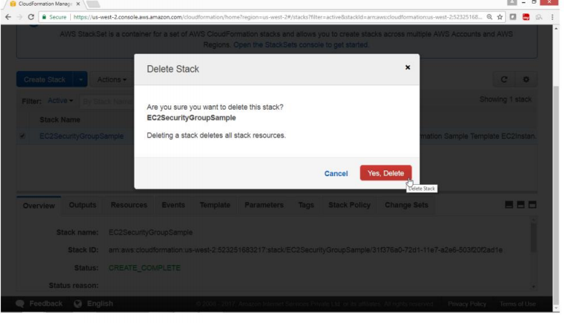

**Verify**

**Deletion is in progress**

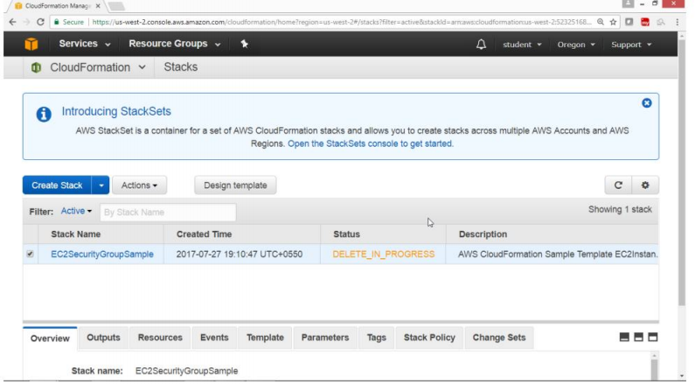

**Verification**

**After deletion again starting screen of CloudFormation is displayed**

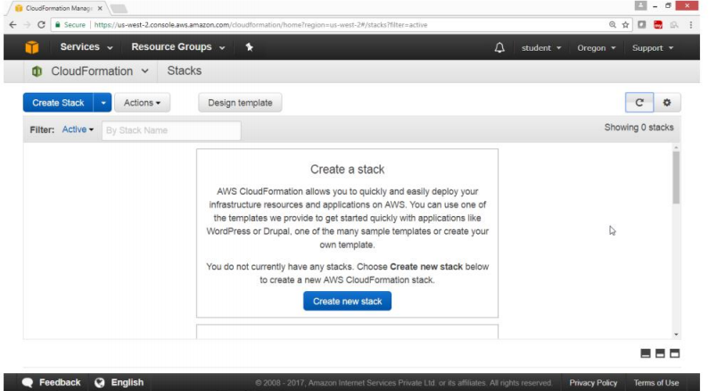

**Exercise 21. To Configure Simple EMail Service(SES)**

Amazon Simple Email Service enables you to send and receive email using a reliable and scalable email platform.

We can configure Amazon Simple Email Service in three different regions:

1. North Virginia
2. Oregon
3. EU(Ireland)

To use SES service click on <https://console.aws.amazon.com/ses/>

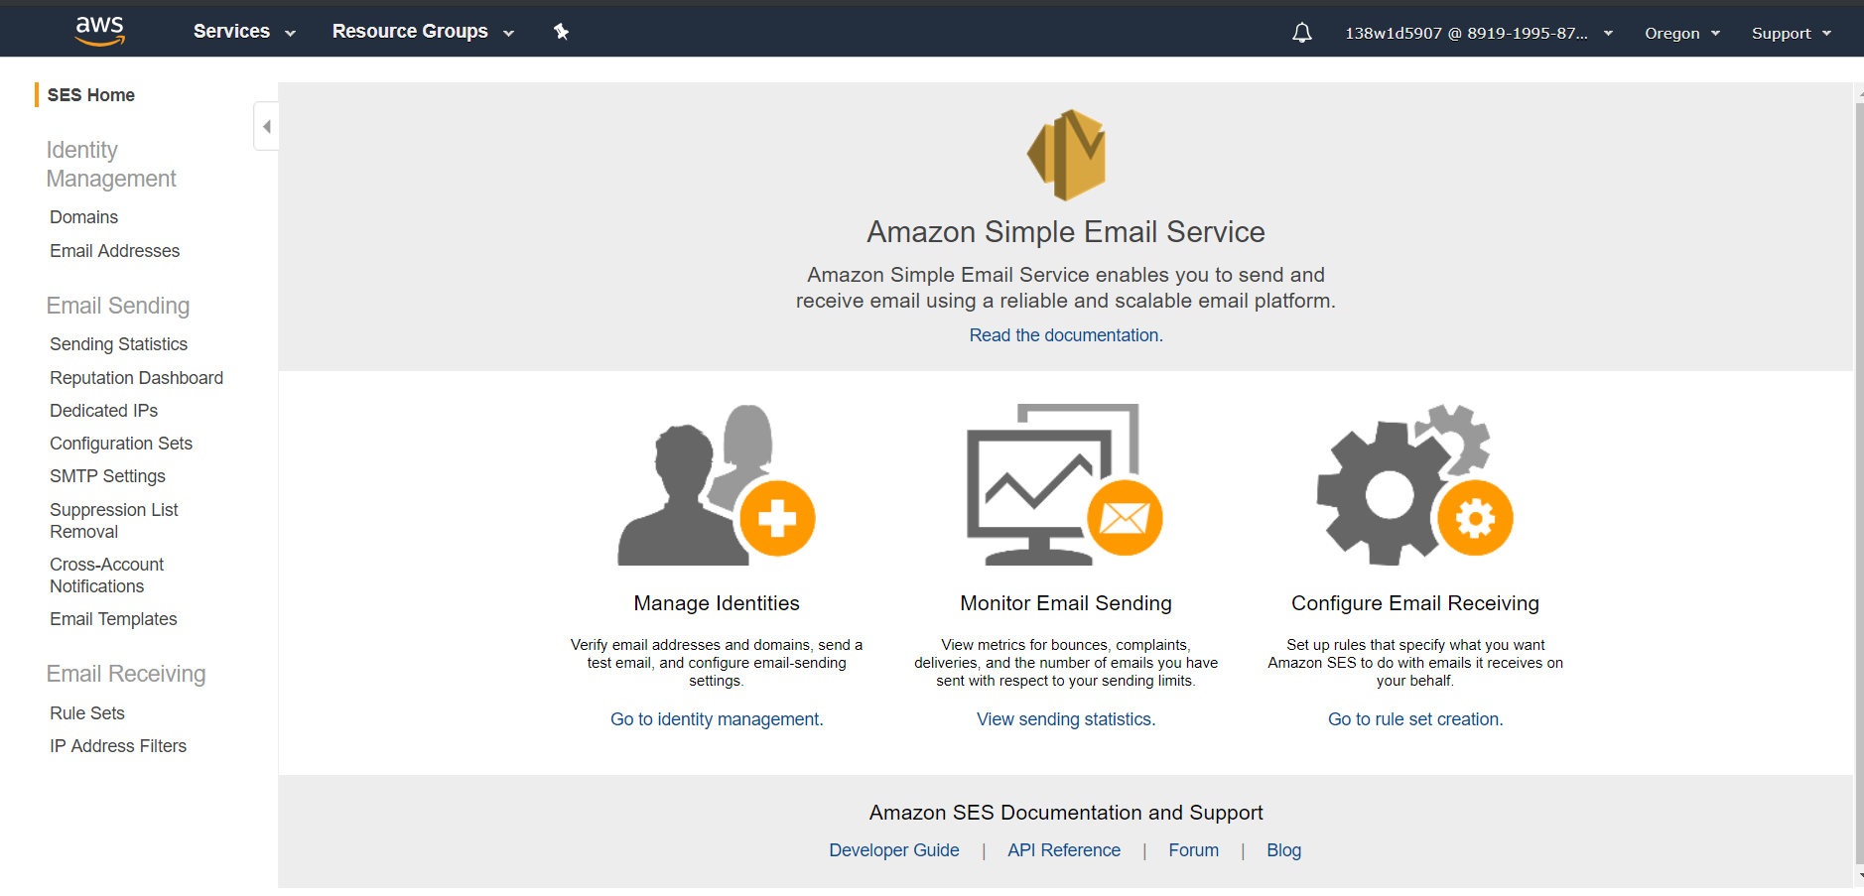

* Here in the left menu panel click on Email Addresses
  + Click on verify a new Email Address
  + Enter the Email ID you can cross verify
  + A pop will be shown as “An Email Sent to the mail ID entered”
  + Login to the Email address entered for cross verification and check out the mail by clicking on the cross verification link.
  + You can see the message like
* Once the verification is done the status resembles as verified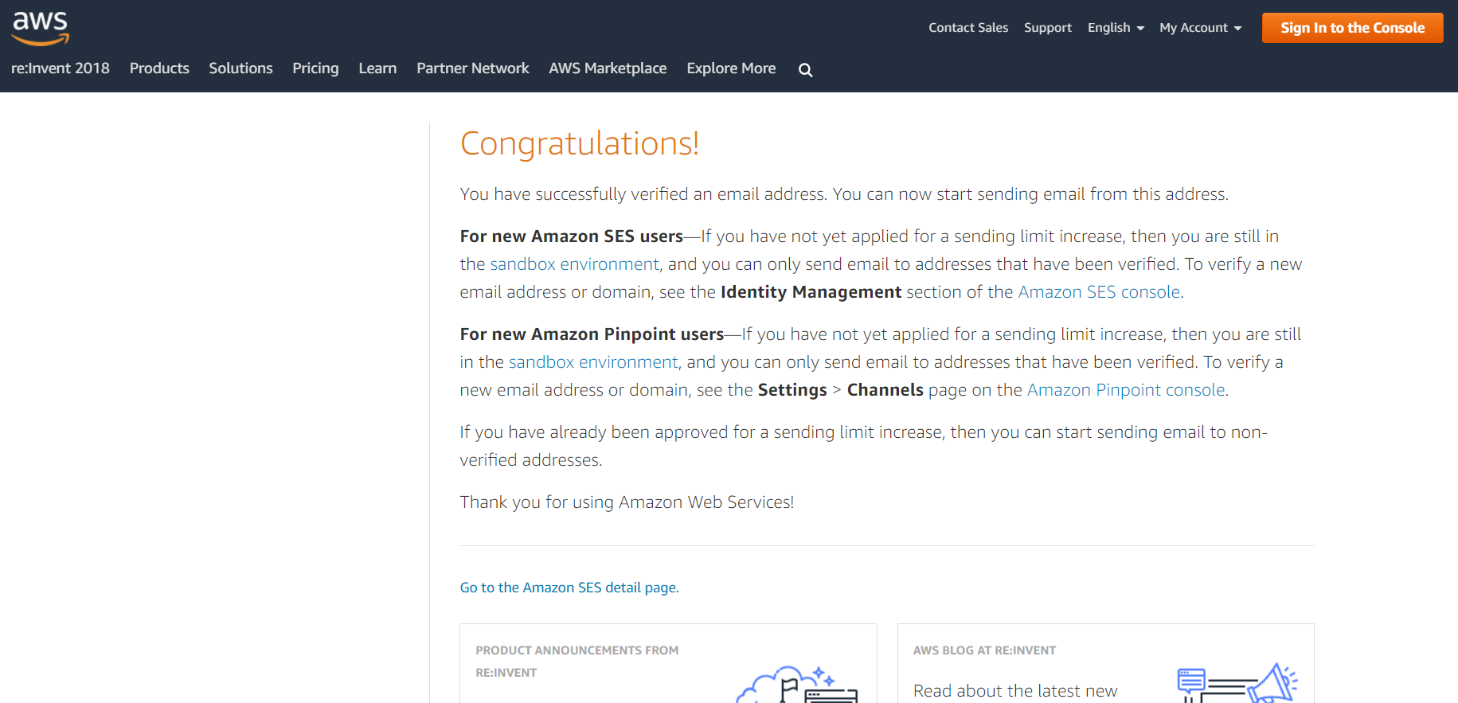
  + Configure SMTP settings
  + Click on “Create My SMTP Credentials” button

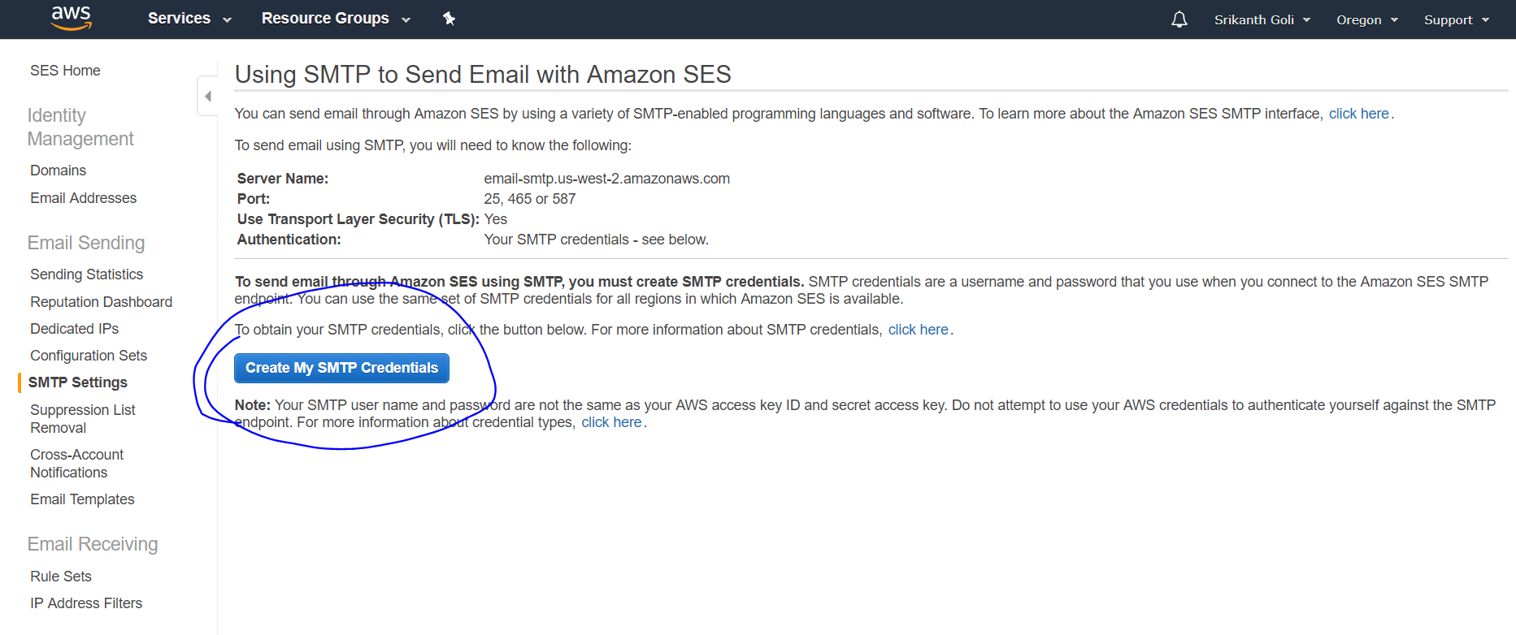

* + Default IAM user name will be provided
  + Click on Create button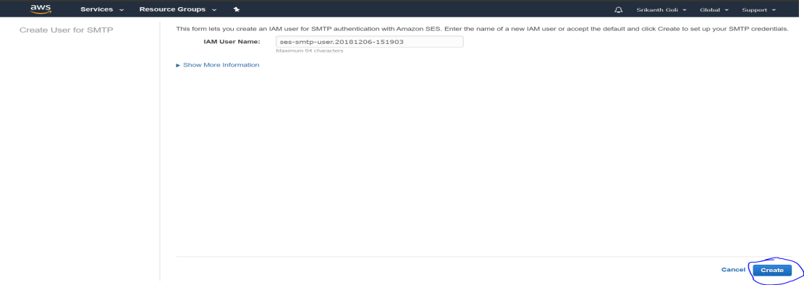
  + User SMTP credentials will be displayed
  + Click download credentials and keep it safe

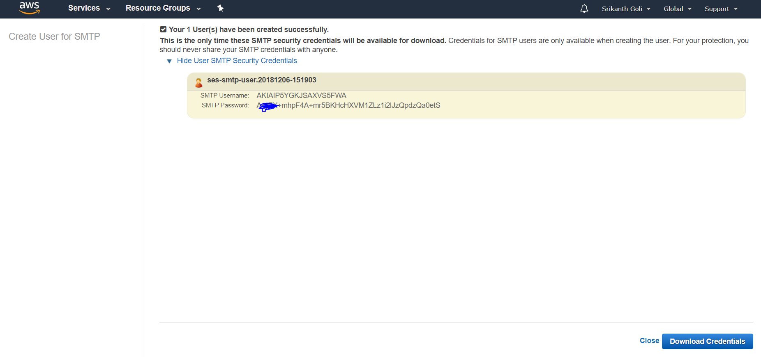

* + Verify Credentials
  + Open Outlook

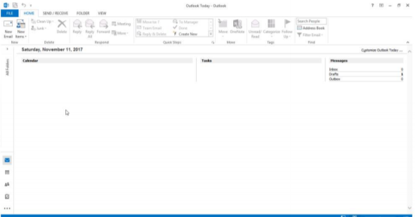

* + Click Add Account

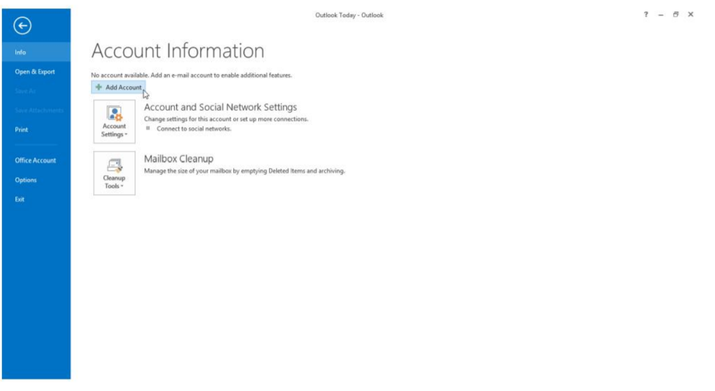

* + Select Manual Setup

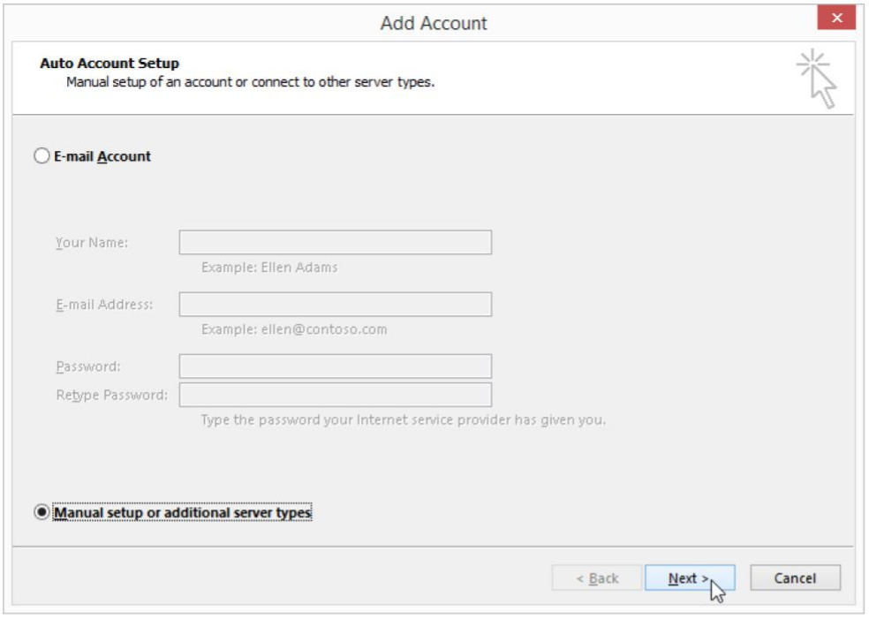

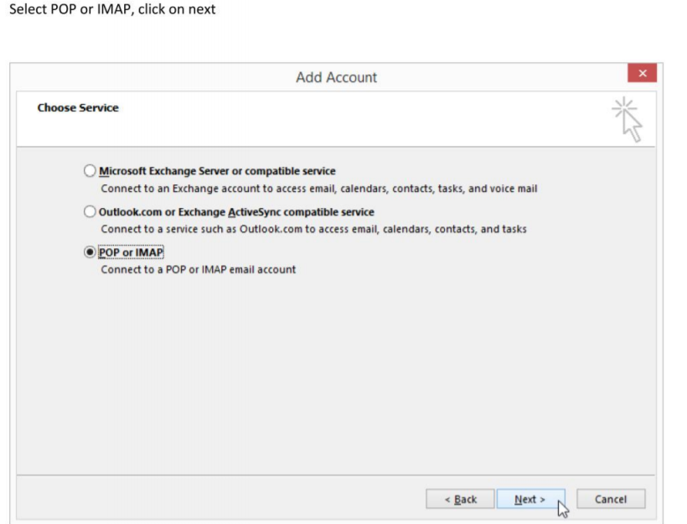

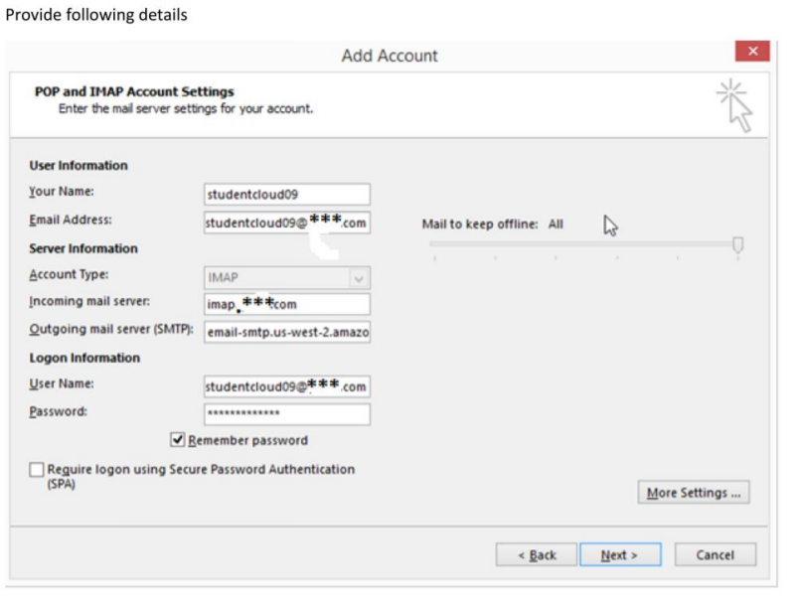

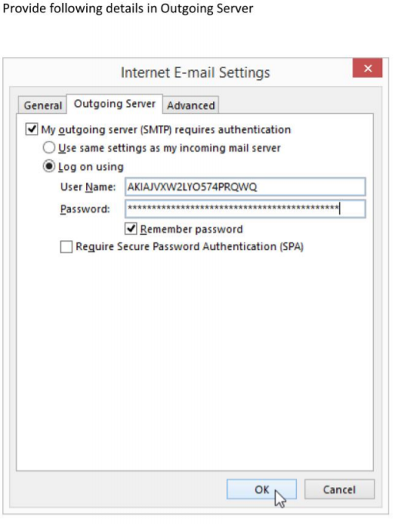

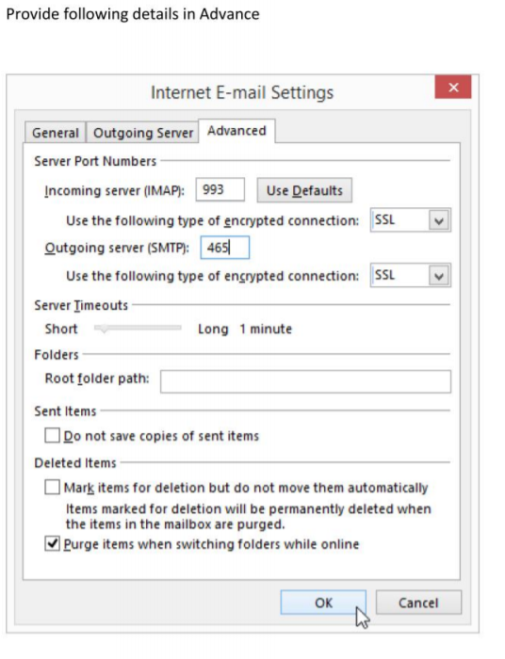

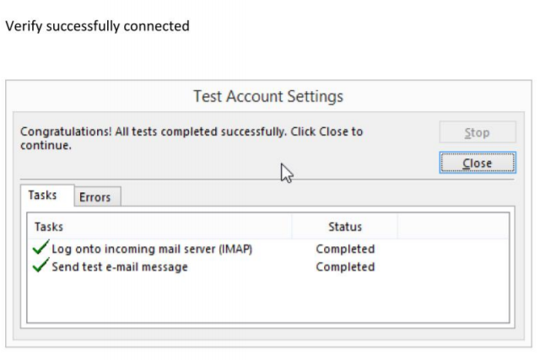

**Exercise 22. To Configure Simple Queue Service (SQS)**

* Amazon Simple Queue Service (SQS) is a reliable, scalable, fully-managed message queuing service.
  + Configure SQS with the following steps:
  + Create the queue
  + Send the message
  + Pool the queue
  + View the message
  + Delete the message
* Goto https://console.aws.amazon.com/sqs
  + Click on Get Started Now
  + In **“Create New Queue”** wizard

Provide the following details

Queue Name : SDC queue 1

Region : US West (Oregon)

Leave the remaining values as default

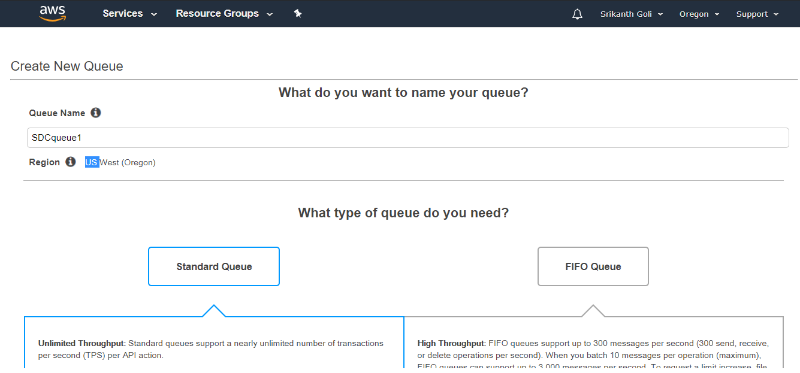

Click on 

* + Verify Queue is created

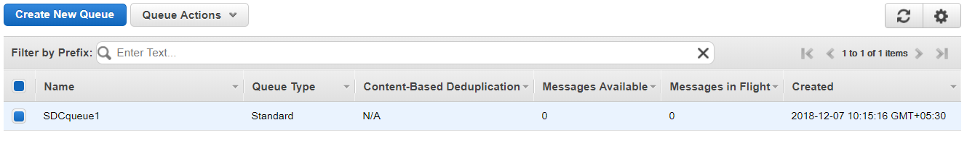

* + Select the Queue
  + Click on Queue Actions and select **“Send a Message”**

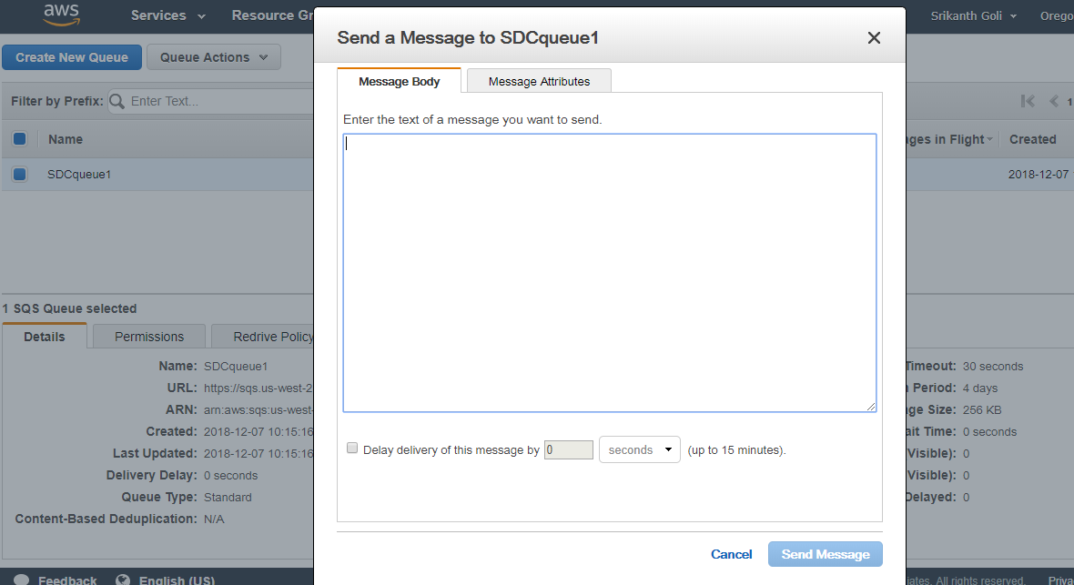

* + From "Send a Message to SDK queue" Wizard
  + In Message Body type the message: “Sample Message”
  + Note: Message size should not be more than 64k
  + click on "Send Message" then click on close

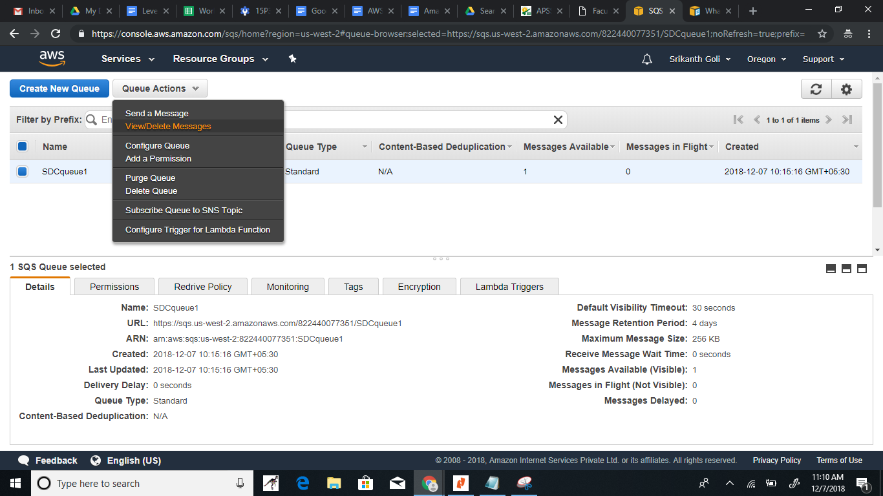

Click on **“Start polling for Messages”**

Verify message is in the queue

And click on Close

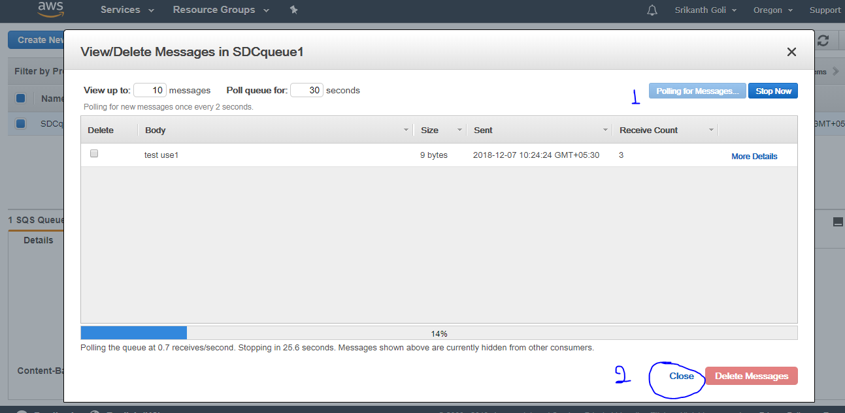

* Now delete the message created.
  + Click on Queue Actions by selecting the queue created
  + From the DropDown click on Delete Queue

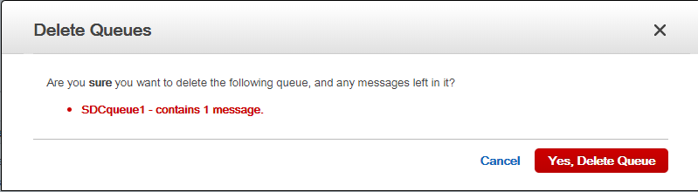

* + Click on Yes Delete Queue

**Exercise 23. To Configure Route 53**

**Objective**

To configure and use AWS Route53 service

**TOPOLOGY**

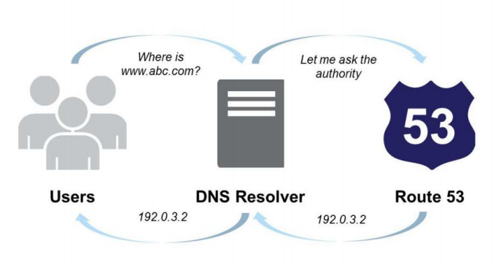

**Pre-Requisites**

User should have AWS account ,or IAM user with Amazon Route53 FullAccess

By default AWS does not provides to Register Domain Name with AWS

You should have a registered domain name one with your ISP

**To Configure Route53 with following task:**

To Transfer existing DNS service from your ISP to Amazon Route 53

Creating records set

Creating CNAME record set

**step-1:Configuration of Route53 for your Domain Name**

Open AWS console

Select “Networking & Content Delivery”

Click on Route 53 services

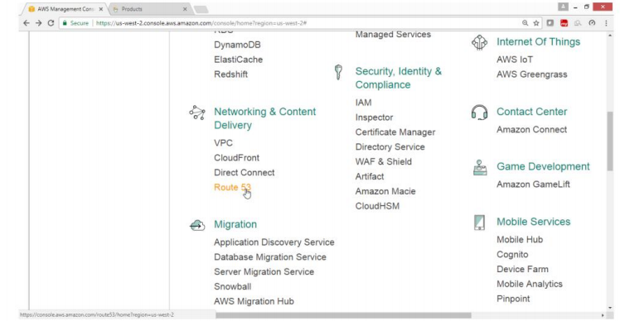

Route53 Dashboard wizard opens

Under DNS management

Click on **“Get started Now”** button

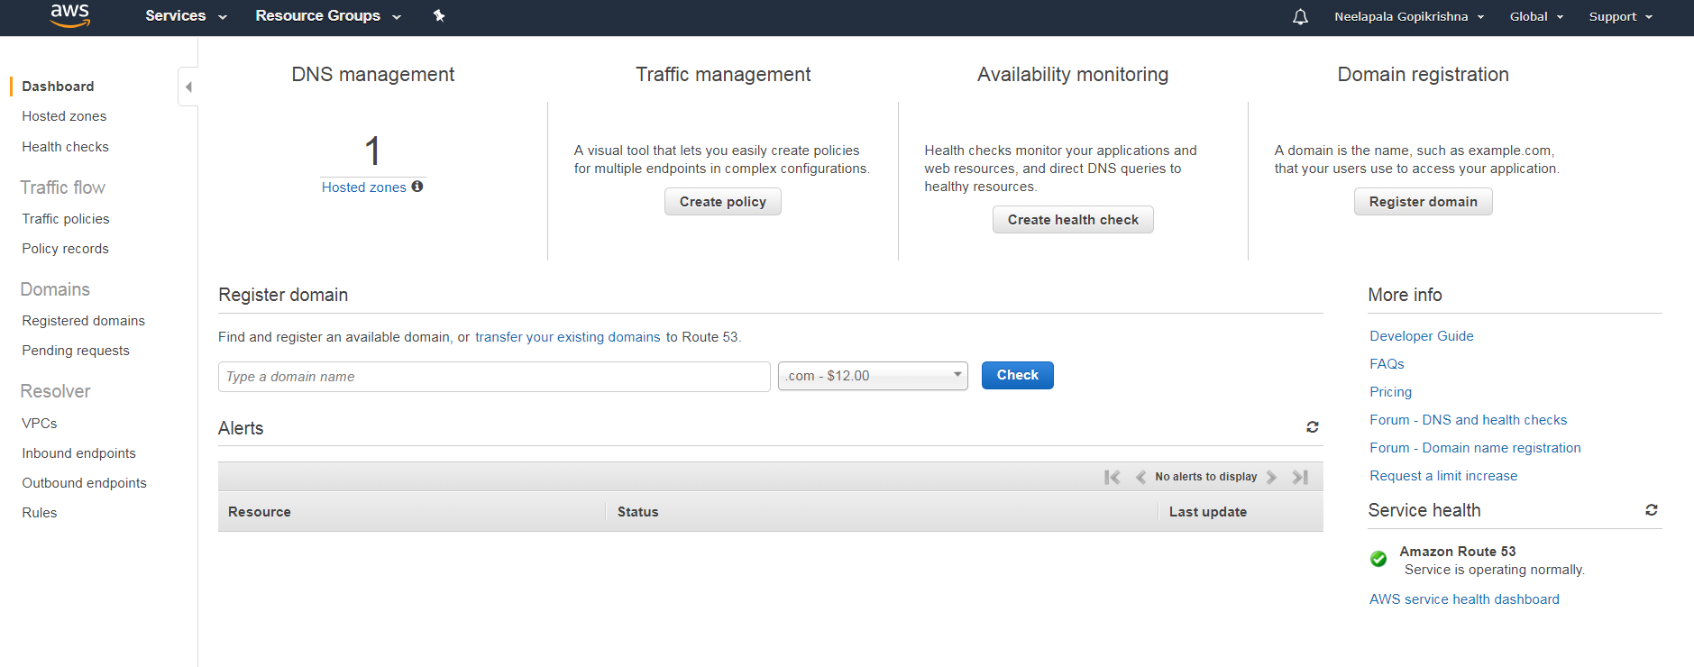

Click on **“Created Hosted Zone”** button

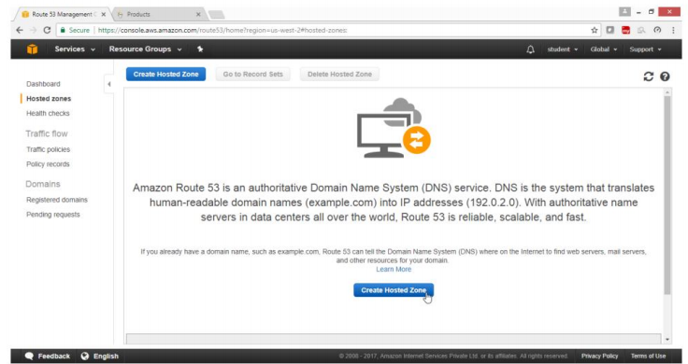

Again Click on **Create Hosted Zone** button

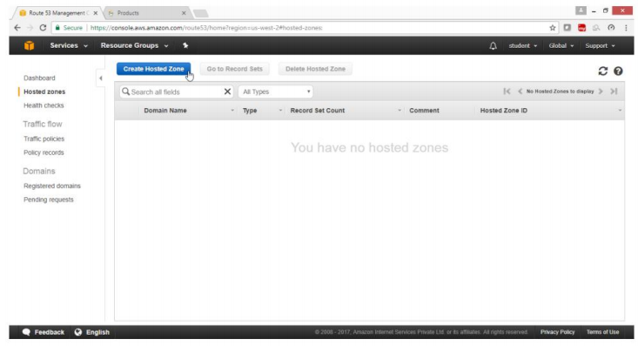

Under **“Created Hosted Zone ”**,wizard

On right side panel provide following values

For Domain Name: ->cloudskillsindia.com

For Comment ->india

For Type ->public Hosted Zone

Click on **Create** button

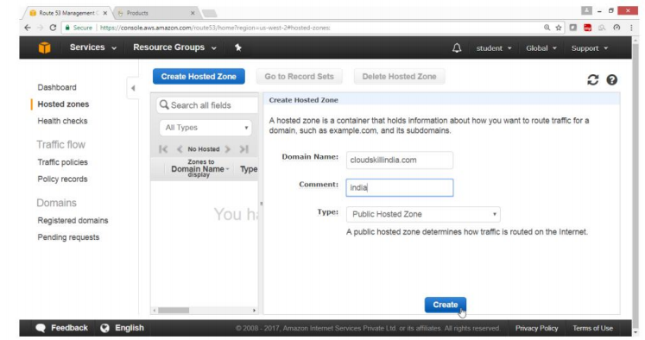

Now the list of AWS NS records will appear

Now add all AWS NS record to your local DNS NS record (Freenom.com)

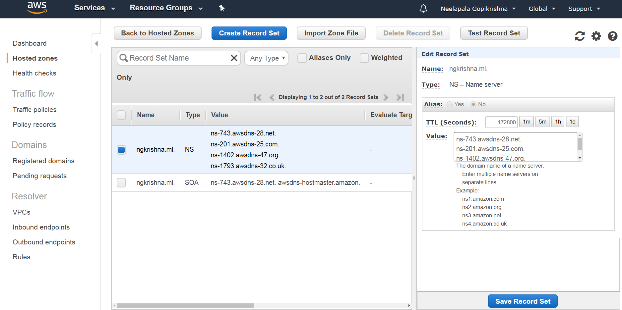

**Step-2**: Now copy these DNS NS record in Freenom.com for ngkrishna.ml domain

ns-743.awsdns-28.net.

ns-201.awsdns-25.com.

ns-1402.awsdns-47.org.

ns-1793.awsdns-32.co.uk.

Open the browser

Go to Freenom.com site

Login and select your domain name

Click on **Services -> My Domains -> Manage Domain**

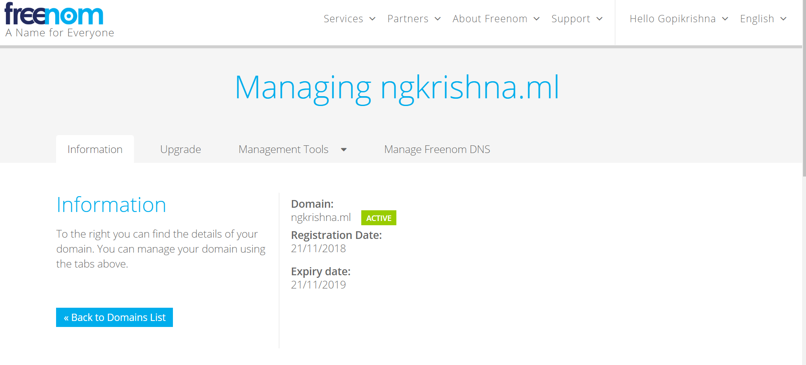

Click on **Management Tools**

Add latest entries provided by Route53 NS records

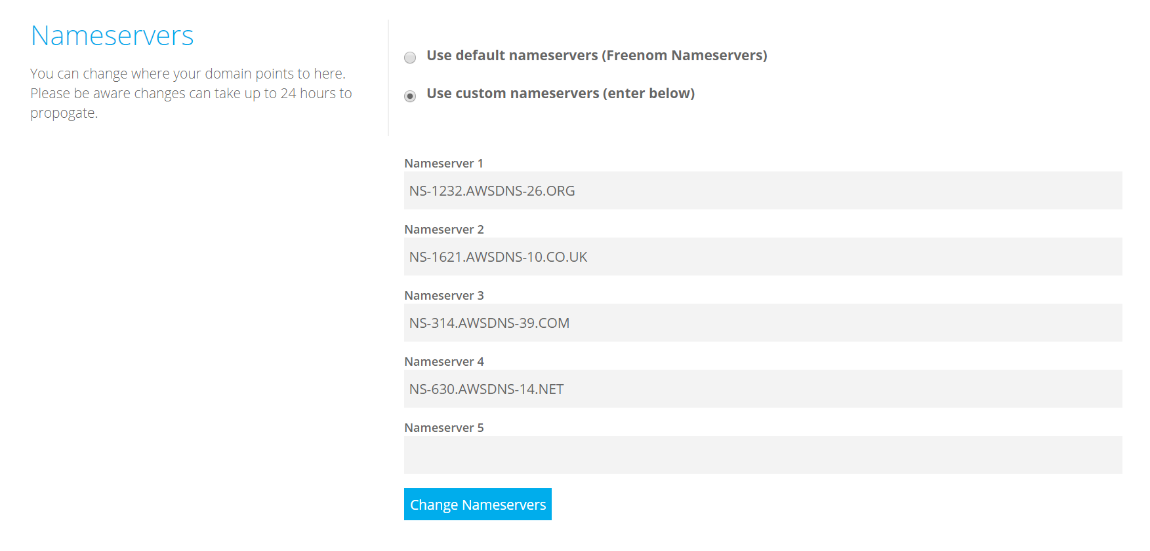

For Choose your new name server ->custom

Replace old NS records with latest NS records

Click on **Change Nameservers** button

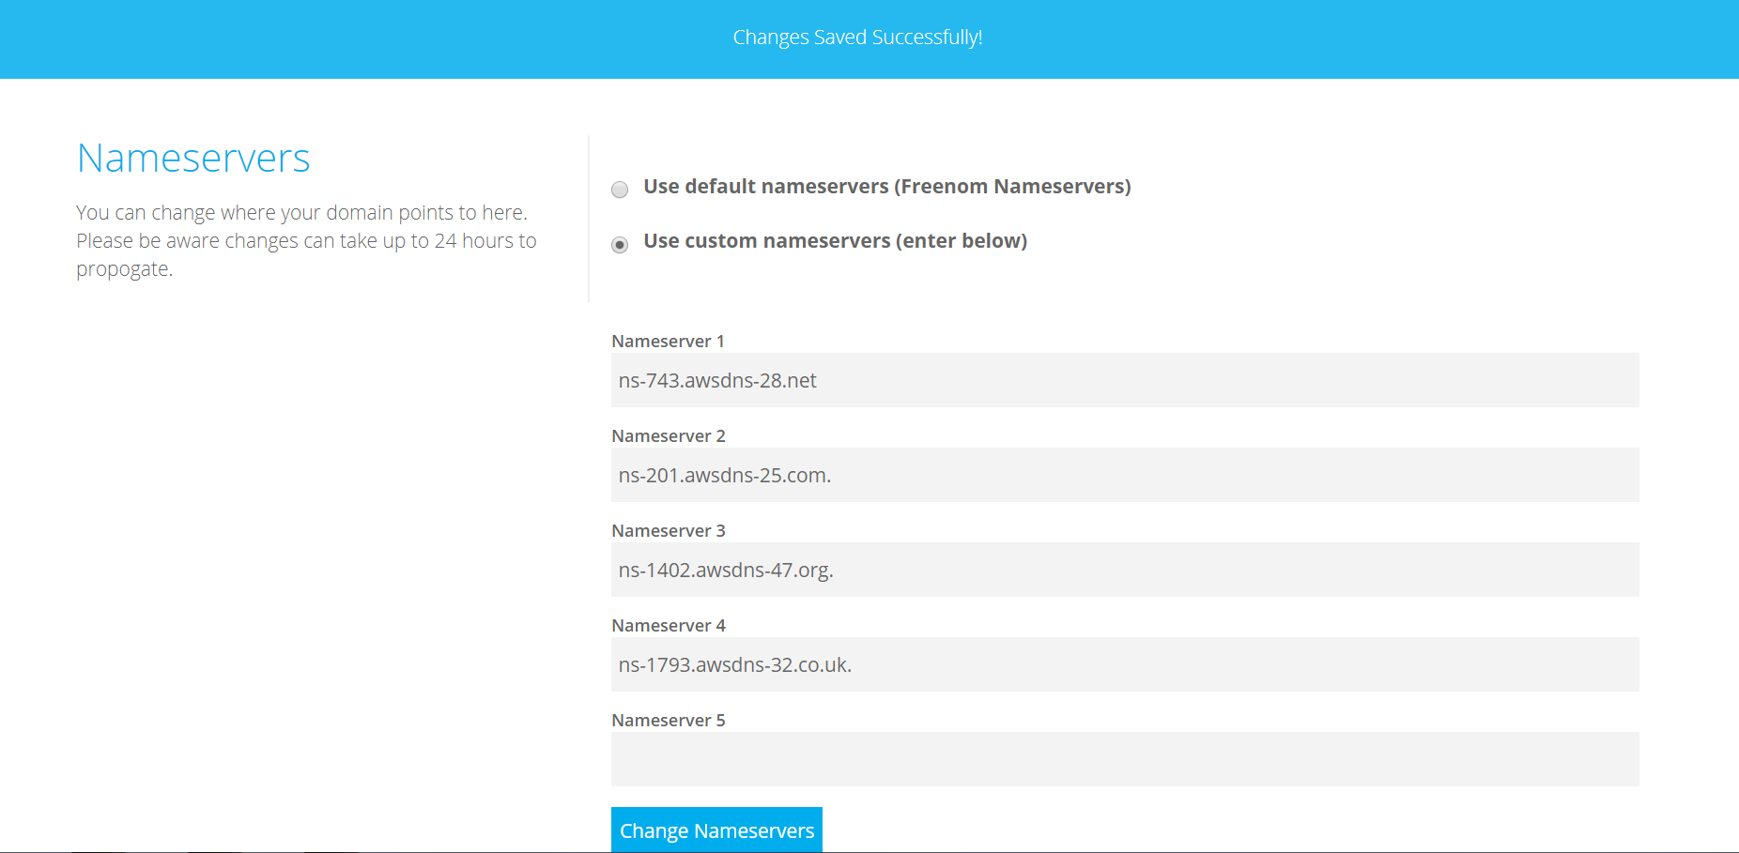

**Step-3:launch an instance Configure it as a Web Server**

**Launch an Amazon linux Instance**

**Configure it as a Web Server**

**Note:Repeat Hosting web server on linux**

**Copy the public IP and type in Browser**

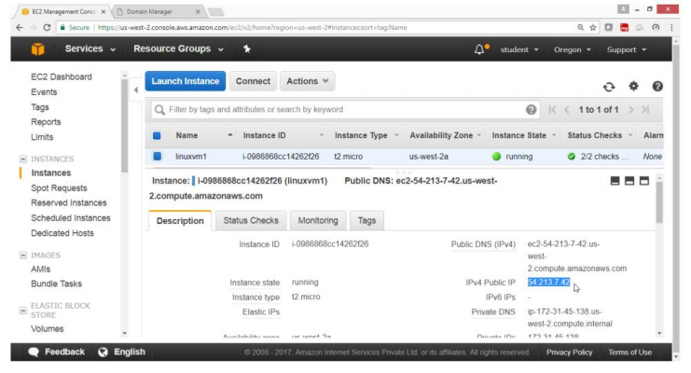

**Verify Website is accessible**

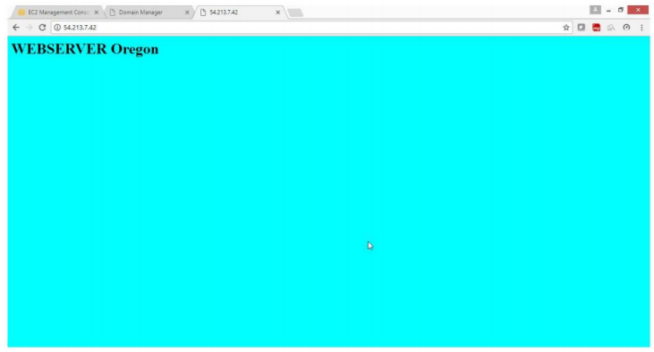

**step-4:To add a A record and CNAME record in Route53**

From **Route53** Dashboard

Click on **“Hosted Zones”**

Select **Domain Name**

Click on **“ngkrishna.ml”**

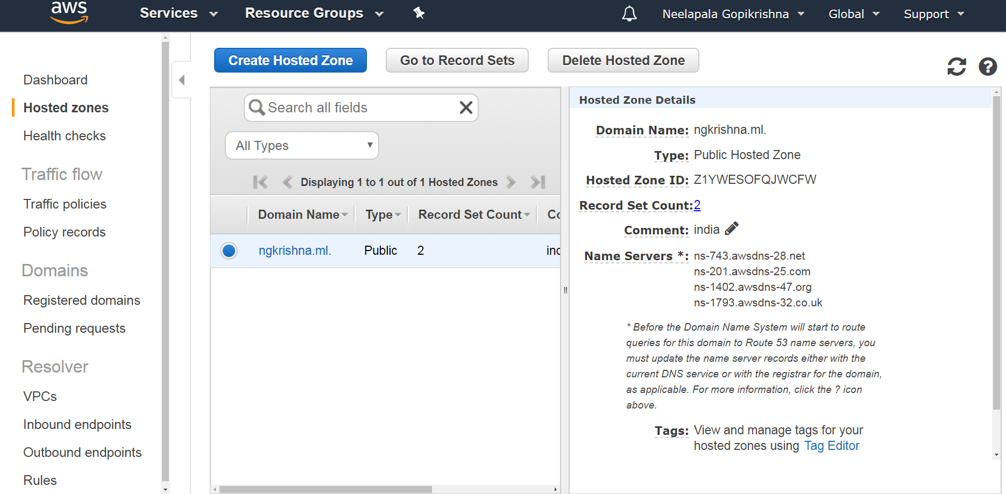

Click on Create Record set button

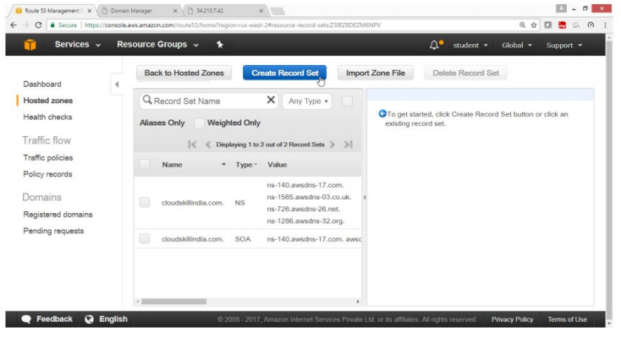

To add A record

On right side Under **create record set**

Provide following values

NAME -> org.ngkrishna.ml

Type -> A-IPv4 address

Alias -> No

Value => 54.213.7.42[Give your instance Public IP]

Click on **“Create”**button

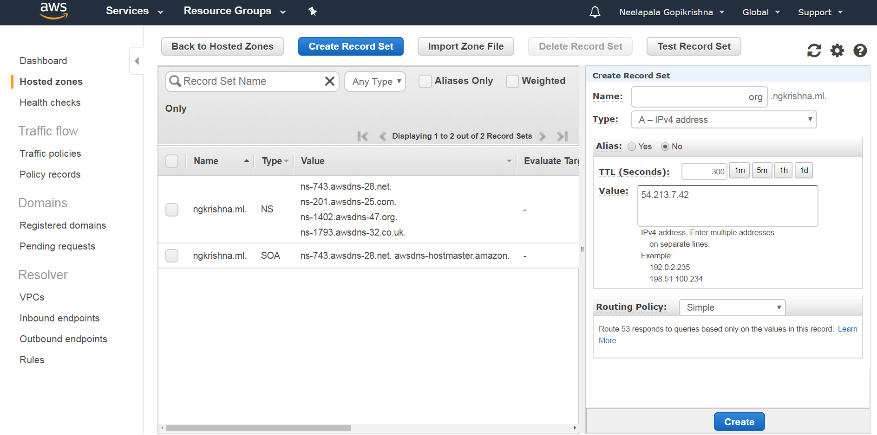

Verify the A record got created

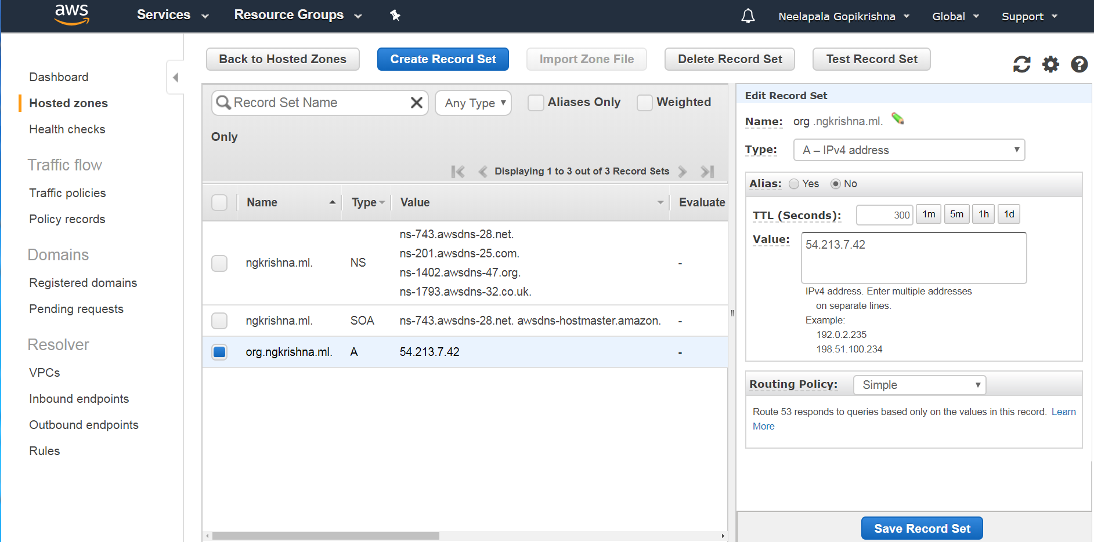

Create Alias record

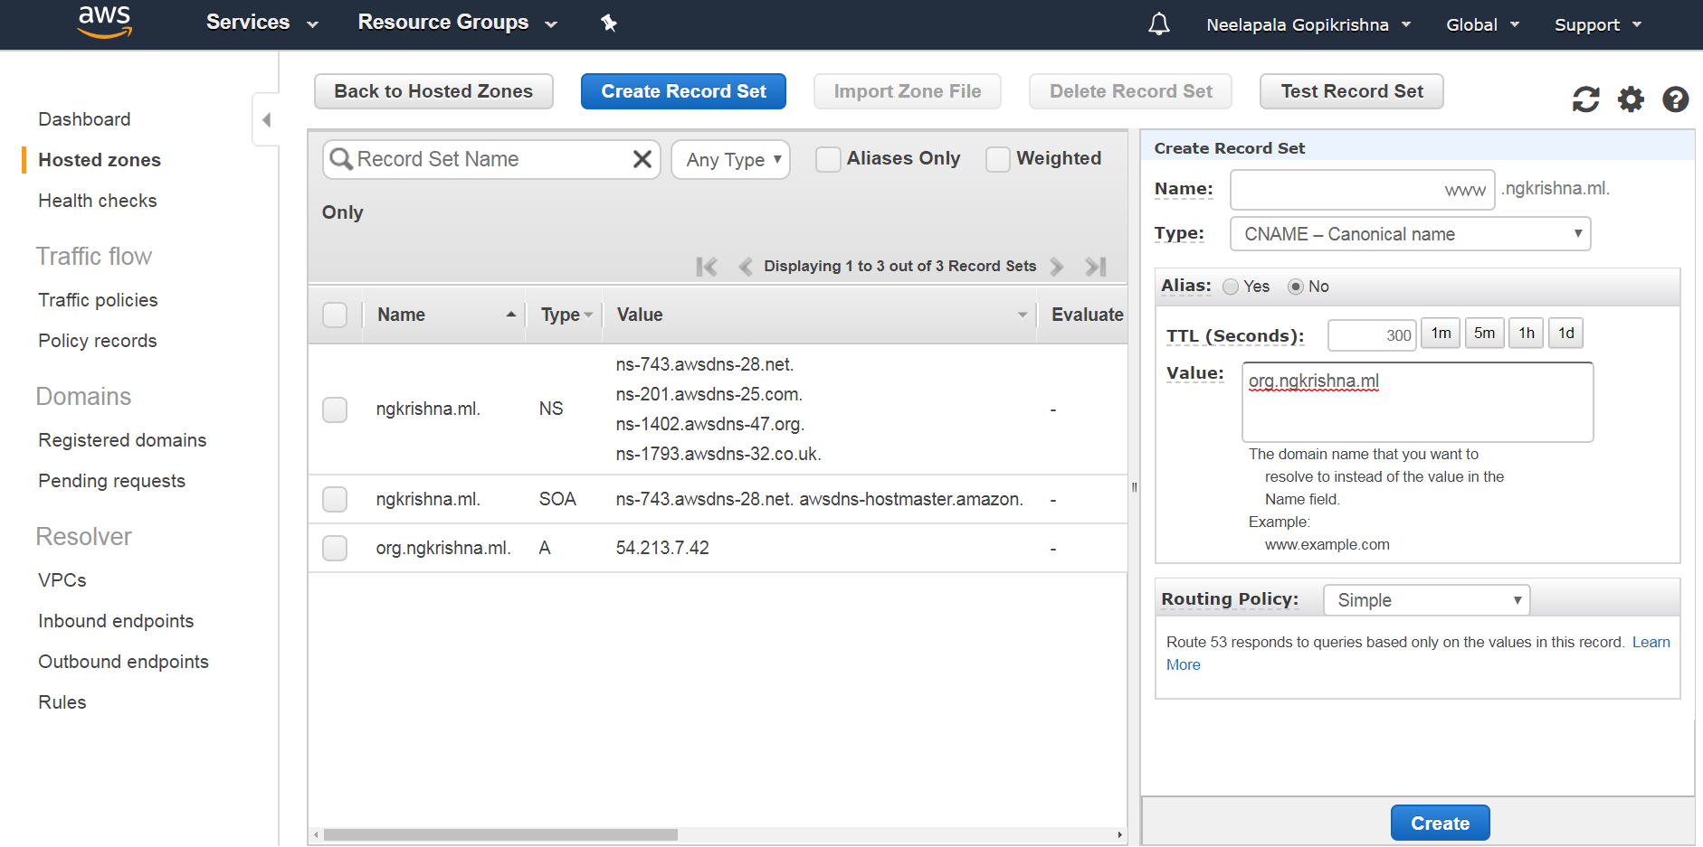

Verify the CNAME record got created

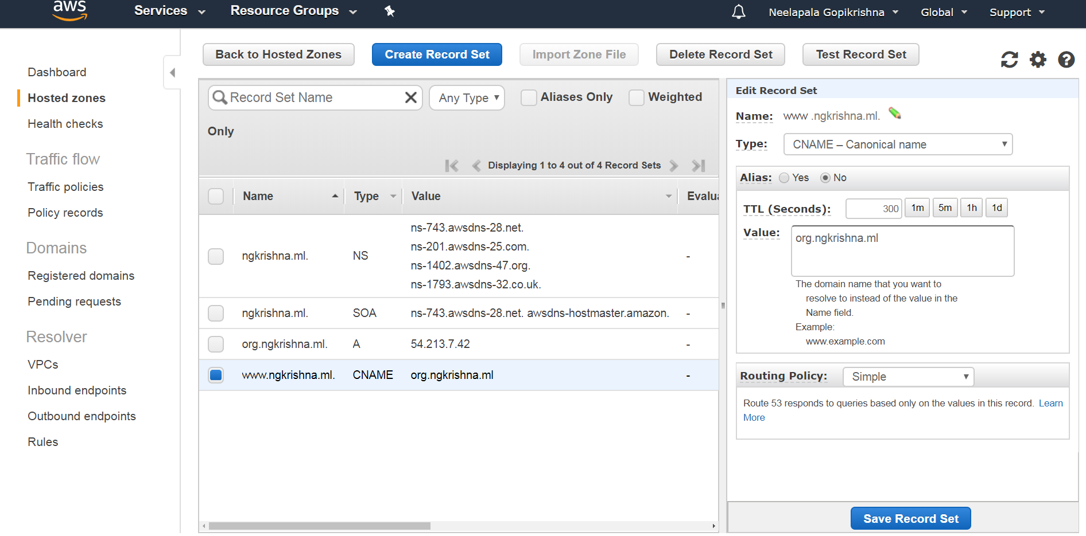

Verification

Now access the website with A record -> org.ngkrishna.ml

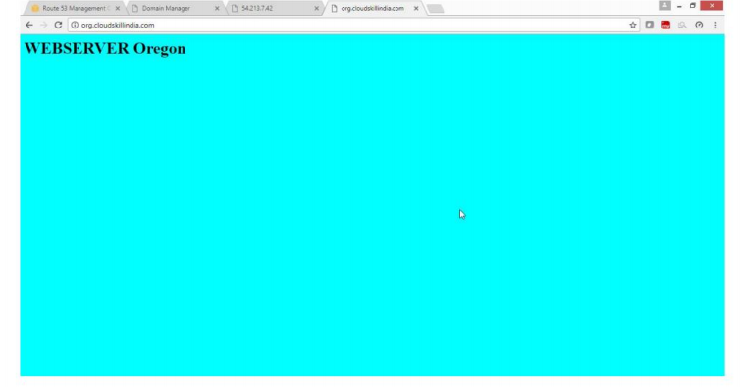

Verification

Now access the website with CNAME record -> www.ngkrishna.ml



**Exercise-24** : **To Configure Cloudfront Service**

**OBJECTIVE**

**To configure and use AWS CloudFront Service**

**TOPOLOGY**

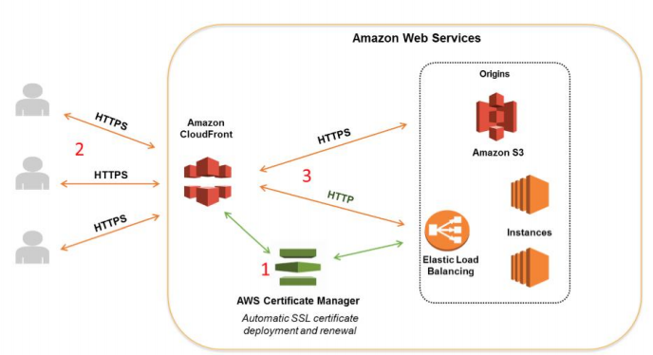

**Pre-Requisites**

User should have AWS account ,or IAM user with Cloudfront Full Access policy

**To Configure Cloudfront with following task.**

Configure a website with Amazon S3 bucket by uploading your content

Create a CloudFront Web Distribution

Verify your site by providing cloudfront DNS link

1)Configure a Website with Amazon S3 bucket by uploading your content

Open AWS Console go for S3 Service

Follow the lab steps of Website Hosting in S3

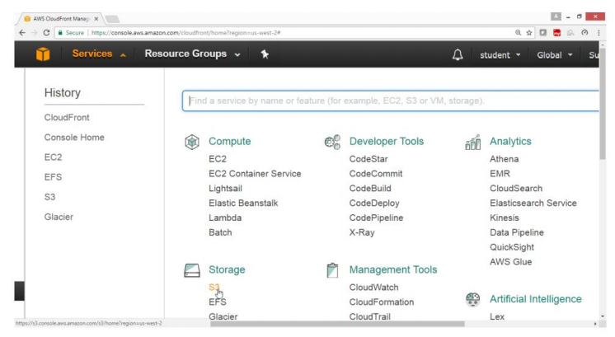

Check the S3 bucket content

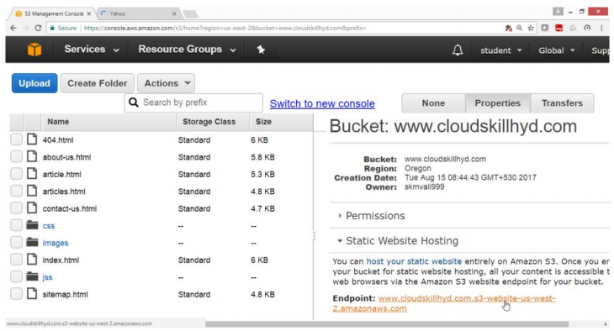

**Step-2:Create a CloudFront Web Distribution**

Open AWS Console

Select Networking and Content Delivery

Click on CloudFront service

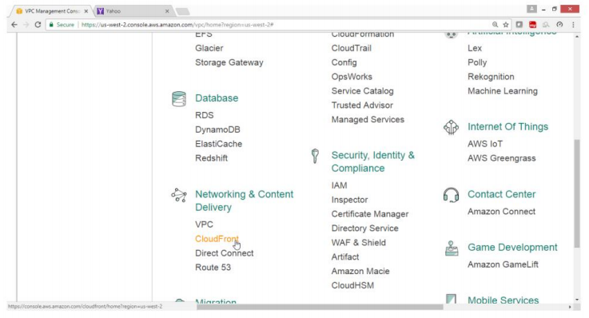

Click on Create Distribution button

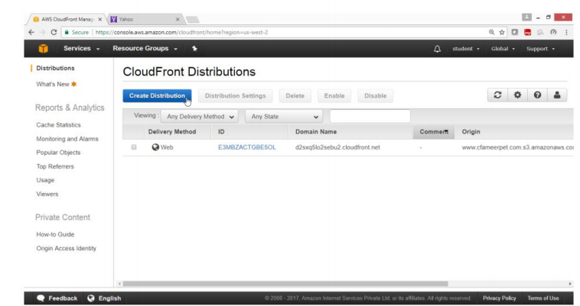

Under **“Select a delivery method for your content”** wizard

Under Web

Click on Get Started button

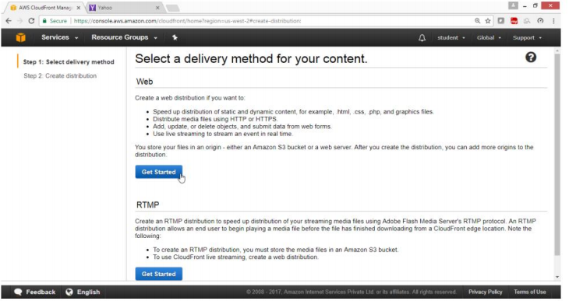

Under Create Distribution

For origin Domain Name ->Drop down ->[www.cloudskill.com.s3.amazon.com](http://www.ngkrishna.ml.s3.amazon.com)

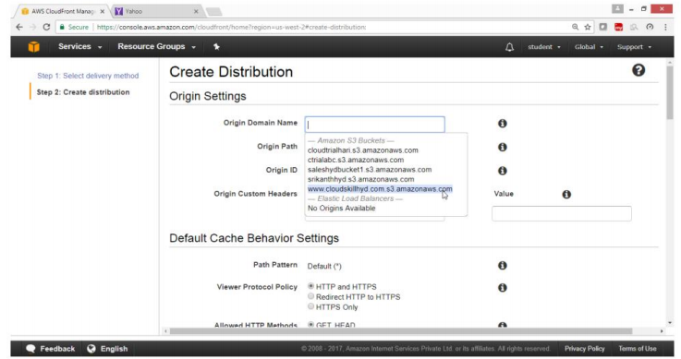

Verify origin Domain name got selected

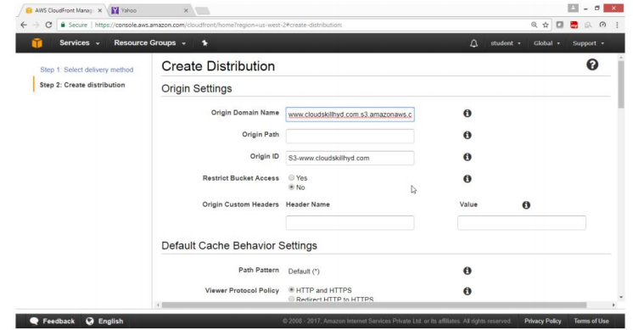

Drag Down

Go for **Distribution Settings**

For **Price Class**

Select **Edge location**

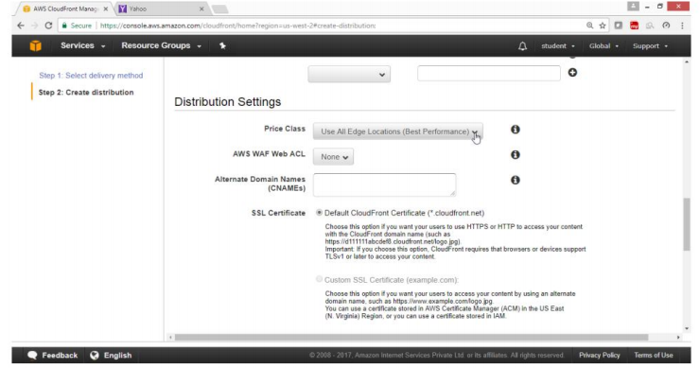

Price Class ->**Use only Canada and Europe**

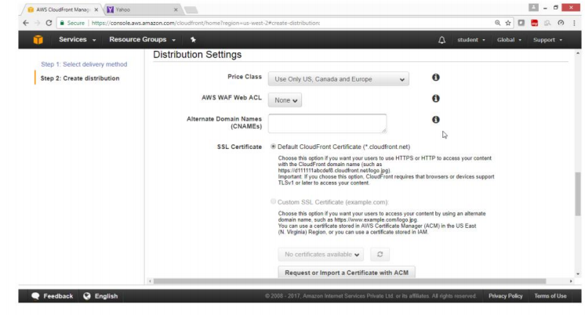

Drag Down

Click on **Create Distribution**

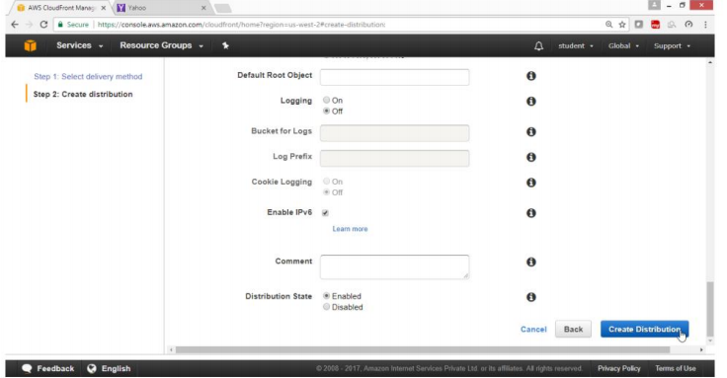

Verify the status

Shows ->In Progress

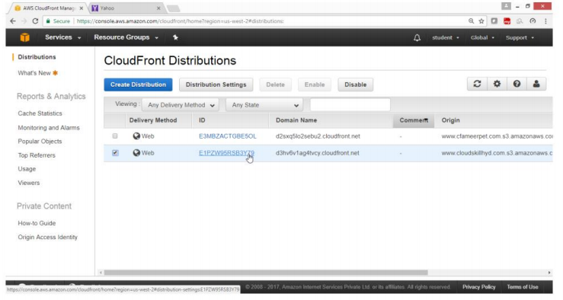

Check column Status

Show ->In Progress

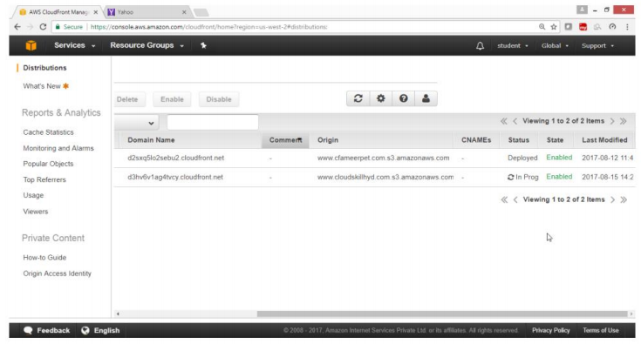

Wait for status to gen **Enable**

**Note :**It takes around 15 minutes

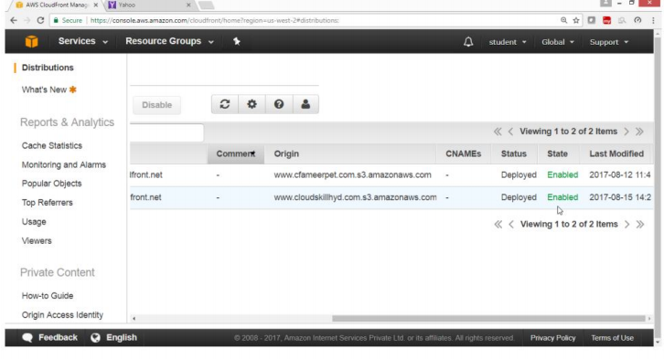

Verify the site with DNS name **“d3hv6v1ag4tvcy.cloudfront.net**”

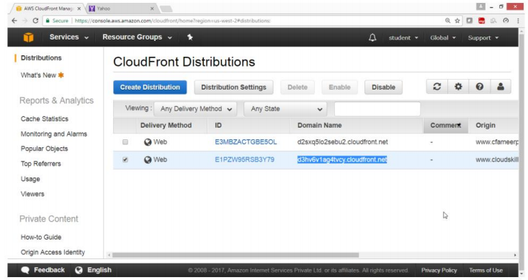

Verify

Now open the Browser and type

[http://**d3hv6v1ag4tvcy.cloudfront.net/index.html**](http://d3hv6v1ag4tvcy.cloudfront.net/index.html)

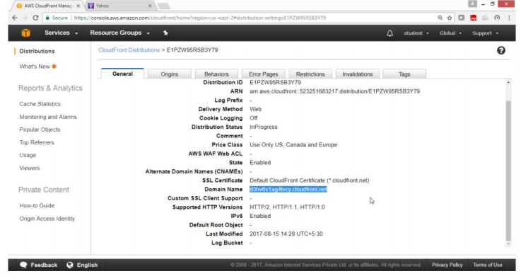

This Website is coming from CloudFront service

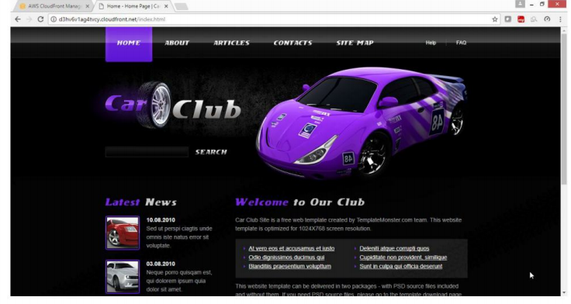

**Exercise 25. Deploy the wordpress website in highly scalable and highly available architecture**

**Step1: launch the AMI select the wordpress**

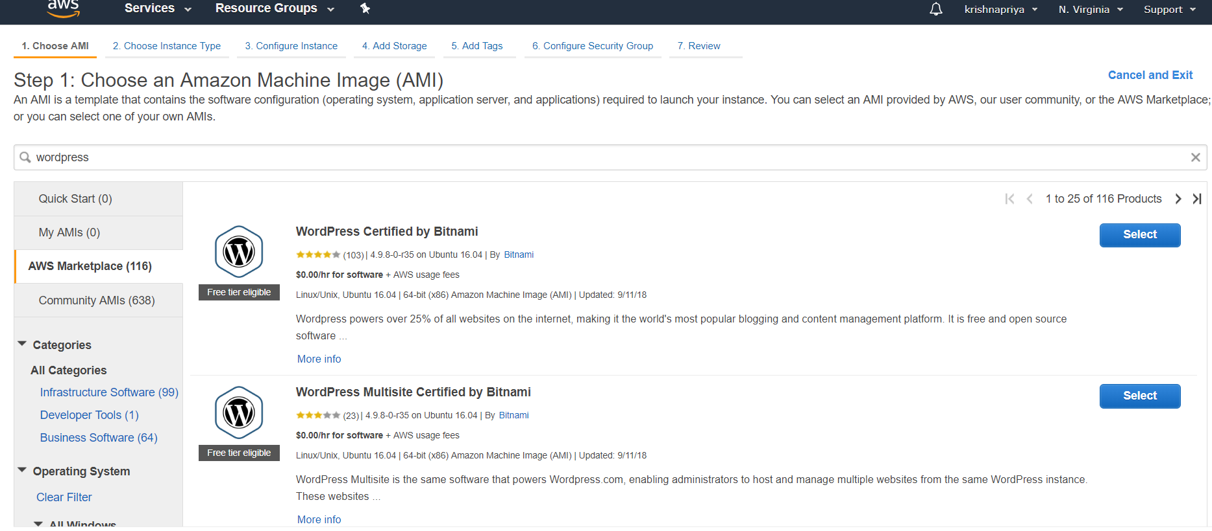

**Step2: choose the instance**

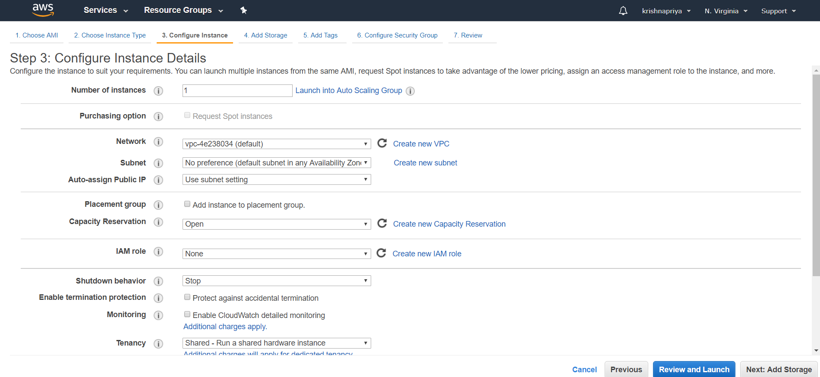

Step 3:configure the instance



Step4: Add storage

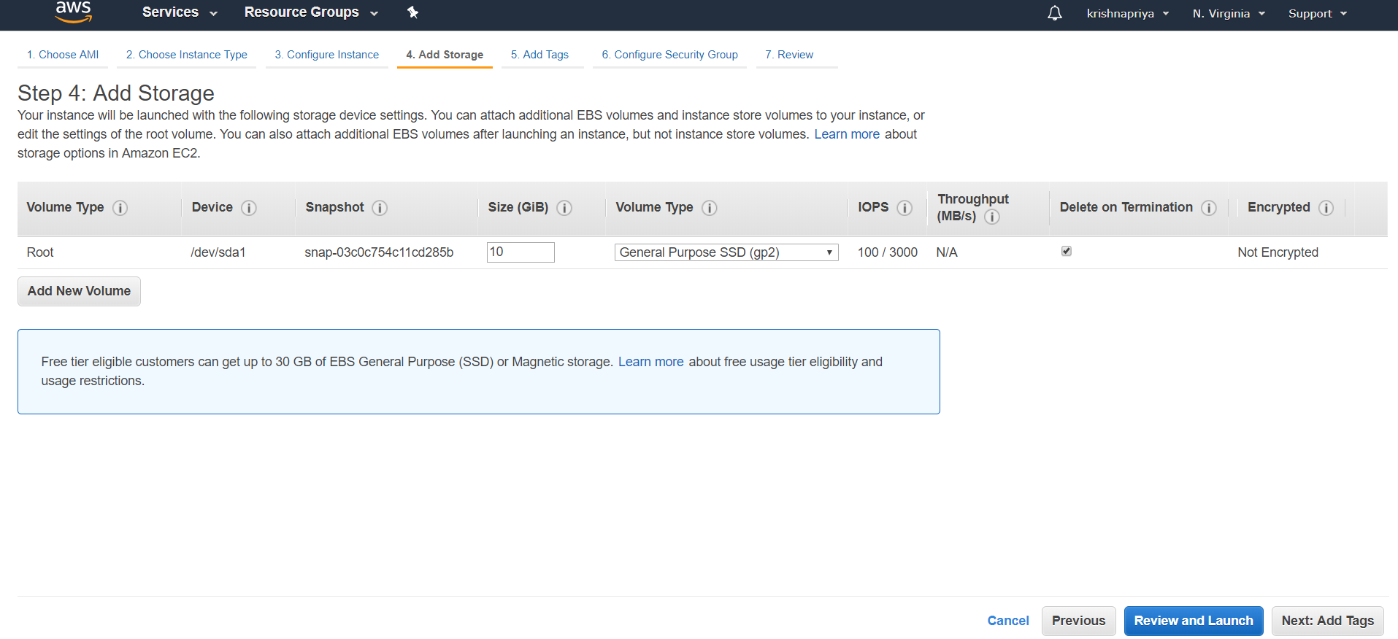

Step5: Add tag

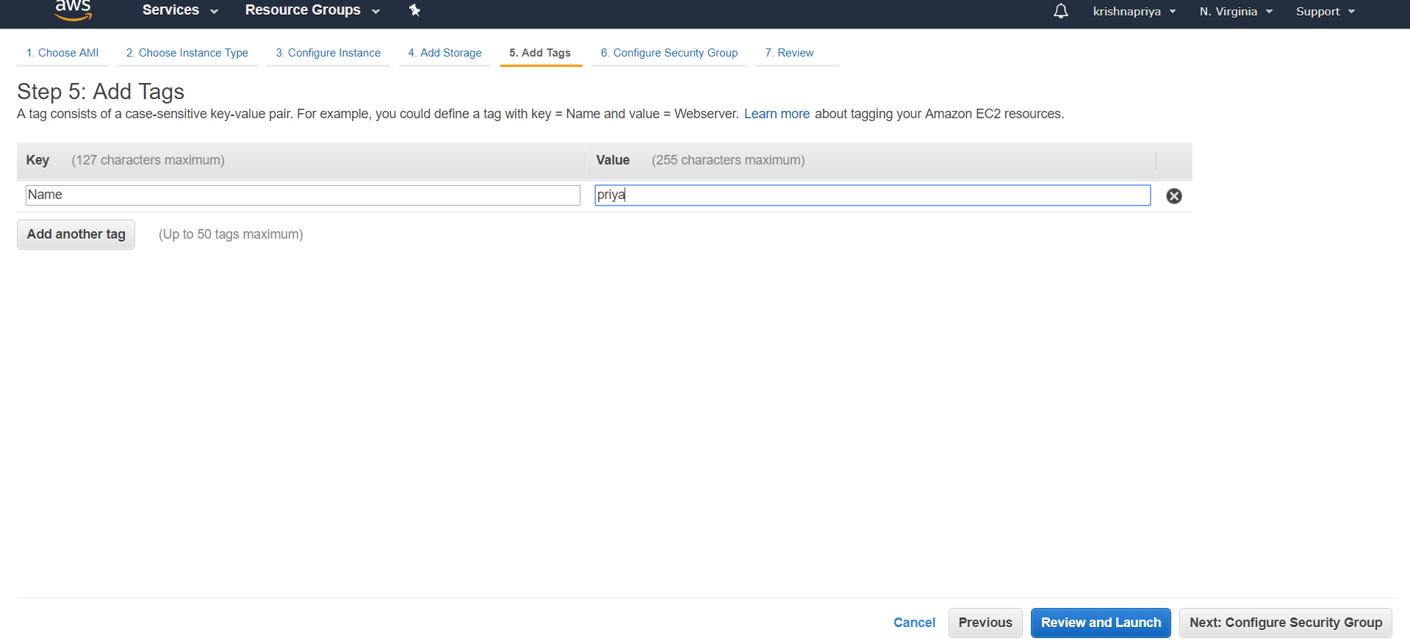

Step6: configure security group

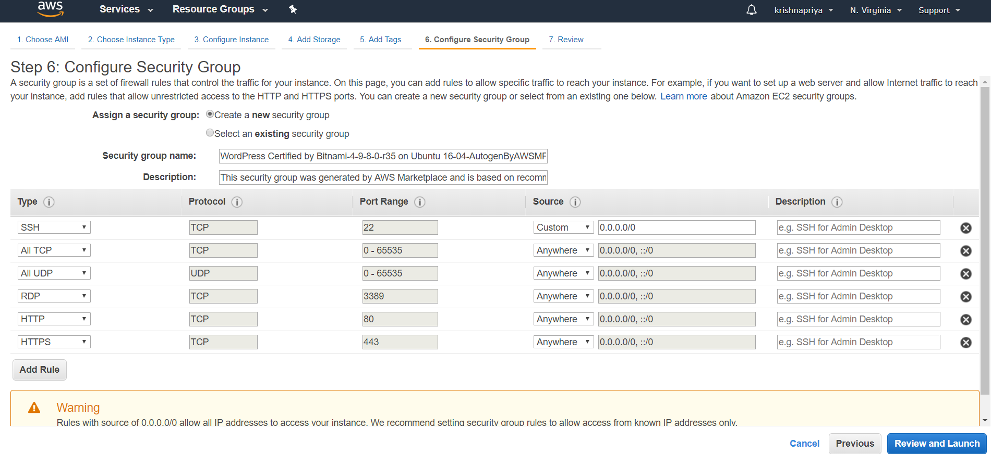

Step7: review the instances

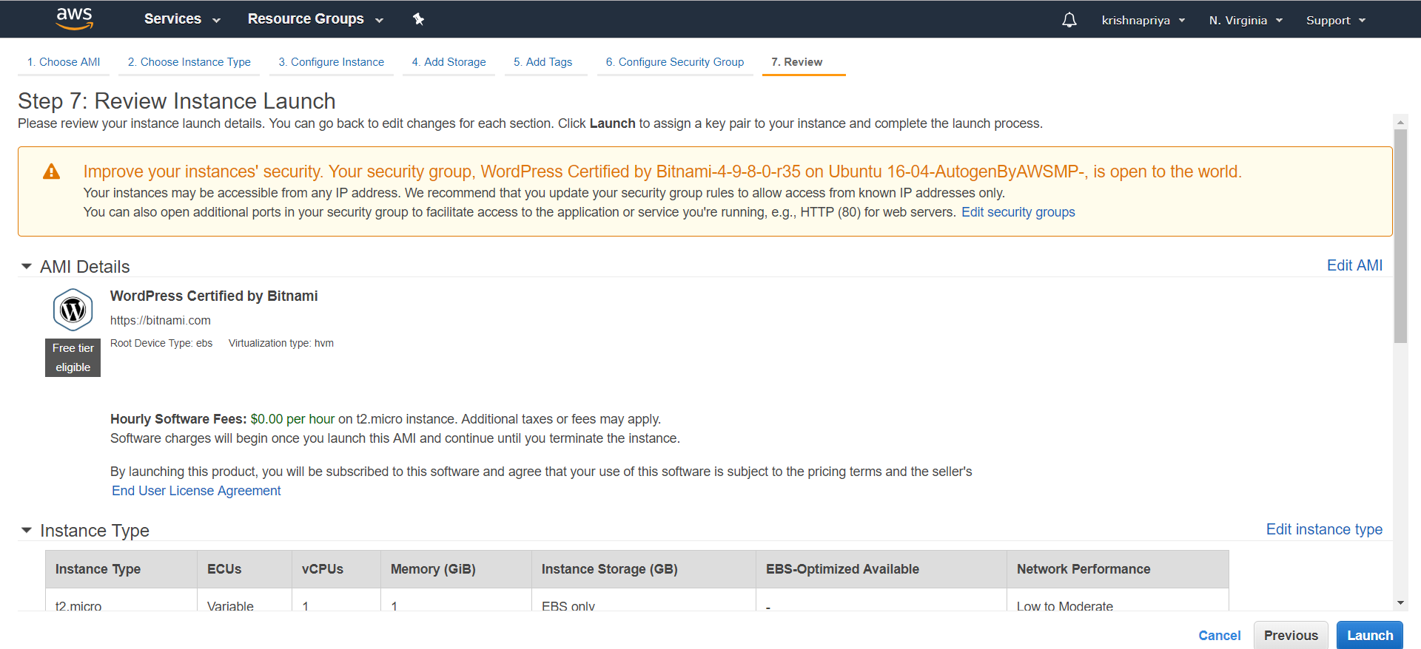

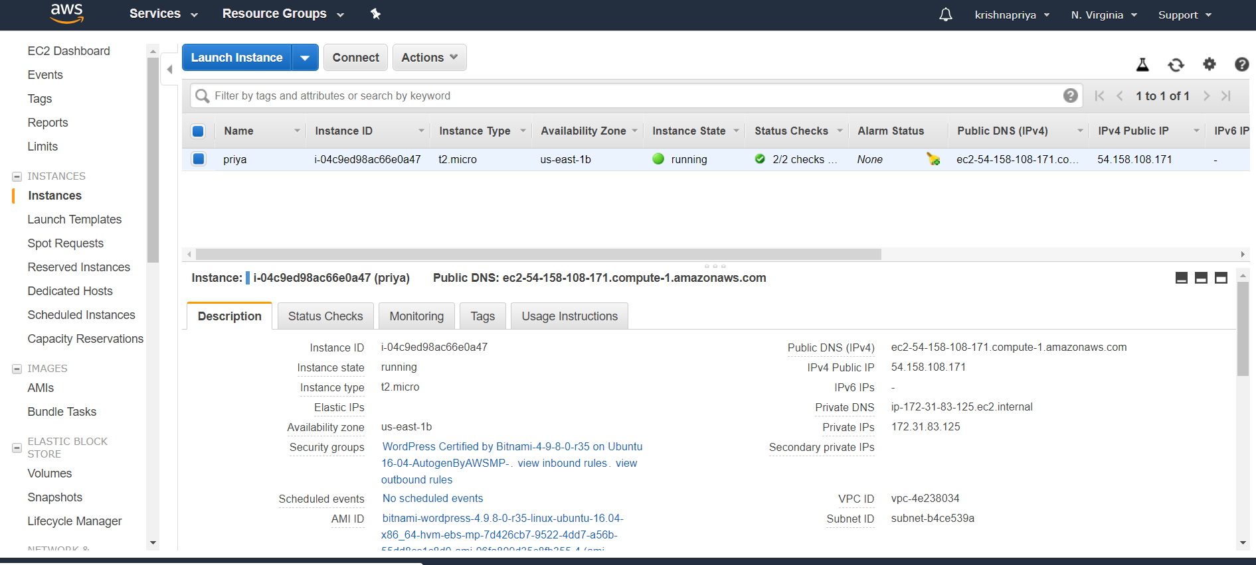

Use that address (and a path to your .pem file) to ssh into your instance:

**ssh ec2-user@ec2-50-17-14-16.compute-1.amazonaws.com -i ~/priya.pem**

**Many of the shell commands below require root access. To avoid having to prefix these commands with sudo, let’s just switch user once and for all: sudo su**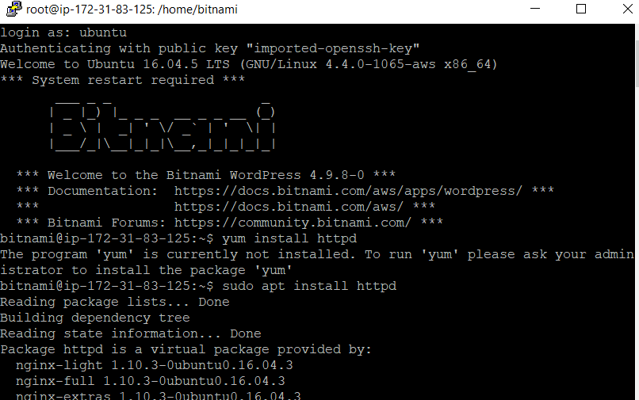

Install the Apache Web Server

**To install the Apache Web Server, type:**

**Sudo apt-get install apache2**

